FORM 4 PHYSICS EXAM
Marking scheme
THIRD TERM 2022
OPENER EXAMINATION TERM 3, 2022
PHYSICS PAPER 1 (232/1)
Instructions to candidates

- Write your name and admission number in the spaces provided above
- Answer all the question in the spaces provided.
- All working must be clearly shown in the spaces provided
- Mathematical tables and calculators maybe used.
- All questions amount to 100 marks

SECTION A (25MKS)
- A 60000cm³ litre giant density bottle has its weight stated as 100N when empty. What would be its weight when filled with a liquid W, whose density is 0.72 g/cm³ (3mks)
d =$\frac{m}{v}$
m=d x v
=0.72 x 60000g
=43,200g
= 43.2kg
Weight of liquid, W = mg = 43.2 x 10N=432N
Weight of density bottle = 100+432=532N
- Given the following graph below
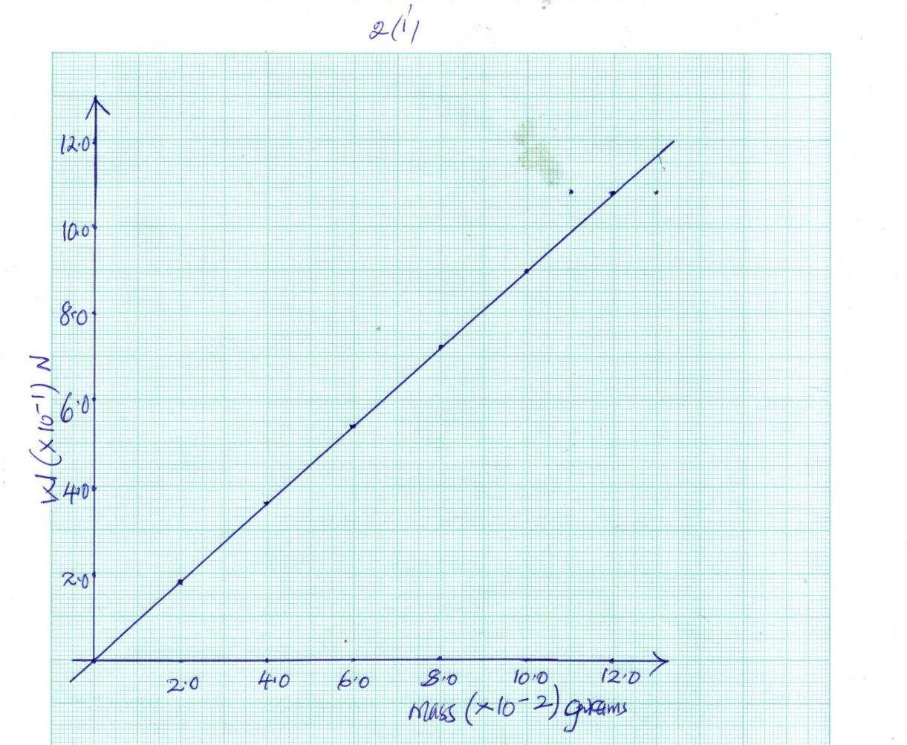

    - Determine the gradient (2mks)

Gradient =$\frac{∆W}{∆M}$ = $\frac{0.72-0.18}{0.080- 0.02}$ = $\frac{0.54}{0.46}$ = 9N/kg
    - state what the gradient represents (1mk)
Gradient represents gravitational field intensity

- state one negative effects of ANOMALOUS EXPANSION of water (1mk)
Icebergs under water in the sea
or water pipes burst due to freezing of water inside the pipes.
- Sketch the variation of density of water with temperature between 0°C to 10°C (2mk)
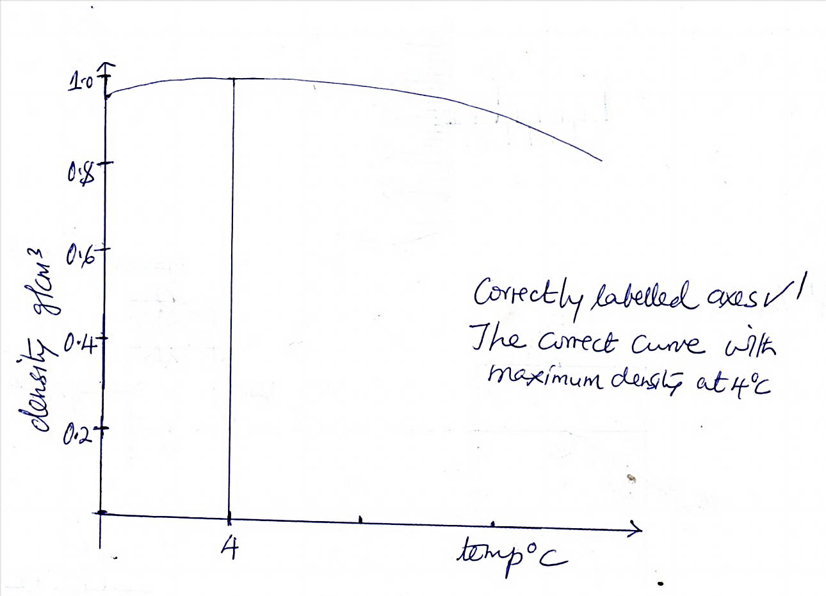
- Apart from conductivity of a material, state other factor which determine rate of heat flow in a material (1mk)
Cross sectional area
Or
Temperature difference
Or
Length of material
- Give one reason why liquids are poor conductors of heat. (1mks)
Liquids have larger inter molecular distances than solids.
Liquids have few collisions between its molecules than solids (any 1)
- Three springs are arranged in parallel as shown and a 600gm mass hanged as shown below. If each spiral spring has 24 N/m spring constant.

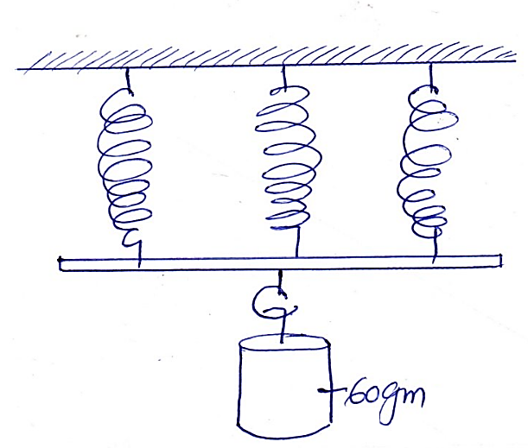
Determine the:
  - Effective spring constant (2 mks)
$\frac{1}{K_{E}}$ =$\frac{1}{K}$ +$\frac{1}{K}$ + $\frac{1}{K}$
=$\frac{1}{24}$ +$\frac{1}{24}$ + $\frac{1}{24}$ =$\frac{3}{24}$ =$\frac{1}{24}$ =$\frac{1}{8}$
K_{E}=8 N/m
  - Extension produced (2 mks)
By Hooke’s Law = F =Ke
W = ke
= $\frac{60}{1000}$ x 10 = 8 X e
0.6=8e
e=$\frac{0.6}{8}$
e= 0.075m
=7.5cm
- A ball is thrown horizontally from the top of a cliff 20m high with a horizontal velocity of 10m/s. calculate the time taken by the ball to strike the ground (2mks)
S = ut + $\frac{1}{2}$ x10 x t²
20= 5t²
T²=4
T=2sec
- State one (1) factor that affect the diffusion of gas (1mk)
Temperature
Density of gas
- A trolley of mass 1.5 kg is pulled along by an elastic cord and given an acceleration of 2m/s ². Find the frictional force acting on the trolley if the tension in the cord is 5N. (2mks)
Resultant force = applied force – frictional force
F = 5 – frictional force
Ma= 5 – frictional force
1.5 x 2 =5 – p
3= 5 –p
P = 5 – 3 = 2N
- State the law of conservation of linear momentum (1mks)
It states that for a system of colliding bodies, the total linear momentum remains constant, provided no external forces act.
- A point in the rim of a wheel has a velocity of 5.6 m/s. if the rim has a radius of 0.4m, determine the angular velocity of the point (2mks)
V =r$ω$
5.6 = 0.4 x $ω$
$ω$ =$\frac{5.6}{0.4}$
=14 rad/sec

- A form 2 student measured the diameter of a ball bearing using a micro meter screw gauge as shown below
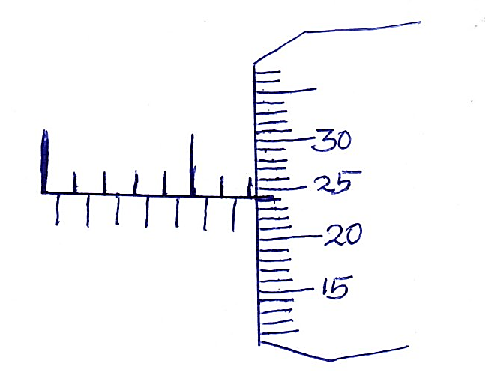
10
5
State the diameter of the ball as read from above if it has an error of -0.02 (2mks)
12.5 mm + $\frac{0.5 x 24}{50}$ + 0.02
12.5mm + 0.24mm + 0.02 = 12.76 mm

SECTION B (55 MARKS)
- (a) State the principle of transmission of pressure in liquids (1mk)
Pressure applied at one part in a liquid is transmitted equally to all other parts of the enclosed liquid.
(b) The figure below shows two masses placed on light pistons. The pistons are held stationery by the liquid, L as shown.
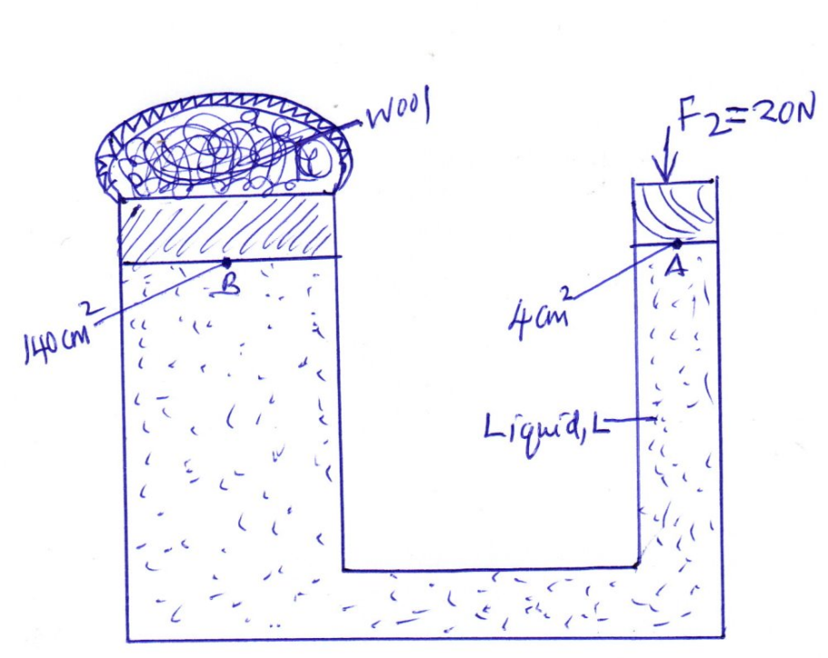
Determine
    - Pressure exerted by force F2 = 20N at point A of the liquid (2mks)
Pressure =$\frac{force}{area}$ =$\frac{20}{4.0 x {10}^{-4}}$ = 50000 N/M²
    - Pressure at point B (1mks)
Pressure at point B = pressure at point A
= 50,000 N/M2
    - Force F1 produced on B to press wool enclosed (2mks)

F = PA
= 50,000 x 140 x 10 ⁻⁴ = 700N
c. An electric motor raises a 50 kg load at a constant velocity, if it takes 40 seconds to raise the load through a height of 24m, determine
- The work done (g = 10N/Kg)(2mks)
w.d = force x distance
=mg x h
= 50 x 10 x 24
w.d = 12,000N
- The power of the motor (2mks)
Power = $\frac{work done}{time taken}$ = $\frac{12000}{40}$ = 300 watts
d. State two (2) factors which determines the mechanical advantage of a
machine (2mks)
- friction between moving parts of a machine
- weight of parts of a machine that have to be lifted when operating it.

- (a) Define centre of gravity (1mk)
The centre of gravity of a body is the point of application of the resultant force due to the earth’s attraction on the body.
(b) State the principle of moments (1mk)
It states that for a system in equilibrium, the sum of clockwise moments about a point is equal to the sum of the anticlockwise moments about the same point.
(c) Calculate the force F required to be applied vertically to the wheelbarrow
handles in the figure below to lift a 50kg load at the centre of gravity
indicated. Disregard the mass of the wheel barrow. (3mks)
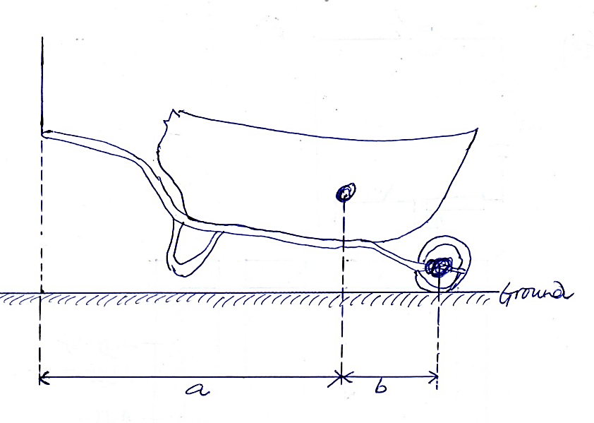
C.O.G
F
Take a =70cm, and b = 30cm.
Clockwise moments = anticlockwise moments
F x (a +b) = (m x g) x b
F x $\frac{100}{100}$ = (50 x 10) x $\frac{30}{100}$
F x 1 = 150
F = 150N
(d) The graph below shows the force on a tennis ball when served during a
game. Assuming the ball is stationery before it is struck and it is struck
with velocity of 40m/sec.

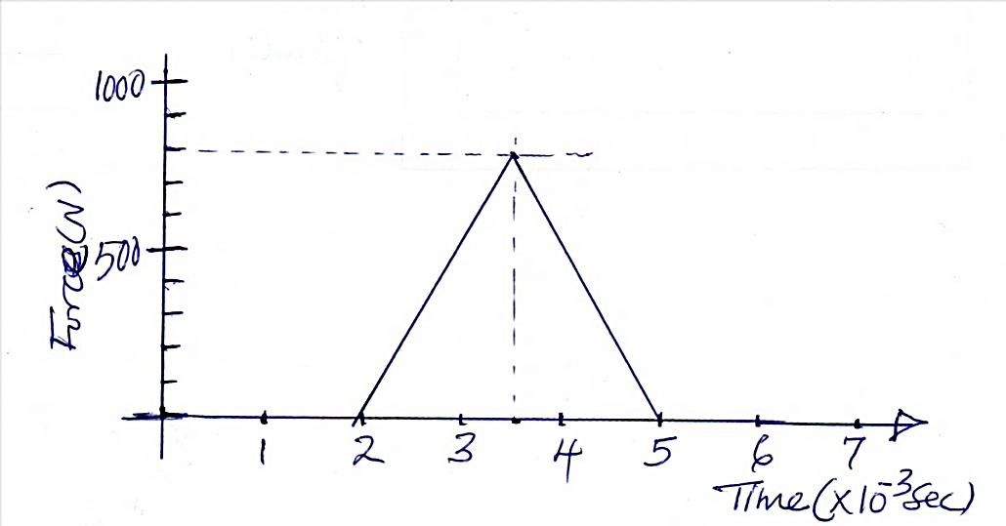
Find
- The impulsive force on the ball (2mks)
Impulse force = F t
=area under the curve
= $\frac{1}{2}$ x (5 - 2) x 10⁻² x 800
= 1.2 NS
- The mass of the racket (2mks)
Ft = change in momentum
1.2 = mv – mu
=m (v - 0)
1.2 =mv
1.2 = m x 40
M = $\frac{1.2}{40}$ = 0.03kg
(e) A passenger of mass 80kg stands on the floor of a lift car. Determine the
Reaction of the floor when the car
- Accelerates at 1.2 m/s² downwards (2mks)
F= mg – R
Ma = mg –R
R = mg –ma
=m(g -a)
=80(10 – 1.2)
=704N
- Decelerates at 0.8 m/s² upwards (2mks)
F=R-Mg
Ma = R –Mg
R=ma +mg
R = m(a +g)
R =80(-0.8+10)
=736N

- (a) State Charles law as it relates to ideal gas (1mk)
It states that the volume of a fixed mass of gas is directly proportional to its absolute temperature if the pressure is kept constant
(b) Distinguish between evaporation and boiling (2mks)
Evaporation | boiling
- Takes place at all temperatures  - Takes place on the surface f the liquid and no bubbles formed  - Decreasing the atmospheric pressure increases the rate of evaporation | - Takes place at a fixed temperature  - Takes place throughout the liquid with bubbles of stream forming all over  - Decreasing atmospheric pressure lowers the boiling point.
(c) Study the diagram below.
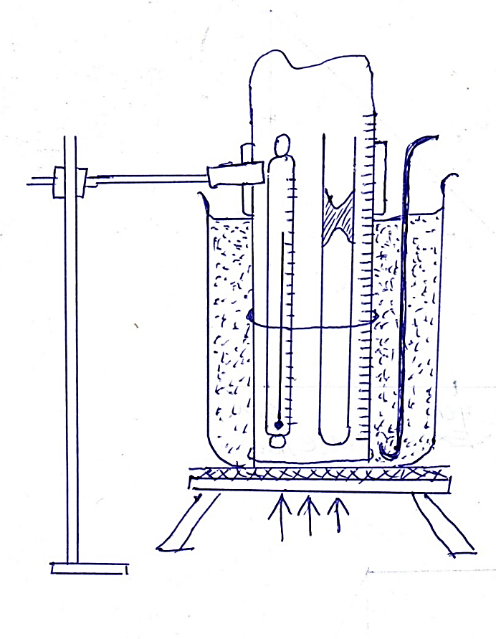
- State two quantities to be measured (2mks)
Temperature
Height of air in the tube
- Explain how the measurements obtained above can be used to verify Charles law (4mks)
The heights of the air columns with their corresponding temperatures recorded are used to plot a graph of height (cm) against temperature (°C).
Since the tube containing the expanding air has a uniform crossection area, the height of the air column recorded is proportional to the volume of the air inside, hence the graph is volume of air against temperature.
The graph obtained is a straight line graph hence constant gradient. This implies that the volume of the fixed mass of gas is directly proportional with temperature.
i.e. V$∝$ T
(iii ) A mass of a gas has a volume of 800cm³ and is heated at a constant pressure from 10°C to 100°C. Calculate the final volume of the gas (3mks)
$$\frac{V1}{T1}$$ = $\frac{V2}{T2}$ = $\frac{800}{(273+10)}$ = $\frac{V2}{(273+100)}$ = $\frac{800}{(283)}$ =$\frac{V2}{(373)}$
V2 = $\frac{800 X 373}{(283)}$
=1054.4 CM³
- (a) Define heat capacity (1 mk)
Heat capacity is the quantity of heat energy required to raise temperature of a given mass of a material by 1°C or 1 kelvin.
(b) The figure below illustrates an experiment in which electrical energy is
Used to determine specific heat capacity of a metal heated for a period of time.
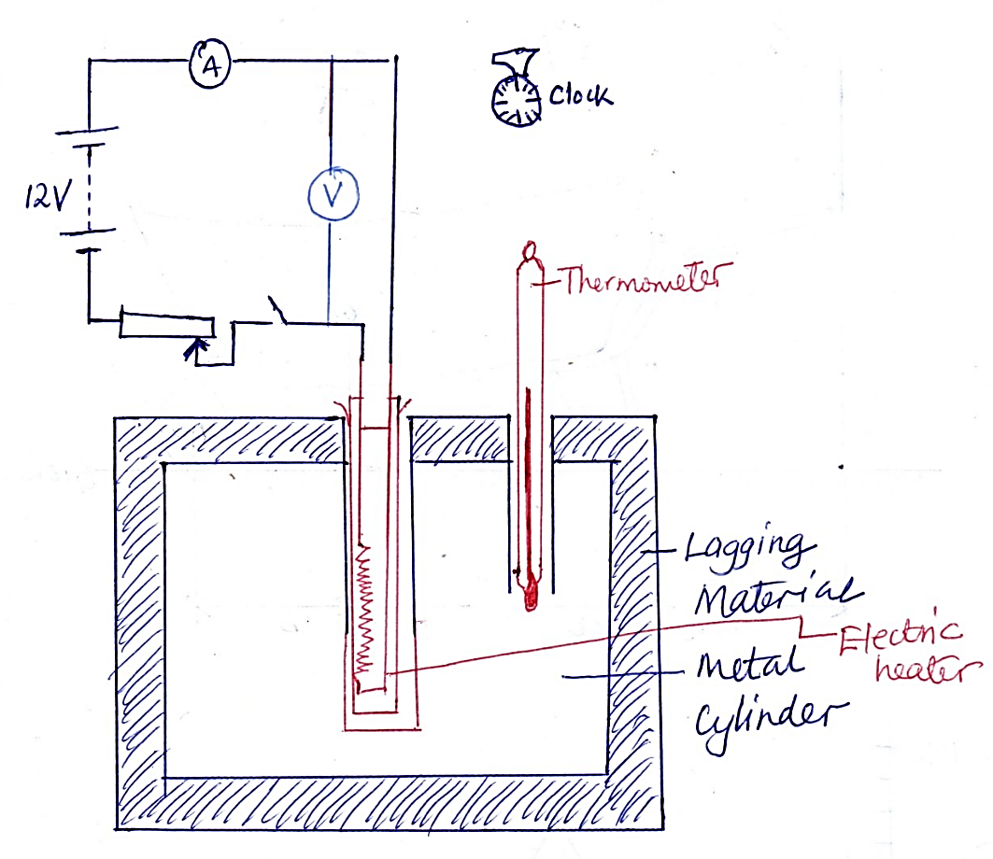

    - Complete the circuit to show connection of the essential circuit components and name them (2mks)
Voltmeter, thermometer

    - Outline the procedure on how to determine the value of specific heat capacity, C, of the metal block. (3mks)
- Weight the metal block and record its mass, m
- Record the initial temp of the block O₁
- Start the stop watch as you switch on the heater
- record the readings of the ammeter and voltmeter
- To ensure the values are kept constant
- Record the time taken for the temperature to rise to O₂ and record temperature O₂ too.
In a similar experiment the following readings were obtained when the heater was switched on for 10 minutes
Voltmeter reading = 15v
Ammeter reading = 3A
Temp after 10min = 80c
If the mass of the metal cylinder was 0.5kg and the initial temperature of the metal block before switching on current was 20°c determine the specific heat capacity of the metal cylinder (3mks)
Heat supplied by the heater = heat gained by the metal cylinder
Vit = mc$θ$
15x3x (10 x 60) = 0.5 x cx (80-20)
15 x 3 x 600 = 0.5 x cx 60
C = $\frac{15 x 3 x 600}{0.5 x 60}$
= 900JKg⁻¹ k⁻¹
- (a) State Archimedes principle (1mk)
It states that when a body is partially or totally immersed in a fluid, it experiences an up thrust equal to the weight of the fluid displaced
(b) A cylinder of length 5cm and uniform cross section area 50.24cm² is suspended from a spring balance and totally immersed in water. If the density of the material of the cylinder is 1.25g/cm³ determine:
    - The up thrust on the cylinder (3mks)
Upthrust = weight of water displaced
U=mg
= ($δ$v) x g
= $δ$g x V
=$δ$g x Ah
= 1000 x 10 x 50.24 x 5
= 2.512 N
    - Weight of the cylinder (3mks)
W = mg =$δ$vg
=1250 X$(\frac{5X50.24}{100X100X100}$) X10
3.14N
    - The reading on the spring balance (2mks) (take g = 10m/s² or N/kg S_{h2O} =1000kg/m³) (2mks)
= Reading = apparent weight of the cylinder
= weight in air – up thrust
= 3.14 – 2.512
= 0.628N

