Name: ………………………………………………………………… Adm. No………..................Date……………………...
232
PHYSICS
(THEORY)END TERM 2
TIME: 2½ HOURS
MULTILATERAL EXAM SECOND TERM
PHYSICS FORM 3
INSTRUCTIONS TO CANDIDATES:
- Write your name, admission number, date of examination in the spaces provided above.
- This paper consists of sections: A and B.
- Answer all the questions in section A and B in the spaces provided.
- All working must be clearly shown in the spaces provided.
- Mathematical tables and electronic calculators may be used.

For Examiner’s Use Only

SECTION | QUESTION | MAXIMUM SCORE | CANDIDATE’S SCORE
A | 1 – 16 | 50
B | 17 | 7
 | 18 | 7
 | 19 | 6
 | 20 | 6
 | 21 | 7
 | 22 | 10
 | 23 | 7
TOTAL SCORE |  | 100

This paper consists of 10 printed pages. Candidates should check the question paper to ascertain that all the pages are printed as indicated and no questions are missing

SECTION A (50 MARKS)
ANWERS ALL QUESTIONS IN THE SPACES PROVIDED
- Figure 1 shows a reading of a micrometer screw gauge when a metallic spherical ball of mass 60g is measured by it.
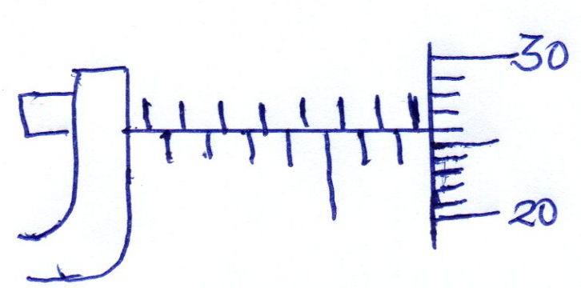
If the micrometer screw gauge had a zero error of -0.01, what is
  - The reading of the sphere. (2mks)

  - The density of the metal ball. (3mks)

- (a) Define upthrust force. (1mk)

(b) A body weights 180N in air and 100N when immersed in water. Determine the
up thrust acting on the body. (2mks)

- (a) Define pressure, stating SI units. (1mk)

(b) A building brick measures 40cm long, 20cm wide and 10cm thick and has a mass of
2500g. determine the least pressure that can be exerted by the brick on a flat surface.
(2mks)

- In a smoke cell experiment bright specs are observed to be in random motion .
  - Explain what causes the random motion . (1mk)

  - What conclusion can be made from (i) above. (1mk)

- (a) What is anomolous expansion of water. (1mk)

(b) State two (2) differences between alcohol and mercury as thermometric
liquids. (2mks)

- (a) State two (2) factors on which rate of heat flow in a solid depends on (2mks)

(b)The following set up was used to show convection in gases.
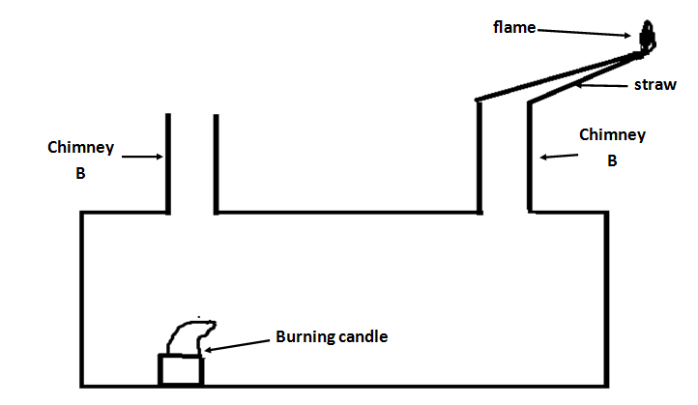

A smoldering straw was placed in chimney A as the candle inside continued burning.
- State the observation made and indicate it in the diagram (2mk)

- Explain your observation (2mks)

- (a) The photographic film of a pinhole camera is 20cm away from the pinhole. A student
of height 1.6m stands 8m from the opening of the pinhole. Determine the height of
the students image (2mks)

(b) The figure below shows a ray of light incident on a plane mirror at a point 0.
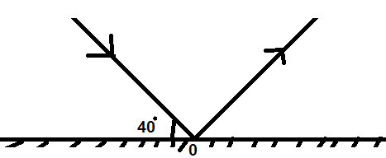
The mirror is rotated through an angle of 25 o about an axis perpendicular to the paper.
Determine the angle through which the reflected ray is rotated (1mks)

- (a) What is local action in a simple cell, and state how it can be minimised. (2mks)

(b) Determine the amount of current flowing through a bulb if 450 coulombs of charge
flows through it in five minutes. (2mks)

- Describe how you would magnetize a steel needle by single stroke method given a steel needle and a bar magnet. (3mks)

- (a) State the principle of moments. (1mk)

(b) A uniform metre rule is balanced at the 30cm mark when a load of 0.48N is hung at the zero mark. Calculate the weight of the metre rule. (2mks)
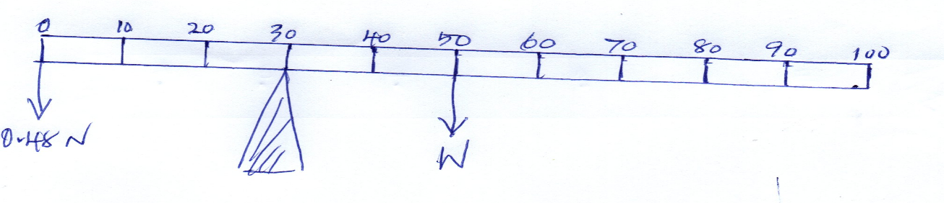

- (a) The diagram below shows the image formed by a convex mirror. Complete the
diagram to show the position of the object (drawn to scale) (2mks)
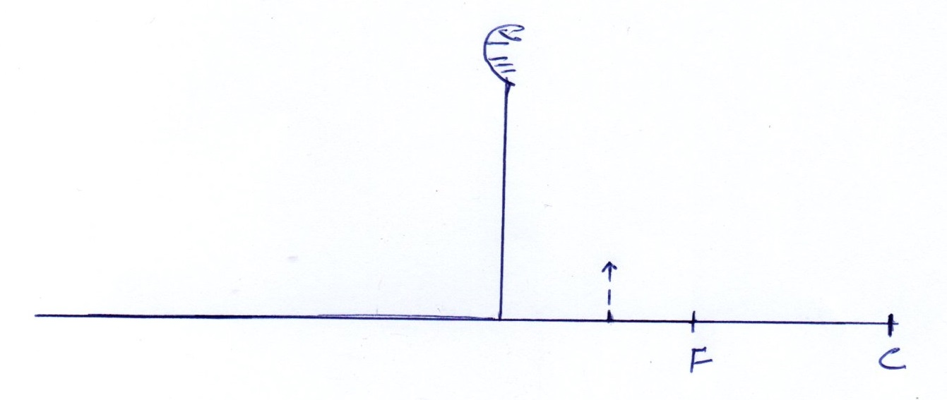
(b) From your diagram above determine the magnification of the image (2mks)

- A 4N load causes a 10cm extension of a spring. What would be the extension when two such identical springs are connected in parallel and a load of 2N is applied at their lower end point. (2mks)

- Given the following displacement – time graph for a mass oscillating on a spring.
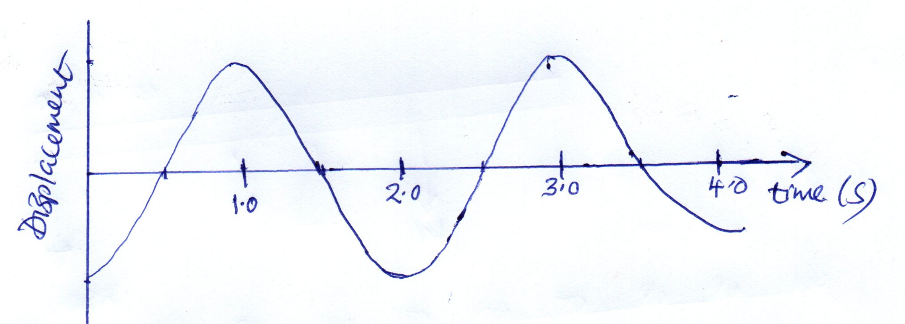
  - period (1mk)

  - Find the frequency of the above wave (2mks)

- Two girls stood 200m from a wall. One of the girls banged two pieces of wood together while the second started a stop watch and stopped it when she heard the echo. If the time shown on the stop watch was 1.2 sec determine the speed of the sound. (2mks)

- A lawn sprinkler has 40 holes each of cross section area 2.0 X 10⁻² cm². The sprinkler is connected to a hose pipe of cross section area 1.6cm², if the speed of the water in the hose pipe is 1.2 m/sec, calculate the flow rate in the hose pipe (2mks)

- State two factors affecting boiling point of a liquid (2mks)

SECTION B (50 MKS) ANWERS ALL QUESTIONS IN THE SPACES PROVIDED
- (a) The diagram below shows a permanent magnet suspended by a spring. State with reason the behaviour of the magnet when the switch is closed. (2mks)
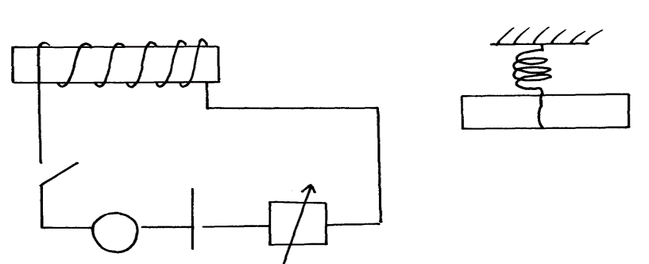
Spring
S
A
Y
N S
X
+ -

(b) Mention the material used the material used as XY and state the reasn why its used.
(2mks)

(c) give one rule that is used to identify the polarity of XY (1mk)

(d) State two (2) factors affecting the STRENGTH of an electromagnet (2mks)

- The figure below shows a section of a ticker – tape produced by a ticker – timer operating at a frequency of 50HZ.
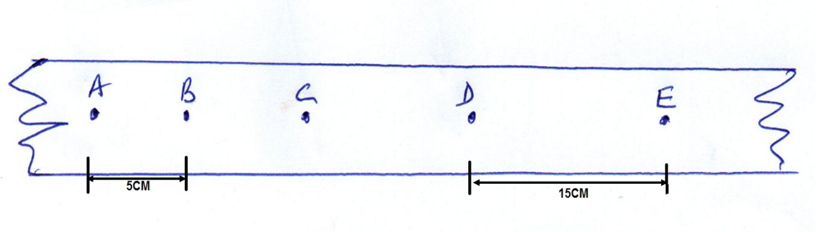
  - Find the average velocity between A and B (3mks)

  - Find the average velocity between D and E (2mks)

  - Determine the average acceleration (2mks)

- (a) Define critical angle (1mk)

(b)The figure below shows a ray of light incident on a glass – air interface.
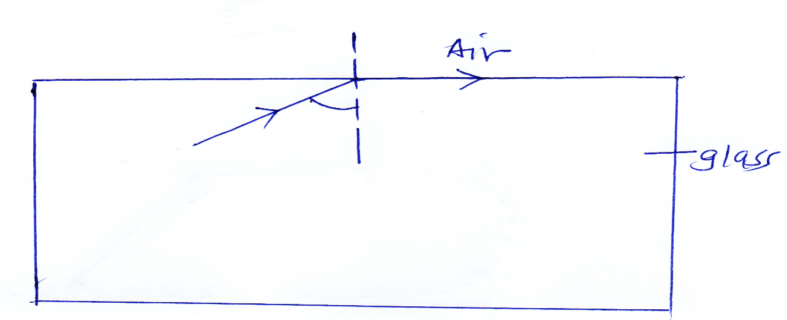
Given that the refractive index of the glass is 1.6 determine angle $θ.$ (2mks)

(b) Given that the refractive index of diamond is 2.42 and the velocity of light in air is
3.0 x 10⁸ m/s, determine the velocity of light in diamond (3mks)

- (a) State Newton’s second law of motion (1mk)

(b) (i) Determine the change in momentum produced when force of 3.5 X 10³N acts on a
body which is at rest for 0.02 sec. (2 mks)

(ii) Find what velocity will be given to the body if it has a mass of 20kg for it to attain
the above impulse. (3mks)

- (a)(i) Give one reason why are machines not 100% efficient. (1mk)

(a)(ii) A certain machine uses an effort of 400N to lift a load of 600N. if the efficiency of the machine is 80%, determine the velocity ratio. (3mks)

(b) A form 2 student took 4 seconds to climb upstairs to height of 8m. Determine the
average power in climbing up the height if mass of the student is 50kg. (3Mks)

- (a) State Ohm’s law. (1mk)

(b) The circuit diagram below shows 4 resistors supplied current by a 6V battery. When
switch K is closed current I flows. If the battery have negligible internal resistance.
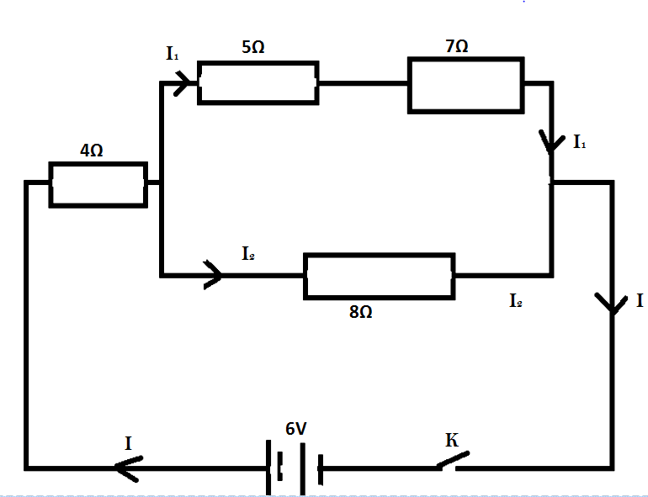
Determine
  - The effective resistance of the circuit (3mks)

  - The current flowing through the 8$Ω$resistor (3mks)

(c) A house has twenty 60W bulbs, two 1000W heater and two 500W security lights. If
the appliances are running on a 240V supply calculate
    - The total power in KW used when all are switched on (2mks)

    - The total current drawn from the mains supply. (1mk)

- (a)Define capacitance. (1 mk)

(b) Two plates of a parallel – plate capacitor are 0.8mm apart and each has an area
4cm². Given that the potential difference between the plates is 100v,
  - Find the capacitance of the capacitor ( take E₀ =8.85 x 10⁻¹² FM⁻¹). (2mks)

  - Calculate the charge stored in the capacitor. (2mks)

(c) State two applications of a capacitor. (2mks)

