MULTILATERAL EXAM SECOND TERM
PHYSICS FORM 3
SECTION A (60 MARKS)
- Figure 1 shows a reading of a micrometer screw gauge when a metallic spherical ball of mass 60g is measured by it.
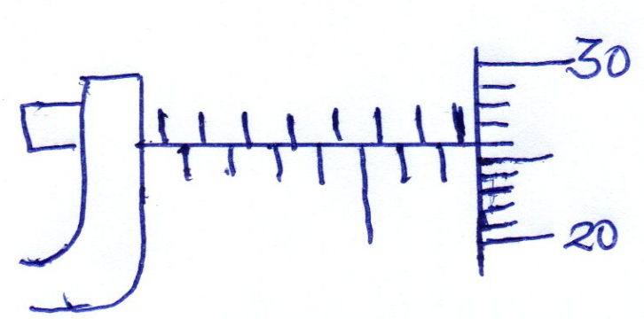
If the micrometer screw gauge had a zero error of -0.01, what is
  - The radius of the sphere (2mks)
D = 7.5 + 0.26 + 0.01 = 7.77mm
R=$\frac{7.77}{2}$ = 3.885 mm
  - The density of the metal ball (3mks)

Volume = $\frac{{4πr}^{3}}{3}$
= $\frac{4}{3}$ x3.142 x (3.885)3
=245.6188mm³
=0.246cm³
Density = $\frac{mass}{volume}$
=$\frac{60}{0.246}$
=243.9g/cm³

- (a) Define up thrust force. (1mk)
The upward force acting on an object immersed in a fluid

(b) A body weights 180N in air and 100N when immersed in water. Determine the
up thrust acting on the body (2mks)
upthrust = weight in air – weight in water
= 180 – 100
= 80N

- (a) Define pressure, stating SI units (1mk)
Pressure is the force acting perpendicularly per unit area expressed in newton’s per square metre.

(b) A building brick measures 40cm long, 20cm wide and 10cm thick and has a mass of
2500g. determine the least pressure that can be exerted by the brick on a flat surface.
(2mks)
Weight of brick =$\frac{2500}{1000}$ X100 = 25N
Largest area of brick face = 40 X 20 =800cm² = $\frac{800}{100 X 100}$ M²
= 0.08M²
Least pressure = $\frac{weight}{largest area}$ = $\frac{25}{0.08}$ =312N/M²

- In a smoke cell experiment bright specs are observed to be in random motion .
  - Explain what causes the random motion . (1mk)
Smoke particles are bombarded by invisible air particles

  - What conclusion can be made from (i) above. (1mk)
Matter is made up of very small particles which are in constant random motion.
- (a) What is anomolous expansion of water (1mk)
It is contraction of water as its temperature is raised from 0⁰C to 4⁰C
or
it is expansion of water as its temperature is lowered from 4⁰C to 0⁰C
(b) State two (2) differences between alcohol and MERCURY as thermometric
liquids. (2mks)
Alcohol | mercury
- Low boiling point , 78⁰C  - Low melting point , -115⁰C  - Poor thermal conductor  - Expansion slightly irregular  - Wets glass  - Transparent | - High boiling point, 357⁰C  - Relatively higher melting point, -39⁰C  - Good thermal conductor  - Expands regularly  - Does not wet glass  - Opaque and silvery  - Any 2

- (a) State two (2) factors on which rate of heat flow in a solid depends on. (2mks)
- Temperature difference
- Length of material
- Cross sectional area of the material
- Thermal conductivity of the material
- Any 2
(b)The following set up was used to show convection in gases.

A smoldering straw was placed in chimney A as the candle inside continued burning.
- State the observation made and indicate it in the diagram (2mk)
The smoke moves from the straw through chimney A to the above the candle then moves out through chimney B.
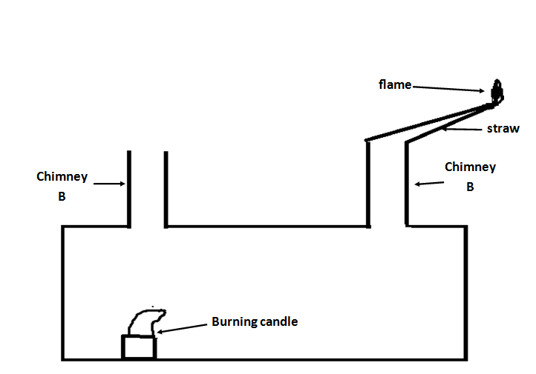
- Explain your observation (2mks)
The candle heats up the air above it, which expands and rises up, cold heavier air is drawn in through A, carrying along the smoke which replaces the air that is escaping through chimney B.

- (a) The photographic film of a pinhole camera is 20cm away from the pinhole. A student
of height 1.6m stands 8m from the opening of the pinhole. Determine the height of
the students image (2mks)
Magnification = $\frac{image distance}{objest distance}$ = $\frac{image height}{object height}$
$$\frac{0.2}{8}= \frac{hi}{1.6}$$
Hi = $\frac{0.2}{8}$ X 1.6 = 0.04M

(b) The Figure below shows a ray of light incident on a plane mirror at a point 0.
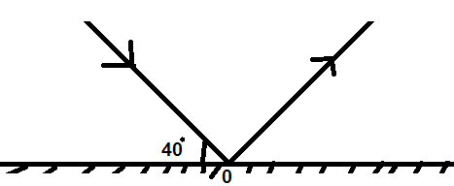
The mirror is rotated through an angle of 25º about an axis perpendicular to the paper.
Determine the angle through which the reflected ray is rotated (1mks)
$θ$ = 2 X 25 =50⁰

- (a) What is local action in a simple cell and state how it can be minimised (2mk)
The eating away of the zinc plate as it reacts with dilute sulphuric acid. Use of pure zinc reduces local action or coating zinc with mercury.
(b) Determine the amount of current flowing through a bulb if 450 coulombs of charge
flows through it in five minutes. (2mks)
$$ϑ=it$$
450 = I x (5 X 60)
I = $\frac{450}{5 x 60}$ = 1.5 A

- Describe how you would magnetize a steel needle by single stroke method
(3mks)
- using a bar magnet
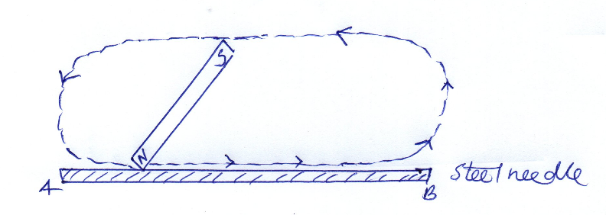
- the steel needle is stroked with one pole of the magnet from end A to end B, lifting away at end B as shown above
- the procedure is repeated several times keeping the inclination of the magnet roughly the same.
- End B of needle acquires South Pole.

- (a) State the principle of moments. (1mk)
The principle of moments states that for a system in equilibrium, the sum of clockwise moments above a point is equal to the sum of anticlockwise moments about the same point.
(b) A uniform metre rule is balanced at the 30cm mark when a load of 0.48N is hung at
the zero mark. Calculate the weight of the metre rule. (2mks)
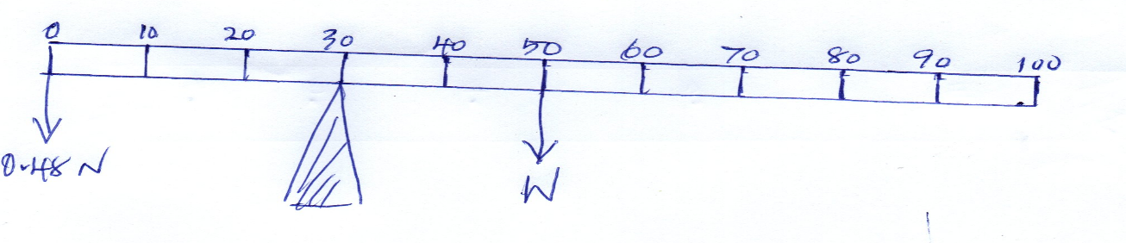
At equilibrium
Clockwise moment = anticlockwise moment
W X 20 =0.48 X 30
W = 0.72N
- (a) The diagram below shows the image formed by a convex mirror. Complete the
diagram to show the position of the object (2mks)
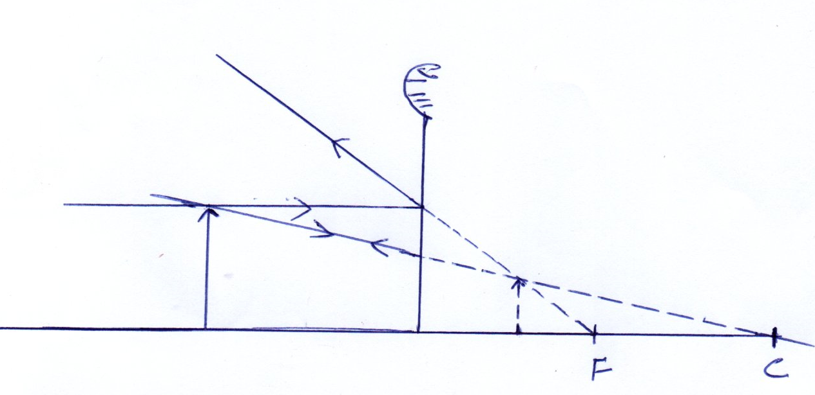
(b) From your diagram above determine the magnification of the image (2mks)
Magnification, m = $\frac{V}{U}$ = $\frac{4.2}{2}$ = 2.1
- A 4N load causes a 10cm extension of a spring. What would be the extension when two such identical springs are connected in parallel and a load of 2N is applied at their lower end point. (2mks)
E = $\frac{2}{4}$ X 10
= 5
=$\frac{5}{2}$ = 2.5
Or
K =$\frac{f}{e}$ = $\frac{4}{10}$ = 0.4 N/CM
K_{P} = 2K = 2 x 0.4 = 0.8
E =$\frac{F}{K}$ = $\frac{2}{0.8}$ = 2.5cm

- Given the following displacement – time graph for a mass oscillating on a spring.
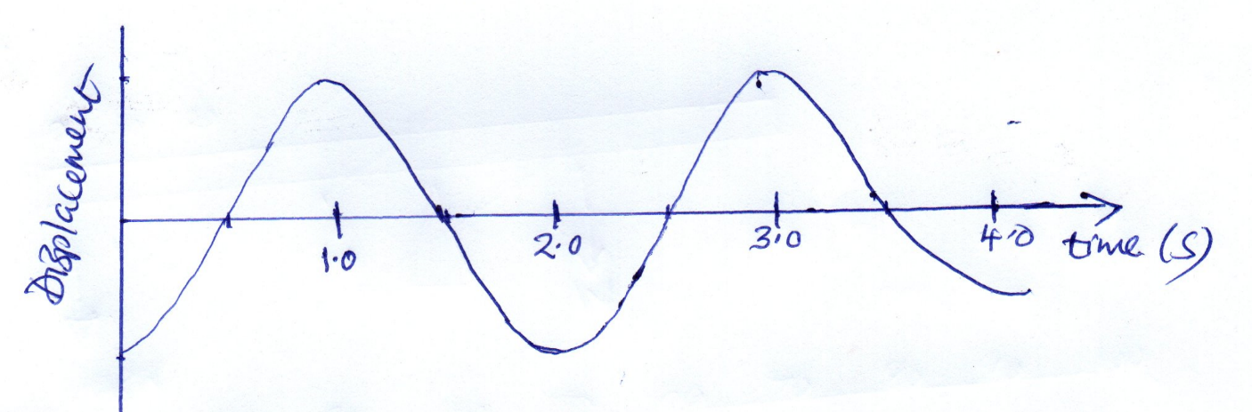
  - period (1mk)
Period is the time taken by a particle to complete one oscillation.

  - Find the frequency of the above wave (2mks)
Period ,T of the above wave = 2.0 sec
F = $\frac{1}{T}$ = $\frac{1}{2}$ = 0.5 HZ

- Two girls stood 200m from a wall. One of the girls banged two pieces of wood together while the second started a stop watch and stopped it when she heard the echo. If the time shown on the stop watch was 1.2 sec determine the speed of the sound. (2mks)
distance travelled by sound = 2 x 200
= 400m
speed of sound = $\frac{DISTANCE}{TIME}$
speed = $\frac{400}{1.2}$
=333.3 m/s
- A lawn sprinkler has 40 holes each of cross section area 2.0 X 10⁻² cm². The sprinkler is connected to a hose pipe of cross section area 1.6cm², if the speed of the water in the hose pipe is 1.2 m/sec, calculate the flow rate in the hose pipe (2mks)
Flow rate = cross section area X speed
=1.6 X 10⁻⁴ X 1.2
=1.92 X 10⁻⁴m³/sec

- State two factors affecting boiling point of a liquid (2mks)
Pressure
Impurities

SECTION B (40 MKS)
- (a) (a) The diagram below shows a permanent magnet suspended by a spring. State with reason the behaviour of the magnet when the switch is closed. (2mks)

The magnet towards on passing the current on the coil, the core XY is magnetized with the South Pole on Y thus attracting the North Pole of the permanent magnet.

(b) Mention the material used the material used as XY and state the reasn why its used.
(2mks)
Iron . its easily magnetized and demagnetised

(c) Give one rule that is used to identify the polarity of XY (1mk)

Flemings right hand grip rule
(b) mention two ways of improving the electric motor you have drawn in (a) above (2mks)
- Winding the coil on a soft iron core
- Increasing the number of turns on the rotating coil
- Using a stronger magnet
- Multiplying the number of coils
- Multiplying the number of commutator segments
Any 2

(c) State two (2) factors affecting the STRENGTH of an electromagnet (2mks)
- Size of current in solenoid
- Number of turns per unit length
- Shape of the core
- Length of the solenoid
Any 2

- The figure below shows a section of a ticker – tape produced by a ticker – timer operating at a frequency of 50HZ.
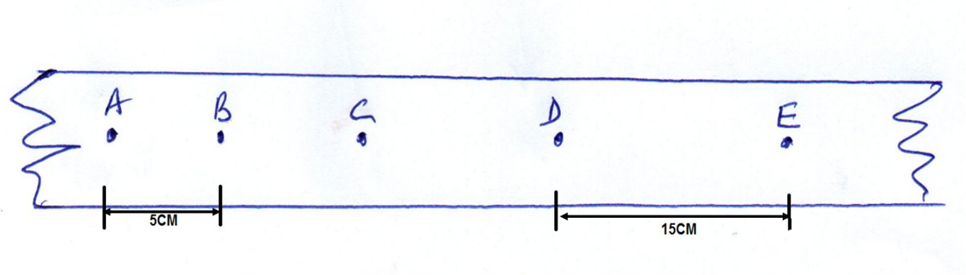

  - Find the average velocity between A and B (3mks)
V_{AB} = $\frac{5CM}{T}$
= $\frac{5cm}{0.02sec}$ where t =$\frac{1}{50}=0.02$
=250cm/sec = 2.5m/s

  - Find the average velocity between D and E (2mks)
V_{DE} = $\frac{15CM}{0.02}$ = 750CM/SEC =7.5 M/S
  - Determine the average acceleration (2mks)

acc = $\frac{VDE-VAB}{3 x 0.02}$
=$\frac{7.5-2.5}{3 x 0.02}$
=$\frac{5}{0.06}$
=83.33 M/S ²
- (a) Define critical angle (1mk)
It is the angle of incidence in the denser medium for which the angle of refraction in the less dense medium is 90º.
(b)The figure below shows a ray of light incident on a glass – air interface. Given that the refractive index of the glass is 1.6. determine angle $θ.$ (2mks)
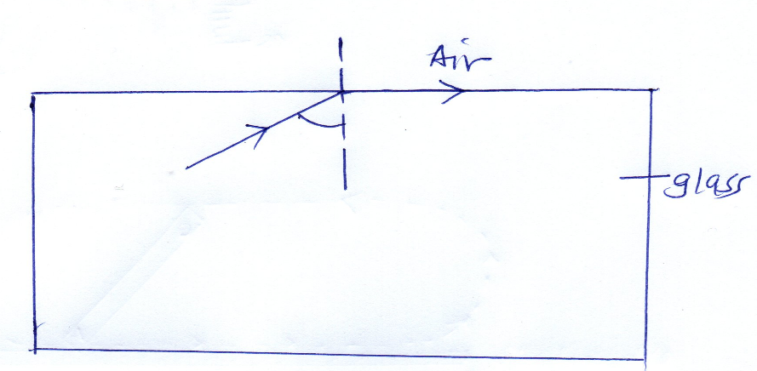
Sin c = $\frac{1}{n}$
Sin c =$\frac{1}{1.6}$
Sin c = 0.625
C = sin ⁻¹ 0.625
=38.7 ⁰

(b) Given that the refractive index of diamond is 2.42 and the velocity of light in air is
3.0 x 10⁸ m/s, determine the velocity of light in diamond (3mks)
N = $\frac{velocity of light in air}{velocity of light in diamond}$
2.42 = $\frac{3.0 X {10}^{8}}{v}$
V=$\frac{3.0 X {10}^{8}}{2.42}$
V= 1.2397 X 10⁸
V= 1.24 X 10⁸ m/s

- (a) State Newton’s second law of motion (1mk)
It states that the rate of change of momentum of a body is directly proportional to the resultant force producing the change and takes place in the direction of the force.

(b) (i) Determine the change in momentum produced when force of 3.5 X 10³N acts on a
body which is at rest for 0.02 sec. (2 mks)
change in momentum = ft
=3.5 X 10³ X 0.02
= 70NS
(ii) Find what velocity will be given to the body if it has a mass of 20kg for it to attain
the above impulse. (3mks)
Momentum change = mv – mw; but u =o
70 = mv
70 = 20v
v=$\frac{70}{20}=3.5 M/S$

- (a)(i) give one reason why are machines not 100% efficient. (1mk)
Friction between the moving parts of a machine.
The weight of lifted parts of the machine.
(a)(ii)A certain machine uses an effort of 400N to lift a load of 600N. if the efficiency of the machine is 80%, determine the velocity ratio. (3mks)
EFFICIENCY =$\frac{ma}{v.r }$ X 100 %
MA =$\frac{LOAD}{EFFORT}$ = $\frac{600}{400}$ = 1.5
80 = $\frac{1.5}{v.r} X 100$
VR = $\frac{1.5 x 100}{80}$ = 1.875

(b) A form 2 student took 4 seconds to climb upstairs to height of 8m. Determine the
average power in climbing up the height if mass of the student is 50kg. (3Mks)
power = $\frac{work done }{time}$
= $\frac{force X distance}{time}$
=$\frac{weight X dist}{time}$
=(50 x 10) X $\frac{8}{4}$
=1000w

- (a) State ohm’s law (1mk)
It states that the current flowing through a conductor is directly proportional to the potential difference across it provided the temperature and other physical conditions are kept constant.

(b) The circuit diagram below shows 4 resistors supplied current by a 6V battery. When
switch K is closed current I flows. If the battery have negligible internal resistance.
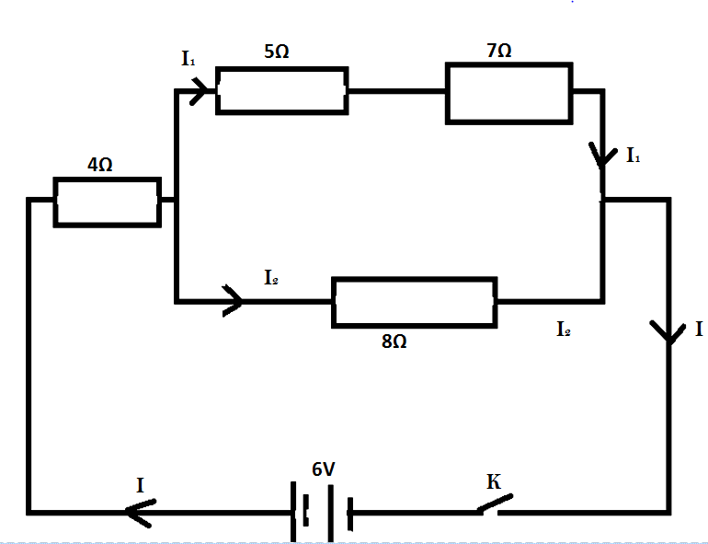
Determine
  - The effective resistance of the circuit (3mks)
= $\frac{1}{R}$ =$\frac{1}{(5+7)}$ + $\frac{1}{8}$ = $\frac{1}{12}$ +$\frac{1}{8}$ = $\frac{2+3}{24}$ = $\frac{5}{24}$
R = $\frac{24}{5}$ = 4.8Ω
RE = 4 +4.8 =8.8 Ω
  - The current flowing through the 8$Ω$resistor (3mks)
By ohms law, V =IR
6 = I (8.8)
I= $\frac{6}{8.8}$
=0.682A
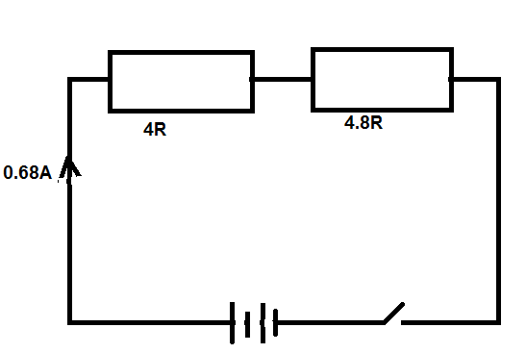

V= V₁ + V₂
6 = IR₁ + V_{2.}
6= 0.682 x 4 +V₂
6 =2.728 +V₂
V₂= 6- 2.728
=3.272
P.D across 8Ω resistor = 3.272V
But p.d = I2R
3.272 = I₂ x 8
I₂ =$\frac{3.272}{8}$
=0.409A
(c) A house has twenty 60W bulbs, two 1000W heater and two 500W security lights. If
the appliances are running on a 240V supply calculate
    - The total power in KW used when all are switched on (2mks)
Total power = (20 X 60) + (2 X 1000) + (2 x 500)
= 4200W
=$\frac{4200}{100}$
=42kw
    - The total current drawn from the mains supply (1mk)
Total current, I, = $\frac{4200}{240}$
=17.5 A

- (a)Define capacitance. (1 mk)
is charge stored per unit voltage
(b) Two plates of a parallel – plate capacitor are 0.8mm apart and each has an area
4cm². Given that the potential difference between the plates is 100v,
  - Find the capacitance of the capacitor ( take $ε$₀ =8.85 x 10⁻¹² FM⁻¹) (2mks)
C = $\frac{ε_{0A}}{d}$ = $\frac{8.85 x {10}^{12} x 4 x {10}^{-4}}{8x{10}^{-4}}$ =
= 4.425 X 10⁻¹² farads

  - Calculate the charge stored in the capacitor (2mks)
Q = cv
=4.425 X ${10}^{-12}$ x 100
=4.425 X ${10}^{-12}$ C
(c) State two applications of a capacitor. (2mks)
    - In rectification (smoothing circuits)
    - In turning circuits
    - In delay circuits
    - In camera flash
    - Reduction of sparking in induction coil contact
Any 2.

