NAME……………………………………………….ADM. NO…………..CLASS..…….……..

END OF TERM II
FORM 2 PHYSICS
TIME: 2 HOUR 30MINS
INSTRUCTIONS TO CANDIDATES:
- Write your name, admission number, date of examination and the name of your school in the spaces provided above.
- This paper consists of sections: A and B.
- Answer all the questions in section A and B in the spaces provided.
- All working must be clearly shown in the spaces provided.
- Mathematical tables and electronic calculators may be used.
For Examiner’s Use Only

SECTION | QUESTION | MAXIMUM SCORE | CANDIDATE’S SCORE
A | 1 – 16 | 40
B | 17 | 17
 | 18 | 10
 | 19 | 11
 | 20 | 10
 | 21 | 12
TOTAL SCORE |  | 60

Answer ALL questions this section in the spaces provided.

SECTION A : (40 MARKS)
1. Figure 1 shows a micrometer with a negative error of 0.02mm used to measure the diameter of a ball bearing.
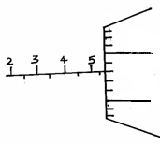
40
35

Record the diameter of the ball. (2mks)
……………………………………………………………………………………………………………………………………………………………………………………………………
2. An oil drop of volume 0.4mm³ was placed on a clean water surface. It spreads to form a monolayer circular patch of area 2000mm². Use this data to calculate the thickness of a molecule of oil. (3mks)
……………………………………………………………………………………………………………………………………………………………………………………………………………………………………………………………………………………………………………………………………………………………………………………………………………………………………………………………………………………………………………
3. A fixed mass of pure water was heated from 0°C to 2O°C. Sketch a graph of density of the water against temperature. (2mks)

4. Two 10g masses are fixed onto two similar aluminum plates, one polished and the other painted black, using wax as shown in the figure below.
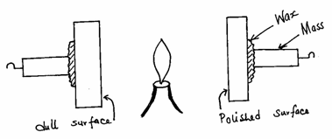

i)State which one will fall first (1mk)
……………………………………………………………………………………………………………………………………………………………………………………………………
ii) give a reason for the answer above. (1mk)
……………………………………………………………………………………………………………………………………………………………………………………………………
5. The figure below shows a negatively charged leaf electroscope.

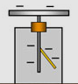

State and explain what happens to the electroscope when highly positive rod is brought near the cap of the electroscope. (2mks)
………………………………………………………………………………………………………………………………………………………………………………………………………………………………………………………………………………………………………
6. State one advantages of alkaline accumulator over the lead-acid cell. (1mks)
…………………………………………………………………………………………………………………………………………………………………………………………………
7. The figure below shows two magnets whose North poles are brought close to each other.
Indicate the magnetic field pattern between the two magnets. (2mks)

S
N
N
S

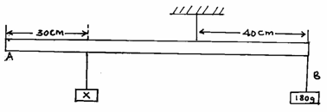
8. The diagram shows a system in equilibrium with the uniform rule supported at Q and resting horizontally.

The rule is 1m long and weighs 1.8N. Calculate the weight of the block X. (3mks)
…………………………………………………………………………………………………………………………………………………………………………………………………………………………………………………………………………………………………………………………………………………………………………………………………………
9. An object is placed in front of a concave mirror as shown in the figure below.
Complete the diagram to show how the image is formed. (3mks)

C
F

10. State and explain what will happen to the freely suspended magnet when the switch S is closed. (2mks)
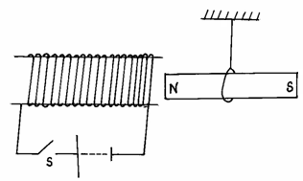

………………………………………………………………………………………………………………………………………………………………………………………………………………………………………………………………………………………………………
11. Three identical springs A, B and C and of negligible weight are used to support a 15.5N weight as shown in the figure below.
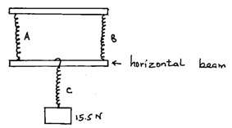

If the weight of the horizontal beam is 0.5N, determine the extension of each spring given that the spring constant of each spring is 4N/cm (3mks)
………………………………………………………………………………………………………………………………………………………………………………………………………………………………………………………………………………………………………
12. State one of the major differences between mechanical waves and electromagnetic waves. (1mk)
…………………………………………………………………………………………………
13. A boat sent an ultrasound signal to the bottom of the sea and its echo received after 0.5
seconds. If the velocity of the sound in water is 1500m/s, calculate the depth of the sea. (3mks)
……………………………………………………………………………………………………………………………………………………………………………………………………………………………………………………………………………………………………………………………………………………………………………………………………………………………………………………………………………………………………………
14. 1800cm³ of fresh water of density 1g/cm³ is mixed with 2200cm³ of sea water of density 1.025g/cm³. Calculate the density of the mixture (4mk)
………………………………………………………………………………………………………………………………………………………………………………………………………………………………………………………………………………………………………
15. Distinguish between a basic physical quantity and a derived physical quantity giving an example of each. (3mks)
 | Physical quantity | Derived physical quantity
difference
example

- a)State any two ways by which frictional force between two surfaces can be reduced. (2mk)
……………………………………………………………………………………………………………………………………………………………………………………………………
- Explain why large mercury drops form oval balls on a glass slide (1mks)
………………………………………………………………………………………………………………………………………………………………………………………………………………………………………………………………………………………………………

SECTION B: (60 MARKS)
- a) Figure1 below shows two mirrors M1 and M2 are inclined at right angles to each other.
Fig 1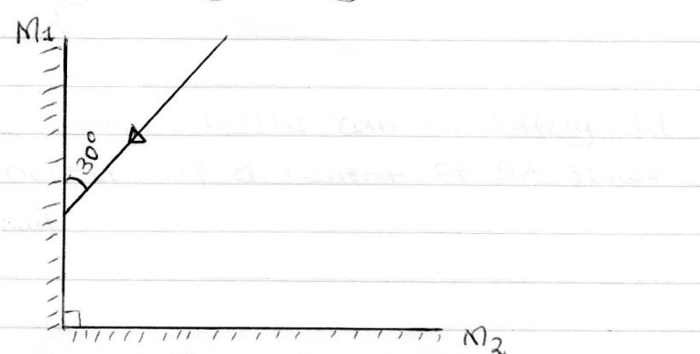
Trace the reflection of the ray through the two mirrors and find the angle between the incident ray and reflected ray of mirror M₂. (2mks)
- Distinguish between Lunar and Solar eclipse by stating the arrangements that lead to the formation of each (4mks)
…………………………………………………………………………………………………………………………………………………………………………………………………………………………………………………………………………………………………………………………………………………………………………………………………………………………………………
(c) Complete the diagram below to show how an image is formed in a pinhole camera. (3mks)
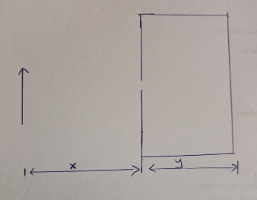

(d) State two characteristics of the image above. (2mks)
……………………………………………………………………………………………………………………………………………………………………………………………………
e) State two changes that will be observed about this image if the pinhole is made wider. (2mks)
……………………………………………………………………………………………………………………………………………………………………………………………………
- If χ = 30cm, y = 12cm and the heights of the image is 4cm, calculate the height of the object. (3mks)
………………………………………………………………………………………………………………………………………………………………………………………………………………………………………………………………………………………………………
- The diagram below shows the wave profile of a transverse wave.
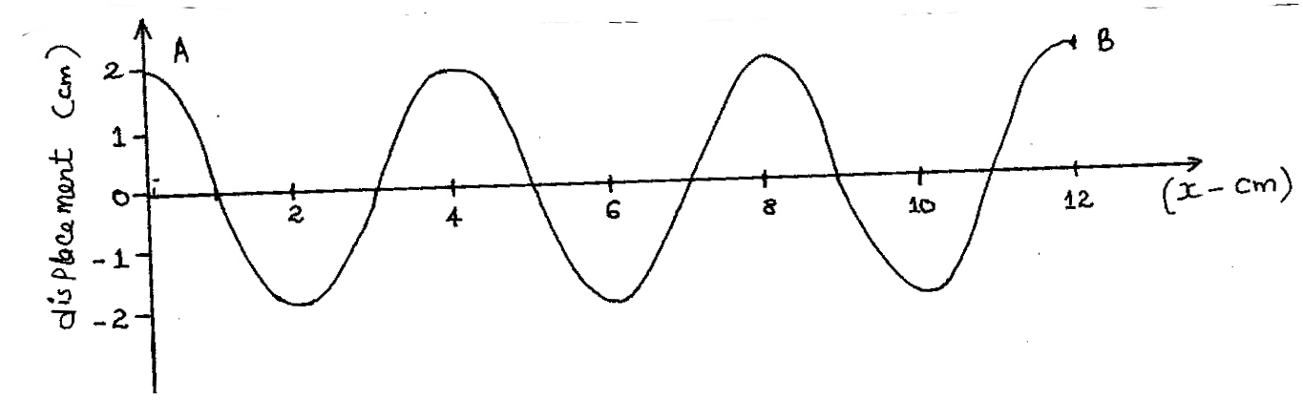

- Determine
(i) the amplitude of the wave. (1mk)
………………………………………………………………………………………………………
(ii) the wavelength of the wave in metres. (2mks)

…………………………………………………………………………………………………
(iii) the period of the wave if it takes 1.5 seconds to move from A to B. (3mks)
………………………………………………………………………………………………………………………………………………………………………………………………………………………………………………………………………………………………………………………
Calculate:
- the frequency of the wave. (2mks)
………………………………………………………………………………………………………………………………………………………………………………………………………………………………………………………………………………………………
(ii) the velocity of the wave. (2mks)
………………………………………………………………………………………………………………………………………………………………………………………………………………………………………………………………………………………………………
19. (a) What is diffusion? (1mk)
……………………………………………………………………………………………………………………………………………………………………………………………………
b) state two factors that affect diffusion (2mks)
………………………………………………………………………………………………………………………………………………………………………………………………………………………………………………………………………………………………………………………

- A smoke cell contains a mixture of trapped air and smoke. The cell is brightly lit and viewed through a microscope. State and explain what is observed. (2mks)
………………………………………………………………………………………………………………………………………………………………………………………………………………………………………………………………………………………………
- A beaker is filled completely with water. A spoonful of common salt is added slowly. The salt dissolves and the water does not overflow.
(i) State why the salt is added slowly. (1mk)
……………………………………………………………………………………………………………………………………………………………………………………………………
(ii) Why doesn’t the water overflow? (1mk)
……………………………………………………………………………………………………………………………………………………………………………………………………
- In the figure below, ammonia gas and acid gas diffuse and react to form a white deposit on the walls near ammonia gas of a long glass tube as shown.

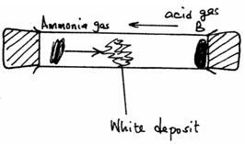

(i) What conclusion can be made from this result of this experiment? (1mk)
………………………………………………………………………………………………………………………………………………………………………………………………………………
(ii) why is a white deposit formed near ammonia gas? (1mk)
…………………………………………………………………………………………………………………………………………………………………………………………………………………………………………………………………………………………………………………
The experiment is performed at a lower temperature.
- State what would happen to the rate of diffusion of the gases. (1mk)
………………………………………………………………………………………………………………………………………………………………………………………………………………

- explain your answer in (iii) above (1mk)
………………………………………………………………………………………………………………………………………………………………………………………………………………
20. (a) Give four differences between mass and weight. (4mks)

Mass | weight

(b) State Pascal’s Principle. (1mk)
………………………………………………………………………………………………………………………………………………………………………………………………………………

(c) Name two applications of Pascal’s Principle. (2mks)
………………………………………………………………………………………………………………………………………………………………………………………………………………
(d) Figure 3 shows a U-tube containing two liquids L₁ and L₂ of densities 1.6g/cm³ and 0.8g/cm³ respectively in equilibrium.
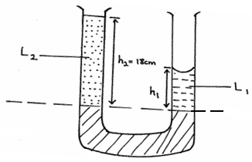

Given that h₂ = 18cm, determine the value of h₁. (3mks)
……………………………………………………………………………………………………………………………………………………………………………………………………………………………………………………………………………………………………………………………………………………………………………………………………………………………………………………………………………………………………………
- a) Define current and state its SI unit ( 2mks)
………………………………………………………………………………………………………………………………………………………………………………………………………………………………………………………………………………………………………………………
b) A charge of 120 coulombs flow through a lamp every minute. Calculate the current flowing through the lamp. ( 3mks)
………………………………………………………………………………………………………………………………………………………………………………………………………………………………………………………………………………………………………………………
- Differentiate between open and closed circuits. ( 2mks)
………………………………………………………………………………………………………………………………………………………………………………………………………………………………………………………………………………………………
- The diagram bellow shows a dry cell. Use to answer to the question that follows.

C
B
D
D

- State the polarities of A and B. (2 mks)
A…………………………………………………..
B……………………………….
- Name the chemical substances in the parts labeled C and D ( 2mks)
C…………………………………………………
D………………………………………………..
- Give reasons why it is necessary to leave the caps of the cells open when charging an accumulator ( 1mk)
………………………………………………………………………………………………………………………………………………………………………………………………………………………………………………………………………………………………………………………

