DECEMBER ASSIGNMENT
FORM 2 PHYSICS
- Define a wave. (1 mark )
- Briefy explain how sound is produced ? ( 1 mark )
- Name 2 other types of flow other than turbulent flow. ( 2 marks )
- State Hooke’s law ( 1 mark )
- A Bunsen burner has a wide and heavy base. Explain. ( 1 mark )
- Name 3 factors that affect the strength of an electromagnet. ( 3 marks )
- An object is placed 30 cm from a concave mirror of focal length 20cm. Calculate:
a) The image position. (2 marks )
b) The magnification. ( 1 mark )
- Calculate the amount of current flowing through a bulb if 300 coulombs of charge flows through It in 3 minutes. ( 2 marks )
- A girl stands 2m infront of a plane mirror. Calculate the distance between the girl and her image.
( 3 marks )
- A spring stretches by 8mm when supporting a load of 2N. By how much would it stretch when supporting a load of 5N. ( 3 marks )
- a) Define a turbulent flow. ( 1 mark )
b) Water flows through a pipe of length 0.3m and of uniform cross sectiorial area 20cm² in 2 seconds,
Calculate the rate of flow. ( 3 marks )
c) Water flows through a horizontal pipe of cross-sectional area 36cm². The speed of the water is 6m/s but this speed increases to 9,/s in a constriction in the pipe.
What is the area of this narrow part of the pipe? ( 3 marks )
- a) Define a pulse. (1 mark )
b) State two conditions for particles in a wave to be oscillating in phase with each other. (2 marks )
- a)The figure below shows a simple mercury barometer
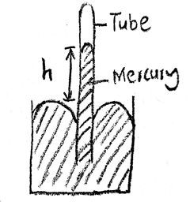
- when the tube was tilted mercury did not fill the tube completely. Give a reason for the observation (2 mark)
- give a reason why mercury is preferred as a liquid in a glass barometer (1mark)

- A town at an altitude of 548m has abarometric height of 70cmHg.Given that the standard atmospheric pressure is 76cmHgand that the density of mercury is 13600kg/m³, determine the density of air (3marks)
b) A student half-filled a container with water, boiled the water for several minutes with the cork removed. Then later replaced the cork and poured some cold water on the container. State and explain the observation made (2marks)
c) Determine the pressure on a piston of cross-sectional 20cm² when a force of 50MN is applied to its surface (2marks)
- In an experiment to determine the approximate diameter of an oil molecule,the following measurements were obtained: -diameter of oil drop=0.05cm; -diameter of oil patch=0.2m
Determine:
- volume of oil drop (3marks)
- area of oil patch (2marks)
- thickness of oil molecule (3marks)
- state two assumptions made in the above experiment (2marks)
- a) You are provided two glass rods of the same length and a straight wire to make springs of
the same length
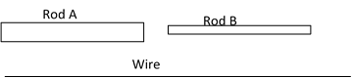
State with reason the rod you would use to make a spring of higher spring constant using the wire (2marks)
b) The figure below shows identical spring of negligible weight joined with light wires to
make a system. The combined spring constant of the system is 6N/cm.
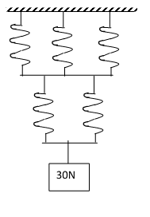
- Determine the extension of the system (2marks)
- Determine the spring constant of each spring (3 marks)
- (a) Given a bar magnet, an iron bar and a string
- Describe a simple experiment to distinguish between the magnet and the iron bar(2marks)
- State with reasons the observation that would be made in the experiment. (2marks)

