Name: …………………………………………… Adm. No………...... Date……………………...

232
PHYSICS
(THEORY)END TERM 2
TIME: 2½ HOURS

MULTILATERAL EXAM SECOND TERM
PHYSICS FORM 1

INSTRUCTIONS TO CANDIDATES:
- Write your name, admission number, date of examination in the space provided above.
- Answer all the questions in the spaces provided.
- All working must be clearly shown in the spaces provided.
- Mathematical tables and electronic calculators may be used.
- This paper consists of 10 printed pages. Candidates should check the question paper to ascertain that all the pages are printed as indicated and no questions are missing

For Examiner’s Use Only

Candidate scores

ANWERS ALL QUESTIONS IN THE SPACES PROVIDED

- Name three physical quantities and their SI units. (3mks)
(i)………………………………………………………………………………

(ii)………………………………………………………………………………

(iii)……………………………………………………………………

- Name the instruments you would use to measure each of the following:
- The height of your physics teacher. (1mk)

………………………………………………………………………………………..

- Distance from your class to the staff room. (1mk)

……………………………………………………………………………….

- Volume of one drop of a liquid. (1mk)

…………………………………………………………………………………

3. Convert each of the volumes to the unit brackets.
- 150000cm³ (m³) (2mks)
……………………………………………………………………………………………………………………………………………………………………………………………………………………………………………………………………………………………..

- 20litres (m³) (2mks)
………………………………………………………………………………………………………………………………………………………………………………………………………………………………………………………………………………………………………………………………………………………………………………………………..

4. (a).A student is investigating the volume of different small pieces of stones using the displacement method as shown in the figure shown..

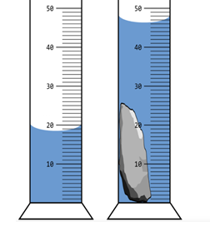

i). Write down the volume shown in each measuring cylinder.

V₁ = ………………………………. (1mk)

V₂ = ……………………………….. (1mk)

ii) determine the volume V of the stone. (3mks)

………………………………………………………………………………………………………………………………………………………………………………………………………………………………………………………………………………………………………………………
………………………………………………………………………………………………………

iii).Calculate the density of the stone given that the mass of the stone is 150grams.

………………………………………………………………………………………………………………………………………………………………………………………………………………………………………………………………………………………………………………………………………………………………………………………………………………………………..

b)1.5m³ of fresh water was mixed with 0.5m³ of alcohol.The density of water is 1000kg/m³ and the density of alcohol is 800kg/m³.Determine

- Mass of fresh water in the mixture. (1mk)
………………………………………………………………………………………………………………………………………………………………………………………………………………………………………………………………………………………………………

- Mass of alcohol in the mixture. (1mk)
……………………………………………………………………………………………………………………………………………………………………………………………………………………………………………………………………………………………………………

- Total volume of the mixture. (1mk)
……………………………………………………………………………………………………………………………………………………………………………………………………………………………………………………………………………………………………………….

- The density of the mixture. (1mk)
………………………………………………………………………………………………………….. ……………………………………………………………………………………………………………………………………………………………………………………………………………………………………………………………………………………………………………………………………..

5.(i). Define the term pressure . State its SI unit. (2mks)
……………………………………………………………………………………………………………………………………………………………….

(ii). Give a reason why vehicles that carry heavy loads have many wheels. (3mks)
……………………………………………………………………………………………………………………………………………………………………………………………………………………………………………………………………………………………………………………………

(iii). A brick 20cm long, 10cm wide and 5cm thick has a mass of 500g. Determine the:
- Area of the largest face in square metres. (m²) (2mks)
……………………………………………………………………………………………………………………………………………………………………………………………………………………………………………………………………………………………………………………………………………………………………………………………………………………………………………..

(b).Force exerted by the brick on a horizontal surface. (2mks)
…………………………………………………………………………………………………………………………………………………………………………………………………………………………………………………………………………………………………………………………………………………………………………………………………………………………………

(c) . Least pressure that can be exerted by the brick on a flat surface. (Take g = 10N/kg) (2mks)
……………………………………………………………………………………………………………………………………………………………………………………………………………………………………………………………………………………………………………………………………………………………………………………………………………………………………………………………………………………………………………………………………………………………… 6.You are provided with the following;
.*A can with a tight fitting cork.
*Water in a container.
*Source of heat.
Briefly describe how you would use the above apparatus to show the existence of atmospheric pressure. (5mks)
………………………………………………………………………………………………………………………………………………………………………………………………………………………………………………………………………………………………………………………………………………………………………………………………………………………………………………………………………………………………………………………………………………………………………………………………………………………………………………………………………………………………………………………………………………………………………………………………………………………………………….

7.The figure below shows a U-tube filled liquid X, mercury and liquid Y. Given that the density of liquid x =800kg/m³,height of liquid X =25cm and height of liquid Y =20cm.

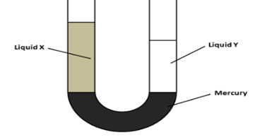

…Determine the density of liquid Y. (3mks) …………………………………………………………………………………………………………………………………………………………………………………………………………………………………………………………………………………………………………………………………………………………………………………………………………………………………………………………………………………………………………………………………………………………….. 8.The figure below shows a simple hydraulic press used to compress a bale. The cross-section areas of A and B are 0.002m² and 0.30m² respectively:

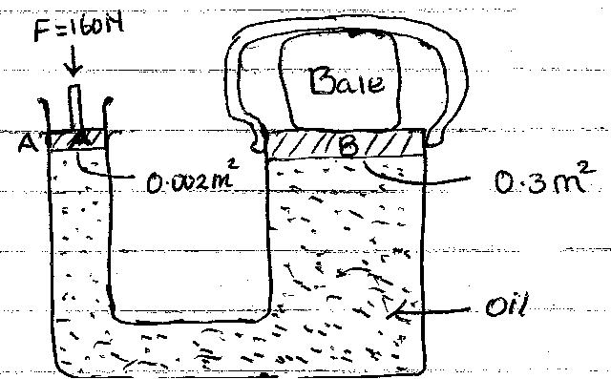

- Pressure exerted on the oil by the force applied at A. (3mks)
…………………………………………………………………………………………………………………………………………………………………………………………………………………………………………………………………………………………………………………………………………………………………………………………………………………………………………………………………………………………………………………………………………………………………

- Pressure exerted on B by the oil. (2mks)
……………………………………………………………………………………………………………………………………………………………………………………………………………………………………………………………………………………………………………………………………………………………………………………………………………………

- Force produced on B compressing the bale. (3mks)
………………………………………………………………………………………………………………………………………………………………………………………………………………………………………………………………………………………………………………………………………………………………………………………………………………………………………………………………………………………………………………………….

9 (a).Define matter. (1mk)
…………………………………………………………………………………………………………… ……………………………………………………………………………………………………

(b).State the kinetic theory of matter. (2mks)
………………………………………………………………………………………………………………………………………………………………………………………………………………………………………………………………………………………………………………………………………

(c). Describe the difference between solids and liquids in terms of ;

(i).the arrangement of molecules. (1mk)
………………………………………………………………………………………………………………………………………………………………………………………………………………………….

(ii) distance separating molecules. (1mk)
………………………………………………………………………………………………………………………………………………………………………………………………………………………..

10 (a).Define diffusion. (1mk)

………………………………………………………………………………………………………………………………………………………………………………………………………………………

(b). State 2 factors that affect the rate of diffusion in gases. (2mks)

- …………………………………………………………………………………………….
(ii). …………………………………………………………………………………………….

11. A smoke cell contains a mixture of trapped air and smoke. The cell is brightly lit and viewed through a microscope as shown in the diagram.
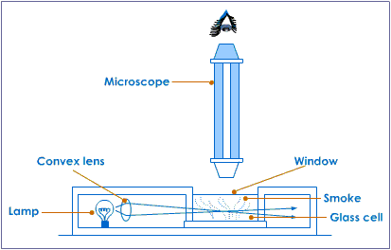

- Small bright specks are seen moving randomly. What are these small bright specks ? (1mk)
………………………………………………………………………………………………………………………………………………………………………………………………………………………..

.(b).Why do they move in a manner described above ? (2mks)
…………………………………………………………………………………………………………………………………………………………………………………………………………………………………………………………………………………………………………………

12. (a). Define force and give its SI units. (2mks)
…………………………………………………………………………………………………………………………………………………………………………………………………………

(b). state any 2 effects of force. (2mks)
(i…………………………………………………………………………………………
(ii)………………………………………………………………………………………….

(c).State 2 differences between mass and weight. (2mks) (i)……………………………………………………………………………………………………………………………………………………………………………………………………
(ii)……………………………………………………………………………………………………………………………………………………………………………………………………..

(d). An astronaut weighs 900N on earth. On the moon he weighs 150N. calculate the moons gravitational field strength. ( take g = 10N/kg). (3mks).

……………………………………………………………………………………………………………………………………………………………………………………………………………………………………………………………………………………………………………………………………………………………………………………………………………………

(e). state any 2 factors affecting surface tension.
(2mks)
(i).
……………………………………………………………………………………………………
(ii)…………………………………………………………………………………………………

13.(a). Define thermal expansion
…………………………………………………………………………………………...........

…………………………………………………………………………………………………..
………………………………………………………………………………………………
(b).The figure shows ball and ring apparatus. The ball just fits into the ring at room temperature. The metal ball is heated strongly and fitted into the ring.

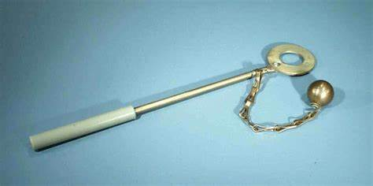

(i) State the observations made. (1mk)
……………………………………………………………………………………………………………

(ii)Explain your observation above. (2mks)
……………………………………………………………………………………………………………………………………………………………………………………………………………………………………………………………………………………………………………….

(c). The diagram below shows a flask fitted with a glass tube dipped into a beaker containing water at room temperature.The cork fitting the glass tube is tight.

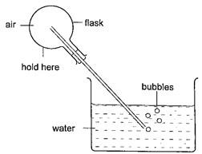

(i).When the flask was held with hands as indicated, air bubbles are seen as in the figure above. Explain this observation. (2mks)
…………………………………………………………………………………………………………………………………………………………………………………………………………………………

(d)(i) .State one advantage of anomalous expansion of water. (1mk)
………………………………………………………………………………………………………………………………………………………………………………………………………………………..

(ii)Sketch the graph of volume against temperature of water between 0⁰ C and 10⁰ C (3mks)

(e).State two special features of a clinical thermometer (2mks)
.
(i)………………………………………………………………………………………
(ii)……………………………………………………………………………………..

(f). State 3 properties of a good thermometric liquid. (3mks)
(i)…………………………………………………………………………………

(ii)……………………………………………………………………………………

(iii)……………………………………………………………………………………..

(g). Convert 307 Kelvins into degrees Celsius. (2mks)

………………………………………………………………………………………………..
…………………………………………………………………………………………………
…………………………………………………………………………………………………
……………………………………………………………………………………………….
……………………………………………………………………………………………….

14(a).State 3 modes of heat transfer. (3mks)
(i)………………………………………….
(ii)…………………………………………
(iii)………………………………………….

(b).State 2 factors that affect rate of heat transfer in metals. (2mks)
(i)………………………………………………………………………………………………

(ii)………………………………………………………………………………………………

(c).The diagram shows a vacuum flask.
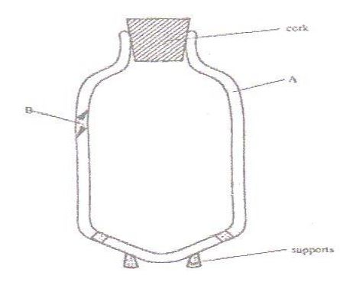

(i).Name the parts labeled A and B. (2mks)

A ……………………………………………………………………..

B ………………………………………………………………………

(ii).State the specific part in thermos flask that minimizes heat loss by; (3mks)

- Conduction ………………………………..

- Convection …………………………………

- Radiation …………………………………

