NAME: ………………………………………………ADM NO: …………CLASS………… SCHOOL…………………………………………………………………….DATE: …..…….
PHYSICS
Paper 1
Time: 2 HOURS
April 2023.
MOMALICHE 2 CYCLE 10 2023.
KENYA CERTIFICATE OF SECONDARY EDUCATION (KCSE)
Instructions to candidates
- Write your Name, Adm no., class and date in the spaces provided at the top of the page.
- This paper consists of two sections A and B.
- Answer all the questions in the two sections in the spaces provided after each question
- All working must be clearly shown.
- Electronic calculators, mathematical tables may be used.
- All numerical answers should be expressed in the decimal notations.
- This paper consists of 11 printed pages. Candidates should check to ascertain that all pages are printed as indicated and that no questions are missing.
- Take g=10ms⁻² and Specific Heat capacity of water=4,200JKg⁻¹K⁻¹
SECTION | QUESTION | MAX MARKS | CANDIDATE’S SCORE
A | 1 – 13 | 25
B | 14 | 11
 | 15 | 13
 | 16 | 12
 | 17 | 08
 | 18 | 11
TOTAL |  | 80

This paper consists of 11 printed pages. Candidates should check the question paper to ensure that all the pages are printed as indicated and no questions are missing.
SECTION A: 25 MARKS Answer All the Questions in this Section.
- On the space provided below sketch a micrometer screw gauge clearly showing the reading 14.43mm. (Take the pitch of the screw gauge as 0.5mm) (2mks)
……………………………………………………………………………………………………………………………………………………
..........................................................................................................................................................
……………………………………………………………………………………………………………………………………………………
……………………………………………………………………………………………………………………………………………………
……………………………………………………………………………………………………………………………………………………
- Distinguish between Cohesive and Adhesive forces. (2mks)
……………………………………………………………………………………………………………………………………………………
……………………………………………………………………………………………………………………………………………………
……………………………………………………………………………………………………………………………………………………
……………………………………………………………………………………………………………………………………………………
- The fig.1 below shows a liquid-in-glass thermometer.

Y

Fig. 1
- Name the: Thermometer……………………………………………………………………………… (1mk)

: Part labeled Y……………………………………………………..………………….. (1mk)
- State the change that can be made to the capillary bore in order to make the thermometer more sensitive. (1mk)
……………………………………………………………………………………………………………………………………………………
…………………………………………………………………………………………………………………………………………………
- A form four student lifts on his palm a mass of 1Kg as shown in as shown in fig.2
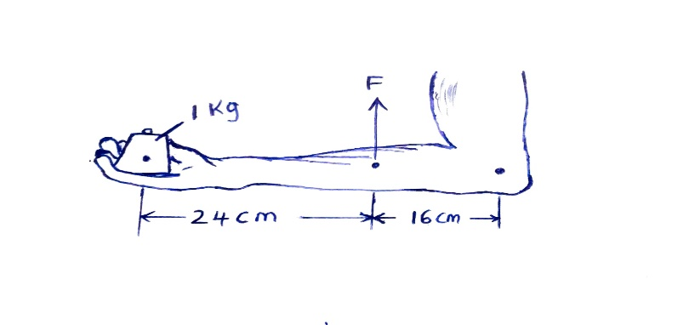
Determine force F required to keep holding the mass horizontally as shown. (3mks)
……………………………………………………………………………………………………………………………………………………
……………………………………………………………………………………………………………………………………………………
……………………………………………………………………………………………………………………………………………………
……………………………………………………………………………………………………………………………………………………
- Give a reason why pollen grains placed on the surface of clean water are seen moving continuously and randomly. (1mk)
……………………………………………………………………………………………………………………………………………………
……………………………………………………………………………………………………………………………………………………
……………………………………………………………………………………………………………………………………………………
- In the Fig.3 below, the cardboard is pulled suddenly. State the reason why the coin falls into the beaker. (1mk)
Coin

Can
Cardboard

Fig. 3

……………………………………………………………………………………………………………………………………………………
……………………………………………………………………………………………………………………………………………………
- Fig.4 below shows a single movable pulley used to raise a load of 50N.
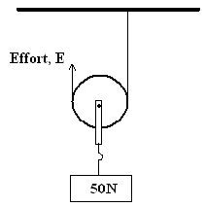

Fig.4

- State the velocity ratio of this arrangement. (1mk)

- Assuming that friction experienced is negligible and the weight of the pulley wheel is 7.5N, determine the minimum force required to raise the load at a constant speed. (1mk)
…………………………………………………………………………………………………………………………………………………….
………………………………………………………………………………………………………………………………………………......
- State the pressure law of gases. (1mk)
……………………………………………………………………………………………………………………………………………………
……………………………………………………………………………………………………………………………………………………
……………………………………………………………………………………………………………………………………………………
- A block of copper mass 0.5Kg and specific Heat capacity 400JKg⁻¹K⁻¹ initially at 80°C is immersed in water at 20◦C. If the final temperature is 21◦C, determine the mass of the water. (3mks)
.……………………………………………………………………………………………………………………………………………………
…………………………………………………………………………………………………………………………………………………….
……………………………………………………………………………………………………………………………………………………
…………………………………………………………………………………………………………………………………………………….
…………………………………………………………………………………………………………………………………………………….
- State the reason why heat transfer by radiation is faster than conduction. (1mk)
……………………………………………………………………………………………………………………………………………………
……………………………………………………………………………………………………………………………………………………
- A dripless candle is weighted slightly on the bottom so that it floats upright in a container filled with water as shown in Fig. 5 below.

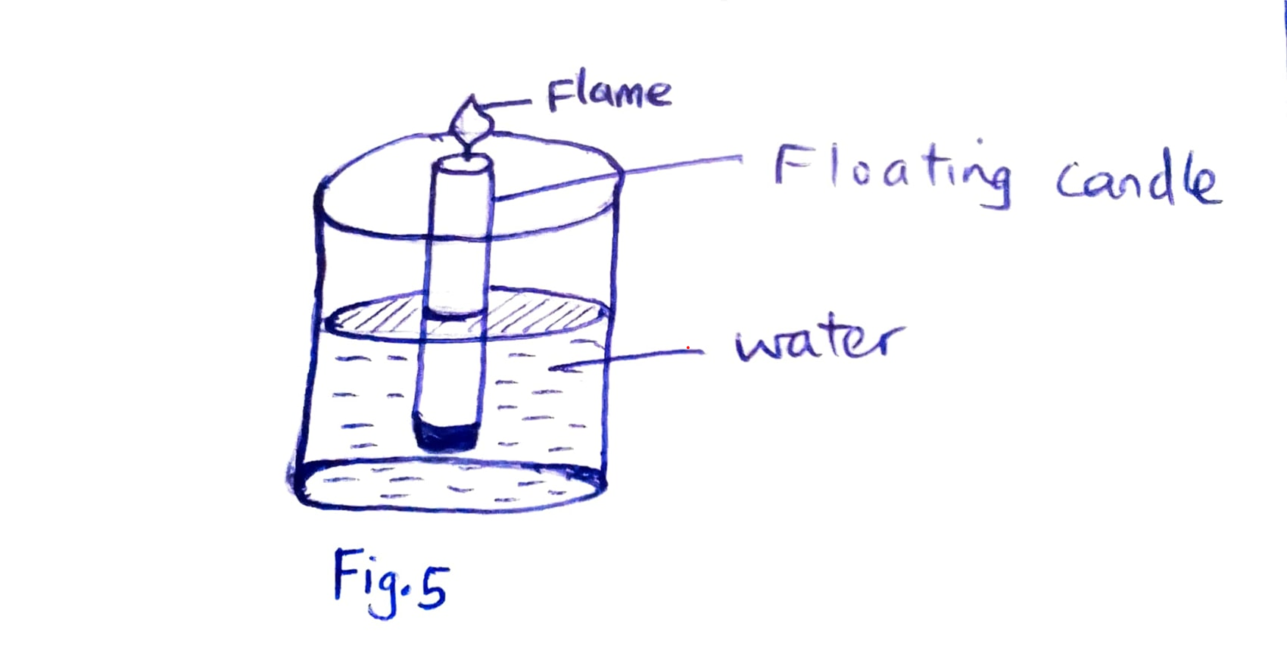

State and explain what happens as the candle burns. (2mks)
……………………………………………………………………………………………………………………………………………………
……………………………………………………………………………………………………………………………………………………
……………………………………………………………………………………………………………………………………………………
…………………………………………………………………………………………………………………………………………………….
- Determine the least pressure that can be exerted by a 20kg solid of dimensions 10cmx20cmx40cm on a horizontal surface. (3mks)
……………………………………………………………………………………………………………………………………………………
……………………………………………………………………………………………………………………………………………………
……………………………………………………………………………………………………………………………………………………
…………………………………………………………………………………………………………………………………………………..
- State the SI unit of the quantity amount of substance. (1mk)
…………………………………………………………………………………………………………………………………………………….
SECTION B: 55 Marks.
- a) State the Archimedes’ principle. (1mk)
……………………………………………………………………………………………………………………………………………………
……………………………………………………………………………………………………………………………………………………
……………………………………………………………………………………………………………………………………………………
b)Fig.6 below shows a simple hydrometer.

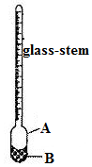 Fig.6 A…………………………………….. (1mk)

B…………........………………………… (1mk)
- Identify the parts labelled A and B.
- State the purpose of part labelled B. (1mk)
…………………………………………………………………………………………………………………
- How the hydrometer would be made more sensitive. (1mk)
………………………………………………………………………………………………………………...
- A weather balloon of volume 1.2m³ is tied to a rigid support while being filled with helium gas. The mass of the fabric making the balloon is 0.30kg. Determine the maximum tension on the string tying the balloon to the rigid support.
(Density of air is 1.25kgm⁻³ and density of helium is 0.18kgm⁻³). (4mks)
……………………………………………………………………………………………………………………………………………………
…………………………………………………………………………………………………………………………………………………….
……………………………………………………………………………………………………………………………………………………
……………………………………………………………………………………………………………………………………………………
……………………………………………………………………………………………………………………………………………………
- Explain how a submarine can be made to float and sink in water. (2mks)
……………………………………………………………………………………………………………………………………………………
……………………………………………………………………………………………………………………………………………………
……………………………………………………………………………………………………………………………………………………
…………………………………………………………………………………………………………………………………………………….
- a) State Hooke’s law. (1mk)
……………………………………………………………………………………………………………………………………………………
……………………………………………………………………………………………………………………………………………………
……………………………………………………………………………………………………………………………………………………
……………………………………………………………………………………………………………………………………………………
- A student carried out an experiment to investigate the relationship between the force and extension produced on a spiral spring. The student tabulated his results as shown below.

Force (N) | 0 | 0.8 | 1.5 | 3.0 | 4.5 | 6.0 | 7.5
Extension (cm) | 0 | 0.5 | 1.0 | 2.0 | 3.0 | 4.0 | 5.0

- Plot a graph of extension in (cm) y-axis against Force (N) (5mks)
- Determine the spring constant. (4mks)
……………………………………………………………………………………………………………………………………………………
……………………………………………………………………………………………………………………………………………………
……………………………………………………………………………………………………………………………………………………
……………………………………………………………………………………………………………………………………………………
……………………………………………………………………………………………………………………………………………………
- What force would be required to produce an extension of 2.5cm? (1mk)
…………………………………………………………………………………………………………………………………

- What extension is produced by:
- A force of 5.5N………………………………………… (1mk)

- A mass of 700g………………………………………… (1mk)

- a) Define a radian as applied in circular motion. (1mk)
……………………………………………………………………………………………………………………………………………………
……………………………………………………………………………………………………………………………………………………
……………………………………………………………………………………………………………………………………………………
b) A car negotiating a corner at a constant speed is said to have a change of momentum.
Explain this observation. (1mk)
……………………………………………………………………………………………………………………………………………………
……………………………………………………………………………………………………………………………………………………
- The Fig.7 below shows a ball being whirled in a vertical plane.
Sketch on the same figure the path followed by the ball if the string cuts when the ball is at the position shown in the figure. (1mk)

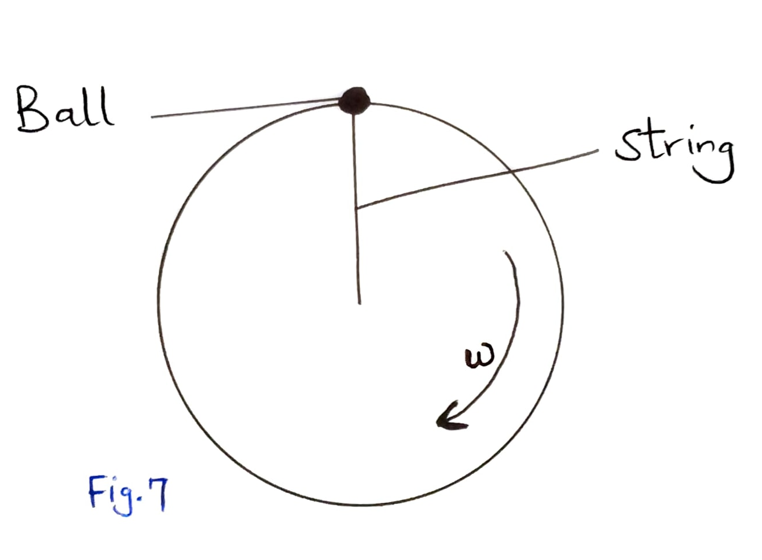
- State the purpose of banking roads at bends. (1mk)
……………………………………………………………………………………………………………………………………………………
..........................................................................................................................................................
- A boy whirls a stone of mass 0.2kg tied to a string of length 0.4m in a vertical plane at a constant speed of 2rev/s. (Take g=10ms⁻²)
- State two forces acting on the stone when it is at the highest point. (2mks)
…………………………………………………………………………………………………………………………
- Determine the :
I angular velocity of the stone; (3mks)
……………………………………………………………………………………………………………………………………………………
……………………………………………………………………………………………………………………………………………………
…………………………………………………………………………………………………………………………………………………….
II tension in the spring when the stone is at the highest point; (3mks)
……………………………………………………………………………………………………………………………………………………
……………………………………………………………………………………………………………………………………………………
……………………………………………………………………………………………………………………………………………………
……………………………………………………………………………………………………………………………………………………
- a) State Bernoulli’s principle. (1mk)
……………………………………………………………………………………………………………………………………………………
……………………………………………………………………………………………………………………………………………………
……………………………………………………………………………………………………………………………………………………
b) Fig.8 below shows a tube of varying cross-sectional area. V₁V₂V₃ and V₄ represents the velocities of water as it flows steadily through the sections of the tube.
V₄
V₂
V₃
V₁

_{Fig. 8}

Arrange the velocities V₁, V_{2,} V3 and V₄ in descending order. (1mk)

c)The diagram below shows a Bunsen burner

Gas in

Barrel

Hole
Nozzle

Explain how air is drawn into the barrel (2mks)
……………………………………………………………………………………………………………………………
……………………………………………………………………………………………………………………………
d)The Fig.8 below shows air being blown through a tube of a varying cross-sectional area.
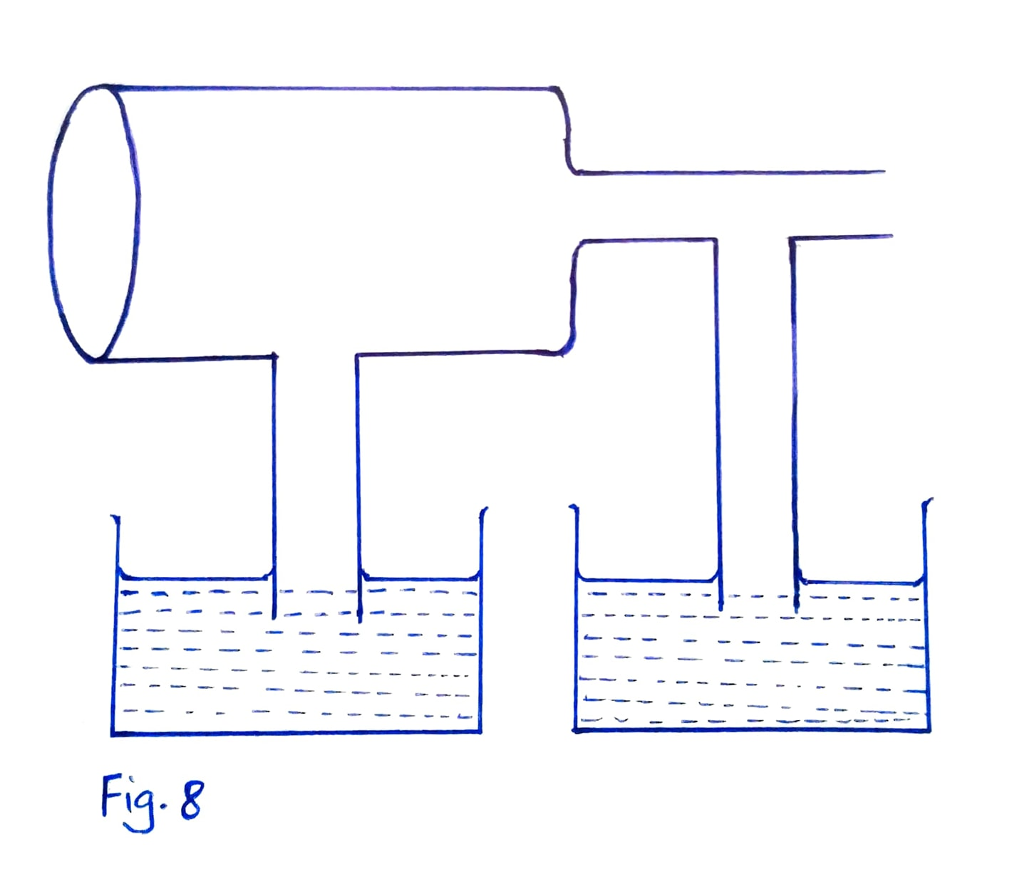
Using the information in the diagram
- Calculate the outlet velocity v_{2.} (2mks)
……………………………………………………………………………………………………………………………
……………………………………………………………………………………………………………………………
……………………………………………………………………………………………………………………………
……………………………………………………………………………………………………………………………
- Show the relative water levels in the two capillary tubes. (2mks)

- a) Fig.9 below shows the path of a light ball projected horizontally.

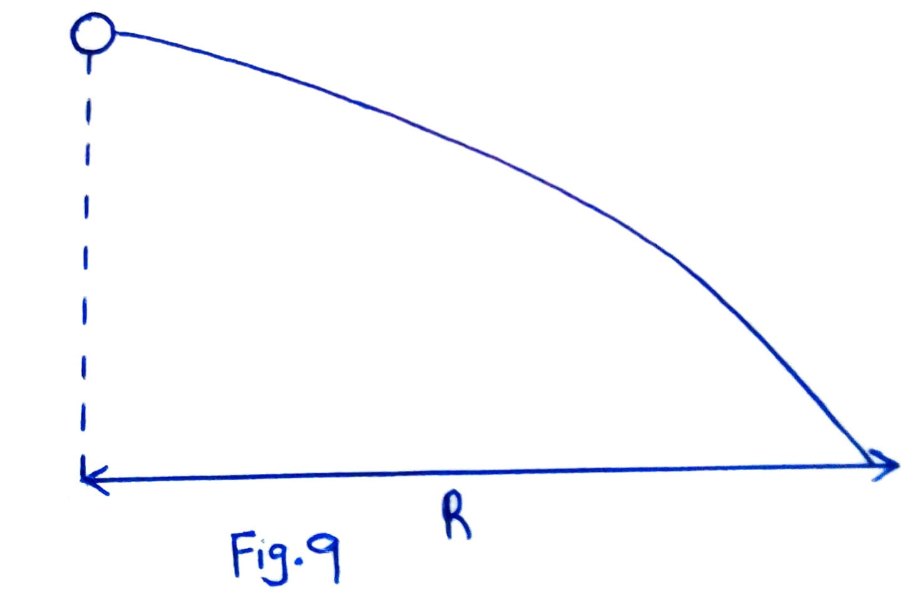

The ball is then made to spin in an anticlockwise direction as it moves;
On the same axis, sketch the new path of the ball. (2mk)

b) Using the definition of impulsive force, show that F=ma. (3mks)
……………………………………………………………………………………………………………………………
……………………………………………………………………………………………………………………………
……………………………………………………………………………………………………………………………
……………………………………………………………………………………………………………………………
c) Two stationary trolleys A and B are separated by a compressed spring and held together by a thread. The mass of trolley A is 2.0kg and that of B is 1.0kg. When the thread is cut the trolleys move rapidly apart.
i) What is the cause of movement of trolleys when the thread is cut? (1mk)
……………………………………………………………………………………………………………………
ii) What is the total momentum of the trolleys just before the thread is cut. (2mks)
……………………………………………………………………………………………………………………………
……………………………………………………………………………………………………………………………
……………………………………………………………………………………………………………………………
……………………………………………………………………………………………………………………………
……………………………………………………………………………………………………………………………
- If trolley A moves off with a speed of 0.25m/s. Calculate the speed with which trolley B moves off. (3mks)
…………………………………………………………………………………………………………………………….
…………………………………………………………………………………………………………………………………………………….
…………………………………………………………………………………………………………………………………………………….
……………………………………………………………………………………………………………………………………………………
…………………………………………………………………………………………………………………………………………………..
LAST PRINTED PAGE

