PHYSICS
FORM 2
END OF TERM 3 2022
TIME: 2 Hours

NAME………………………………………………………..CLASS……… ADM NO: ………

- State the laws of reflection. (2mks)
………………………………………………………………………………………………………………………………………………………………………………………………………………………………………………………………………………………………………………………………………………………………………………………………………………………………………………………………………………………………………………………………………………………………………………
- The figure below shows an object O being viewed using two inclined mirrors M1 and
M2. Complete the diagram by sketching rays to show the position of the image as seen
by the eye. (3mks)
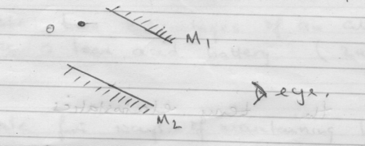
- The figure below shows rays of light being reflected from a mirror. What is the angle
of reflection.
30º
(2mks)

Mirror

- How many images would be seen from two mirrors when reflecting surfaces makes an
angle of 60º with each other ? (2mks)

- A pinhole camera of length 15cm formed an image 3cm high of a man standing 9m in
front of the camera. What is the height of the man? (3mks)

- Define the term linear magnification (1 mark)
…………………………………………………………………………………………………………………………………………………………………………………………………………………………………………………………………………………………………………………………………………………………………………………………………………………………………………

- (a) A concave spherical mirror has a focal length of 10 cm. Calculate the distance where an object must be placed in order to produce a real magnified image three times the size of the object and 30cm from the mirror. (2 marks)

(b) An object is placed 20 cm in front of
i) a plane mirror
ii) a concave mirror
State two differences between the images formed in each case. (2 marks)
………………………………………………………………………………………………………………………………………………………………………………………………………………………………………………………………………………………………………………………………………………………………………………………………..……………………………………………………………

- (a) Make a list of four devices in your house which are operated by electricity. (4mks)
………………………………………………………………………………………………………………………………………………………………………………………………………………………………………………………………………………………………………………………………………………………………………………………………………………………………………………………………………………………………………………………………………………………………………………
(b) Two dry cells, two bulbs and connecting wires are provided to you. Show by means of circuit diagrams how you will arrange the two cells to give a large current to flow. (2mks)

- (a) What are the main sources of electricity. (2mks)
………………………………………………………………………………………………………………………………………………………………………………………………………………………………………………………………………………………………………………………………………………………………………………………………………………………………………………………………………………………………………………………………………………………………………………

(b) Define the following terms;
(i) Polarization (1mk)
………………………………………………………………………………………………………………………………………………………………………………………………………………………………………………………………………………………………………………………………………………

(ii) Local action (1mk)
………………………………………………………………………………………………………………………………………………………………………………………………………………………………

(c) What are the remedies of;
(i) Polarization (1mk)
………………………………………………………………………………………………………………………………………………………………………………………………………………………………………………………………………………………………………………………………………………
(ii) Local action (1mk)
………………………………………………………………………………………………………………………………………………………………………………………………………………………………………………………………………………………………………………………………………………
- (i) State two advantages of an alkaline battery over a lead acid battery. (2mks)
………………………………………………………………………………………………………………………………………………………………………………………………………………………………………………………………………………………………………………………………………………………………………………………………………………………………………………………………………………………………………………………………………………………………………………
(ii) State three ways of maintaining lead acid accumulator. (3 mks)
………………………………………………………………………………………………………………………………………………………………………………………………………………………………………………………………………………………………………………………………………………………………………………………………………………………………………………………………………………………………………………………………………………………………………………
………………………………………………………………………………………………………………………………………………………………………………………………………………………………
- .(a) State the basic law of magnetism. (1mk)
………………………………………………………………………………………………………………………………………………………………………………………………………………………………………………………………………………………………………………………………………………………………………………………………………………………………………………………………………………………………………………………………………………………………………………
(b) Using Domains theory distinguish between a magnet and a magnetic substance. (3mks)
……………………………………………………………………………………………………………………………………………………………………………………………………………………………………………………………………………………………………………………………………………………………………………………………………………………………………………………………………………………………………………………………………………………………………………
- State what is meant by;
(a) a magnetic field (1mk)
………………………………………………………………………………………………………………………………………………………………………………………………………………………………………………………………………………………………………………………………………………
(b) a line of magnetic force (1mk)
………………………………………………………………………………………………………………………………………………………………………………………………………………………………………………………………………………………………………………………………………………

- Sketch the arrangement of lines of force in the following case. (2 mks)

S N
N S

- .(a) Show on a ray diagram the centre of curvature, axis, pole and principal focus for a
concave spherical mirror. (2mks)

(b) A concave mirror has a radius of curvature of 20cm. Find the position, magnification
and nature of the image of small pin placed on the axis and at right angles to it and
15cm from the pole by scale drawing (3mks)

- List down three properties of an object whose volume can be measured using the displacement method ( 3 mks)
………………………………………………………………………………………………………………………………………………………………………………………………………………………………………………………………………………………………………………………………………………………………………………………………………………………………………………………………………………………………………………………………………………………………………………
- The density of mercury is 13.6 g/cm3. Find the volume of 2720g of mercury in m³ ( 2 mks)

- The density of liquid X is 13600 kg.m³ and that of water is 1000 kg/m³.
- What is relative density ( 1 mk)
………………………………………………………………………………………………………………………………………………………………………………………………………………………………………………………………………………………………………………………………………………

- Determine the relative density of liquid X. ( 2mks)

- Mixture is made liquid A and water. Liquid A has a volume of X cm³ and water has a volume of 100cm³. Liquid A has a density of 800 kg/m³ and water has a density of 1000 kg/m³. If the mixture has a density of 960 kg/m³, calculate X of liquid A. ( 4 mks)

- The mass of an empty density bottle is 25.5g. Its mass when filled with water is 45.2g. When filled with liquid L, its mass 55.2g. Calculate the density of liquid X.
(Density of water is 1000kg/m³) ( 4 mks)

- In the diagram below two pins are attached to the end of a magnet as shown.
Explain the behaviour of the pins. (2mks)
S

N

magnet

Pin Pin
………………………………………………………………………………………………………………………………………………………………………………………………………………………………………………………………………………………………………………………………………………

- State one advantage and one disadvantage of using a convex mirror as a driving mirror. (2mks)
……………………………………………………………………………………………………………………………………………………………………………………………………………………………………………………………………………………………………………………………………………………………………………………………………………………………………………………………………………………………………………………………………………………………………………
- Sketch rays to show the image formed by the object in the following ray diagram, C is
the centre of curvature of the mirror. (2mks)

- a) Define pressure and state its S.I Units. (2 marks)
…………………………………………………………………………………………………………………………………………………………………………………………………………………………………………………………………………………………………………………………………………….
b) State Pascal’s principal. (1 mark)
………………………………………………………………………………………………………………………………………………………………………………………………………………………………………………………………………………………………………………………………………………………………………………………………………………………………
c) In construction of a mercury barometer care is taken to make sure it has no gas in the space above mercury.
i) How would you test whether there is gas above? (1 mark)
…………………………………………………………………………………………………………………………………………………………………………………………………………………………………………………………………………………………………………………………………………………………………………………………………
ii)State the problem caused by the presence of gas in the barometer. (1 mark)
………………………………………………………………………………………………………………………………………………………………………………………………………………………………………………………………………………………………………..
d) Find the total pressure experienced by a diver 8 meters below the sea surface. Take; Atmospheric pressure = 103 360N/m². Density of sea water 1030kg/m³ (3 marks)
………………………………………………………………………………………………………………………………………………………………………………………………………………………………………………………………………………………………………………………………………………………………………………………………………………………………………………………………………………………………………………………………………
- (a) (i) Why must a liquid and not a gas be used as the ‘fluid’ in a hydraulic machine. (1mk)
………………………………………………………………………………………………………………………………………………………………………………………………………………………………………………………………………………………………………………………

(ii) State the other important property of a liquid to hydraulic machine depends on (1mark)
………………………………………………………………………………………………………………………………………………………………………………………………………………………………………………………………………………………………………………………………………………
(b)The diagram below shows the principle of the hydraulic car jack
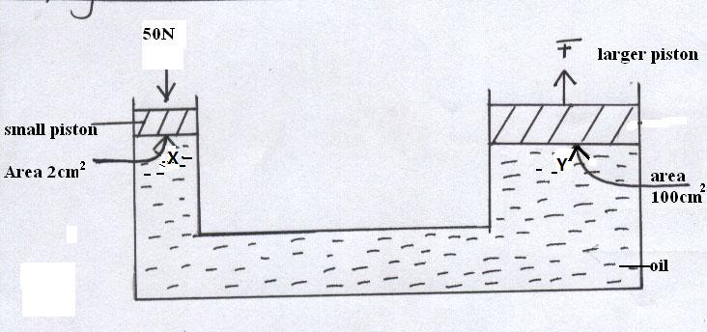
- If a force of 50N is applied to the smaller piston ;calculate the pressure produced in the oil at X (2marks)
………………………………………………………………………………………………………………………………………………………………………………………………………………………………………………………………………………………………………………………………...………………………………………………………………………………………………………………………….
- Determine the pressure exerted by oil at Y (1mark)
………………………………………………………………………………………………………………………………………………………………………………………………………………………………………………………………………………………………………………………………………………
- If the small piston moves down a distance of 5cm, determine how far upwards the larger piston moves. (2marks)
………………………………………………………………………………………………………………………………………………………………………………………………………………………………………………………………………………………………………………………………………………………………………………………………………………………………………………………………

