**NAME ………………………………………………………INDEX NO…………………………… SCHOOL………………………………………………………SIGNATURE………………………**

***Kenya Certificate of Secondary Education (K.C.S.E.)***

**232/3**

**PHYSICS**

**PAPER 3 PRACTICAL**

**TIME: 2 1/2 HOURS**

**FORM 4 TERM 2 2021**

**INSTRUCTIONS**

* **Write you name, index number, admission number and your class.**
* **Use the first 15 minutes of 2 $\frac{1}{2}$ hrs to study the questions properly.**
* **answer all questions**

**FOR EXAMINERS USE ONLY**

|  |  |  |
| --- | --- | --- |
| **QUESTION** | **MAX. SCORE** | **CAND. SCORE** |
| **1** | **20** |  |
| **2** | **20** |  |
|  | **40** |  |

1. a) You are provided with the following apparatus;

* Concave mirror
* Lit candle
* Metre rule
* Screen

***Procedure***

1. Arrange the apparatus as follows;



1. Place the candle at distance u = 20cm from the mirror. Move the screen towards or away from the mirror until a sharp image of the flame is formed on the screen.
2. Measure the distance between the screen and the mirror .
3. Record the values as V in the table below; (5 marks)

|  |  |  |  |  |  |  |  |
| --- | --- | --- | --- | --- | --- | --- | --- |
| U(cm) | 25 | 30 | 35 | 40 | 45 | 50 | 55 |
| V(cm) |  |  |  |  |  |  |  |
| (cm-1) |  |  |  |  |  |  |  |
| (cm-1) |  |  |  |  |  |  |  |

e) (i)Plot the graph of $\frac{1}{v}$ (vertical axis) against $\frac{1}{u}$ (5 marks)

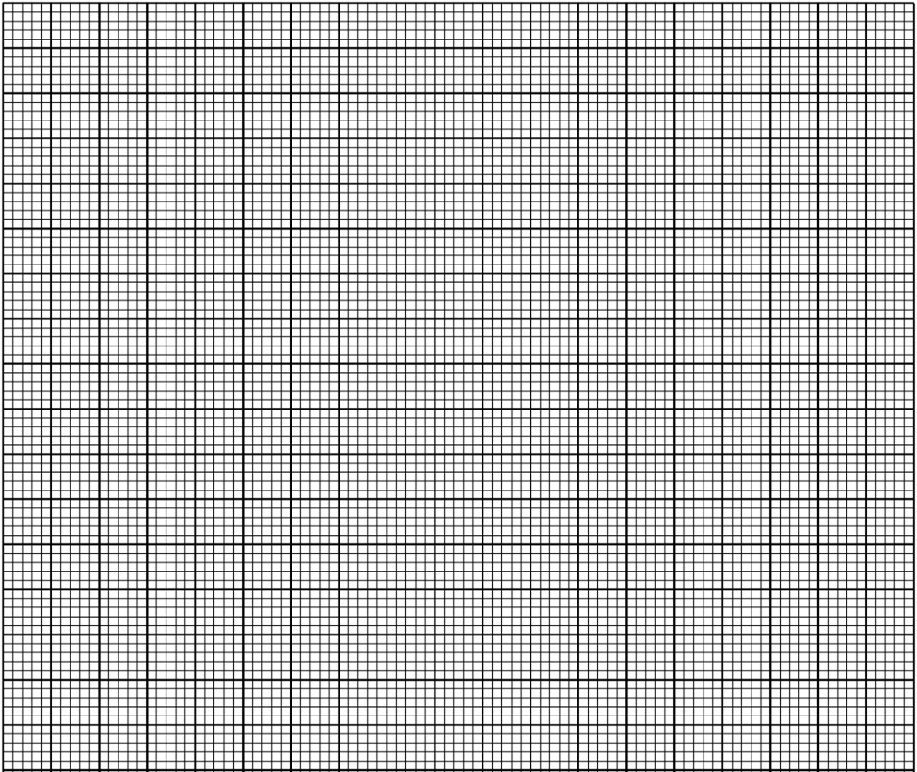

(ii) The graph is related by the equation $\frac{1}{u}$ = - $\frac{1}{v}$ + $\frac{1}{f}$

Use your graph to determine the focal length of the mirror, $f$. (3 marks)

1. b) You are provided with the following apparatus:

* prism (60 $° -60°-60°$)
* 4 optical pins
* Plain paper
* Protractor
* Some plasticine

1. Set up the apparatus as shown below:



1. Measure the angle A of the prism using a protractor. (1 mark)

A = ___________________________________

1. Place the prism on a plain paper and trace its outline with a pencil.

Attach some plasticine to the prism to indicate the refracting angle, A.

Construct a normal at point T along LM. Draw an incident ray to strike the prism at T at 60 $°$.

Replace the prism and press pins P1 and P2 to define the incidence ray. View the pins P1  and P2  from the opposite face (MN). Insert pins P3 and P4 so that they appear to be in line with the images of P1 and P2 .

Remove the prism and join P3 and P4 to give emergent ray.

Extrapolate the emergent ray into the prism so as to meet the extrapolated incident ray at Q.

1. a) Measure angle D.

D = ____________________________________ (1 mark)

b) Calculate the value of n; from the expression. (3 marks)

n = $\frac{\cos\left\{ 90° - \left(\frac{A+D}{2}\right)\right\}}{\sin{\frac{A}{2}}}$

c) What is the significance of ‘n’? (1 mark)

1. (a) You are provided with the following:

* An ammeter
* A wire P mounted on a millimeter
* One cell (1.5 v)
* Four connecting wires (two with clips at the end)
* Switch
* Micrometer screw gauge.

***Procedure***

1. Set up the apparatus as shown in the figure below



1. Adjust the length L of the wire to 20 cm by placing the crocodile clip at Y. Record the ammeter reading.
2. Repeat the procedure above for other values of length L given in the table below and record the corresponding ammeter readings.

|  |  |  |  |  |  |  |
| --- | --- | --- | --- | --- | --- | --- |
| Length, L (cm) | 20 | 30 | 40 | 50 | 60 | 70 |
| Length (100 – L) cm |  |  |  |  |  |  |
| Current, *I* (A) |  |  |  |  |  |  |
| (A -1) |  |  |  |  |  |  |

1. Complete the table above. (5 marks)

v) Plot the graph of Length (100 – L) (vertical axis) against $\frac{1 }{I}$ (5 marks)



vi) Determine the slope of the graph. (3 marks)

vii) Measure the diameter of the mounted wire using the micrometer screw gauge.

Record the diameter, d.

d = ________________ mm (1 mark)

iv) Given the relation $K= \frac{SE πd^{2}}{4}$ where S is the slope of the graph and E = 1.5 v, determine the value of K.

(2 marks)

2.(b) You are provided with the following apparatus:

* A voltmeter (0 – 3 or 0 – 5V)
* An ammeter(0 – 1 A)
* 10 Ω resistor (fixed)
* A switch
* One dry cell and a cell holder
* Six connecting wires.

1. Connect the above apparatus as shown in the circuit diagram below with the switch S open.



1. With the switch S open, record E the voltmeter reading.

E = ___________________________________ (I mark)

1. Close the switch and record V, the voltmeter reading and I, the ammeter reading.

V = ______________________________________ (1 mark)

I = ______________________________________ (1 mark)

1. Given that : E – V = Ir . Find r for the dry cell. (2 marks)