232/3
PHYSICS
Paper 3
PRACTICAL
November, 2021.
MARKING SCHEME

Question One
- (i) I = 0.5 ± 0.05A $1/2mk$
p.d = 2.50 ± 0.2V $1/2mk$
(ii) e.m.f, E = 3.0V ± 0.21 mk

Length AB (cm) | 100 | 70 | 60 | 50 | 40 | 30 | 20
Current (A) | 0.50 | 0.60 | 0.65 | 0.70 | 0.75 | 0.80 | 0.90 | ± 0.05
p.d (V) | 2.50 | 2.30 | 2.25 | 2.15 | 2.10 | 2.00 | 1.90 | ± 0.2
E – V (V) | 0.50 | 0.70 | 0.75 | 0.85 | 0.90 | 1.00 | 1.10

- (i) Graph
  - Axis labeled with units 1
  - Scale: uniform and simple1
  - 4 correctly plotted points 1
  - Line through at least 3 correctly plotted points 1
Total 5mks
(ii) Gradient
$$=\frac{∆Y}{∆X}$$
$$=\frac{∆\left(E-V\right)}{∆I}$$
$$=\frac{0.5}{0.3}$$
$$=\frac{5}{3}=1.67V/A$$
Internal substitution 1
Correct evaluation 1
Accuracy 1
Total 3mks
NB: No line no slope
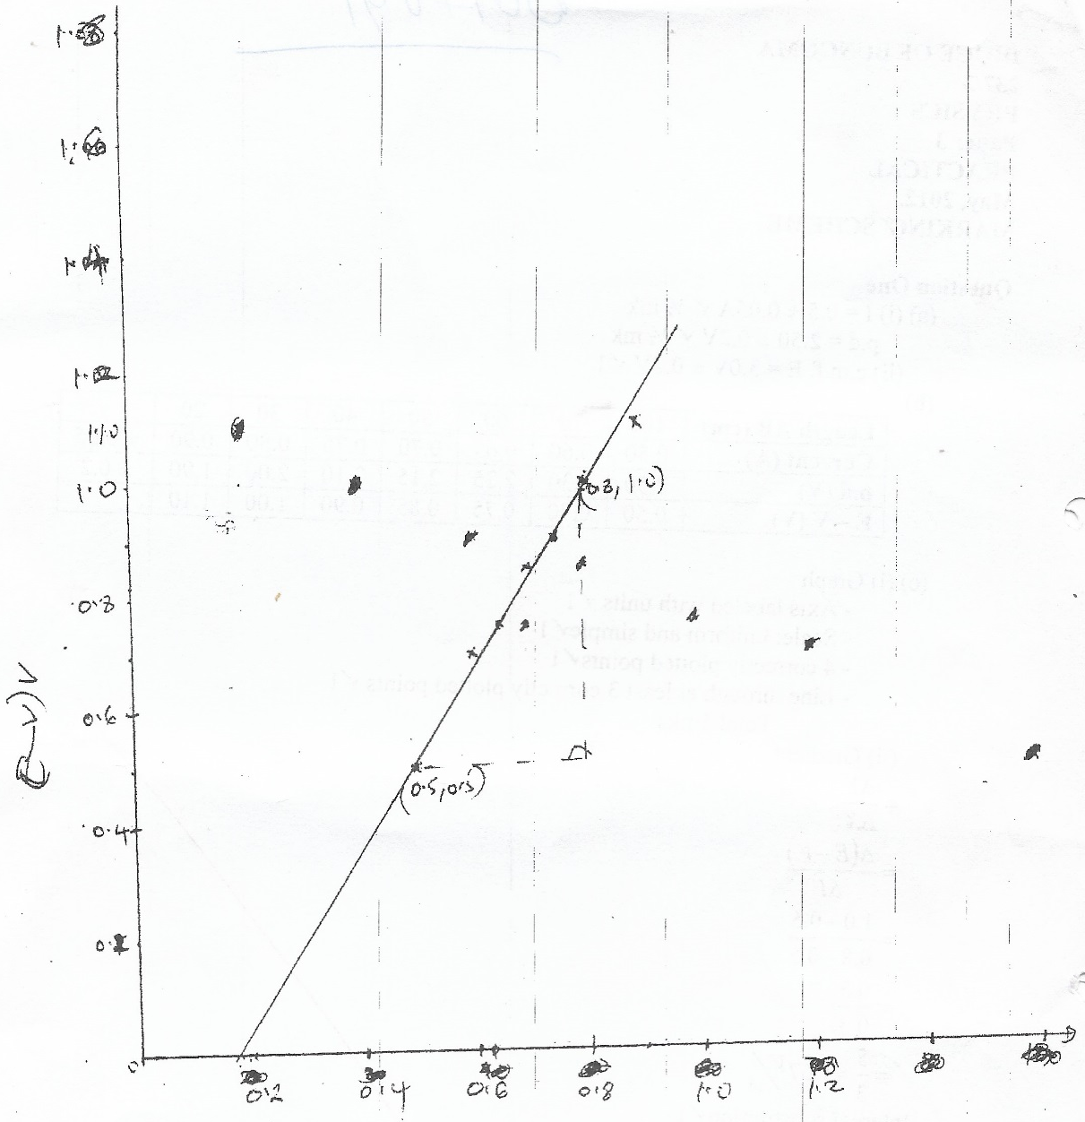
Question Two
Part A
(c) c.o.g = 50.0 ± 0.5 1
(e) (i)
Mass, m (g) | 10 | 20 | 30 | 40 | 50 | 60
Distance, d₁ (cm) | 3.70 | 7.00 | 10.00 | 12.30 | 14.40 | 16.40
Distance, d2 (cm) | 44.80 | 41.50 | 38.50 | 36.20 | 34.20 | 32.20
Mass, (cm) x  Distance, d₂ (md₂) | 448.0 | 830 | 1155 | 1448 | 1710 | 1932 | V1

- Axis labeled with units (1mk)
- Scale simple and uniform (1mk)
- Atleast 4 correctly plotted points (2mks)
- Line through atleast 3 correctly plotted points (1mk)
Total marks 5mks
(iv) Gradient
$=\frac{∆Y}{∆X}$
$=\frac{∆md_{2}}{∆d_{1}}$
$=\frac{360-444}{12.4-4}$
$=\frac{-84}{8.4}$
$=-10$
1 Evaluation
1 answer
Total 2mks
u (cm) | v (cm) | m = $v/u$
20 | 601 | 3$1/2$
30 | 301 | 1$1/2$

$$f=\frac{v}{1+m}=\frac{60}{1+3}=10cm+2cm$$
$f=\frac{v}{1+m}=\frac{30}{1+1}=15cm+2cm$ 1 1
$$Average Value=\frac{15+15}{2}=15cm±2cm$$

