NAME: …………………………..……………….. DATE: …………………………

ADM NO: ……….……….…………………...…..… STREAM: ……………..…………..

Kenya Certificate of Secondary Education.
FORM 4 TERM 2 2021 EXAM
232/2
PHYSICS
PAPER 2
TIME: 2 HOURS.

INSTRUCTIONS TO CANDIDATES
- Write your name and your index number in the spaces provided above.
- This paper consists of two sections A and B
- Answer all questions in section A and B in the space provided
- All working must be shown in the spaces provided in this booklet.
- Mathematical tables and silent electronic calculators may be used
- This paper consists of 10 printed pages. Candidates should check to ensure that all pages are printed as indicated and no questions are missing

FOR EXAMINER USE

Section | Question | Max. score | Candidate’s score
A | 1-12 | 25
B | 13 | 11
 | 14 | 06
 | 15 | 14
 | 16 | 15
 | 17 | 09
TOTAL SCORE |  | 80

PHYSICS FOR LIFE!
SECTION A – 25 MARKS

- Figure 1 shows a ray of light incident on a plane mirror.
Figure 1
70⁰

The plane mirror is then rotated clockwise through an angle of 20⁰ keeping the incident ray fixed. Determine the new angle of reflection. (2 Marks)
………………………………………………………………………………………………………………
………………………………………………………………………………………………………………
………………………………………………………………………………………………………………
………………………………………………………………………………………………………………
- A dry cell is not recharged once used up. However when used well, it can serve one for some time. State the precautions necessary when using it other than storing it in dry condition. (2 Marks)
………………………………………………………………………………………………………………
………………………………………………………………………………………………………………
………………………………………………………………………………………………………………
………………………………………………………………………………………………………………
- A charged rod A is used to charge another rod B by contact. When rod B is brought close to a charged acetate rod, repulsion occurs. State the type of charge on rod A. (1 Mk)
………………………………………………………………………………………………………………
………………………………………………………………………………………………………………
- A nail is electrically magnetised, it attracts an increasing number of pins as the magnetising current increase. After some time it can no longer attract any more pins. Explain this observation domain theory.
(2 Marks)
………………………………………………………………………………………………………………
………………………………………………………………………………………………………………
………………………………………………………………………………………………………………
- Figure 2 below shows a current carrying vertically right wire at right angle to a cardboard. Iron fillings are sprinkled on the card and card slightly tapped.
Cardboard
Current flow
Wire

Draw and indicate the direction of the magnetic field pattern displayed on the card. (2 Marks)

- Figure 3 below shows a wave profile for a wave whose frequency is 2.5HZ
Figure 3
t₁
t₂
t₃
t₄
t₅
Time (s)
Time (s)
Displacement (m)

Determine the value of t₃ (2marks)
………………………………………………………………………………………………………………
………………………………………………………………………………………………………………
………………………………………………………………………………………………………………
- An electric kettle has an element of resistance 28.8Ω. It is operating from a 240V main supply. Determine its power rating. (3 Marks)
………………………………………………………………………………………………………………
………………………………………………………………………………………………………………
………………………………………………………………………………………………………………
………………………………………………………………………………………………………………
- Distinguish between intrinsic and extrinsic semi-conductor. (1 Mark)
………………………………………………………………………………………………………………
………………………………………………………………………………………………………………
- The following is part of a radioactive series.

$\begin{matrix}238 \\ 92\end{matrix}$u $\begin{matrix}(i) \\ \end{matrix}$ $\begin{matrix}234 \\ 90\end{matrix}$Th $\begin{matrix}(ii) \\ \end{matrix}$ $\begin{matrix}234 \\ 91\end{matrix}$Po

Identify the radioactive particles emitted in stages (i) and (ii) (2 Marks)
(i) …………………………………………..

(ii) …………………………………………..
- Figure 4 shows light passing through a transparent block.
Figure 4
41.8⁰

Determine the refractive index of the block. (3 Marks)
………………………………………………………………………………………………………………
………………………………………………………………………………………………………………
………………………………………………………………………………………………………………
………………………………………………………………………………………………………………

- Figure 5 shows part of the electromagnetic spectrum.
Figure 5

Z W P

Ultra Visible
violet Light
Identify radiation W and state one of its uses.(2marks)
………………………………………………………………………………………………………………
………………………………………………………………………………………………………………
………………………………………………………………………………………………………………
………………………………………………………………………………………………………………
- Figure 6 shows a permanent magnet placed near a solenoid connected to a source of e.m.f.
Figure 6

B
A
Source of e.m.f
N S
Permanent magnet

(a) State and explain what is observed when the North – pole of the permanent magnet is brought to end
A. (2marks)
………………………………………………………………………………………………………………
………………………………………………………………………………………………………………
………………………………………………………………………………………………………………
(b) State the law applied (1mark)
………………………………………………………………………………………………………………
………………………………………………………………………………………………………………
………………………………………………………………………………………………………………
………………………………………………………………………………………………………………

SECTION B – 55 MARKS
Answer ALL questions in the spaces provided after each section of the question
- (a) A strong positive charged rod is brought close to the cap of a charged electroscope from a high
Position. It is observed
(i) State the charge on the electroscope (1 Mark)
………………………………………………………………………………………………………………
………………………………………………………………………………………………………………
(ii) Explain this observation (2 Marks)
………………………………………………………………………………………………………………
………………………………………………………………………………………………………………
………………………………………………………………………………………………………………
………………………………………………………………………………………………………………

(b) A parallel – plate capacitor is connected to an electroscope as shown in Fig. 7 below.
Figure 7

d

State and explain the behaviour of the leaf when the distance (d) between the plates is increased
(2 Marks)
………………………………………………………………………………………………………………
………………………………………………………………………………………………………………
………………………………………………………………………………………………………………
………………………………………………………………………………………………………………
(c) Figure 8 shows an arrangement of capacitors to a 12V d.c. supply.
Figure 8

8µF
4µF
6µF
8µF
12V

Determine
(i) Effective capacitance (3 Marks)
………………………………………………………………………………………………………………
………………………………………………………………………………………………………………
………………………………………………………………………………………………………………
(iii) Charge across the 8µF capacitor. (3 Marks)
………………………………………………………………………………………………………………
………………………………………………………………………………………………………………
………………………………………………………………………………………………………………
14. (i) The figure 9 below shows a step-up transformer commonly used at a power station.
Figure 9

Input AC
Ouput AC
Laminated soft iron core

(i) What is meant by a step-up transformer? (1 Mark)
………………………………………………………………………………………………………………
………………………………………………………………………………………………………………
………………………………………………………………………………………………………………
(ii) Why does a transformer work with AC only? (1 Mark)
………………………………………………………………………………………………………………
………………………………………………………………………………………………………………
………………………………………………………………………………………………………………
(iii) What is the purpose of the soft iron core? (1 Mark)
………………………………………………………………………………………………………………
………………………………………………………………………………………………………………
………………………………………………………………………………………………………………
(iv) State four ways in which power is lost in a transformer (1 Mark )
………………………………………………………………………………………………………………
………………………………………………………………………………………………………………
………………………………………………………………………………………………………………
………………………………………………………………………………………………………………

(v) Why is the e.m.f. produced at a power station stepped up to high voltage for long distance
transmission (2 Marks)
………………………………………………………………………………………………………………
………………………………………………………………………………………………………………
………………………………………………………………………………………………………………

15. (a) Figure 10 shows the trace on the screen of a.c. signal connected to the Y-plates of a C.R.O with the
time – base on.
Figure 10
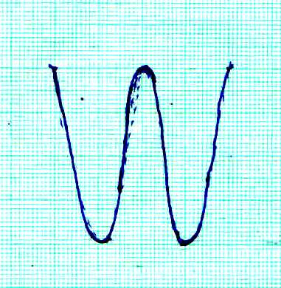

Given that the time base control is 10ms/cm and the Y-gain is at 120V/cm determine
(i) The frequency of the a.c. signal (3 Marks)
………………………………………………………………………………………………………………
………………………………………………………………………………………………………………
………………………………………………………………………………………………………………
………………………………………………………………………………………………………………
(ii) The peak voltage of the input signal (3 Marks)
………………………………………………………………………………………………………………
………………………………………………………………………………………………………………
………………………………………………………………………………………………………………
(iii) State what would be observed on the screen if the time base is switched off (1 Mark)
………………………………………………………………………………………………………………
………………………………………………………………………………………………………………
(b) Figure 11 shows a circuit whose output voltage with time as displayed on the CRO screen. (2 Marks)
Figure 11

To CRO
R

(i) Sketch a graph to show the variation of output voltage with time as displayed on the CRO screen. ( 2 Marks)

(ii) Show on the diagram (Figure 11) how a capacitor should be connected to smooth the output voltage
(1 Mark)

(iii) Sketch a curve of smoothed output voltage against time. (2 Marks)

16. a) X-rays are used for detecting cracks inside metal beams: State the type of X-rays used. (1mark)
b) The figure 12 below shows the feature of an X-ray tube.
Figure 12

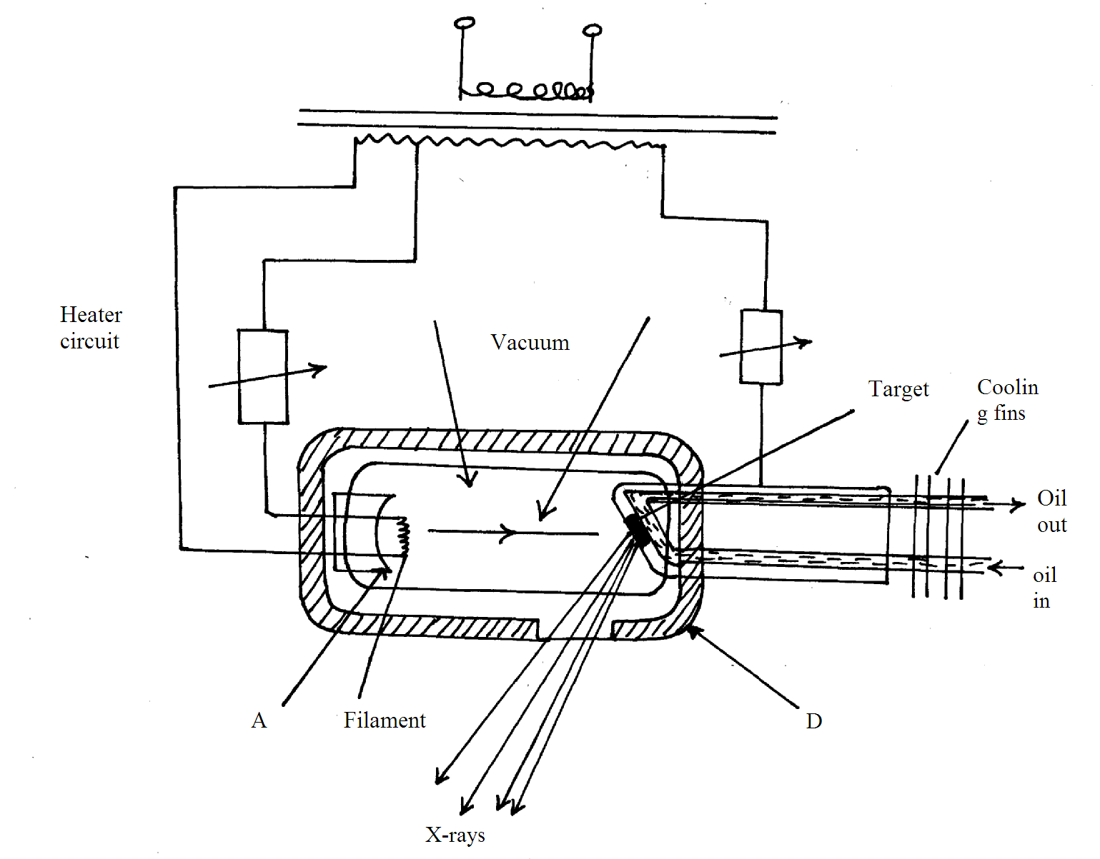
i) Name the parts labelled A,B,C,D. (2marks)
…………………………………………………………………………………………………………………………………………………………………………………………………………………………………………………………………………………………………………………………….......................................
ii) Explain how X-rays are produced in the tube. (3marks)

iii) During the operation of the tube, the target becomes very hot explain. (2marks)
iv) Name one feature of the X-ray tube which makes it possible for heat to be conducted away safely without causing overheating. (1mark)
……………………………………………………………………………………………..
v) Explain the use of X-ray in textile industries. (3marks)
……………………………………………………………………………………………………………………………………………………………………………………………
vi) The frequency of X-rays ranges from 3.0x10¹⁶Hz to 3.0x10¹⁹Hz. determine the range of wavelength . (take C =3.0x10⁸m/s) (3marks)
………………………………………………………………………………………………………………………………………………………………………………………………………………………………
17. (a) With the aid of a labelled diagram, explain how the focal length of a convex lens may be estimated
by focusing a distant object.(3marks)

(b) The graph below shows values obtained in an experiment to determine the focal length of a convex
lens. Use the graph to determine the focal-length of the lens.(4 marks)
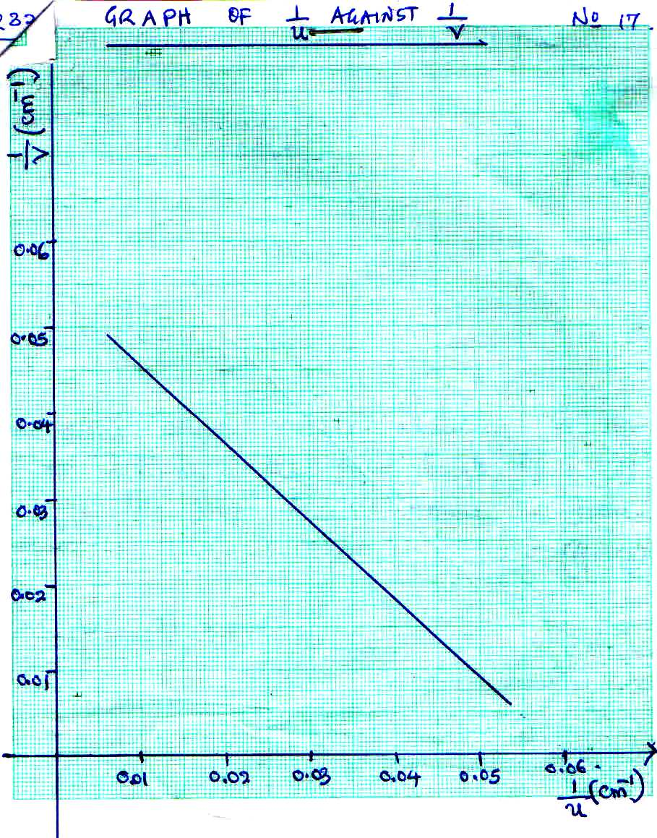
GRAPH OF $\frac{I}{u}$ AGAINST $\frac{I}{V}$

(c) An object is placed 30cm infront of a converging lens of focal length 20cm.
(i) By calculation determine the position of the image. (2 Marks)
………………………………………………………………………………………………………………
………………………………………………………………………………………………………………
………………………………………………………………………………………………………………
………………………………………………………………………………………………………………
(ii) State the nature of the image (1 Mark)
………………………………………………………………………………………………………………
………………………………………………………………………………………………………………
………………………………………………………………………………………………………………
………………………………………………………………………………………………………………

