Name: …………………………………………………………… Index No.:……………………................
School: …………………………………………………………. Candidate’s Sign:……………………...
Date:…..……………..…………………………….........................

232/2
PHYSICS
PAPER 2
TIME: 2 HOURS

ACK JOINT EXAM – 2021
Kenya Certificate of Secondary Education (K.C.S.E)

PHYSICS
PAPER 2
2 HOURS

INSTRUCTIONS TO THE CANDIDATES
- Write your name and index number in the spaces provided above.
- Sign and write the date of examination in the spaces provided.
- This paper consists of two sections, A and B.
- Answer all the questions in section A and B in the spaces provided.
- All workings must be clearly shown.
- Mathematical table and silent non programmable electronic calculators may be used.
- Candidates should answer the questions in English.
For Examiner’s Use Only:-
SECTION | QUESTION | MAXIMUM SCORE | CANDIDATE’S SCORE
A | 1 – 11 | 25
B | 12 | 11
 | 13 | 10
 | 14 | 13
 | 15 | 11
 | 16 | 10
TOTAL SCORE |  | 80

This paper consists of 11 printed pages.
Candidates should check the question paper to ascertain that all pages are printed as indicated.
And that no questions are missing.

SECTION A (25 MKS): Answer all questions in this section in the spaces provided.
- Figure 1 shows a ray of light incident on a mirror at an angle of 45⁰. Another mirror is placed at an angle of 45⁰ to the first one as shown
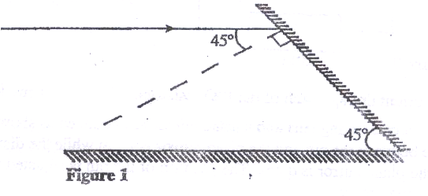

Sketch the path of the ray until it emerges (2 mks)
- Figure 2 shows a soft iron bar AB placed in a coil near a freely suspended magnet.
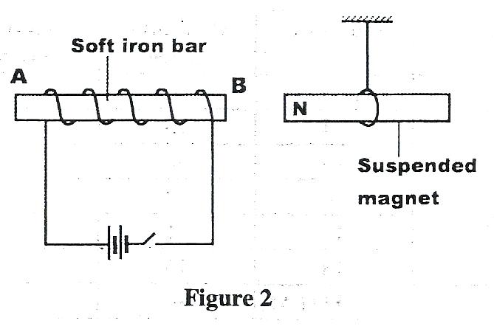
Explain the observation made when the switch is closed. (2 mks)
…………………………………………………………………………………………………………………………………………………………………………………………………………………………………………………………………………………………………………………
- Table 1 shows radiations and the irrespective frequencies.

Type of radiation | Yellow light | Gamma rays | Radio waves | Micro waves
Frequency (Hz) | 1 x 10¹⁵ | 1 x 10²² | 1 x 10⁶ | 1 x 10¹¹

Arrange the radiations in the order of increasing energy. (l mk)
…………………………………………………………………………………………………………………………………………………………………………………………………………………………………………………………………………………………………………………………………….
- State the reason why electrical power is transmitted over long distances
at very high voltages. (1 mk)
……………………………………………………………………………………….............................................
……………………………………………………………………………………………………………………………………
- A boy standing in front of a cliff blows a whistle and hears the echo after 0.5s. He then moves 17 metres further away from the cliff and blows the whistle again. He now hears the echo after 0.6s. Determine the speed of the sound. (4mks)
…………………………………………………………………………………………………………………………………………………………………………………………………………………………………………………………………………………………………………………………………………………………………………………………………………………………………………………………………………………………………………………………………………………………………………………………………………………………………………………………………………
- Figure 3 shows a human eye with a certain defect

Figure 3
Eye lens
Normal near point
(i) Name the defect (1 mk)
……………………………………………………………………………………………
(ii) On the same diagram, sketch the appropriate Len and rays to show how the defect can be corrected. (2mks)
- Polarisation is a defect of a simple cell. State how it reduces the current produced and how this defect can be minimized (2mks)
……………………………………………………………………………………………………………………………………………………………………………………………
8. The figure below shows container loader which uses electromagnet to offload containers from a ship.
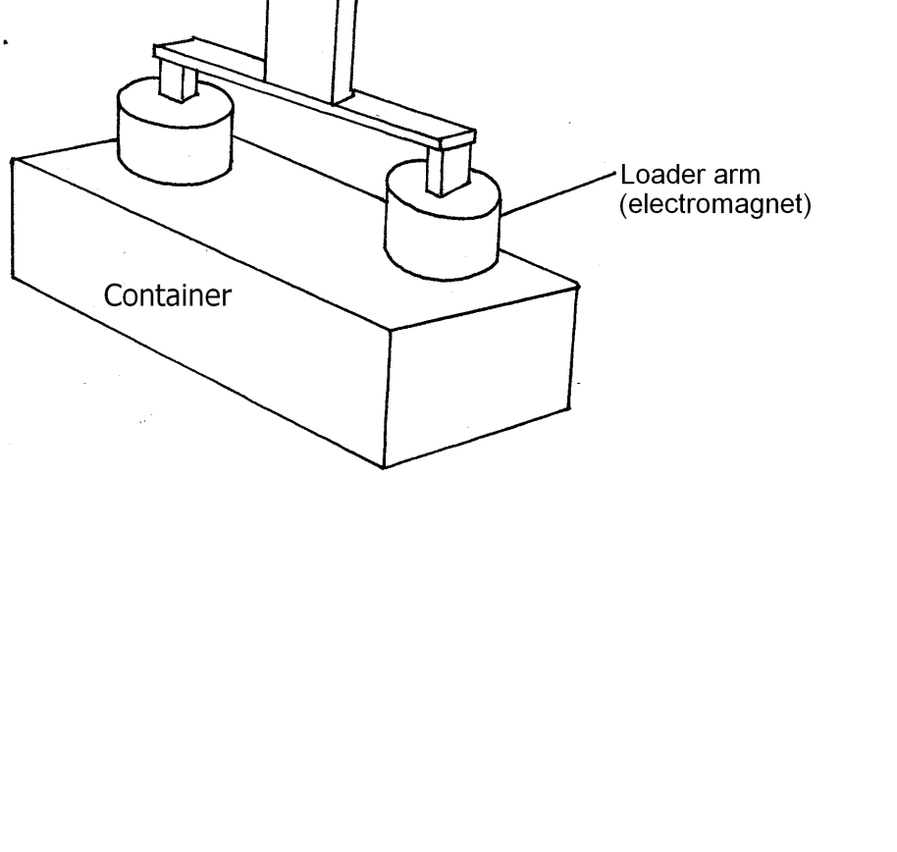
(i) Why should the container be made of iron or steel (1mk)
…………………………………………………………………………………………………………
(ii) State two ways in which the loader can be made to lift heavier container (2mks)
……………………………………………………………………………………………………………………………………………………………
9. Two 12V lead acid accumulators are rated 60Ah and 70Ah. State two physical differences between the accumulators (2mks)
………………………………………………………………………………………………………………………………………………………………
- The diagram below shows part of a wave form. The numbers on the diagram show scales in meters. If the speed of the wave is 20ms⁻¹, determine the frequency and wavelength of the wave. (3mks)
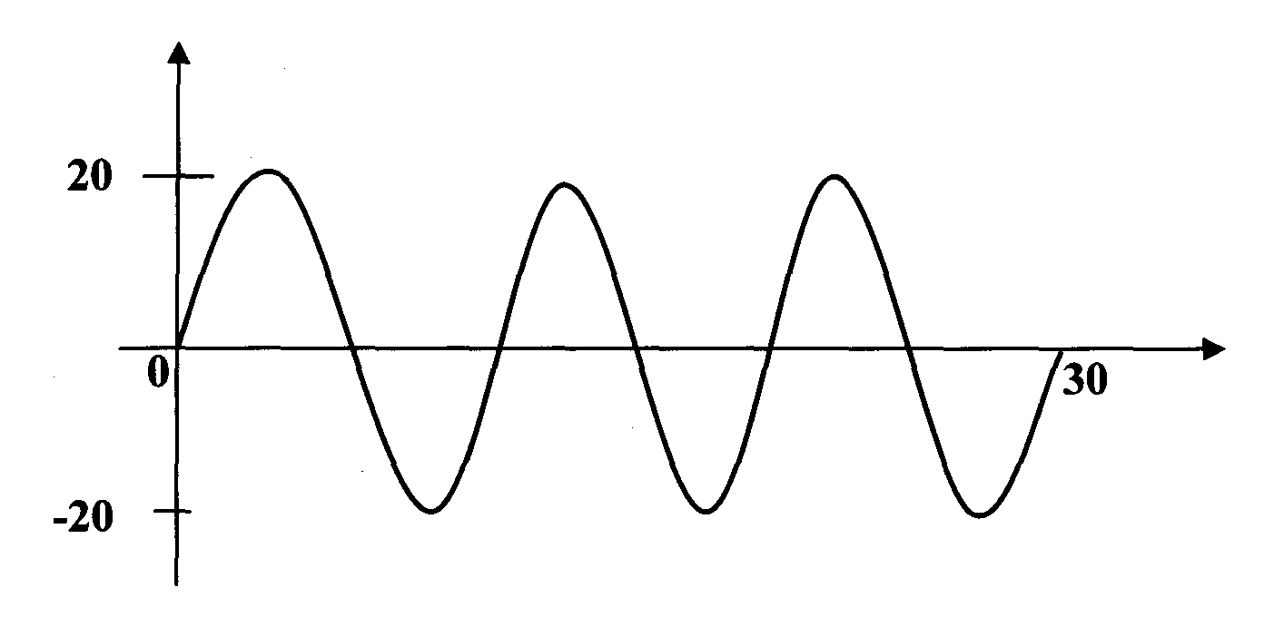
………………………………………………………………………………………………………………………………………………………………
………………………………………………………………………………………………………………………………………………………………
………………………………………………………………………………………………………………………………………………………………
………………………………………………………………………………………………………………………………………………………………
- A gold leaf electroscope is positively charged as shown in the diagram below where C is the cap and L is the gold leaf. State and explain what happens to L when a positively charged rod is brought near C without touching it. (2mks)

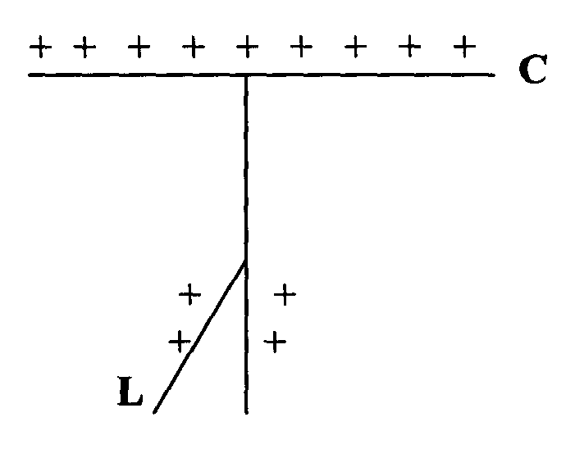

SECTION B (55 MARKS)
12. (a) State Ohm’s law (1mk)
……………………………………………………………………………………………………………………………………………………………………………………………………………………………………………………………………………………………………………………………………………………………………………………………………………………………………………………………………………………………………..
(b) The figure below shows the voltage – current relating for a certain battery used in an electrical circuit.
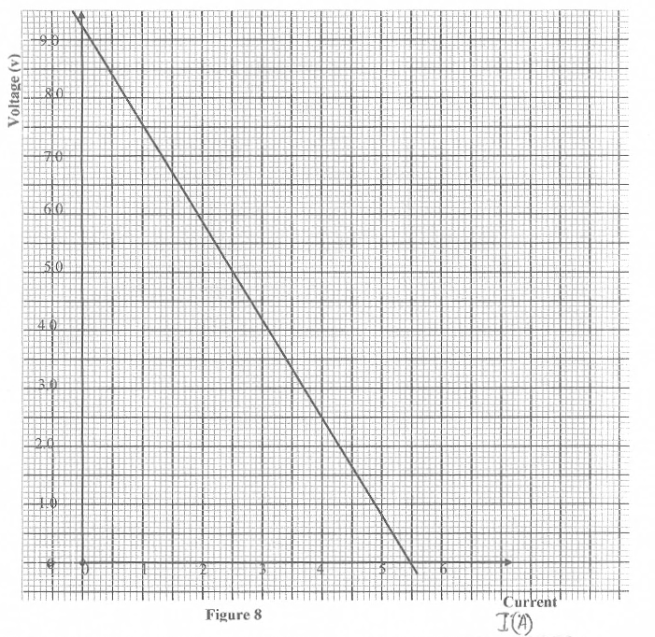
Given that the equation of the graph is V = E – Ir , from the graph , determine
(i) The e.m.f of the battery. (1mk)

(ii) The internal resistance of the battery used. (3mks)

(c) The figure below shows a circuit with a coil used to warm oil in a beaker.

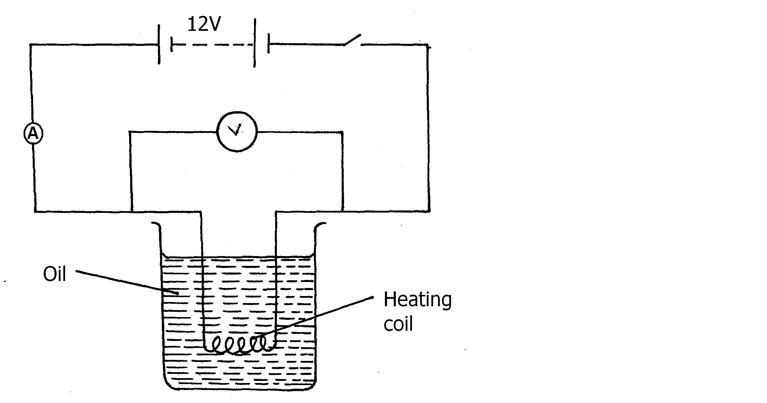
(i) Explain how heat is produced in the coil (2mks)
…………………………………………………………………………………………………………………………………………..
(ii) Given that the reading of the ammeter is 2.4A determine the resistance of the coil. (3mks)
………………………………………………………………………………………………………………………………………………
……………………………………………………………………………………………………………………………………………..
…………………………………………………………………………………………………………………………………………….
(iii) How much heat is produced in the coil in a minute? (2mks)
……………………………………………………………………………………………………………………………………………..
……………………………………………………………………………………………………………………………………………….
……………………………………………………………………………………………………………………………………………….
(iv) Give two changes that can be made in the set up in order to produce more
heat per minute. (2mks)
…………………………………………………………………………………………………………………………………………………
………………………………………………………………………………………………………………………………………………….

13. a) With an aid of a ray diagram show how a convex lens can be used as a magnifying glass
(3mks)

(b) From the definition of magnification M and equation $f=\frac{uv}{v+u}$ show that magnification
$M=\frac{v}{f}-1$where the symbols have their usual meanings. (3mks)

(c) Two converging lenses whose focal lengths are f₁=5cm and f₂=10cm are arranged to have a common axis as shown in figure below.
A point object is placed 10cm from L1. Given that the final image is formed 20cm to the left of L2₁ calculate the separation d of the lenses (4mks)

14.(a) Figure 8 shows a circuit that may be used to charge a capacitor.
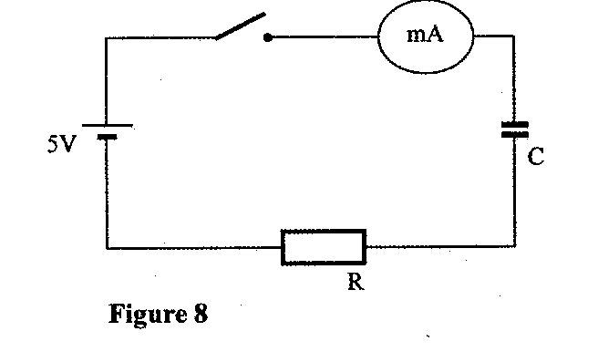
(i) State the observation on the milliameter when the circuit is switched on: (1mk)
……………………………………………………………………………………………………………………………………………………………………………………………………………………………………………………………………………………………………………………………………
(ii) Explain the observation in (i) above. (2mks)
……………………………………………………………………………………………………………………………………………………………………………………………………………………………………………………………………………………………………………………………………
(b) The circuit in figure 8 is left on for some time. State the value of p.d. across:
(i) the resistor R; (1mk)
……………………………………………………………………………………………………………………………………………………………
(ii) the capacitor C; (1mk)
…………………………………………………………………………………………………………………………………………………………..

(c) Sketch the graph of potential difference (V) across R against time. (3mks)

(d) The Figure shows three capacitors connected to a 10V battery.
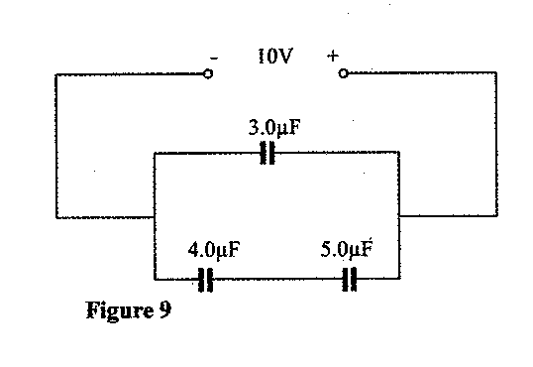
Calculate:
(i) the combined capacitance of the three capacitors; (3mks)
………………………………………………………………………………………………………………………………………………………………………………………………………………………………………………………………………………………………………………………………………………………………………………………………………………………………………………………………………………………………………
(ii) the charge on the 5.0 μF capacitor. (2mks)
………………………………………………………………………………………………………………………………………………………………………………………………………………………………………………………………………………………………………………………………………………………………………………………………………………………………………………………………………………………………………………………………………………………………………………………………………………………………………………………………………….
- (a) Figure below shows two circuits close to each other
Coils
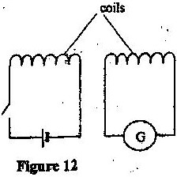

Figure

When the switch is closed, the galvanometer shows a reading and then returns to zero. When the switch is then opened, the galvanometer shows a reading in the opposite direction and then returns to zero. Explain these observations. (3mks)
………………………………………………………………………………………………………………………………………………………………………………………………………………………………………………………………………………………………………………………………………………………………………………………………………………………………………………………………………………………………………………………………………………………………………………………………………………………………………………………………………..
- An ideal transformer has 2000 turns in the primary circuit and 200 turns in the secondary circuit. When the primary circuit is connected to a 400V a.c. source the power delivered to a resistor in the secondary circuit is found to be 800W. Determine the current in:
  - The secondary circuit (3mks)
………………………………………………………………………………………………………………………………………………………………………………………………………………………………………………………………………………………………………………………………………………………………………………………………………………………………………………………………………………………………………………………………………………………………………………………………………………………………………………………………………..
  - The primary circuit (3mks)
……………………………………………………………………………………………………………………………………………………………………………………………………………………………………………………………………………………………………………………………………
c) Explain how energy losses in a transformer are reduced by having a soft- iron core (2mks)
……………………………………………………………………………………………………………………………………………………………………………………………………………………………………………………………………………………………………………………………………
- (a) (i) State the meaning of the statement diode characteristic. (1mk) …………………………………………………………………………………….
………………………………………………………………………………………
(ii).Sketch a circuit diagram that can be used to investigate p-n junction diode characteristics. (2mks)

(b) Define the term acceptor atom as applied in semiconductor. (1mk)
……………………………………………………………………………………………………………..
……………………………………………………………………………………………………………...
(c).Study figure 7 below and use it to answer questions that follow.
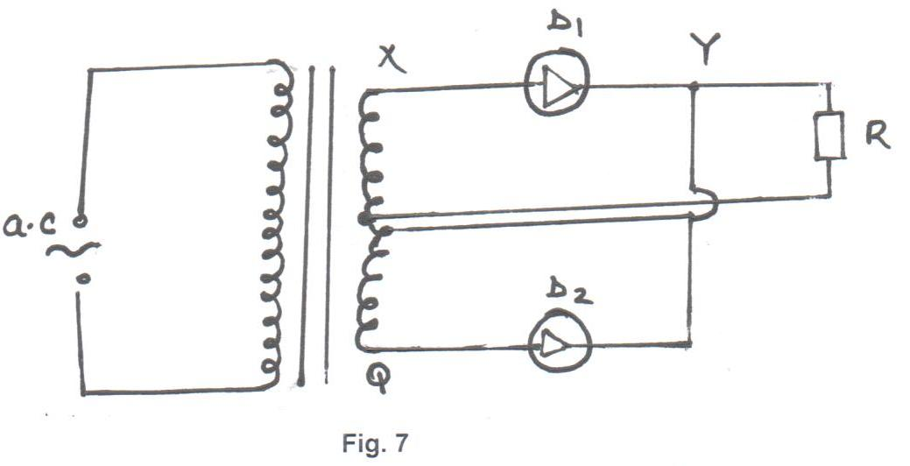
  - Briefly explain how the circuit works to produce a rectified alternating current. (3mks)

  - Draw on the diagram to show the position of the capacitor. (1mk)

  - State the functions of the capacitor in the circuit. (1mk)

  - Sketch the graph of the output as seen on a CRO screen. (1mk)

