NAME: …………………………..……………….. DATE: …………………………

ADM NO. ……….……….…………………...…..… STREAM: ……………..…………..

TERM 2 2021 FORM 4
232/2
PHYSICS MARKING SCHEME
PAPER 2
TIME: 2 HOURS.

INSTRUCTIONS TO CANDIDATES
- Write your name and your index number in the spaces provided above.
- This paper consists of two sections A and B
- Answer all questions in section A and B in the space provided
- All working must be shown in the spaces provided in this booklet.
- Mathematical tables and silent electronic calculators may be used
- This paper consists of 10 printed pages. Candidates should check to ensure that all pages are printed as indicated and no questions are missing

FOR OFFICIAL USE

Section | Question | Max. score | Candidate’s score
A | 1-12 | 25
B | 13 | 11
 | 14 | 15
 | 15 | 12
 | 16 | 07
 | 17 | 10
TOTAL SCORE |  | 80

Physics
Paper 2
SECTION A – 25 MARKS

- Figure 1 shows a ray of light incident on a plane mirror.
Figure 1
70⁰

The plane mirror is then rotated clockwise through an angle of 20⁰ keeping the incident ray fixed. Determine the new angle of reflection. (2 Marks)
Angle of incidence = $\frac{{70}^{0}}{2}$ = 35⁰
Angle of reflection = 35⁰
New angle of reflection = 354 + (2 x 20)
= 75⁰
- A dry cell is not recharged once used up. However when used well, it can serve one for some time. State the precautions necessary when using it other than storing it in dry condition. (2 Marks)
Do not draw large current from it
Do not short circuit its terminals
- A charged rod A is used to charge another rod B by contact. When rod B is brought close to a charged acetate rod, repulsion occurs. State the type of charge on rod A. (1 Mk)
Charge on rod A is positive
- A nail is electrically magnetised, it attracts an increasing number of pins as the magnetising current increase. After some time it can no longer attract any more pins. Explain this observation domain theory.
(2 Marks)
- Nail attains magnetic saturation
- All dipoles are aligned
- Figure 2 below shows a current carrying vertically right wire at right angle to a cardboard. Iron fillings are sprinkled on the card and card slightly tapped.
Figure 2
Cardboard
Current flow
Wire

Draw and indicate the direction of the magnetic field pattern displayed on the card. (2 Marks)
X
>

>

>

<
<
<
Pattern
Direction
- Figure 3 below shows a wave profile for a wave whose frequency is 2.5HZ
Figure 3
t₁
t₂
t₃
t₄
t₅
Time (s)
Time (s)
Displacement (m)

Determine the value of t₃ (2 Marks)
T = $\frac{1}{f}$ = $\frac{1}{2.5}$
= 0.4 Sec
t₃ = $\frac{3}{4}$ x 0.4
= 0.3 sec
- An electric kettle has an element of resistance 28.8Ω. It is operating from a 240V main supply. Determine its power rating. (3 Marks)
P = IV
= $\frac{V}{R}$(v)
= $\frac{V^{2}}{R}$ = $\frac{{(240)}^{2}}{28.8}$
= 2000W
- Distinguish between intrinsic and extrinsic semi-conductor. (1 Mark)
- Intrinsic – Pure semiconductor Both correct
- Extrinsic – An impure semi-conductor
- The following is part of a radioactive series.

$\begin{matrix}238 \\ 92\end{matrix}$u $\begin{matrix}(i) \\ \end{matrix}$ $\begin{matrix}234 \\ 90\end{matrix}$Th $\begin{matrix}(ii) \\ \end{matrix}$ $\begin{matrix}234 \\ 91\end{matrix}$Po

Identify the radioactive particles emitted in stages (i) and (ii) (2 Marks)
Alpha particles
Beta particle
- Figure 4 shows light passing through a transparent block.
Figure 4
41.8⁰

Determine the refractive index of the block. (3 Marks)
C = 41.8⁰
n = $\frac{1}{Sin C}$
= $\frac{1}{Sin {41.8}^{0}}$ =1.500

- Figure 5 shows part of the electromagnetic spectrum.
Figure 5
Z W P

Ultra Visible
violet Light
Identify radiation W and state one of its uses. (2marks)
W – Microwave
Uses – Cooking
- Communication
- Figure 6 shows a permanent magnet placed near a solenoid connected to a source of e.m.f.
Figure 6
B
A
Source of e.m.f
N S
Permanent magnet

(a) State and explain what is observed when the North – pole of the permanent magnet is brought to end
A.(2marks)
-End A and the Norrth pole repels
- Current flows to form a North pole at A
(b) State the law applied (1mark)
Lenz’s law
SECTION B – 55 MARKS
Answer ALL questions in the spaces provided after each section of the question
- (a) A strong positive charged rod is brought close to the cap of a charged electroscope from a high
position. It is observed
(i) State the charge on the electroscope (1 Mark)
Negative

(ii) Explain this obervation (2 Marks)
The rod attracts the negative charges from the leaf and the plate to the cap to make the leaf and
plate neutral
- One coming closer, more negative charges are attracted and the leaf and the plate becomes positive thus the leaf diverges

(b) A parallel – plate capacitor is connected to an electroscope as shown in Fig. 7 below.
Figure 7
d

State and explain the behaviour of the leaf when the distance (d) between the plates is increased
(2 Marks)
The leaf divergence increases.
- As d- increases, potential difference (V) across the plates increases, thus the capacitance of the
capacitors reduces, and some charges moves to the electroscope.
From, C = $\frac{Q}{V}$
Keeping Q – Constant as V – Increases C – Decrease
(c) Figure 8 shows an arrangement of capacitors to a 12V d.c. supply.
Figure 8
8µF
4µF
6µF
8µF
12V

Determine
(i) Effective capacitance (3 Marks)
C_{T} = $\left(\frac{4 x 6 }{4+6}\right)$ + 8
= 10.4µF OR 1.04 x 10⁻⁵F
(iii) Charge across the 8µF capacitor. (3 Marks)
Q = CV
= 8 x 10⁻⁶ x 12
= 9.6 x 10⁻⁵ C (with V units)
14. a) (i) The figure 9 below shows a step-up transformer commonly used at a power station.

Figure 9
Input AC
Ouput AC
Laminated soft iron core

(i) What is meant by a step-up transformer? (1 Mark)
It is a transformer that is used to increase the value of the output voltage or the ratio of the number
of turns

(ii) Why does a transformer work with AC only? (1 Mark)
AC charges or reverses hence it brings about a charge in magnetic flux in the primary coils. 1
(iii) What is the purpose of the soft iron core? (1 Mark)
It is used to link the two coils hence concentrating field lines and preventing flux loss. 1
(iv) State four ways in which power is lost in a transformer (1 Mark )
– Hysteresis
- Eddy currents
- Flux leakages
- Resistance of copper wires (any one correct)

(v) Why is the e.m.f. produced at a power station stepped up to high voltage for long distance
transmission (2 Marks)
At high voltages, the current in the transmitting cables is less, hence power loss (I²R) is greately reduced.

15. (a) Figure 10 shows the trace on the screen of a.c. signal connected to the Y-plates of a C.R.O with the
time – base on.
Figure 10
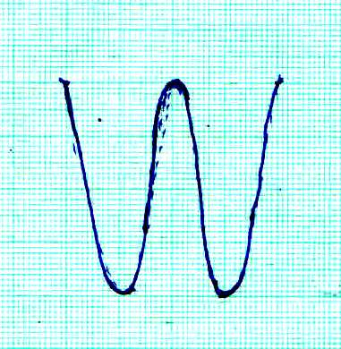

Given that the time base control is 10ms/cm and the Y-gain is at 120V/cm determine
(i) The frequency of the a.c. signal (3 Marks)
Time for 2 cycles shown = 10 x 4cm
= 40ms
T = $\frac{40}{2}$ = 20 ms
f = $\frac{1}{T}$
= $\frac{1}{{20 x 10 }^{-3}}$
= 50HZ
(ii) The peak voltage of the input signal (3 Marks)
Voltage = y – gain x displacement
= 120 x 2
= 240V
(iii) State what would be observed on the screen if the time base is switched off (1 Mark)
The trace on the screen would be a vertical line.
(b) Figure 11 shows a circuit whose output voltage with time as displayed on the CRO screen. (2 Marks)
Figure 11
To CRO
R

(i) Sketch a graph to show the variation of output voltage with time as displayed on the CRO screen.
( 2 Marks)

Axes labelled with units
Voltage Curve
(V)

Time (s)

(ii) Show on the diagram (Figure 11) how a capacitor should be connected to smooth the output voltage
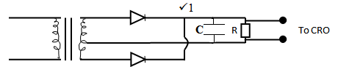
(1 Mark)

(iii) Sketch a curve of smoothed output voltage against time. (2 Marks)

Axes labelled with units
Curve

Time (s)

16. a) X-rays are used for detecting cracks inside metal beams: State the type of X-rays used. (1mark)
Hard X-rays;
b) The figure 12 below shows the feature of an X-ray tube.
Figure 12

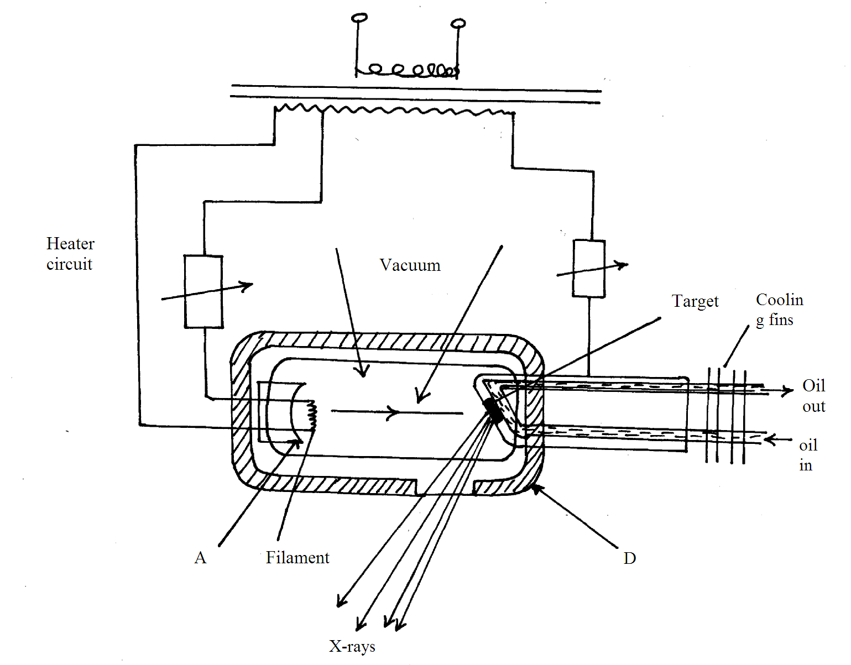
i) Name the parts labelled A,B,C,D. (2marks)
A focusing cathode, B-Electron beam, C-copper anode, D- lead shield ; ½ each.
ii) Explain how X-rays are produced in the tube. (3marks)
Filament is heated it heats the cathode and electrons are emitted thermionically; emitted electrons are accelerated to the target by accelerating potential; upon hitting the target, X-rays are produced;
iii) During the operation of the tube, the target becomes very hot explain. (2marks)
The moving electrons possesses kinetic energy; most of this energy is converted into heat when the electrons meet the target.
iv) Name one feature of the X-ray tube which makes it possible for heat to be conducted away safely without causing overheating. (1mark)
copper cooling fins
v) Explain the use of X-ray in textile industries. (3marks)
X-rays are able to ionise the air particles; ionises air particles are used to discharge cloth materials to remove static charges; the static charges on the cloth can cause fire outbreak;
vi) The frequency of X-rays ranges from 3.0x10¹⁶Hz to 3.0x10¹⁹Hz. determine the range of wavelength . (take C =3.0x10⁸m/s) (3marks)
Also
Range 1.0x10⁻¹¹m to 1.0x10⁻⁸m;
17. (a) With the aid of a labelled diagram, explain how the focal length of a convex lens may be estimated
by focusing a distant object. (3marks)
2F
2F
F
F

Diagram (1) focus a distant object onto a screen distance between the image and the lens is the
focal length

(b) The graph below shows values obtained in an experiment to determine the focal length of a convex
lens. Use the graph to determine the focal-length of the lens. (4marks)
Using, $\frac{1}{f}$ = $\frac{1}{u}$ + $\frac{1}{V}$
Taking $\frac{1}{V}$ = 0
⇒ $\frac{1}{f}$ = $\frac{1}{u}$ = 0.06 Extrapolating the line to intercept the x and y axis.
f₁ = $\frac{1}{0.06}$
= 16.67cm
Taking $\frac{1}{u}$ = 0
⇒ $\frac{1}{f}$ = $\frac{1}{v}$ = 0.055
f₂ = $\frac{1}{0.055}$
= 18.18cm
f = $\frac{f_{1+ f_{2}}}{2}$ ⇒ $\frac{16.67+18.18}{2}$ = 17.43cm

(c) An object is placed 30cm infront of a converging lens of focal length 20cm.
(i) By calculation determine the position of the image. (2 Marks)
$\frac{1}{f}$ = $\frac{1}{u}$ + $\frac{1}{v}$
$\frac{1}{20}$ = $\frac{1}{30}$ + $\frac{1}{V}$
⇒ v = $\frac{600}{10}$ = 60cm
⇒ Image is 60cm from the lens on the opposite side to that object.√
(ii) State the nature of the image (1 Mark)
The image is real

