**ACK JOINT EXAM 2021- PHYSICS PP2 MARKING SCHEME.**

**SECTION A (25 MKS**)

450 - 1 mk for showing all rays

- 1 mk for angles shown

450

1. **The suspended bar magnet is repelled. The soft iron bar is magnetized and end B becomes the North pole hence like poles repel.**
2. ***Radio waves microwave*s *yellow light gamma rays***
3. ***High voltage leads to low current hence low power losses or energy loss***
4. **2d/05 = 2d/0.6 + 34 OR V = d/t**

**D = 17/0.2 = 85 m = 17 x 2**

**0.1**

**Speed = 2 x 86 = 340 m/s**

**0.5**

**= 340m/s**

1. **(i) Long sightedness/ hypermetropia**

**ii) corrected using a convex/ converging lens; check rays converged at retina.**

1. **Polarisation reduces current by production of hydrogen bubbles around the negative plate; can be reduced by adding a depolarizer e.g manganese (iv) oxide**
2. (i) Magnetic material

(ii) – using larger current

- Increasing the no of turns

9. 70Ah 60Ah

- Plates with large surface – smaller surface area plates

- Many plates hence bigger – A few plates hence look smaller

10.  = 30/3 = 10m

f = v/ = 20/10 = 2m/s

11. - Leaf divergence increases

- Like charges repel

**SECTION B**

12. (a) Current flowing through a conductor is directly proportional to the potential difference across its end provided the temperature and other physical conditions are kept constant

(b) (i) emf of the battery equal to v intercept 9.2V

(ii) internal resistance = gradient of the graph .

r = 2.5 3

(c) (i) The work done in driving charges through the coil is high due to its resistance. This energy is converted into heat in the coil

(ii) V = IR R = V🗸 = 12V🗸

I 2.4

= 5.0

(iii) H = VIt

H = 12 x 2.4 x 60

= 1728J

(iv) – Using a source with higher emf

- Reducing the length of the coil

= P =

13. (a)

|  |
| --- |
| mso3C5F6  Object placed between P and two lens  2 correctly drawn rays from object to image ;;  Magnified , virtual, erect image ;  Observer  (b) We have  f = uv  v + u  But m = v/u ;  u = v/m    Substitution v/m for u we have ;  v  F = m + 1 ;    Re – arranging we have m = v/f – 1;    (c) u1 = 10 cm, f1 = 5cm, v1 = ?  1/ v1 + 1/ u1 = 1/f1  1/ v1  + 1/ 10 = 1/5  v1 = 10 cm ;  u2 = ? f2 = 10 cm , v2 = 20 cm  1/v2 + 1/ u2 = 1/f2  1/20 + 1/U2 = 1/10  u2 = 20cm ;  d = v1 + u2 = 10cm + 20cm  ∴d = 30 cm ; |

14. (a) (i) Current falls off to zero / falling to zero / deflects to max. Then zero

Reducing gradually or after sometime.

(ii)Current flows when the capacitor is charging

When fully charged current stops (no current) and p.d is equal to

charging voltage

(b) (i) VR = 0 V

(ii) VC = 5V

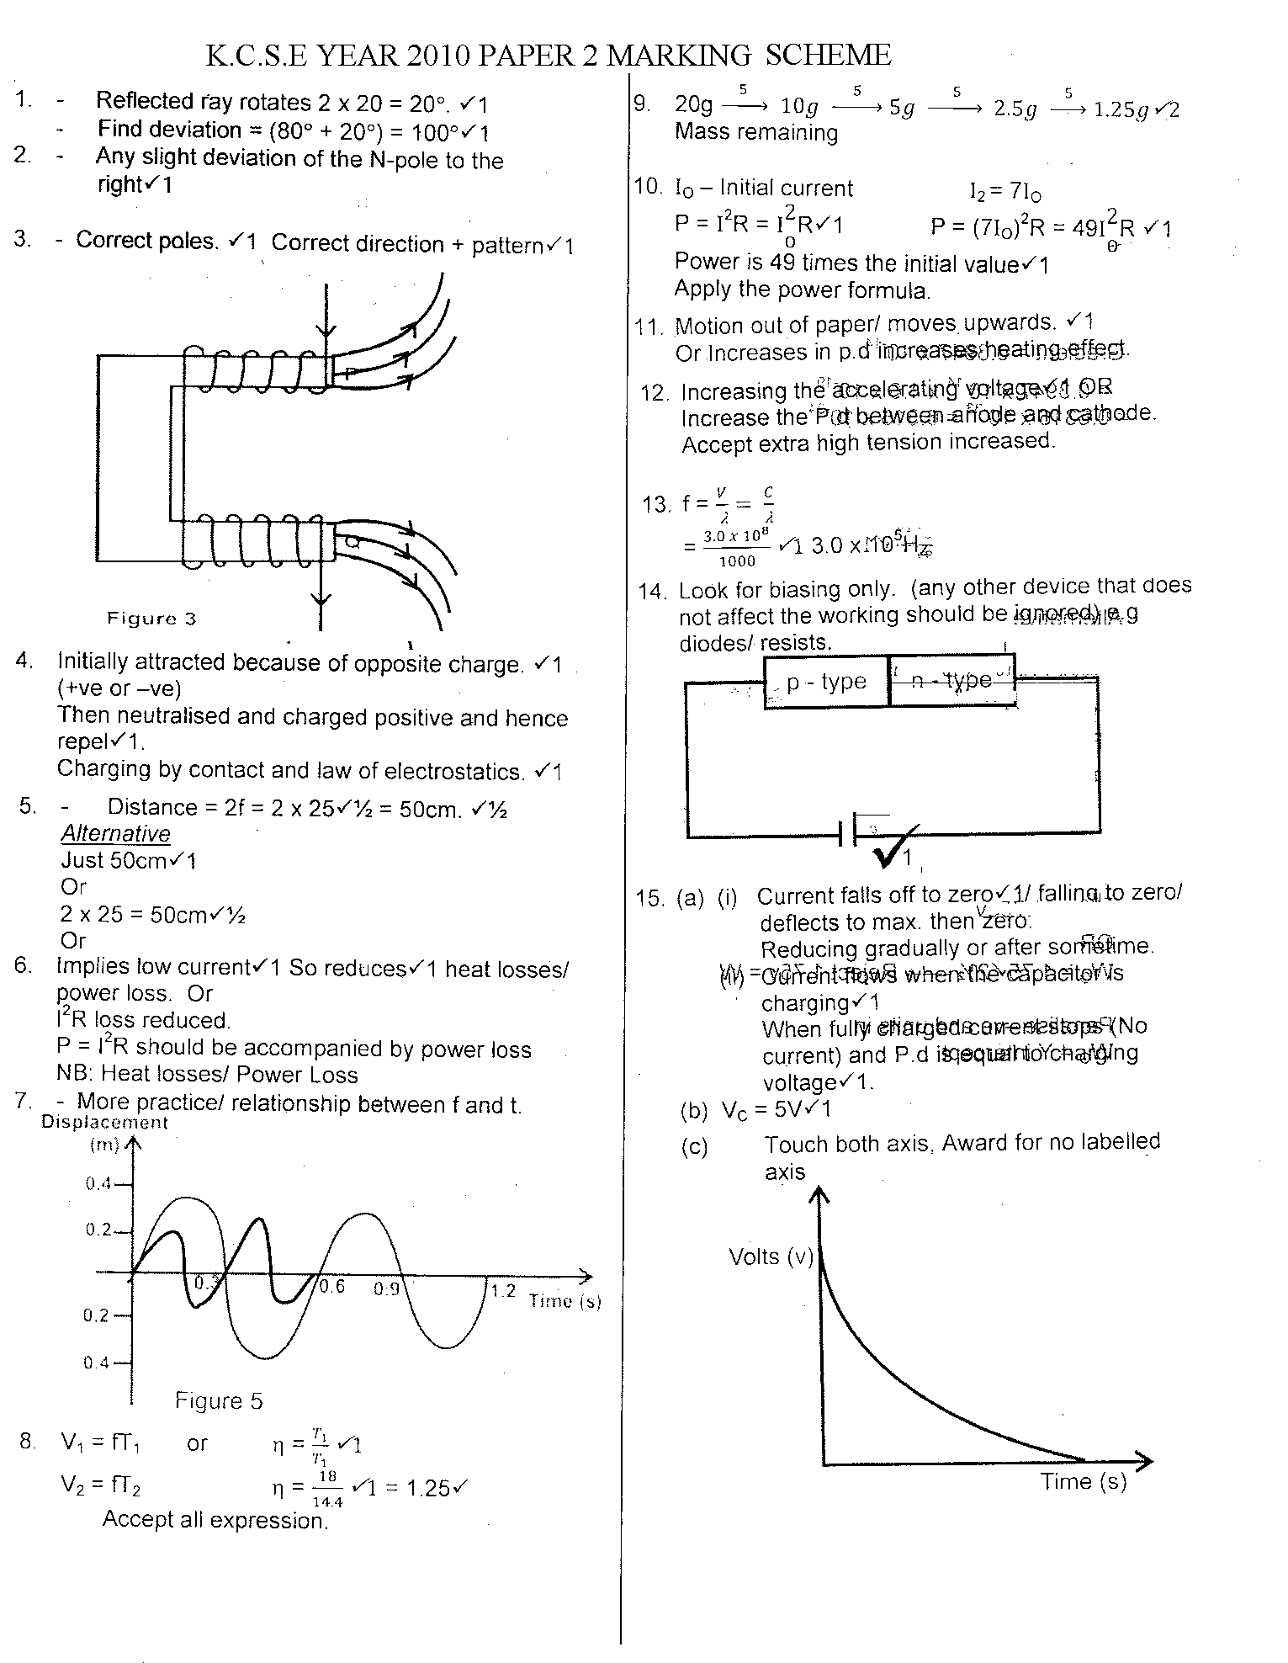

(c)

Touch both axis, award for no labeled axis

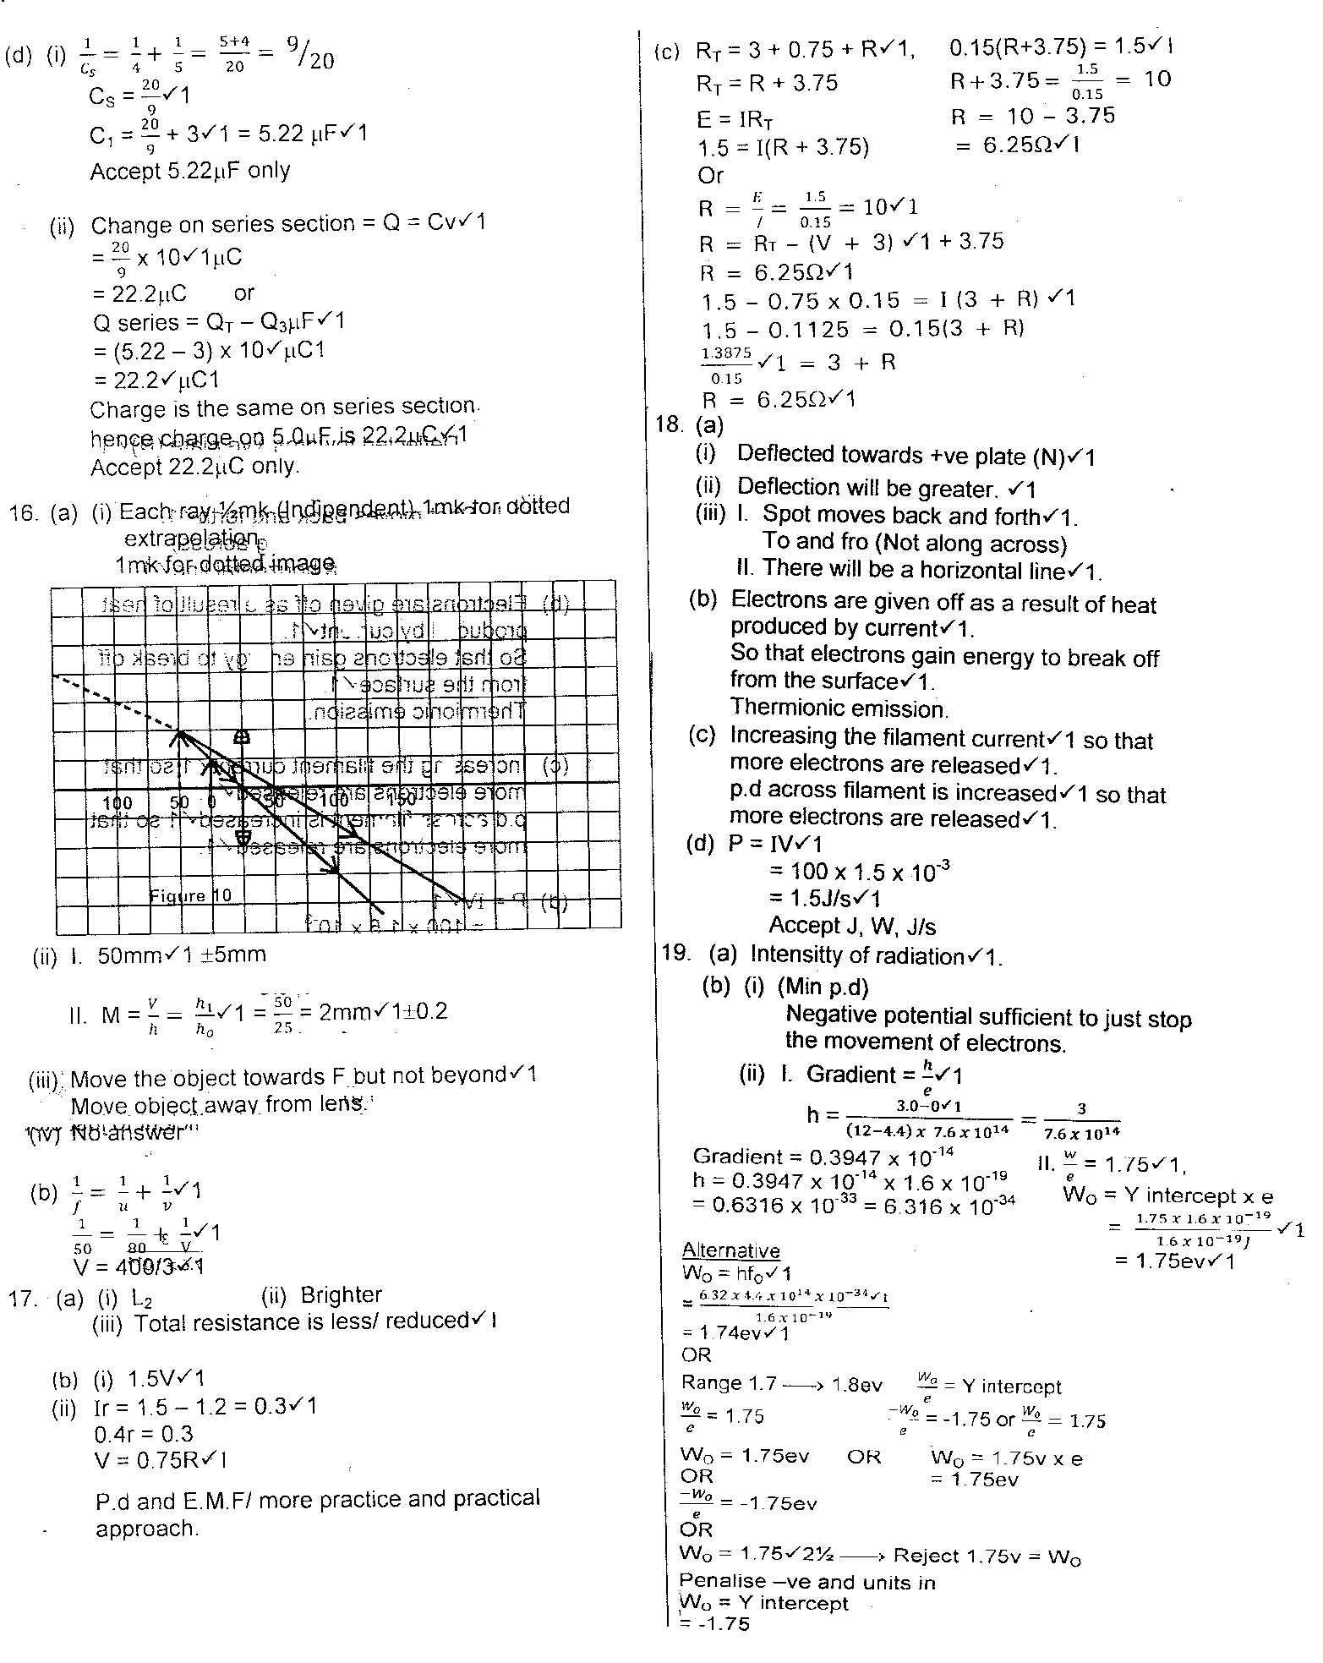

15. (a) Flux growing/ linking

No flux change

Flux collapsing

Switch closed: Flux in the coil grows and links the other coil inducing an

E.M.F

Current steady: No flux change hence induced E.M.F

Switch opened: Flux collapses in the R.H.S coil inducing current in opposite direction

(b) (i) VP = NP P = IsVs

Vs Ns Is = = 20A

400 = 200

Vs 20

Vs = 40 Volts

(ii) Pp Ps

800 = 400 Ip

Ip = = 2A

1. Reduces losses due to hysteresis (or magnetic losses)

Because the domain in soft- iron respond quickly to change in magnetic (or have low reluctance) i.e easily magnetized and demagnetized

16. (a) (i) A graph of current against voltage,

(ii)

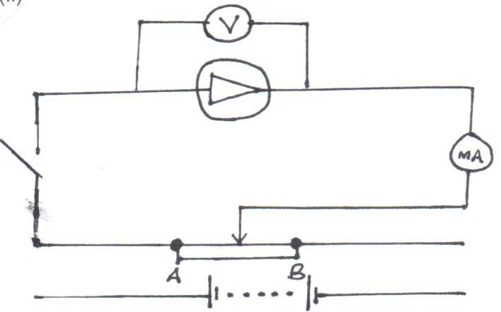

(b) The atoms that introduce holes in the pure semiconductors.

1. (i) - During the first half cycle D1 is forward biased while D2 is reverse biased.
   * + - * The path taken by current is D1, Y R Z.
         * During the next half-cycle D2 is forward biased while D1 is reverse biased and the path of the current is Q D2 Y R Z.
         * During both cycles, current flows through the resistor in the same direction.

(ii)

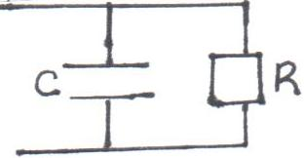

(iii) Smoothen the output signal.

(iv)

V (volts)

Time (s)