**Name………………………………………………………. Adm No……………….**

**Stream……………………………………………………. Date ………………………….**

***Kenya Certificate of Secondary Education (K.C.S.E.)***

**232/1**

**PHYSICS**

**PAPER 1**

**TIME: 2 HOURS**

**FORM 4 TERM 2 2021**

**INSTRUCTIONS TO THE CANDIDATES:**

* Write your **name and index number** in the spaces provided above.
* Answer ***all*** the questions both in section **A** and **B** in the spaces provided below each question
* All workings ***must*** be clearly shown; marks may be awarded for correct steps even if the answers are wrong.
* Mathematical tables and silent electronic calculators may be used.

**For Examiners’ Use Only**

|  |  |  |  |
| --- | --- | --- | --- |
| **SECTION** | **QUESTION** | **MAXIMUM SCORE** | **CANDIDATE’S SCORE** |
| Section A | 1-13 | 25 |  |
| Section B | 14 | 06 |  |
| 15 | 10 |  |
| 16 | 08 |  |
| 17  18 | 11  11 |  |
| **19** | **10** |  |
| **TOTAL** | **80** |  |

*This paper consists of 11 printed pages. Candidates should check to ascertain that all pages are printed as indicated and that no questions are missing*

**SECTION A: (25 MARKS) *Answer all questions in this section in the spaces provided***

1. Figure below shows a scale of vernier calipers when measuring the width of a meter rule.



What is the actual width of the meter rule if the calipers has a zero error of + 0.6mm.? (2mks)

………………………………………………………………………………………………………………

………………………………………………………………………………………………………………

………………………………………………………………………………………………………………

………………………………………………………………………………………………………………

1. Water is known to boil at 100oC. A student heated some water and noticed that it boiled at 101oC. State two possible reasons for this observation (2mks)

………………………………………………………………………………………………………………

………………………………………………………………………………………………………………

………………………………………………………………………………………………………………

………………………………………………………………………………………………………………

1. 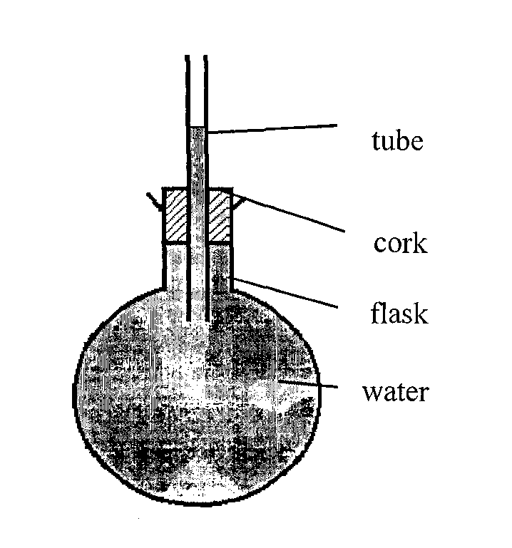The Figure below shows a flask filled with water. The flask is fitted with a cork through which a tube is inserted. When the flask is cooled, the water level rises slightly, and then falls steadily.

Explain the observation (3mks)

………………………………………………………………………………………………………………

………………………………………………………………………………………………………………

………………………………………………………………………………………………………………

………………………………………………………………………………………………………………

1. A pipe of radius 4mm is connected to another pipe of radius 6mm. if water flows in the wider pipe at the speed of 5 ms-1, what is the speed in the narrower pipe? (3mks)

………………………………………………………………………………………………………………

………………………………………………………………………………………………………………

………………………………………………………………………………………………………………

………………………………………………………………………………………………………………

1. Find the total pressure experienced by a diver 8 meters below the sea surface. (3mks)

Take; *Atmospheric pressure = 103360N*

*Density of sea water = 1030 kg/m3*

………………………………………………………………………………………………………………

………………………………………………………………………………………………………………

………………………………………………………………………………………………………………

………………………………………………………………………………………………………………

1. The following is a graph of force against extension for a spring

Force (N)

Extension (cm)

On the same axes, sketch a graph of force against extension for a spring double the length, same thickness, same material as the spring above (1mk)

1. Explain the cause of random motion of particles as observed in Brownian motion in a smoke cell experiment. (1mk)

………………………………………………………………………………………………………………

………………………………………………………………………………………………………………

1. Figure below shows an ammeter used to measure current through the conductor .The student used the lower scale. 

State the reading from the meter (1mk)

………………………………………………………………………………………………………………

1. Convert -200°C into Kelvins (1mk)

………………………………………………………………………………………………………………

………………………………………………………………………………………………………………

1. Figure shows an object held between two straight edges. Determine the radius of the object using the meter rule shown in figure below. (2 marks)

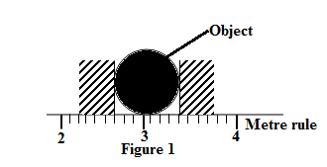

………………………………………………………………………………………………………………

………………………………………………………………………………………………………………

………………………………………………………………………………………………………………

………………………………………………………………………………………………………………

1. Figure below shows two identical springs constant 3N/cm supporting a load of 30N.



Determine the extension of each spring (3mks)

………………………………………………………………………………………………………………

………………………………………………………………………………………………………………

………………………………………………………………………………………………………………

………………………………………………………………………………………………………………

1. Convectional and diffusion both involve motion of fluid molecules. Distinguish between the two (2mks)

………………………………………………………………………………………………………………

………………………………………………………………………………………………………………

1. The figure shows a water tank that is used to heat water and supply through taps.

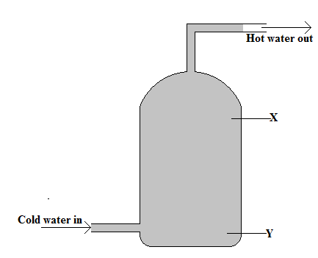

State with a reason whether the appropriate position for a heater is X or Y (2 marks)

………………………………………………………………………………………………………………

………………………………………………………………………………………………………………

**SECTION B (55 MKS) *Answer all questions in this section in the spaces provided***

1. A mixture consists of 80cm3 of water and 120cm3 of liquid X. If the density of water and liquid X are 1.0g/cm3 and 0.8g/cm3 respectively. Calculate the density of the mixture (3 mks)

………………………………………………………………………………………………………………

………………………………………………………………………………………………………………

………………………………………………………………………………………………………………

………………………………………………………………………………………………………………

………………………………………………………………………………………………………………

………………………………………………………………………………………………………………

1. Why is mercury more suitable for use in a simple barometer than water? (2 mks)

………………………………………………………………………………………………………………

………………………………………………………………………………………………………………

1. State one factor that would increase the surface tension of pure water in a beaker of water. ( 1mks)

………………………………………………………………………………………………………………

………………………………………………………………………………………………………………

1. Distinguish between solid and liquid states of matter in terms of intermolecular forces (1mk)

………………………………………………………………………………………………………………

………………………………………………………………………………………………………………

1. In an experiment to estimate the diameter of an oil molecule, an oil drop of diameter 0.05 spreads over a circular patch whose diameter is 20cm. Determine:
2. The volume of the oil drop (2mks)

………………………………………………………………………………………………………………

………………………………………………………………………………………………………………

………………………………………………………………………………………………………………

………………………………………………………………………………………………………………

1. The area of the patch covered by the oil (2mks)

………………………………………………………………………………………………………………

………………………………………………………………………………………………………………

………………………………………………………………………………………………………………

………………………………………………………………………………………………………………

1. The diameter of the oil molecule (2mks)

………………………………………………………………………………………………………………

………………………………………………………………………………………………………………

………………………………………………………………………………………………………………

………………………………………………………………………………………………………………

(c)State

(i) Any assumption made in (b) (iii) above (1mk)

………………………………………………………………………………………………………………

………………………………………………………………………………………………………………

(ii) Two possible sources of errors in this experiment (2mks)

………………………………………………………………………………………………………………

………………………………………………………………………………………………………………

………………………………………………………………………………………………………………

1. The figure shows a conveyor belt transporting a package to a raised platform. The belt is driven by a   
   motor.

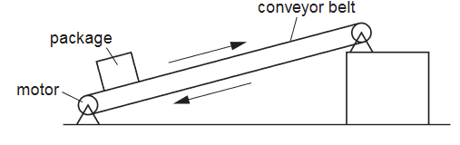

The mass of the package is 36 kg. Determine:

1. The increase in the gravitational potential energy (G.P.E.) of the package when it is raised through a vertical

height of 2.4 m. (2 marks)

………………………………………………………………………………………………………………

………………………………………………………………………………………………………………

………………………………………………………………………………………………………………

………………………………………………………………………………………………………………

1. The power needed to raise the package through the vertical height of 2.4 m in 4 s (2 marks)

………………………………………………………………………………………………………………

………………………………………………………………………………………………………………

………………………………………………………………………………………………………………

………………………………………………………………………………………………………………

1. The electrical power supplied to the motor is much greater than the answer to (b).  
    Explain how the principle of conservation of energy applies to this system. (2 marks)

………………………………………………………………………………………………………………

………………………………………………………………………………………………………………

………………………………………………………………………………………………………………

………………………………………………………………………………………………………………

1. Assume that the power available to raise packages is constant. A package of mass greater  
    than 36 kg is raised through the same height. Suggest and explain the effect of this increase in mass on the operation of the conveyer belt. (2 marks)

………………………………………………………………………………………………………………

………………………………………………………………………………………………………………

………………………………………………………………………………………………………………

………………………………………………………………………………………………………………

1. Explain why a hammer of mass 3kg strikes a nail when moving at 40m/s making the nail sink into wood yet when the same hammer is placed on the nail head, it cannot sink in the wood (1mk)

………………………………………………………………………………………………………………

1. A trolley of mass 20kg moving at 0.6m/s on a frictionless horizontal surface was acted upon by a force of 2.5 N. The resultant velocity of the body was 4.8 m/s. Determine

i) The change in momentum of the trolley (2mks)

………………………………………………………………………………………………………………

………………………………………………………………………………………………………………

………………………………………………………………………………………………………………

………………………………………………………………………………………………………………

ii) The time interval and the force acted on the body (2mks)

………………………………………………………………………………………………………………

………………………………………………………………………………………………………………

iii) The acceleration of the trolley (3mks)

………………………………………………………………………………………………………………

………………………………………………………………………………………………………………

………………………………………………………………………………………………………………

………………………………………………………………………………………………………………

………………………………………………………………………………………………………………

1. A gun of mass 3kg fires a bullet of mass 20g at 600m/s. Calculate the recoil velocity of the gun (3mks)

………………………………………………………………………………………………………………

………………………………………………………………………………………………………………

………………………………………………………………………………………………………………

………………………………………………………………………………………………………………

1. State the two conditions necessary for a system of forces acting on a body to be in equilibrium. (2 marks)

………………………………………………………………………………………………………………

………………………………………………………………………………………………………………

………………………………………………………………………………………………………………

………………………………………………………………………………………………………………

1. The figure shows a loaded wheelbarrow held in equilibrium by a gardener. The wheel of the wheelbarrow is in contact with the ground at point **C**

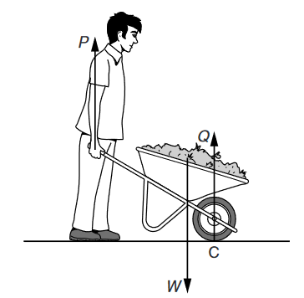

There are three vertical forces acting on the wheelbarrow **P** is the upward force applied by the gardener. **Q** is the upward force of the ground on the wheel at point **C**.**W** is the weight of the wheelbarrow and its contents. Explain why the force **P** is less than the force **W**

1. By considering the forces **P**, **Q** and **W**, ( 2 marks)

………………………………………………………………………………………………………………

………………………………………………………………………………………………………………

………………………………………………………………………………………………………………

………………………………………………………………………………………………………………

1. By considering the moments of the forces **P** and **W** about point **C**. (2 marks)

………………………………………………………………………………………………………………

………………………………………………………………………………………………………………

………………………………………………………………………………………………………………

………………………………………………………………………………………………………………

1. The figure shows a tanker lorry full of liquid. Study the diagram and answer the questions that follow

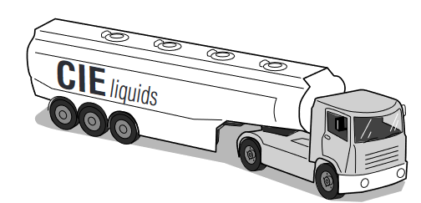

1. The tanker delivers the liquid and drives away empty. Compare the acceleration of the empty tanker with the acceleration of the full tanker for the same resultant force (2 marks)

………………………………………………………………………………………………………………

………………………………………………………………………………………………………………

………………………………………………………………………………………………………………

………………………………………………………………………………………………………………

1. Given that empty tanker has a weight of 50 000 N. The forward force is 6000 N and the total resistive force is 2000N. Determine the acceleration of the tanker (3 marks)

………………………………………………………………………………………………………………

………………………………………………………………………………………………………………

………………………………………………………………………………………………………………

………………………………………………………………………………………………………………

………………………………………………………………………………………………………………

………………………………………………………………………………………………………………

1. (i) State the law of floatation (1mk)

………………………………………………………………………………………………………………

………………………………………………………………………………………………………………

(ii) Explain why a hollow metal sphere floats on water while a solid metal sphere of the same material sinks

in water. (2mks)

………………………………………………………………………………………………………………

………………………………………………………………………………………………………………

………………………………………………………………………………………………………………

………………………………………………………………………………………………………………

1. The figure below shows a uniform block of uniform cross-sectional area of 6.0cm2 floating on two liquids A and B. The lengths of the block in each liquid are shown.

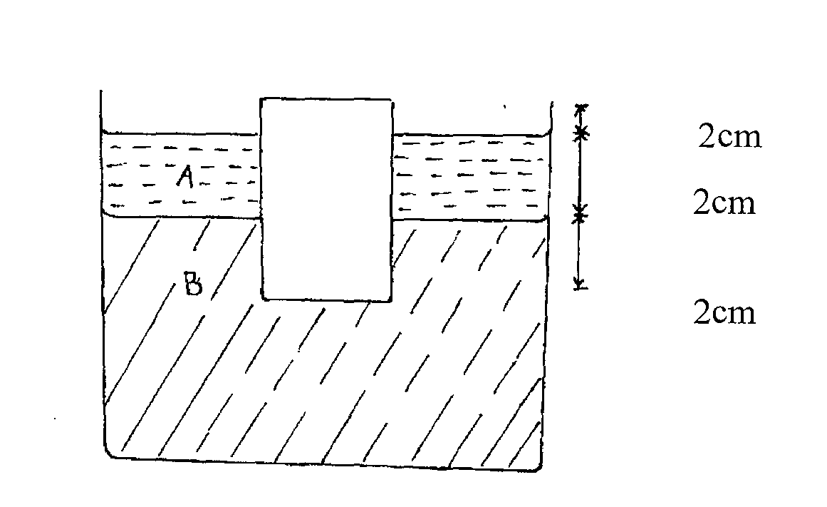

Given that the density of liquid A is 800kg/m3 and that of liquid B is 1000kgm-3, determine the:

(i) Weight of liquid A displaced (2mks)

………………………………………………………………………………………………………………

………………………………………………………………………………………………………………

………………………………………………………………………………………………………………

………………………………………………………………………………………………………………

(ii) Weight of liquid B displaced (2mks)

………………………………………………………………………………………………………………

………………………………………………………………………………………………………………

………………………………………………………………………………………………………………

………………………………………………………………………………………………………………

(iii) Density of block (3mks)

………………………………………………………………………………………………………………

………………………………………………………………………………………………………………

………………………………………………………………………………………………………………

………………………………………………………………………………………………………………