NAME……………………………………………………………….INDEX NO…………………
SCHOOL…………………………………………………………DATE……………….SIGN……..
232/1
PHYSICS
PAPER 1
NOVEMBER

ACK JOINT MOCK 2021
Kenya Certificate of Secondary Education (K.C.S.E)
232/1
PHYSICS
PAPER 1
INSTRUCTIONS TO CANDIDATES
- Write your name and Index Number in the space provided above.
- Sign and write the date of examination in the spaces provided.
- This paper consist of TWO section; A and B.
- Answer ALL questions in Section A and B in the spaces provided.
- ALL working MUST be clearly shown.
- Mathematical tables and electronic calculators may be used.
- This paper consists of 10 pages.
- Candidates should check the question paper to ensure that all the pages are printed as indicated and that no questions are missing.
FOR EXAMINERS USE ONLY
SECTION | QUESTION | MAXIMUM SCORE | CANDIDATES SCORE
A | 1-12 | 25
B | 13 | 9
 | 14 | 11
 | 15 | 13
 | 16 | 09
 | 17 | 13
TOTAL |  | 80

SECTION A (25 MARKS)
- A micrometer screw gauge has a zero error of -0.03mm. It is used to measure the diameter of a wire. If the actual diameter of the wire is 0.30mm, draw the micrometer screw gauge showing the measured diameter of the wire. (3mks)

……………………………………………………………………………………………………….......
……………………………………………………………………………………………………….......
……………………………………………………………………………………………………….......
……………………………………………………………………………………………………….......
- The height of the mercury column in a barometer at a place is 64cm. What would be the height of
a column of paraffin in barometer at the same place? (Density of paraffin = 8.0 x 10² kgm⁻³) (3mks)

……………………………………………………………………………………………………….......
……………………………………………………………………………………………………….......

……………………………………………………………………………………………………….......
……………………………………………………………………………………………………….......
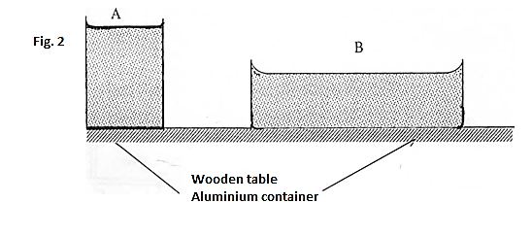
- Figure 1 shows two aluminium container A and B placed on a wooden table containers A and B have equal volume of hot water initially at the same temperature
Figure 1

Explain why water in B cools faster than water in A. (1mk)
……………………………………………………………………………………………………….......
……………………………………………………………………………………………………….......
- Smoke particles in air when strongly illuminated were observed to describe a continuous random and haphazard motion. Explain what would be observed if air temperature is decreased (2mks)
……………………………………………………………………………………………………………………………………………………………………………………………………………………………………
- Two 10g masses were fixed using wax on the sides of two aluminium plates of same thickness. One of the plates was polished shinny while the other was painted black. The heater was placed close to the shiny plate but further away from the blackened plate. Explain why the two masses fell off at the same times (2mks)
10g mass

10g mass

black

shinny

heater

Figure 2
………………………………………………………………………………………………………………………………………………………………………………………………………………………………………………………………
- Explain why gases easily compressible while liquids and solids are almost incompressible (2mks)
…………………………………………………………………………………………………………………………………………………………………………………………………………………………………………………………………………………………………………
- State two properties of a clinical thermometer that make it suitable for measuring body temperature (2mks)
………………………………………………………………………………………………………………
……………………………………………………………………………………………………………………………………………………
- The pointer of a spring points at 2 cm when no load has been added. A mass of 200g is added and the pointer points at 6cm. Determine the load that makes the pointer indicate 9.5cm ( 3mks)
………………………………………………………………………………………………………………………………………………………………………………………………………………………………………………………………………………………………………………………………………………………………………
- Sketch a velocity – time graph to show motion of a body thrown vertically upwards with an initial velocity of u m/s up to the maximum height ( 1mk)

- A uniform rod of length 4m and mass 4 kg is pivoted at 3.6m mark. The rod is held horizontally with a vertical rope at 4m mark as shown below
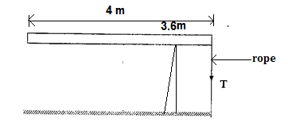
Figure 3

Calculate tension T in the rope (Take g=10N/kg) (3mks)

…………………………………………………………………………………………………….……………………………………………………………………………………………………………….
…………………………………………………………………………………………………….……………………………………………………………………………………………………………….

- One of the transport TLB rules is that a passenger should put on the safety belt. Explain how the belt enhances safety in case of an accident. (1mk)
…………………………………………………………………………………………………….……………………………………………………………………………………………………………….
- The figure below shows a vessel resting on a horizontal bench.
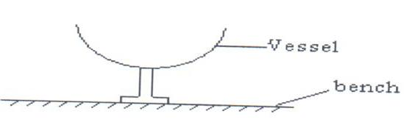
Figure 4
State and explain the effect on the stability of the vessel when it is filled with water. (2mks)

…………………………………………………………………………………………………….……………………………………………………………………………………………………………….
…………………………………………………………………………………………………….……………………………………………………………………………………………………………….

SECTION B : ( 55 marks)
(Answer all the questions in this section)
- (a) 1200g of liquid at 10°C is poured into a well-lagged calorimeter. An electric heater rated 1KW is used to heat the liquid. The graph below shows the variation of the temperature of the liquid
with time.

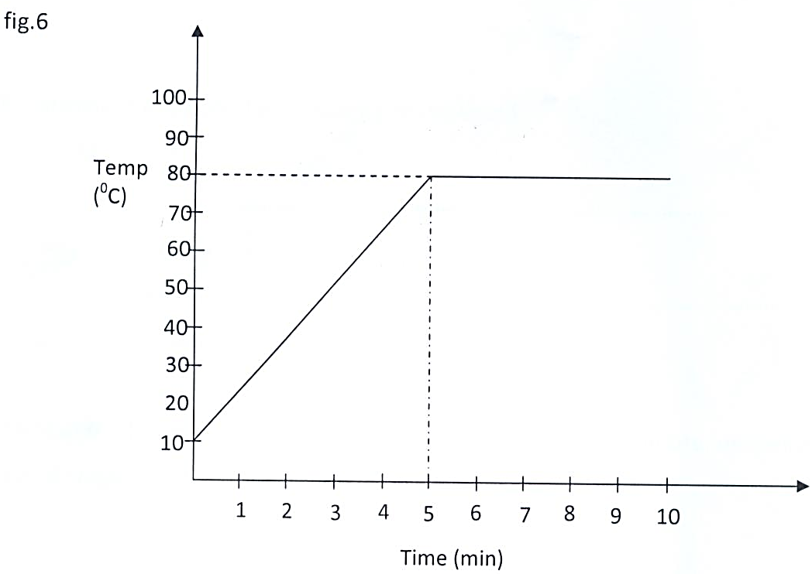
- State the boiling point of the liquid in Kelvin scale. (1mk)
…………………………………………………………………………………………………...
…………………………………………………………………………………………………...
…………………………………………………………………………………………………...
- State a reason why the graph does not start from origin. (1mk)
…………………………………………………………………………………………………...
…………………………………………………………………………………………………...
…………………………………………………………………………………………………...
- Determine how much heat is given out by the heater to heat the liquid to the boiling point. (2mks)

iv. Determine the specific heat capacity of the liquid (2mks)
v. If 50 g of the liquid vapor was collected by the end of the 8th minute, determine the specific
latent heat of vaporization of the liquid. (3mks)

- (a) State the pressure law for an ideal gas. (1mk)
.......................................................................................................................................................................................................................................................................................................................................................................................................................................................................................
(b) The pressure P of a fixed mass of a gas at a constant temperature of T=200K is varied continuously and values of corresponding volume recorded. A graph P against is shown on grid below.
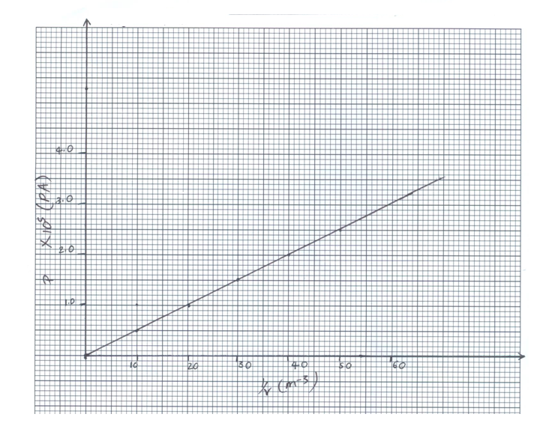

Use the graph to determine:
(i) The volume of the gas when the pressure reads (2mks)

(ii) The Slope of the graph. (2mks)

(iii) Given that $T= \frac{PV}{2R}$ where R is a constant, use the slope obtained in (ii) above to determine the
Value of R (3mks)

(c) The petrol air mixture in the cylinder of a car engine is ignited when the piston is in the position shown below.

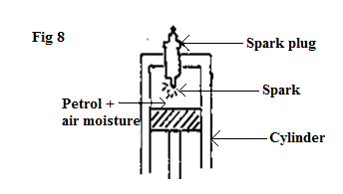
Explain in terms of kinetic theory why the piston moves downwards. (3mks)
....................................................................................................................................................................................................................................................................................................................................................................................................................................................................................................................................................................................................................................................

- (a) State the law of floatation. (1mk)

(b) A block of wood of mass 80kg floats in water with 0.6 of its volume in water. Calculate the
number of rods each 20g that can be placed on the block so that its top is level with the surface of water. (4mks)

(c) The diagram in figure 9 below shows a wooden block of dimensions 50cm by 40cm by
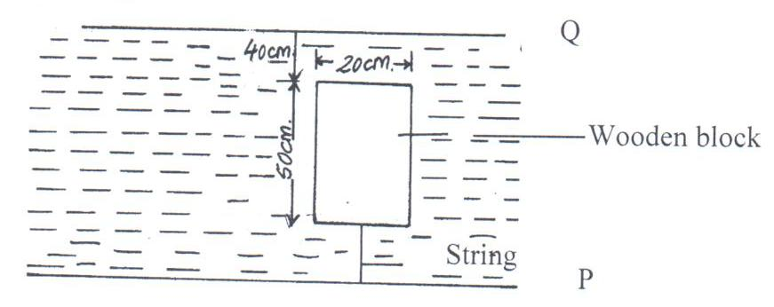
20cm held in position by a string attached to the bottom of a swimming pool. The density of the block is 600kgm⁻³.

          - State the three forces acting on the block and write an equation linking them when the block is stationary. (2mks)

          - Calculate the tension on the string. (3mks)

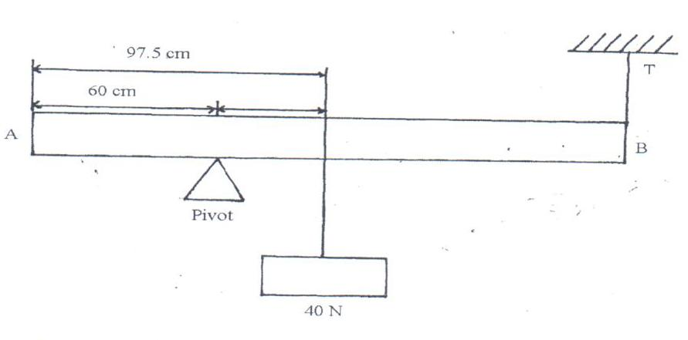
- The figure below shows a metal rod AB of length 2m horizontally balanced while supported by a pivot and a string.
100

Determine the mass of the metal rod if the tension is 15N. (3mks)

- (a) The figure below shows asses A, B and C placed at different points on a rotating table.
The angular velocity W, of the table can be varied
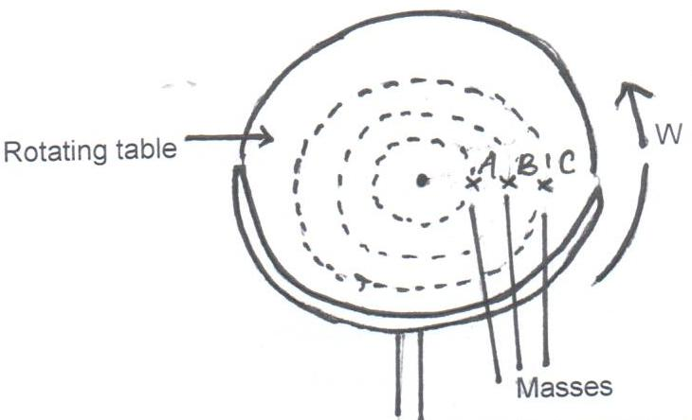
          - State and Explain two factors that determine whether a particular mass slides off the table or not. (4mks)

          - It is found that the masses slide off at angular velocities W_{A}, W_{B} and W_{C} respectively. Arrange the values of W_{A}, W_{B} and W_{C} in decreasing order. (1mk)

(b) A block of mass 200g is placed on a frictionless rotating table while fixed to the centre of the table by a thin thread. The distance from the Centre of the table to the block is 15cm. If the maximum tension the thread can withstand is 5.6N, determine the maximum angular velocity the table can attain before the thread cuts. (4mks)

- A stone thrown vertically upwards from the base of a mountain with an initial velocity of
100m/s. The stone just stopped as the apex and came back. Another boy projected a stone horizontally from the top of the mountain. Calculate:-
- Height of the mountain. (3mks)

- Time taken for the stone to follow the trajectory. (2mks)

- The range if the horizontal velocity is 20m/s, (2mks)

- Calculate the impulse of force produced when a table is pulled for 3s by a constant force of 10N towards the right and then for 2s by a constant force of 20N towards the left. (2mks)

- The figure below shows a tape from a trolley accelerating at 5m/s² and the timer is vibrating at 100Hz.
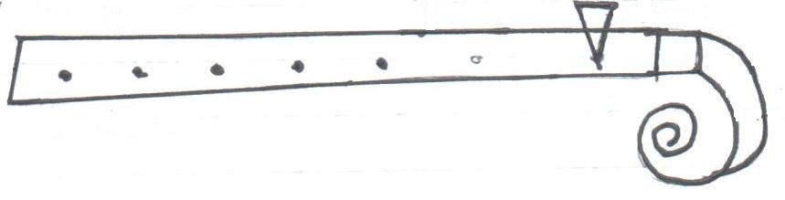
Timer
Trolley
B Tape
A 0.125
Calculate:
(i) Change in velocity from A to B. (2mks)

(ii) The final velocity of the trolley. (2mks)

