***Kenya Certificate of Secondary Education (K.C.S.E.)***

**232/1**

**PHYSICS**

**PAPER 1**

**TIME: 2 HOURS**

**FORM 4 TERM 2 2021**

**Name: MARKING SCHEMES Adm No……………….**

**Stream……………………………………………………. Date ………………………….**

**INSTRUCTIONS TO THE CANDIDATES:**

* Write your **name** **and index number** in the spaces provided above.
* Answer ***all*** the questions both in section **A** and **B** in the spaces provided below each question
* All workings ***must*** be clearly shown; marks may be awarded for correct steps even if the answers are wrong.
* Mathematical tables and silent electronic calculators may be used.

(*Take acceleration due to gravity g= 10ms-2 Density of water 1g/m-3*)

**For Examiners’ Use Only**

|  |  |  |  |
| --- | --- | --- | --- |
| **SECTION** | **QUESTION** | **MAXIMUM SCORE** | **CANDIDATE’S SCORE** |
| Section A | 1-13 | 25 |  |
| Section B | 14 | 06 |  |
| 15 | 10 |  |
| 16 | 08 |  |
| 17  18 | 10  11 |  |
| **19** | **10** |  |
| **TOTAL** | **80** |  |

*This paper consists of 11 printed pages. Candidates should check to ascertain that all pages are printed as indicated and that no questions are missing*

**SECTION A: (25 MARKS) *Answer all questions in this section in the spaces provided***

1. Figure below shows a scale of vernier calipers when measuring the width of a meter rule.



What is the actual width of the meter rule if the calipers has a zero error of + 0.6mm.? (2mks)

*MSR = 6.90cm*

*VSR = 0.04cm*

*= (6.90+ 0.04) cm*

*Actual width = 6.94cm-0.06*

*= 6.58cm*

1. Water is known to boil at 100oC . A student heated some water and noticed that it boiled at 101oC. State two possible reasons for this observation **(2mks)**

* *Atmospheric pressures is higher than normal/standard*
* *Presence of impurities*

1. The Figure below shows a flask filled with water. The flask is fitted with a cork through which a tube is inserted. When the flask is cooled, the water level rises slightly, and then falls steadily.

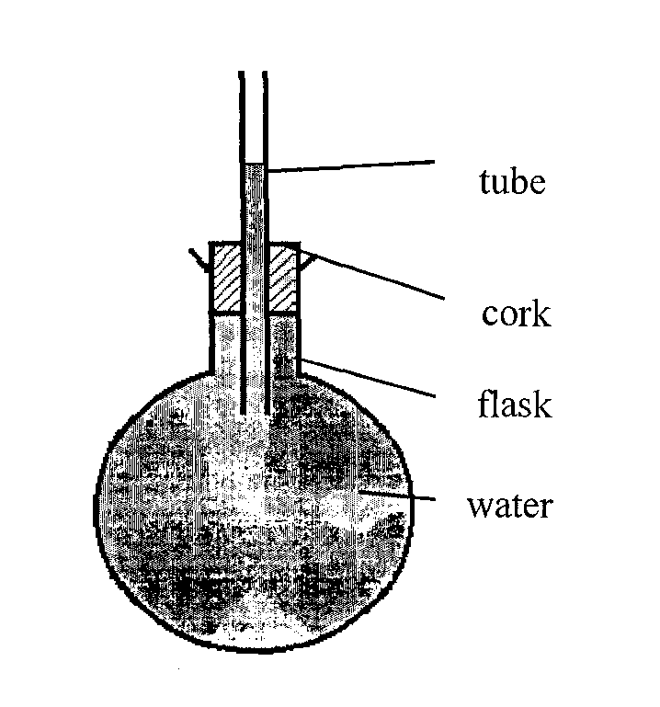

Explain the observation **(3mks)**

*When flask is cooled it contracts/its volume reduces but due to poor conductivity of the glass/materials of the flask water falls as it contraction is greater than the of glass*

1. A pipe of radius 4mm is connected to another pipe of radius 6mm. If water flows in the wider pipe at the speed of 5ms-1, what is the speed in the narrower pipe? **(3mks)**

*A1V1 = A2V2*

*πx 42x v1=π x 62x5x10-3*

*V1 =*

*= 11.25ms-1*

1. Find the total pressure experienced by a diver 8 meters below the sea surface. (3mks)

Take; *Atmospheric pressure = 103360N*

*Density of sea water = 1030 kg/m3*

*Pressure experienced by diver = Atmospheric pressure + Pressure due to sea water*

*= 103360 + 𝜌gh*

*= 103360 + 1030 x 10 x 8*

*= 185760 N/m2*

1. The following is a graph of force against extension for a spring

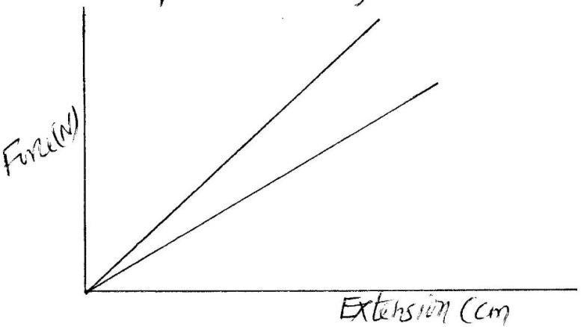

Force (N)

Extension (cm)

On the same axes, sketch a graph of force against extension for a spring double the length, same thickness, same material as the spring above (1mk)

1. Explain the cause of random motion of particles as observed in Brownian motion in a smoke cell experiment.*It is caused by the bombardment of the smoke particles by the invisible air particles that are moving randomly*

(1mk)

1. Figure below shows an ammeter used to measure current through the conductor .The student used the lower scale.



State the reading from the meter (1mk)

*Reading =1.35 A*

1. Convert -200°C into Kelvins (1mk)

-200oC + 273 = 73K

1. Figure shows an object held between two straight edges. Determine the radius of the object using the meter rule shown in figure below. (2 marks)

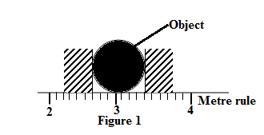

$$Diameter=3.4cm-2.7=0.7cm$$

$$radius=\frac{0.7}{2}$$

$$=0.35cm$$

1. Figurebelow shows two identical springs constant 3N/cm supporting a load of 30N.



Determine the extension of each spring (3mks)

*e = $\frac{F}{k}$*

*e =30*

*2x3*

*e =5cm*

1. Convectional and diffusion both involve motion of fluid molecules. Distinguish between the two (2mks) *Diffusion occurs in all directions, molecules move in all directions*

*Convection occurs in one direction-upwards or downwards*

1. The figure shows a water tank that is used to heat water and supply through taps.

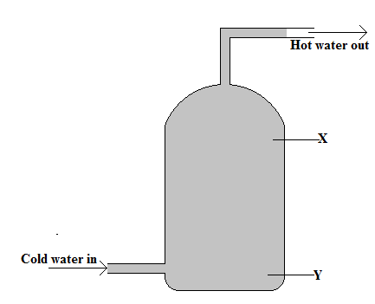

State with a reason whether the appropriate position for a heater is X or Y (2 marks)

*Position Y. To ensure heat is transferred upwardly in the water through convection*

**SECTION B (55 MKS)**

2. A mixture consists of 80cm3 of water and 120cm3 of liquid X. If the density of water and liquid X are 1.0g/cm3 and 0.8g/cm3 respectively. Calculate the density of the mixture (3 mks)

*mw = 80 x 1 = 80g*

*Mx = 0.8 x 120 = 96g*

*Total mass = 176g*

*ᴩmixture =*

*= 0.88g/cm3*

1. Why is mercury more suitable for use in a simple barometer than water. (2 mks)

*Mercury is much denser than water.*

*Therefore the column supported by the atmospheric pressure is much shorter*

1. State one factor that would increase the surface tension of pure water in a beaker of water. ( 1mks)

*. Lowering the temperature*

2. Distinguish between solid and liquid states of matter in terms of intermolecular forces **(1mk)**

*In solids the molecules are held in position by intermolecular forces that are very large. In liquids the molecules are able to roll over one another since the forces are smaller.*

1. In an experiment to estimate the diameter of an oil molecule, an oil drop of diameter 0.05 spreads over a circular patch whose diameter is 20cm. Determine:
2. The volume of the oil drop **(2mks)**

*Volume = πr3*

*=π x 0.253*

*= 6.548 x 10 -2 cm3*

1. The area of the patch covered by the oil **(2mks)**

*Area = πr2*

*πx 102*

*=314.286cm2*

1. The diameter of the oil molecule **(2mks)**

*Ax diameter of molecule=volume*

*314.286 x d = 6.548 x 10 -2*

*D=2.08 x10 -4 cm*

(c)State

(i) Any assumption made in (b) (iii) above **(1mk)**

*The oil is assumed to have spread to thickness of one molecule*

(ii) Two possible sources of errors in this experiment **(2mks)**

* *Getting the right oil*
* *Measuring drop diameter*
* *Measuring diameter of patch*
* *Getting drop of a right size (any 2x1=2mks)*

1. The figure shows a conveyor belt transporting a package to a raised platform. The belt is driven by a   
   motor.

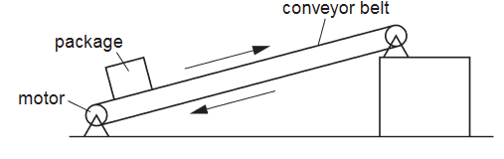

The mass of the package is 36 kg. Determine:

1. The increase in the gravitational potential energy (G.P.E.) of the package when it is raised through a vertical height of 2.4 m. (2 marks)
$$G.P.E=mgh$$

$$=36×10×2.4m$$

$$=864J$$

2. The power needed to raise the package through the vertical height of 2.4 m in 4 s (2 marks)
$$Power=\frac{Workdone }{time }$$

$$=\frac{864}{4}$$

$$=216W$$

3. The electrical power supplied to the motor is much greater than the answer to (b).  
   Explain how the principle of conservation of energy applies to this system. (2 marks)

*The energy is still conserved bit not all energy is used in lifting the load. Some of the energy is used in overcoming friction and also lifting the parts of the conveyor.*

1. Assume that the power available to raise packages is constant. A package of mass greater than 36 kg is raised through the same height. Suggest and explain the effect of this increase in mass on the operation of the conveyer belt. (2 marks)

*The time taken to lift the package through the same height will be longer. This is because the power supplied is constant and work done is directly proportional to the time taken*

1. Explain why a hammer of mass 3kg strikes a nail when moving at 40m/s making the nail sink into wood yet when the same hammer is placed on the nail head, it cannot sink in the wood (1mk)

*Impulse is very high as opposed to the small force*

1. A trolley of mass 20kg moving at 0.6m/s on a frictionless horizontal surface was acted upon by a force of 2.5 N. The resultant velocity of the body was 4.8 m/s. Determine

i) The change in momentum of the trolley (2mks)

*Change is momentum = mV-mU*

*= (4.8 x 20) – (20 x 0.6)*

*= 96 -12*

*=84kgm/s.*

ii) The time interval and the force acted on the body (2mks)

*Ft= change in momentum*

*2.5t =84*

*t =84/2.5*

*=33.6 sec*

iii) The acceleration of the trolley (3mks)

*F=Ma*

*2.5=20 x a*

*a=2.5/20*

*=0.125m/s2*

1. A gun of mass 3kg fires a bullet of mass 20g at 600m/s. Calculate the recoil velocity of the gun (3mks)

*Momentum before = momentum after*

*0=3 x v +20/1000 x 600*

*3v= -6*

*V=-2m/s*

1. State the two conditions necessary for a system of forces acting on a body to be in equilibrium. (2 marks)

• *Sum of clockwise moments must equal to sum of anticlockwise moment at a point*

*• Total upward force must equal to total downward force*

1. The figure shows a loaded wheelbarrow held in equilibrium by a gardener. The wheel of the wheelbarrow is in contact with the ground at point C

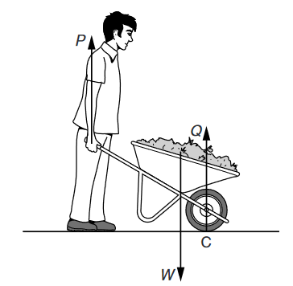

There are three vertical forces acting on the wheelbarrow P is the upward force applied by the gardener. Q is the upward force of the ground on the wheel at point C.W is the weight of the wheelbarrow and its contents. Explain why the force P is less than the force W

1. By considering the forces P, Q and W, ( 2 marks)

*The sum of the forces P and Q are the ones equaling to W since the system is at equilibrium*

*P+Q=W*

1. By considering the moments of the forces P and W about point C. (2 marks)

*P is less than W since it acting at a longer distance from the pivot C and since the system is at equilibrium P must be smaller*

1. The figure shows a tanker lorry full of liquid. Study the diagram and answer the questions that follow

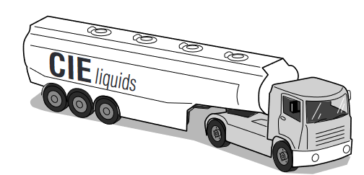

1. The tanker delivers the liquid and drives away empty. Compare the acceleration of the empty tanker with the acceleration of the full tanker for the same resultant force (2 marks)

*The full tanker will travel at a higher acceleration that the empty tanker for the same resultant force. This is because acceleration is inversely proportional to the mass of the object or the body*

1. Given that empty tanker has a weight of 50 000 N. The forward force is 6000 N and the total resistive force is 2000N. Determine the acceleration of the tanker (3 marks)
$$Net force=6000-2000=4000N$$

$$mass of the tanker=5000kg$$

$$F=ma 4000N=5000×a$$

$$a=\frac{4000}{5000}$$

$$=0.8{ms}^{-2}$$

2. (i) State the law of floatation **(1mk)**

*A floating body displaces its own weight of fluid in which floats√1*

(ii) Explain why a hollow metal sphere floats on water while a solid metal sphere of the same material sinks

in water. **(2mks)**

*The weight of the solid sphere is more than the weight of the volume of water it displaces hence it sinks √ 1while the weight of the hollow sphere is equal to the weight of the volume of water it displaces hence it floats √1*

1. The figure below shows a uniform block of uniform cross-sectional area of 6.0cm2 floating on two liquids A and B. The lengths of the block in each liquid are shown.

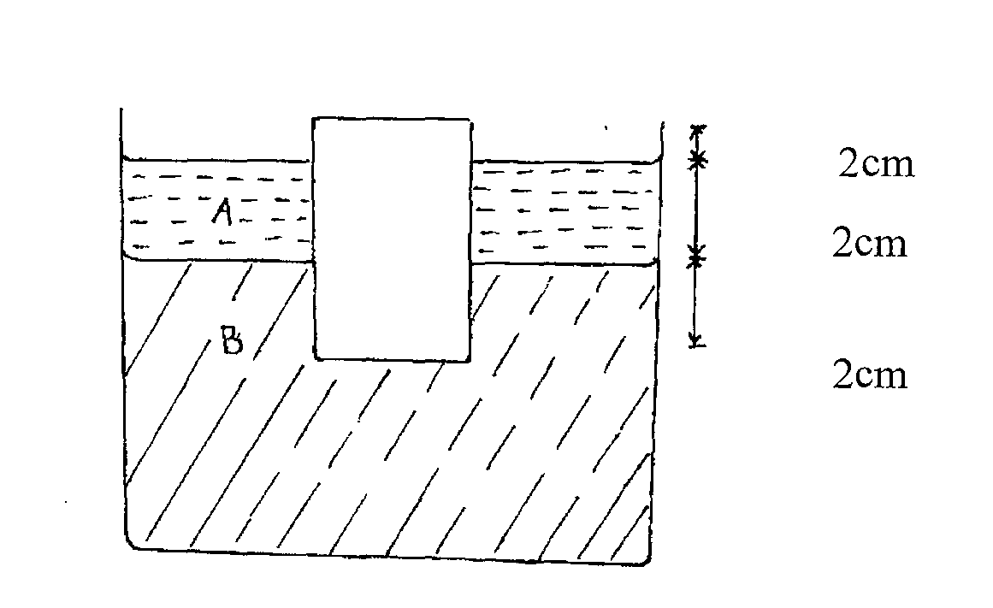

Given that the density of liquid A is 800kg/m3 and that of liquid B is 1000kgm-3,determine the:

(i) Weight of liquid A displaced **(2mks)**

*Weight = vol x density x g*

*=6x10-4 x 2x10-2 x 800 x10*

*= 0.096 N*

(ii) Weight of liquid B displaced (2mks)

*Weight =V x ℓ x g*

*6x10-4x2x10-2x 1000 x10*

*=0.12N*

(iii) Density of block (3mks)

*Weight of block=weight of fluid displaced*

*=1.2 x 10-1+9.6 x10-2*

*=2.16 x10-1N*

*=2.16 x 10-2 kg*

*Density =*

*=600 kg/m3*