**ACK MOCK 2021**

**PHYSICS PAPER 1 (MARKING SCHEME)**

1. Measured diameter = 0.30

0.03

0.27 mm√1

30√ sleave reading √1

25 thimble reading √1 (3mks)

2. (i) 3000N √ 1

(ii) P=√

= 375,000pa √

3. It has a larger surface area exposed for liquid to escape/evaporate escaping with latent heat from the liquid.

4. The K.E of the smoke particles reduce and hence their movements will be slower (reduces)

5. Dull black surface is a good absorber of radiant heat while shinny is a good reflector ( 1 mk)

The heating is same since shinny has been moved closer

6. Gases have larger intermolecular distances√1

7. - Constriction√

- Narrow bore√

- High temperature range√

8. F =Ke ( 1 mk)

2 = K x 0.04

K = 50N/m ( 1 mk)

F = 50 x 0.075

= 3.75N ( 1 mk)

9. 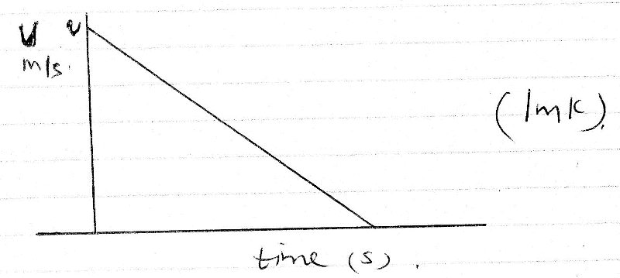

10. Sum of clockwise movement= Sum of anticlockwise movement

or

√

√

=√

11. As the vehicle brakes it stretches increasing time for impact hence reducing the impulse.√

12. Lowered🗸1

As the water fills the vessel the centre of gravity rises and this lowers stability. 🗸1

**SECTION B (45 MKS)**

13. a) (i) √ - working must be shown.

(ii) Room temperature√

(iii) Q=Pt√

=

=√

(iv) √

√



=√

v) Ml=Pt√

√

√

14. a) The pressure of a fixed mass of an ideal gas is directly proportional to the absolute temperature provided the volume remains constant.√

b)i) √



ii) Slope of the graph

Slope = √√= 

iii) 



√

R=12.5J/K√

Graph P against √

T=200K

Allow TE

c) Increase in temperature causes molecules to move faster (gain kinetic-energy √causing more number of collisions with the walls√ of cylinder at constant pressure volume increase as the molecules push √against the wall.

15. (a) Floating object displaces its own weight of the fluid in which it floats.

(b) Mass of water displaced by wood = 80kg

Volume of water displaced = 80 = 0.08m3

1000

but 0.08m3 = 0.6 of the volume of block.

Volume of wood = 0.08 = 0.1333m3;

0.6

Volume displaced by rods = 0.08 – 0.1333 = 0.0533

Mass of he rods = 0.053 x 1000 = 53.3kg;

Mass of one rod = 20g = 0.02kg

Number of rods = 53.3;

0.02

= 2,665 rods;

(c)(i) Up thrust force

Weight 🗸🗸Max. 2 or 3;;

Tension on the string 1

Up thrust = weight + tension on the string;

(ii) Up thrust = weight + tension

(50 x 40 x 20) 1000 x 10 = 50 x 40 x 20 x 6000 + tension;;

1000000 100000

Tension = 200 – 240

= -40N

1. Sum of clockwise Moments = Anti clockwise Moments🗸1

37.5 x 40 + W x 40 = 140 x 15

1500 + 40W = 2100

40W = 2100 – 1500

40W = 600

W = 6N🗸1

W = 15N

M = 1.5Kg or 1500g

16. (a) (i) Roughness🗸 / smoothness🗸 of surface / radius of path / angular velocity/

speed. (any two)

(ii) WA > WB > WC🗸1

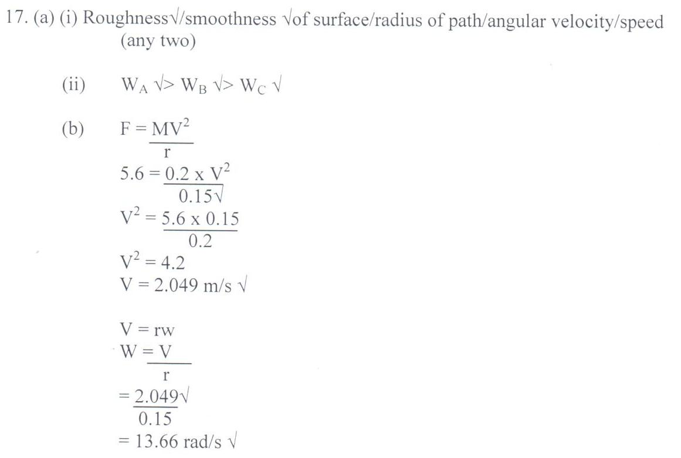

17. (a) Vertical projection U = 100m/s g = -10m/s v = om/s

V2 = u2 – 2gs🗸1

O2= (100)2 – 2 x 10 x 5

20s = 10,000

s = 500m🗸1

(b) Horizontal projection h = ½ gt2🗸1

500 = ½ x 10 x t2

t2 = 100

t = 10s🗸1

(c) Range R = ut🗸1

R = 20 x 10

= 200m🗸1

(d) Impulse = change in momentum🗸1

Ft = (10N x 35)🗸1 – (20N x 25)

= -10NS🗸1

(e) (i) v – u = a

t

t = (5 ticks x 0.01)s

= 0.05s🗸1

Therefore Δv = 5cm/s2

0.05

Δv = 0.25cm/s🗸1

(ii) v – u = 0.25cm/s

u = 0.125cm

0.01

= 12.5cm/s🗸1

V – 12.5 = 0.25

V = 12.75cm/s🗸1