232/2

PHYSICS

PAPER 2
JULY/AUGUST 2021

TIME: 2 HOURS

PRE-MOCK 1 2021
PHYSICS PAPER 2
PAPER 2

INSTRUCTIONS TO CANDIDATES:
- Write your name and index number in the spaces provided above
- This paper consists of two sections A and B.
- Answer all questions in section A and B in the spaces provided.
- All working must be clearly shown in the spaces provided.
- Mathematical tables and electronic calculators may be used.

For Examiners’ Use Only

SECTION | QUESTION | MAXIMUM SCORE | CANDIDATE’S SCORE
A | 1-12 | 25
B | 13 | 11
 | 14 | 14
 | 15 | 11
 | 16 | 09
 | 17 | 10
 | TOTAL | 80

This paper consists of 11 printed pages. Candidates should check to ascertain that all pages are printed as indicated and that no questions
are missing

SECTION A (25MARKS)
Answer all the questions in this section
1. A polythene rod can be charged by rubbing it with a cloth but a brass rod held in the hand
cannot be charged this way.
(a) State what happens when the polythene rod is being charged. (1mk)
…………………………………………………………………………………………………………..
…………………………………………………………………………………………………………..
(b) Explain why the brass rod cannot be charged this way (1mk)
…………………………………………………………………………………………………………..
…………………………………………………………………………………………………………..
2. Figure 1 below shows an object placed infront of a plane mirror. Draw appropriate rays to
locate the image as seen by the observer. (2mks)
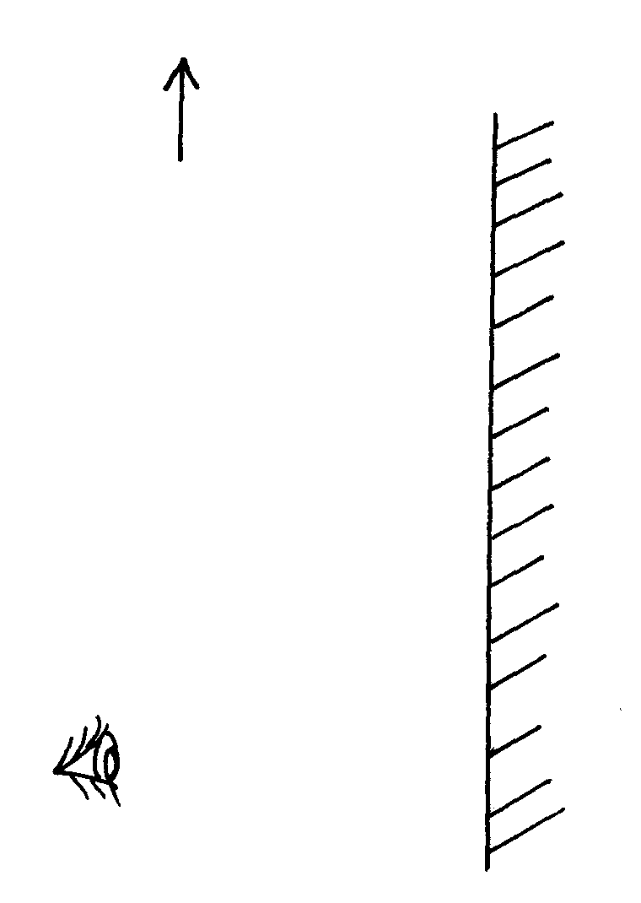
Object
Observer
Plane mirror
Fig.1

3. A student in a school in Rachuonyo South constructed an electric bell. When he switched
it on, the bell just rang once and not continuously. Identify the possible fault in the bell (2mks)
…………………………………………………………………………………………………………..
…………………………………………………………………………………………………………..
…………………………………………………………………………………………………………..

4. A magnifying glass of focal length 50mm produces a virtual image three times the size
of the object. Use the lens formula to find the position of the image. (3mks)
…………………………………………………………………………………………………………..
…………………………………………………………………………………………………………..
…………………………………………………………………………………………………………..
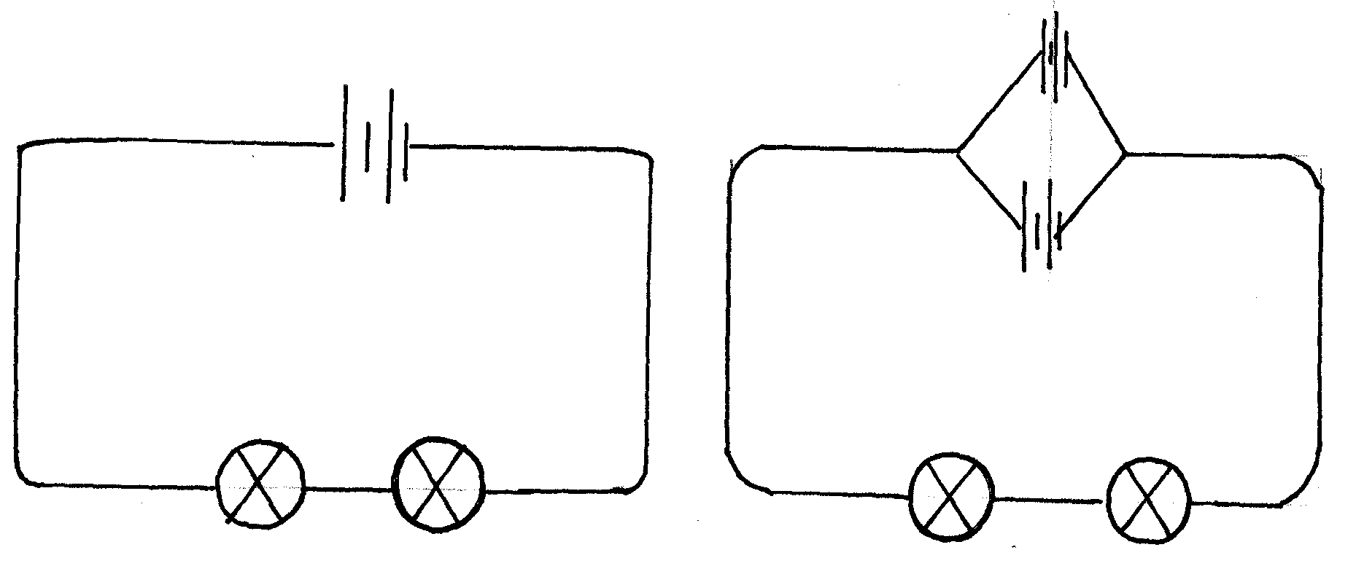5. Figure 2 below shows two circuits with identical dry cells and identical bulbs;
A
B

A
B

Fig.2
(i) In which circuit will the bulbs be brighter (1mk)
…………………………………………………………………………………………………………..
(ii) Give a reason for your answer in (i) above (1mk)
…………………………………………………………………………………………………………..
…………………………………………………………………………………………………………..

6. Three capacitors are arranged as shown in the figure3 below. If the effective capacitance
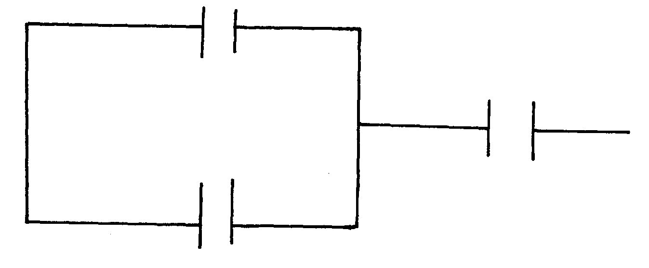of the circuit is 1.25F, calculate the value of C (3mks)
1.5µF
2µF
C

…………………………………………………………………………………………………………..
…………………………………………………………………………………………………………..
…………………………………………………………………………………………………………..
…………………………………………………………………………………………………………..

7. A referee standing in a football field some distance from a wall blows a whistle and hears
its echo 1.6 seconds later. How far is the referee from the wall?
(Speed of sound in air = 340m/s) (3mks)
…………………………………………………………………………………………………………..
…………………………………………………………………………………………………………..
…………………………………………………………………………………………………………..
………………………………………………………………………………………………………….
8. Define the term critical angle as used in refraction of light (1mk)
…………………………………………………………………………………………………………..
…………………………………………………………………………………………………………..
9. Figure 4 below shows an object placed infront of a convex lens.

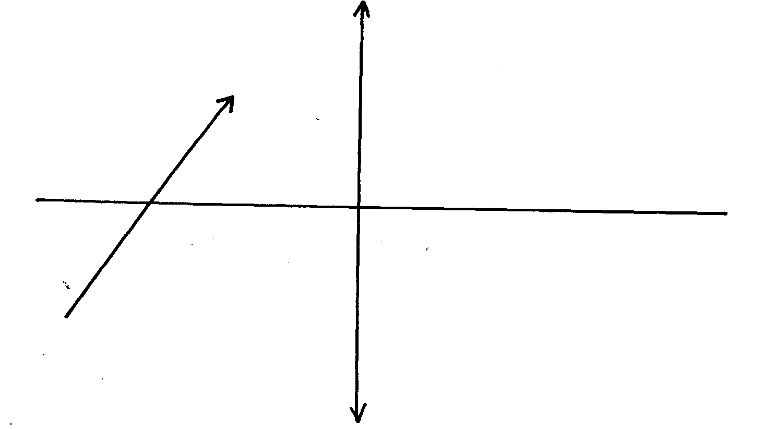
Object
F
Fig.4

Complete the ray diagram to show the position of the image. (3mks)

10. A charge of magnitude flows through a point in 15 minutes. Calculate the current. (2mks)

…………………………………………………………………………………………………………..

11. Which part of the electromagnetic spectrum plays a major role in the green house
phenomenon (1mk)
…………………………………………………………………………………………………………..

12. Complete the diagram below in figure 6 to show the shape of the wave fronts after
passing through the deep gap (1mk)

Fig.6

SECTION B(55MARKS)
Answer all the questions in this section

13. Figure 10 shows a simple d.c. motor;
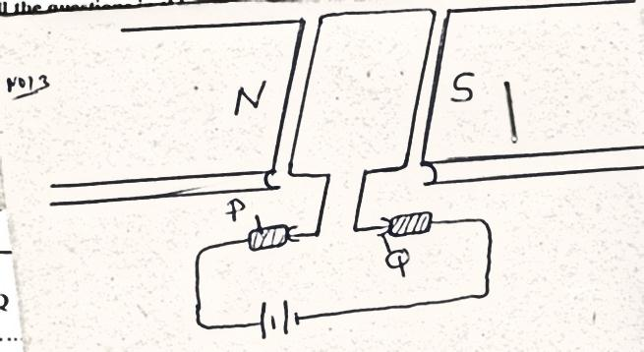

Fig.10
(a) (i) name the parts labeled P and Q
P ………………………………………..……. (1mk)
Q………………………………………………….. (1mk)
(ii) Explain why the pole pieces are curved (1mk)
…………………………………………………………………………………………………………..
…………………………………………………………………………………………………………..
(iii) Show the direction of current flow in the coil and the direction of rotation of the coil (1mk)
(b) State two ways in which the motor would be modified to rotate faster. (2mks)
…………………………………………………………………………………………………………..
…………………………………………………………………………………………………………..
(c) Explain what would happen if alternating current was used in the motor. (2mks)
…………………………………………………………………………………………………………..
…………………………………………………………………………………………………………..
…………………………………………………………………………………………………………..
……………………………………………………………………………………………………
………………………………………………………………………………………………………….
14. (a) State Ohm’s law (1mk)
…………………………………………………………………………………………………………..
…………………………………………………………………………………………………………..
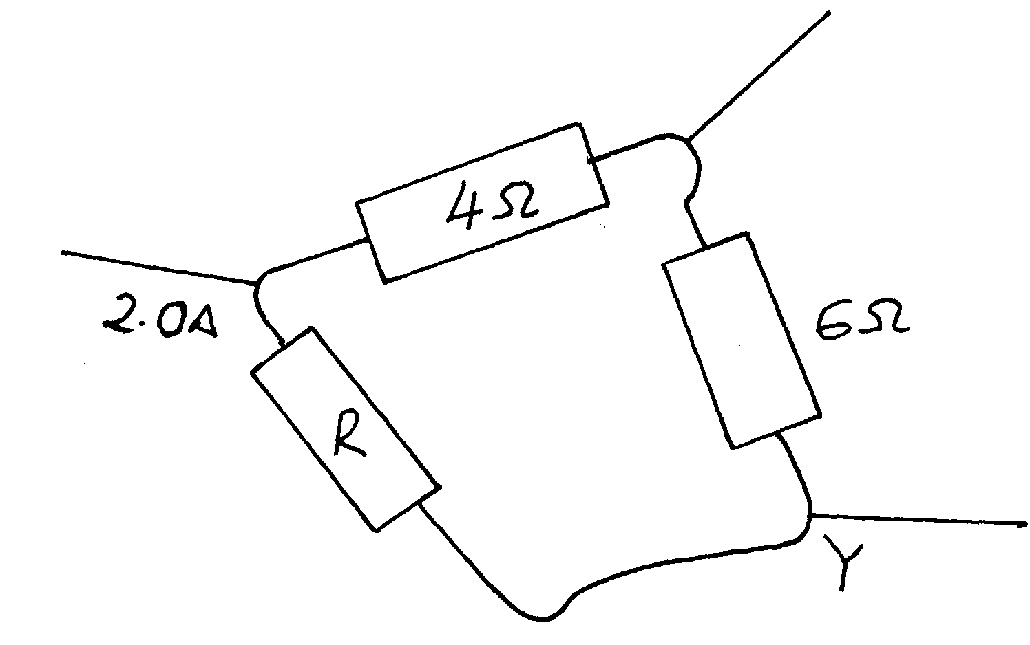 (b)In the circuit shown in figure 11 below, the total resistance between X and Y is 2 Ω;

Fig.11

(i) What is the resistance of the resistor R (3mks)
…………………………………………………………………………………………………………..
…………………………………………………………………………………………………………..
…………………………………………………………………………………………………………..
…………………………………………………………………………………………………………..
…………………………………………………………………………………………………………..
…………………………………………………………………………………………………………..
(ii)The total current flowing through between X and Y is 2.0A. What is the current in the
4Ω resistor? (3mks)
…………………………………………………………………………………………………………..
…………………………………………………………………………………………………………..
…………………………………………………………………………………………………………..
…………………………………………………………………………………………………………..
…………………………………………………………………………………………………………..
…………………………………………………………………………………………………………..
…………………………………………………………………………………………………………..
(iii) state three factors that affects resistance of a metallic conductor (3mks) …………………………………………………………………………………………………………..
…………………………………………………………………………………………………………..
…………………………………………………………………………………………………………..
…………………………………………………………………………………………………………..
…………………………………………………………………………………………………………..
…………………………………………………………………………………………………………..
…………………………………………………………………………………………………………..
…………………………………………………………………………………………………………..

(c)(i) Identify the factors that affect the capacitance of a parallel plate capacitor (2mks)
…………………………………………………………………………………………………………..
…………………………………………………………………………………………………………..
…………………………………………………………………………………………………………..
…………………………………………………………………………………………………………..
…………………………………………………………………………………………………………..
(ii) On the set of axis shown in figure 12 below, show how the charge of a capacitor
varies with time for a discharging capacitor. (1mk)
Charge Q (c)
Time t, (s)

15.(a) The diagram below shows an experimental set up consisting of a mounted lens, L, a screen, S, a metre rule and a candle.
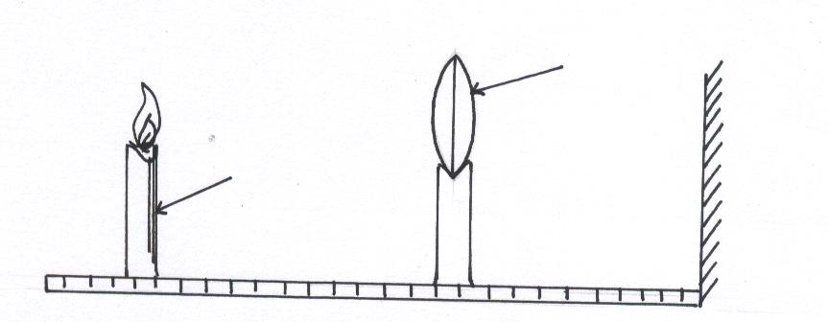
candle
L
A metre rule

Fig 6
(i) Describe how the set-up may be used to determine the focal length, f of the lens. (5mks)
…………………………………………………………………………………………………………………………………………………………………………………………………………………………………………………………………………………………………………………………………………………………………………………………………………………………………………………………………………………………………………………………………………………………………………………………………………………………………………………………………………………………………………………………………………………………………………………………………………………………………………
(ii) State the reason why the set-up would not work if the lens were replaced with a diverging lens (1mk)
…………………………………………………………………………………………… …………………………………………….................................................................
(b) The graph below shows the relationship between and for converging lens where u and v are the object and image distances respectively.
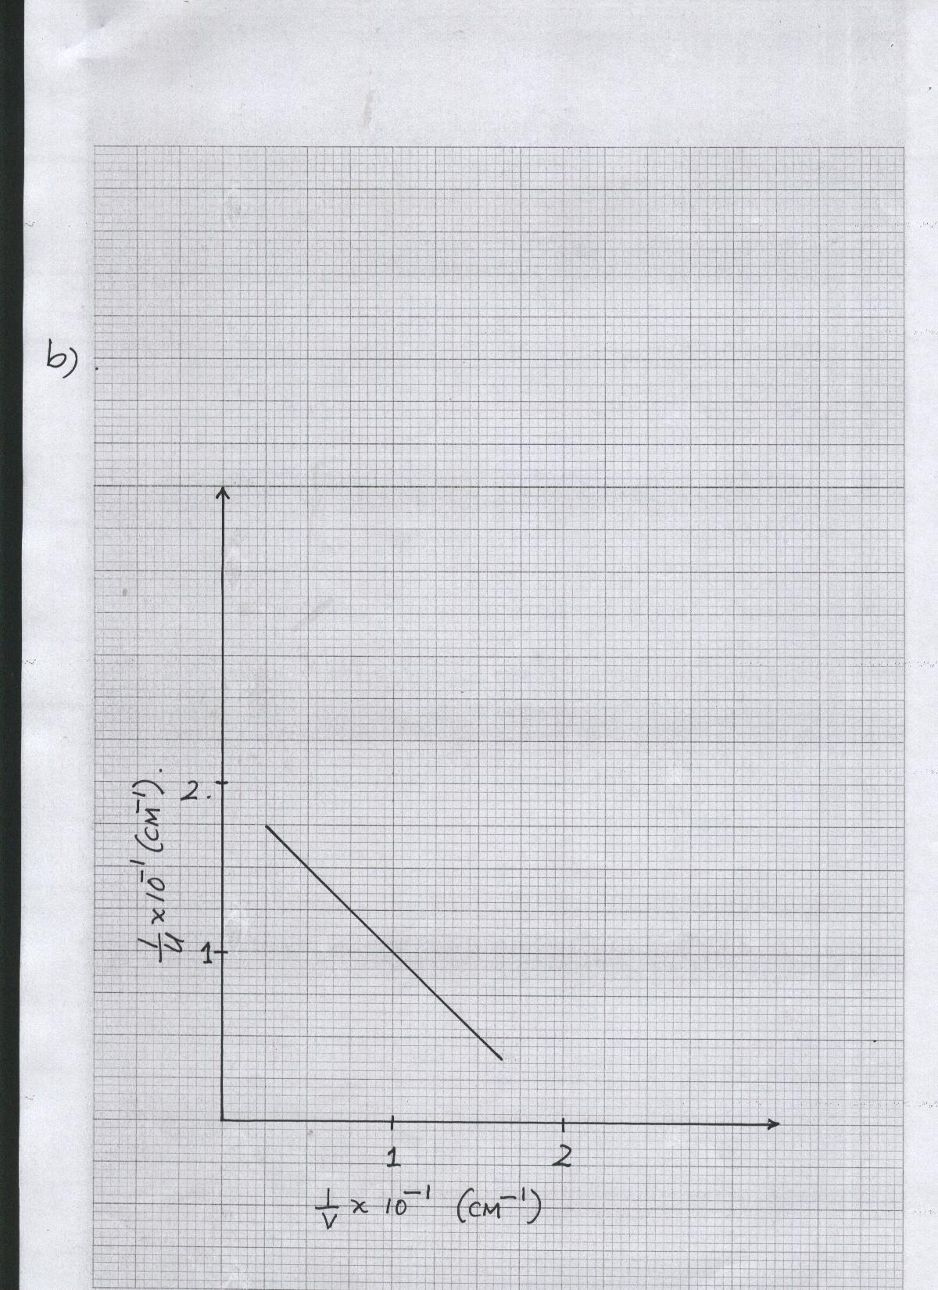
From the graph, determine the focal length, f, of the lens. (5mks)

(c) An object placed 15cm from a convex lens is magnified two times. Determine the focal length of the lens. (3mks)

16. a) State the motor rule. (1 mark)

b) Sketch the resultant field pattern around the following current carrying conductors and show the direction of the forces acting on the conductors. (3 marks)
c) Figure 10 shows an electric bell.

Figure 10

i) Describe how the electric bell works (5 marks)

ii) Explain what would happen if the armature is made of steel (2 marks)

iii) What adjustment should be done to the system to make it operate effectively with a lower voltage battery? (1 mark)

17.(a) An angle of reflection of a reflected ray from a plane mirror is 20⁰. If the mirror is rotated through an angle of 25⁰ , calculate the angle between the incident ray and the new reflected ray. (2 marks)

(b) A concave spherical mirror has a focal length of 10 cm. Calculate the distance where an object must be placed in order to produce a real magnified image three times the size of the object.
(3 marks)

(c) An object is placed 20 cm in front of
i) a plane mirror
ii) a concave mirror
State two differences between the images formed in each case. (2 marks)

………………………………………………………………………………………………………………………………………………………………………………………………………………………………………………………………………………………………………………………………………………………………………………………………..…………………….

(e) State one application of each of the following. (2 marks)
i) convex mirror

ii) parabolic mirror

