Name: …………………………………………………………………….Class:………… Adm.No. ……………
232/2 Candidate’s Signature: …………………...
PHYSICS
THEORY
Paper 2
JUNE – JULY 2021
Time: 2 hours

M O K A S A I J O I N T E X A M I N A T I O N
JUNE - JULY 2021
Kenya Certificate of Secondary Education
PHYSICS
PAPER 2
Instructions to Candidates
- Write your name, admission number, class and signature in the spaces provided at the top of the page. This paper consists of two sections; A and B.
- Answer ALL the questions in the spaces provided.
- Mathematical tables and electronic calculator may be used.
- You may use the following constants where necessary:-
- This paper consists of 11 printed pages.
- Candidates should answer the questions in English.

g = 10 N/kg, or m/s²
e = 1.6 x 10⁻¹⁹C
c= 3.0 x 10⁸ m/s

FOR EXAMINER’S USE ONLY

SECTION | QUESTIONS | MAXIMUM SCORE | CANDIDATE’S SCORE
A | 1 – 07 | 25
B | 08 | 14
 | 09 | 15
 | 10 | 13
 | 11 | 13
TOTAL SCORE |  | 80
SECTION A
- a) Fig.1 below shows an image of an object reflected on a plane mirror. Using ray diagram, locate the position of the object. (3mks)
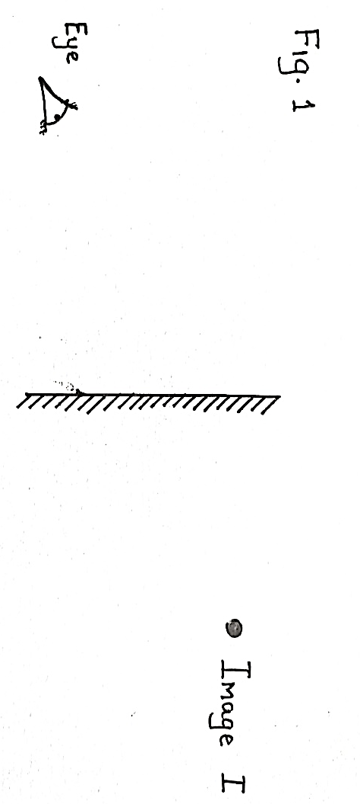
b) A mirror is rotated through an angle of 15º, find the angle through which the reflected ray is rotated. (1mk)
………………………………………………………………………………………………………………………………………………………………………………………………
- A strongly charged glass rod is brought close to a neutral electroscope. State and explain the observations made. (2mks) ……………………………………………………………………………………………………………………………………………………………………………………………………………………………………………………………………………………………
- Fig.2 below shows a circuit made by a form 2 student.
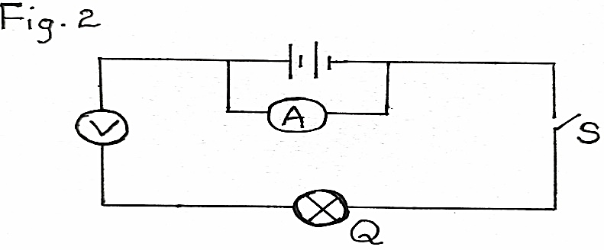
- State and explain the observation made on component Q when switch S closed. (2mks)
………………………………………………………………………………………………………………………………………………………………………………………………………………………………………………………………………………………………………………………
- A current of 1A flows through a circuit for three minutes. Calculate the number of
electrons that flows through a point in the circuit. (charge of an electron = 1.6x10⁻¹⁹C)
(3mks)
………………………………………………………………………………………………………………………………………………………………………………………………………………………………………………………………………………………………………………………………………………………………………………………………
- Fig. 3 below show a copper rod placed inside a solenoid.

Fig.3
Copper rod

- State and explain the observation made when the rod is removed after sometime and dipped into a container with iron fillings (2mks)
……………………………………………………………………………………………………………………………………………………………………………………………………………………………………………………………………………………………………………………………………………………………………………………………………………………………………………………………………
- Using domain theory, distinguish between magnetic and non-magnetic materials
(1mk)
………………………………………………………………………………………………………………………………………………………………………………………………………………………………………………………………………………………………………………………………………………………………………………………………………………………………………………………………………………………………

- Fig.4 below shows rays incident on a curved mirror.
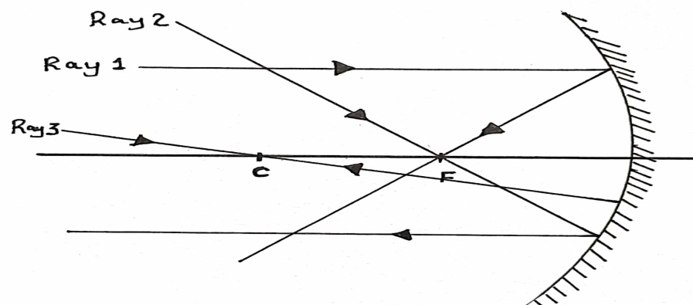
State the rules for drawing the ray 1, ray 2 and ray 3. (3mks)
Ray1………………………………………………………………………………………………………………………………………………………………………………………
Ray 2………………………………………………………………………………………
………………………………………………………………………………………………
Ray3………………………………………………………………………………………
………………………………………………………………………………………………
- a) Define interference as used the waves (1mk)
………………………………………………………………………………………………………………………………………………………………………………………………………………………………………………………………………………………………
b) The fig.5 below shows two ways of monochromatic light incident on two adjacent slit
S₁, and S₂
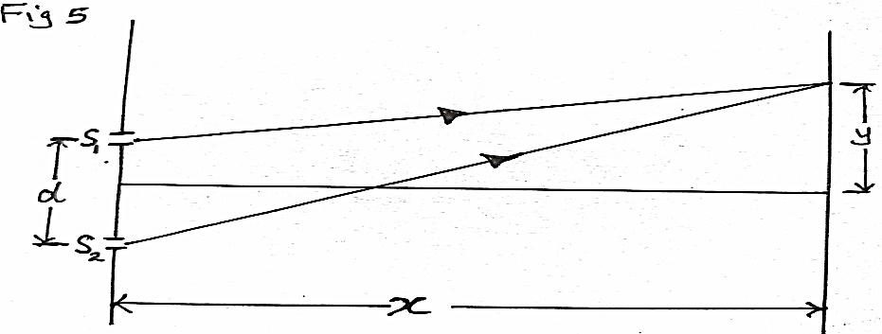
Fig.5
State what is observed on the screen when:
- The distance x is increased. (1mk)
……………………………………………………………………………………………………………………………………………………………………………………
- The slit separation d is reduced. (1mk)
………………………………………………………………………………………………………………………………………………………………………………………………………………………………………………………………………………
- The white light is used. (1mk)
………………………………………………………………………………………………………………………………………………………………………………………………………………………………………………………………………………

- The fig.6 below shows a circuit with a heating element L of resistance 30Ω immersed in a container of water.
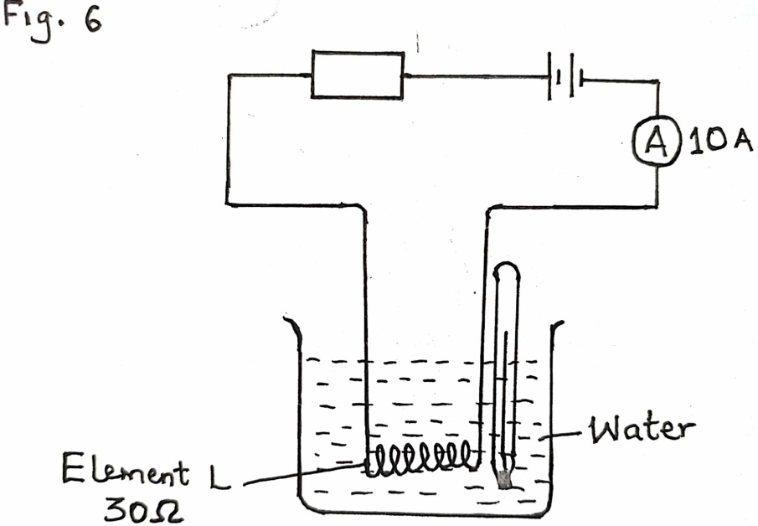
Water
Element L 30Ω
Fig.6
Thermometer T

- If current in the circuit is 10A and the switch is on for 2minutes. Calculate the heat energy absorbed by the water in kilojoules. (ignore heat gained by the container) (3mks)
…………………………………………………………………………………………………………………………………………………………………………………………………………………………………………………………………………………………………………………………………………………………………………
- State the adjustment made on the element L so that high temperature is recorded by the thermometer T in the same duration of time. (1mks)
……………………………………………………………………………………………………………………………………………………………………………………
SECTION B (55MKS)
- a) A gun was fired at a point 150m from a vertical wall while listening to an echo. The echo coincides with the sound from the gun at each time the gun is fired. After 20 successive shots, time recorded was 18.5seconds. Determine:
- Time taken for one echo to be heard (2mks)

- Speed of sound in air (3mks)

- What difference would you expect if the gun was short on a colder day (1mks)
………………………………………………………………………………………………………………………………………………………………………………
- Sound is classified as a longitudinal mechanical wave, explain why sound is classified as
- A longitudinal waves (1mk)
……………………………………………………………………………………………………………………………………………………………………
- A mechanical waves (1mk)
……………………………………………………………………………………………………………………………………………………………………
- Fig.7 below shows a progressive waves of frequency 10Hz
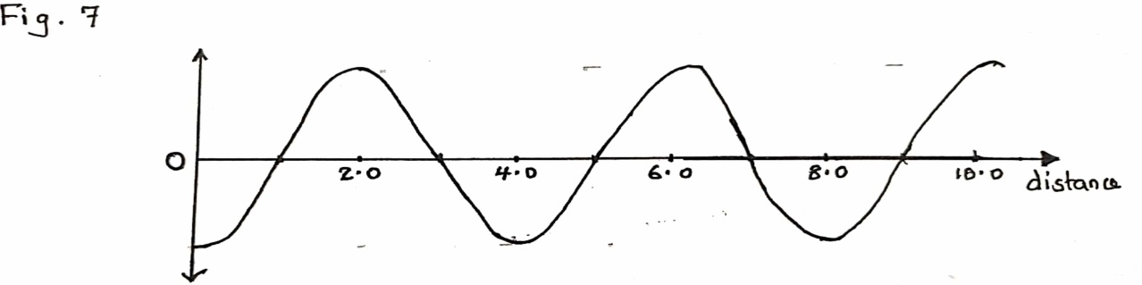
distance(cm)
Fig.7

Determine the speed of the wave (3mks)
……………………………………………………………………………………………………………………………………………………………………………………
- Calculate the wavelength of the KBC FM radio wave transmitted at a frequency of 95.6MHz. (v = 3.0 x 10⁸m/s) (3mks)
…………………………………………………………………………………………………………………………………………………………………………………………………………………………………………………………………………………………………………………………………………………………………………

- a) The figure 8 below shows a narrow beam of white light passed onto a glass Prism.
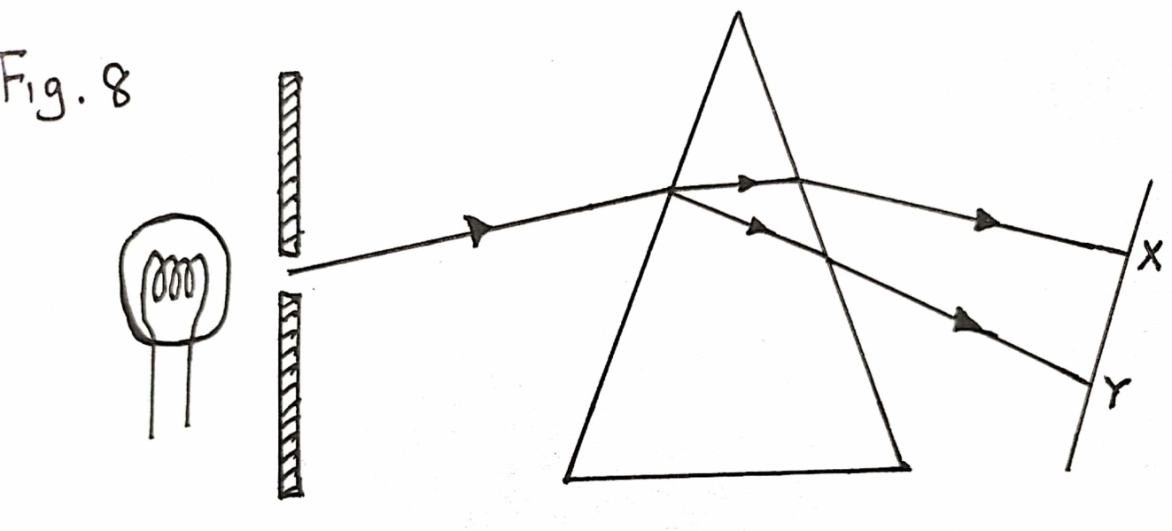
Fig.8
  - What is the name of the phenomenon represented in the diagram? (1mk) ……………………………………………………………………………………………………..………………………………………………………………
- Name the colour at X and Y. (2mk)
X: .............................................................
Y: ………………………………………
iii. Give a reason for your answer in part (ii) above. (2mks)
……………………………………………………………………………………………………………………………………………………………………………………………………………………………………………………………………
iv. What is the purpose of the slit? (1mk)
……………………………………………………………………………………………………………………………………………………………………………....
- Figure 9 below shows the path of ray of yellow light through a glass prism. The speed of yellow light in the prism is 1.8 x 10⁸ m/s.
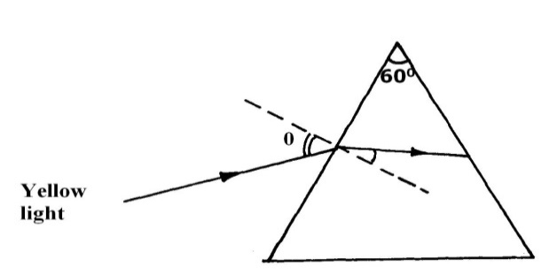 fig.9
θ

r
i. Determine the refractive index of the prism material (Speed of light in vacuum, C
= 3.0 x 10⁸ m/s) (3mks)
……………………………………………………………………………………….
……………………………………………………………………………………….
………………………………………………………………………………………..
ii. Given that r = 31.2⁰, determine the angle θ. (3mks)
……………………………………………………………………………………….
……………………………………………………………………………………….
………………………………………………………………………………………..
iii. Show on the same diagram, the critical angle c and hence determine its value. (3mks)
……………………………………………………………………………………….
……………………………………………………………………………………….
………………………………………………………………………………………..
- Fig.10 below shows a circuit in which a bulb. A resister R, a voltmeter V, a light dependent resistor(LDR) and ammeters A1 and A2 of negligible resistors are connected
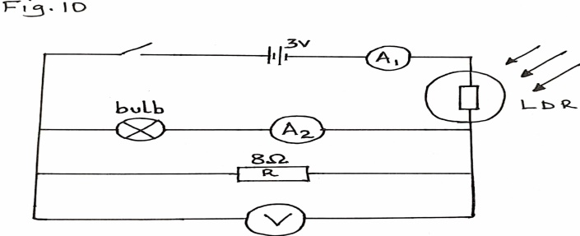
R has a resistance of 8Ω when the switch is closed with no source of light. Ammeter A2 reads 0.12A while the voltmeter reads 2.4V
a) Determine;
i) The current passing through R (2mk)
………………………………………………………………………………………………………………………………………………………………………………………………………………………………………………………………………………………………
ii) The resistance of the bulb (2mks)
……………………………………………………………………………………….
……………………………………………………………………………………….
………………………………………………………………………………………..

b) Light is now shone onto the Light Dependent resistor (LDR)
i) State how this will affect the reading of ammeter A1 (1mk)
……………………………………………………………………………………….
……………………………………………………………………………………….
………………………………………………………………………………………..

ii) Explain your answer in b) (i) above (2mks)
……………………………………………………………………………………….
……………………………………………………………………………………….
………………………………………………………………………………………..

- If the LDR has a resistance of 10Ω at room temperature, determine:
- The total resistance in the circuit at room temperature (2mks)
………………………………………………………………………………………………………………………………………………………………………………………………………………………………………………………..
- The voltage across the LDR (3mks)
………………………………………………………………………………………………………………………………………………………………………………………………………………………………………………………..

- Name one application of light dependent resistor(LDR) (1mk)
…………………………………………………………………………………………………………………………………………………………………

- a) Explain how negatively charged electroscope gets discharged when the cap is touched with a finger. (1mks)
………………………………………………………………………………………………………………………………………………………………………………………………………………………………………………………………………………………..……..

b) Fig.11 below show a capacitor A,B,C connected as shown with a battery of e.m.f 6V
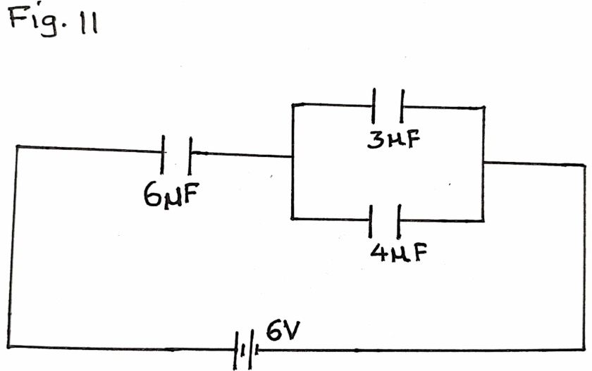
C

Fig.11
B
A
Determine:
- Effective capacitance of the circuit (3mks)
………………………………………………………………………………………………………………………………………………………………………………………………………………………………………………………………………………………..……………………………………………………………………..

- The potential difference across 6µF capacitor (3mks)
……………………………………………………………………………………………………………………………………………………………………………………………………………………………………………………………………
- Charge stored in 4µF capacitor (3mks)
………………………………………………………………………………………………………………………………………………………………………………………………………………………………………………………………………………………..………………………………………………………………………………………………………………………………………………………….
- Energy stored in a 4µF capacitor (2mks)
………………………………………………………………………………………………………………………………………………………………………………………………………………………………………………………………………………………..……………………………………………………………………..

- Fig.12 below shows an isolated positive point charge P

P

On the figure, sketch the electric field pattern around the charge (1mks)
………………………………………………………………………………………………

THIS IS THE LAST PRINTED PAGE

