

**PHYSICS 232/2 ARKING SCHEME**

1. (a) Some electrons from the atoms of the cloth pass over to the rod so that the rod has extra elections

and becomes negatively charged. Polythene rod is an insulator and does not conduct the charges to

the hand. √1mk

(b) The electrons generated from the cloth are conducted away the brass rod to the hand which earths the rod by conducting or absorbing the electrons due to its potential. √1mk

2.

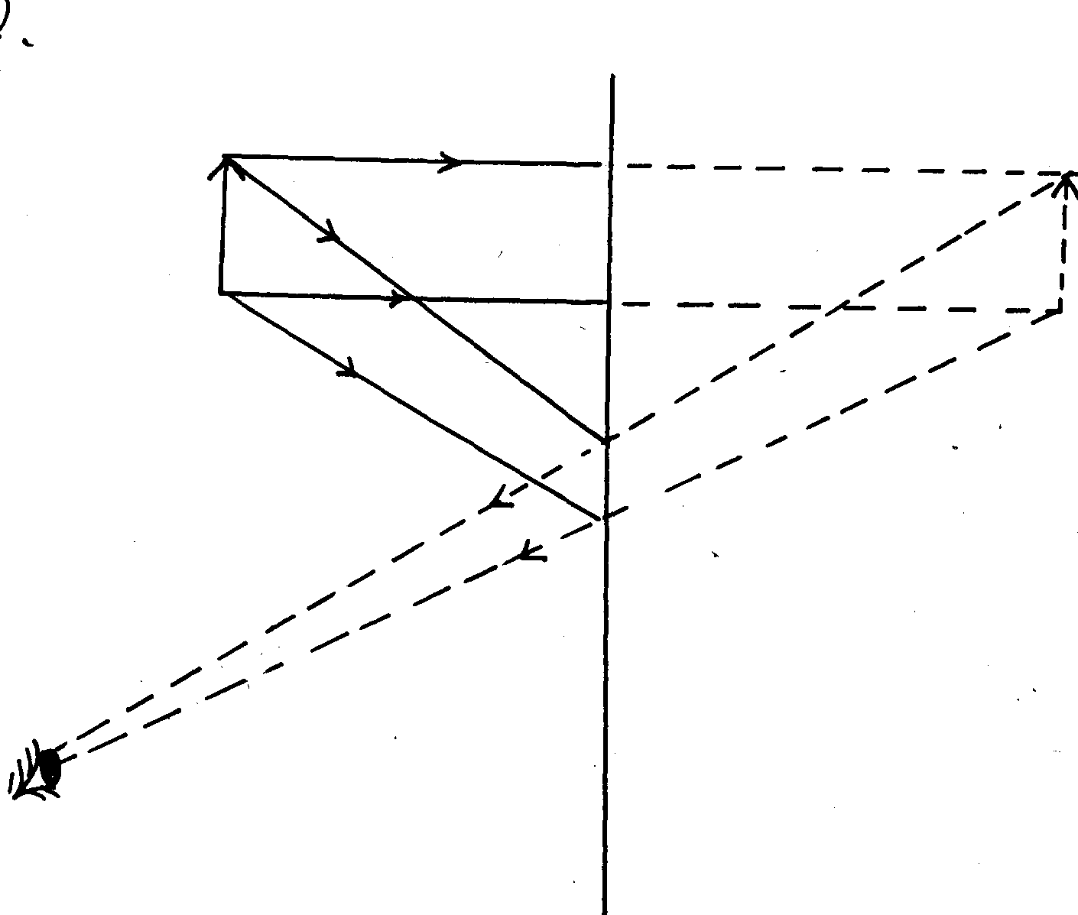

Object

Observer

Image (2mks)

. √1mk

. √1mk

3. Use of a steel core that forms a permanent magnet when current is passed through the solenoid. √1mk

4. f = 50mm, m = 3



5 (i) B √1mk

(ii) In both A and B the voltage is the same while current in B is twice the current in A

6  √1mk for correct expansion leading to CT.  √1mk for correct substitution.

7. 2 x distance = speed x time OR distance (s) = speed x  √1mk

2 x S = 340m/s x 1.6seconds S = 340x 0.8 √1mk

S= 340x1.6 = 272m √1mk

2

= 272m

8. It is the angle of incidence in one medium for which the angle of refraction in the other medium is 90o. √1mk

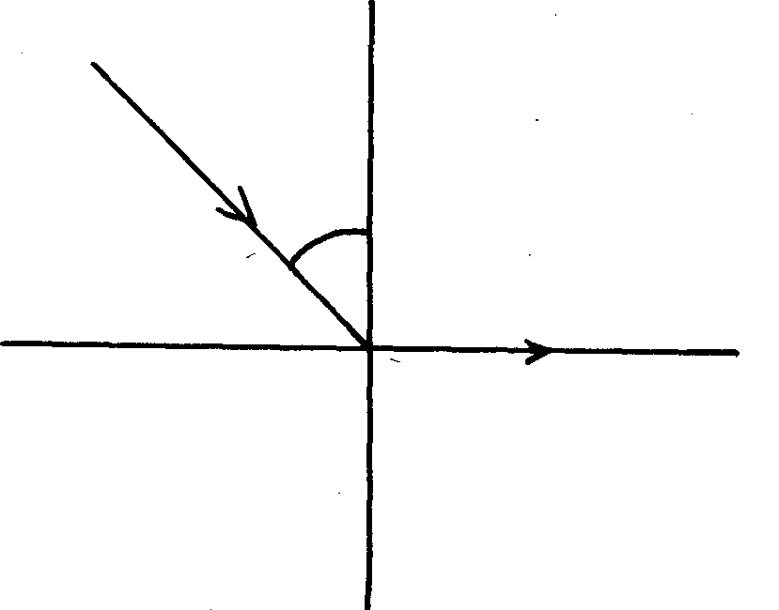

C

r

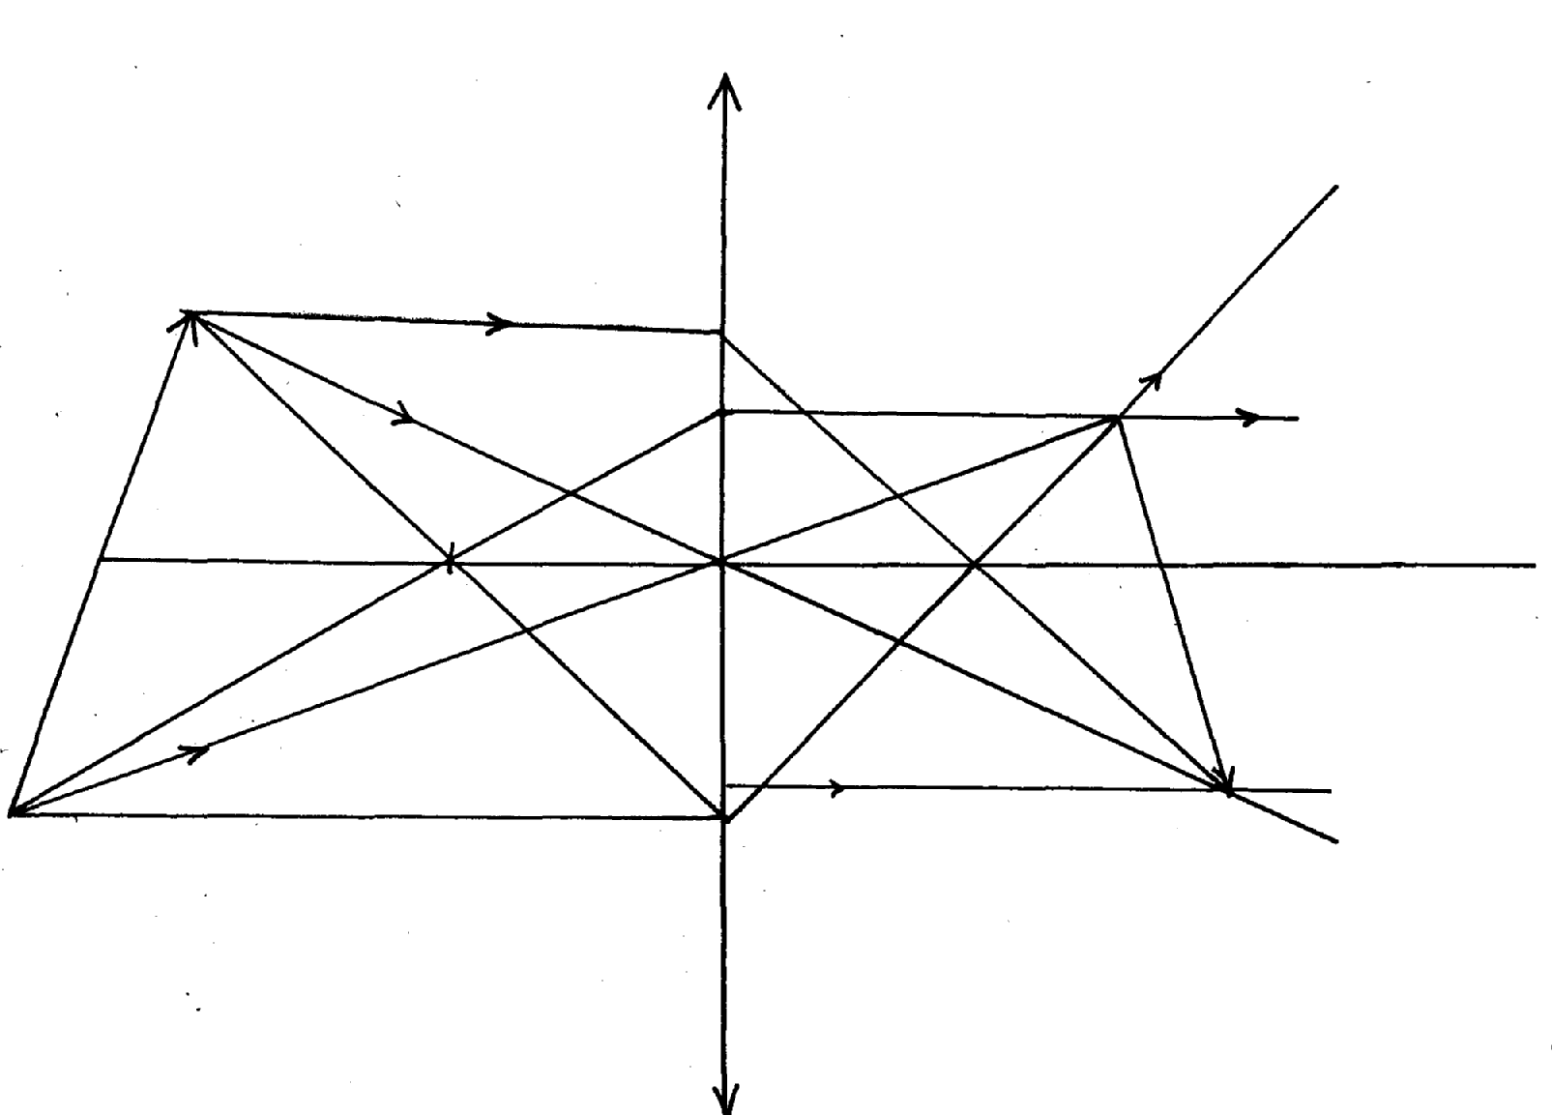

*For any two sets of rays forming the tip*√1mk

*For the other two sets of rays forming the image.* √1mk

*For continuous rays* √1mk

Object

Image

**F**

**F**

9.

11. Infra-red radiation √1mk

12.

(For correct illustration of emerging wave

joints curved at corners) √1mk

**SECTION B: (55MKS)**

13. (a)(i) P – carbon brushes; √1mk

Q- split ring commutation√1mk

(ii) To concentrate magnetic field in the small space√1mk

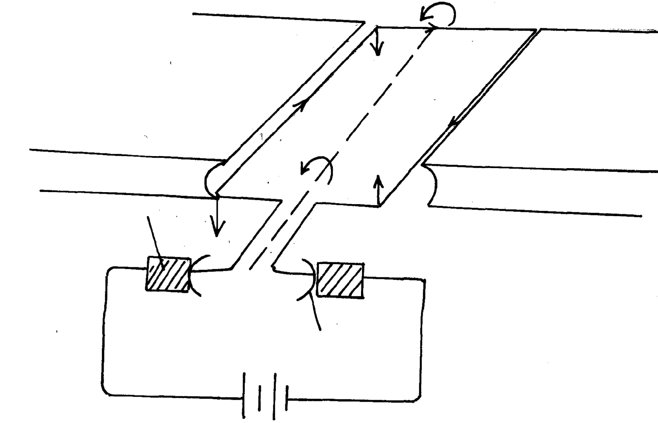

Coil

N

S

P

Q

(iii)

(b) (i) Using more than one coil /increasing the number of coils √1mk

(ii)Increasing the magnitude of the current √1mk

(c) If an a.c current was used the coil would turn in one direction during the positive half cycle and in

the other direction the negative half cycle. The oil would not turn continuously √1mk

(d) a.c voltages can be stepped up; and down √1mk

(e)

14. (a) The current through a conductor is directly proportional to the potential difference across the

conductor provided temperature remains constant i.e (=constant) √1mk

(b)(i)

 √3mk

(ii) Divide 2.0 in the ratio 10:25 i.e 4:1 √1mk

This will be 1.6 and 0.4A √1mk

Less current flows through the circuit with high resistance i.e 0.4A passes through the 4.0Ω

(as well as 6Ωresistor. √1mk

(c) (i) - Area of overlap of plates

- Separation distance of plates

- Presence of dielectric (1mk *for each two correct answers in that order*)

(ii)

***Time ,t,(S)***

***Charge, Q(c)***

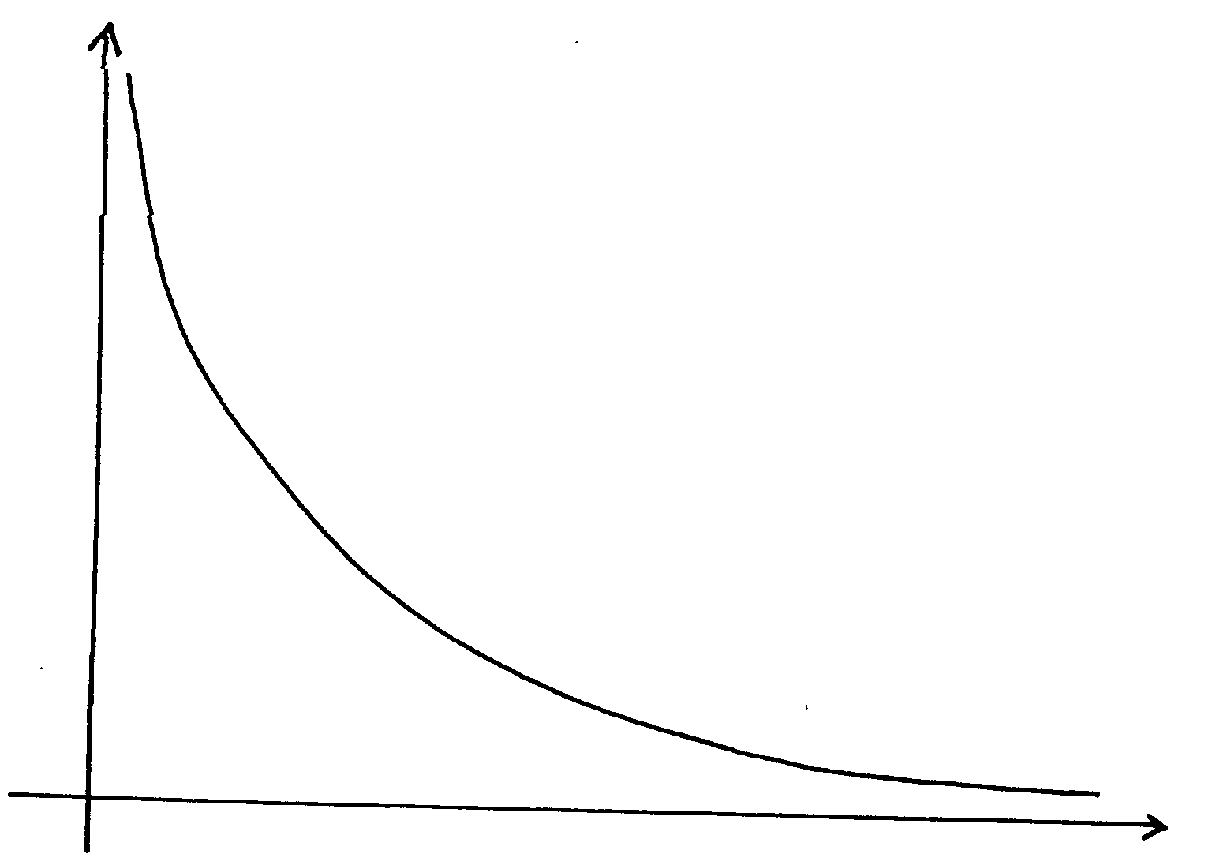

15. (a) (i) Adjust the position of the lens back and forth until a sharply focused image is formed on the screen. Start by pushing the lens to the front until you reach a position where the candle flame is focused on the screen. MCWB01114_0000[1] Measure, u and v and record in a table. MCWB01114_0000[1]

Now push the lens backwards gradually until a new position is reached where the image is once again focused MCWB01114_0000[1]on the screen and once again measure u and v. MCWB01114_0000[1]

apply the formula MCWB01114_0000[1]

(ii) A diverging lens would spread the light in a divergent manner instead of focusing it to a

point. MCWB01114_0000[1]

(b) From the graph.

MCWB01114_0000[1] at (a) Flemings left hand rule;

MCWB01114_0000[1] cm MCWB01114_0000[1]

(c)

MCWB01114_0000[1] cm

 MCWB01114_0000[1] 

16. If the thumb, first and second fingers of the left hand are held at right angles to each other, then if the first finger represents the direction of the magnetic field and the second finger the direction of current, thumb represents the direction of motion;

(b)

Pattern of field;

Direction of field;

Direction of force;

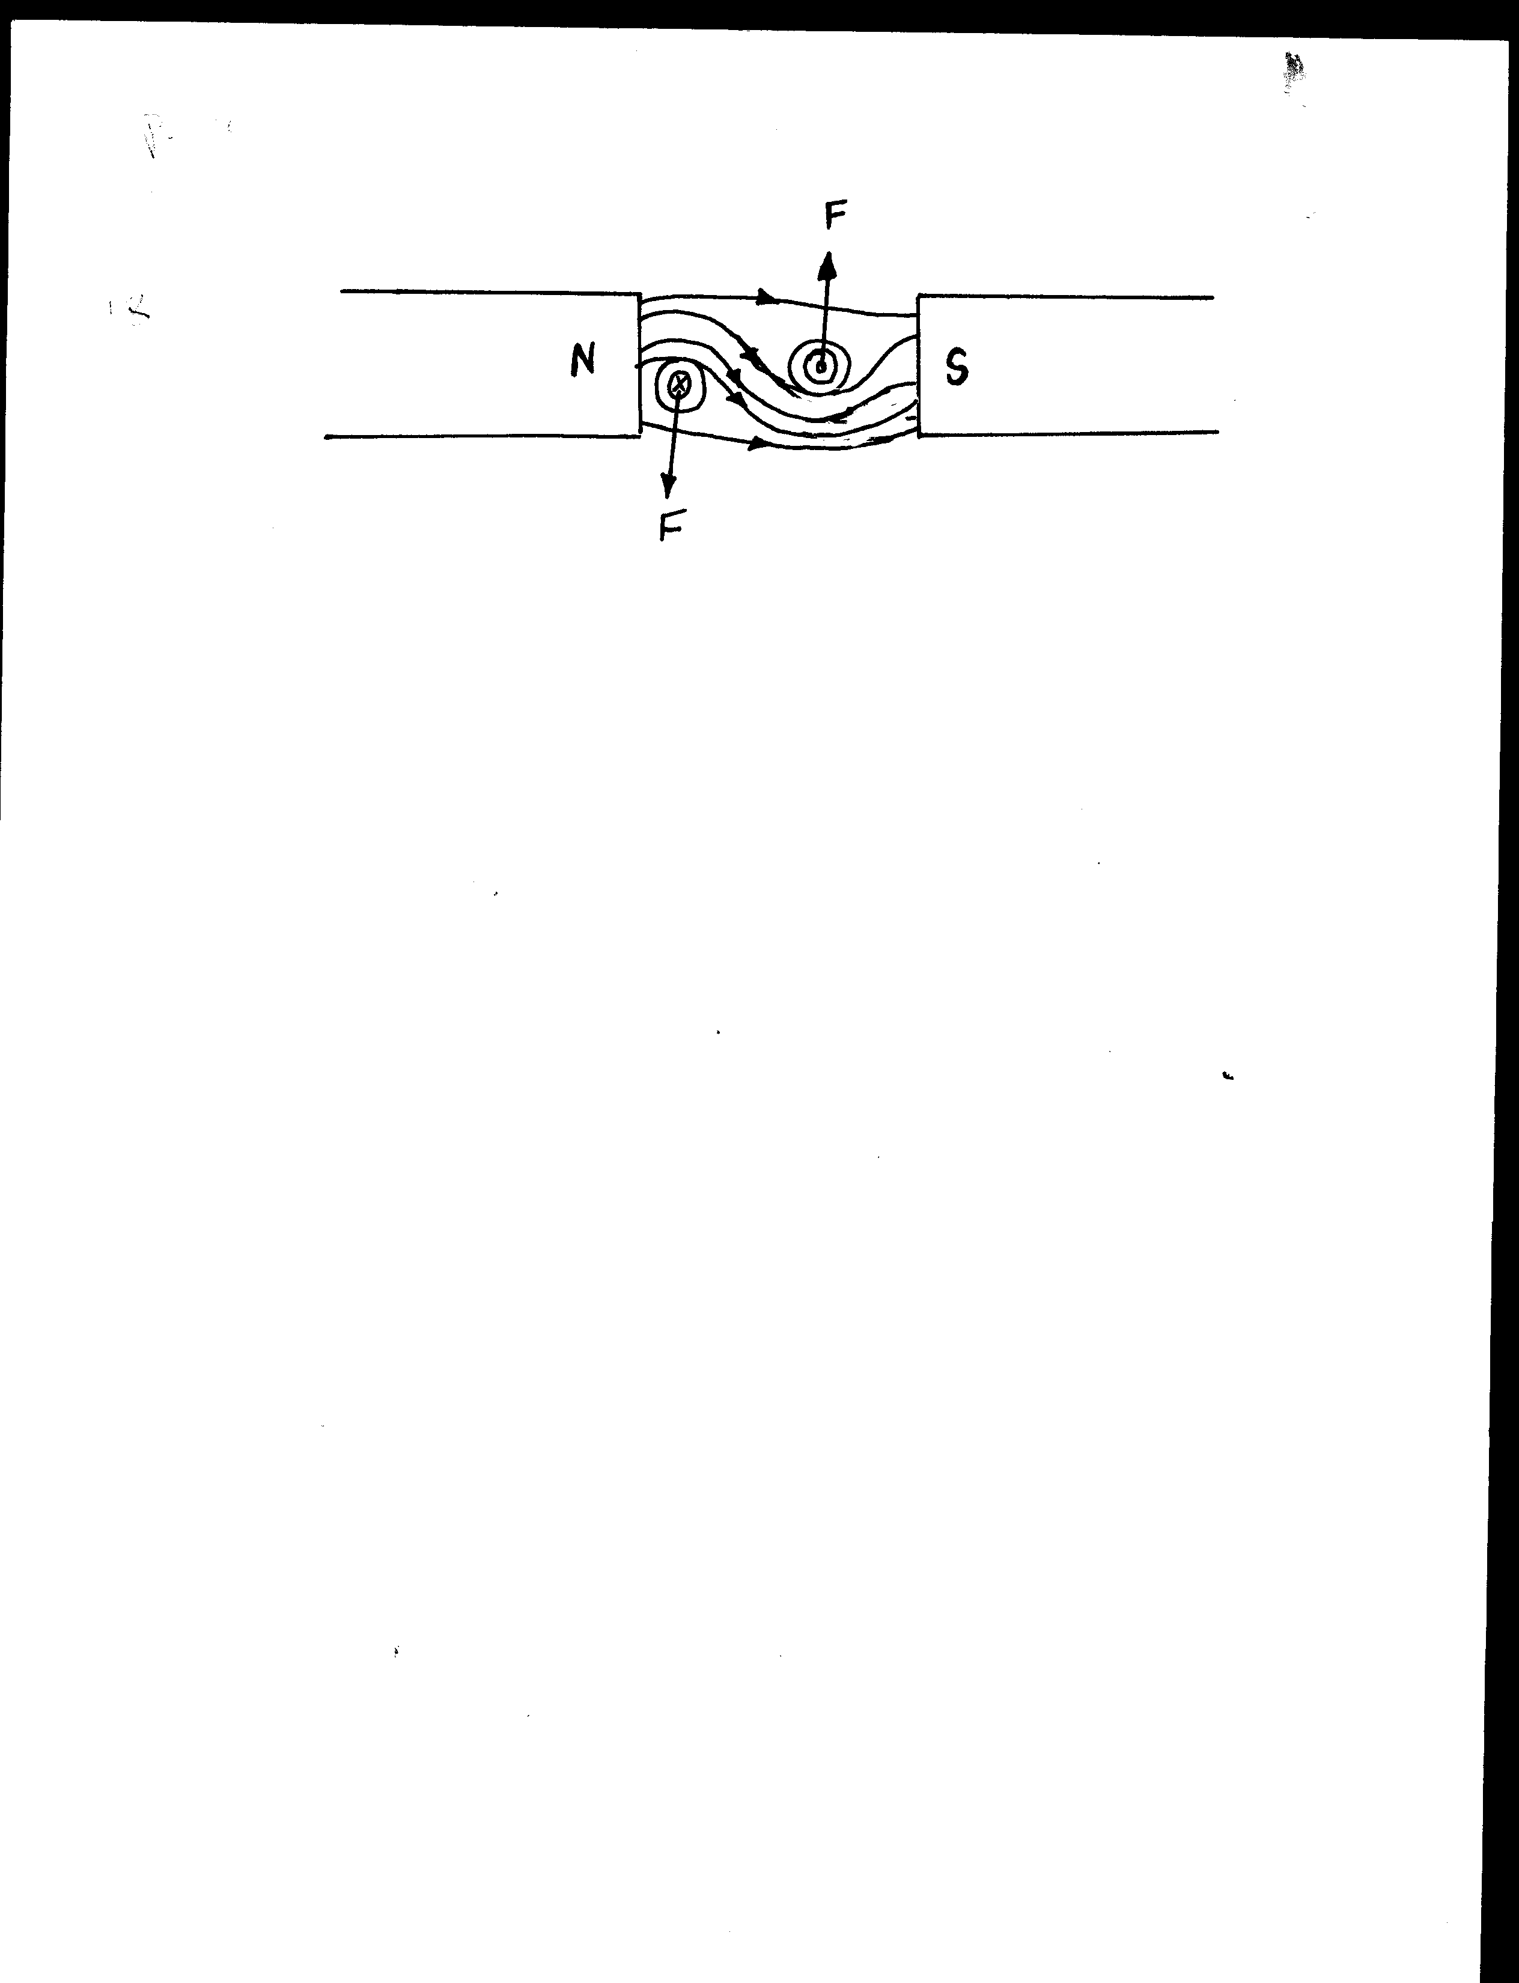

(c) when the push button switch is pushed on, current flow ; the soft iron core is magnetized;

Soft iron core (magnetized ) attract, the soft iron armature and the hammer hits the gong ;

Meanwhile the contact is broken stopping current flow. The core demagnetized releases the armature and the hammer goes back;

The process is repeated again ;

(ii)If the armature is made of steel ; the hammer hits the gong and remains there / the bell rings once ; this is because steel acquires permanent magnetism ;

(iii) the soft iron core should be u – shaped ;

(d) the diaphragm can be made to vibrate using sound input ;

As the coil attached to it vibrates cutting the magnetic fields of the magnet; current is induced in it which can be amplified and directed to another loud speaker;