

PHYSICS SCHOOL BASED EXAM –MARKING SCHEME

1)Reading indicated = 2.4 +( 8 x 0.01)

= 2.48 cm√

Error - 0.05cm

Actual reading 2.48

+0.05

2.53cm√

2.

v √shape

√ area

t

3. Add weight at bottom/make base heavier√1

4.Glass expands first√ increasing internal volume.When mercury is heated it expands faster than glass.

5.(a) V.R = 6 🗸①

(b)  🗸①

n =  🗸①

= 49.01% 🗸①

(c) (i) Loudspeaker 🗸①

(ii) Motor 🗸①

6)More air is pumped into the tyre. The **number of** particles **colliding with the walls** increases. the increase in the rate of change of momentum , hence the force per unit area increase.√

7). (a) A collision in which objects combine / fuse, losing kinetic energy in the process.

(b) Final momentum = Initial momentum(0.5 + 1.5 ) V = (1.5 x 1.2) + (0.5 x 0.2)

2.0V = 1.8 + 0.1

2.0V = 0.9

V = 0.95 m/s

8). - Convection takes place in air upwards direct due to density effect √1

Convection requires material medium but the space between the sun and the atmosphere

has no material medium.

9).Extention in A=6+1=4.667m Extention in B and C= 6 =2.0m

1.5 2x1.5

Total extension =6.667m

10.Has higher density thus height is reduced in mercury.√

Does not vaporize easily.√1 Any one correct

11. Clockwise moments = Anticlockwise moments√

W x 0.4 = 2X 0.1√

W = 0.2

0.4

W = 0.5 N

Upward force = downward force.

T = 2 + 0.5

T = 2.5 N√

SECTION B (55 Mrks)

12(a)

(i) V = ω r√

V = 6π x 1.5

= 6 x 3.142 x 1.5

= 28.278m/s √

(ii) At A

Mv2 = TA+ mg √1

r 2

∴ TA = mv2 – mg =0.45(28.28) -0.45x10

r 1.5

=235.43N

13) (a) A floating body displaces its own weight of the fluid in which it floats. √1

(b) (i)

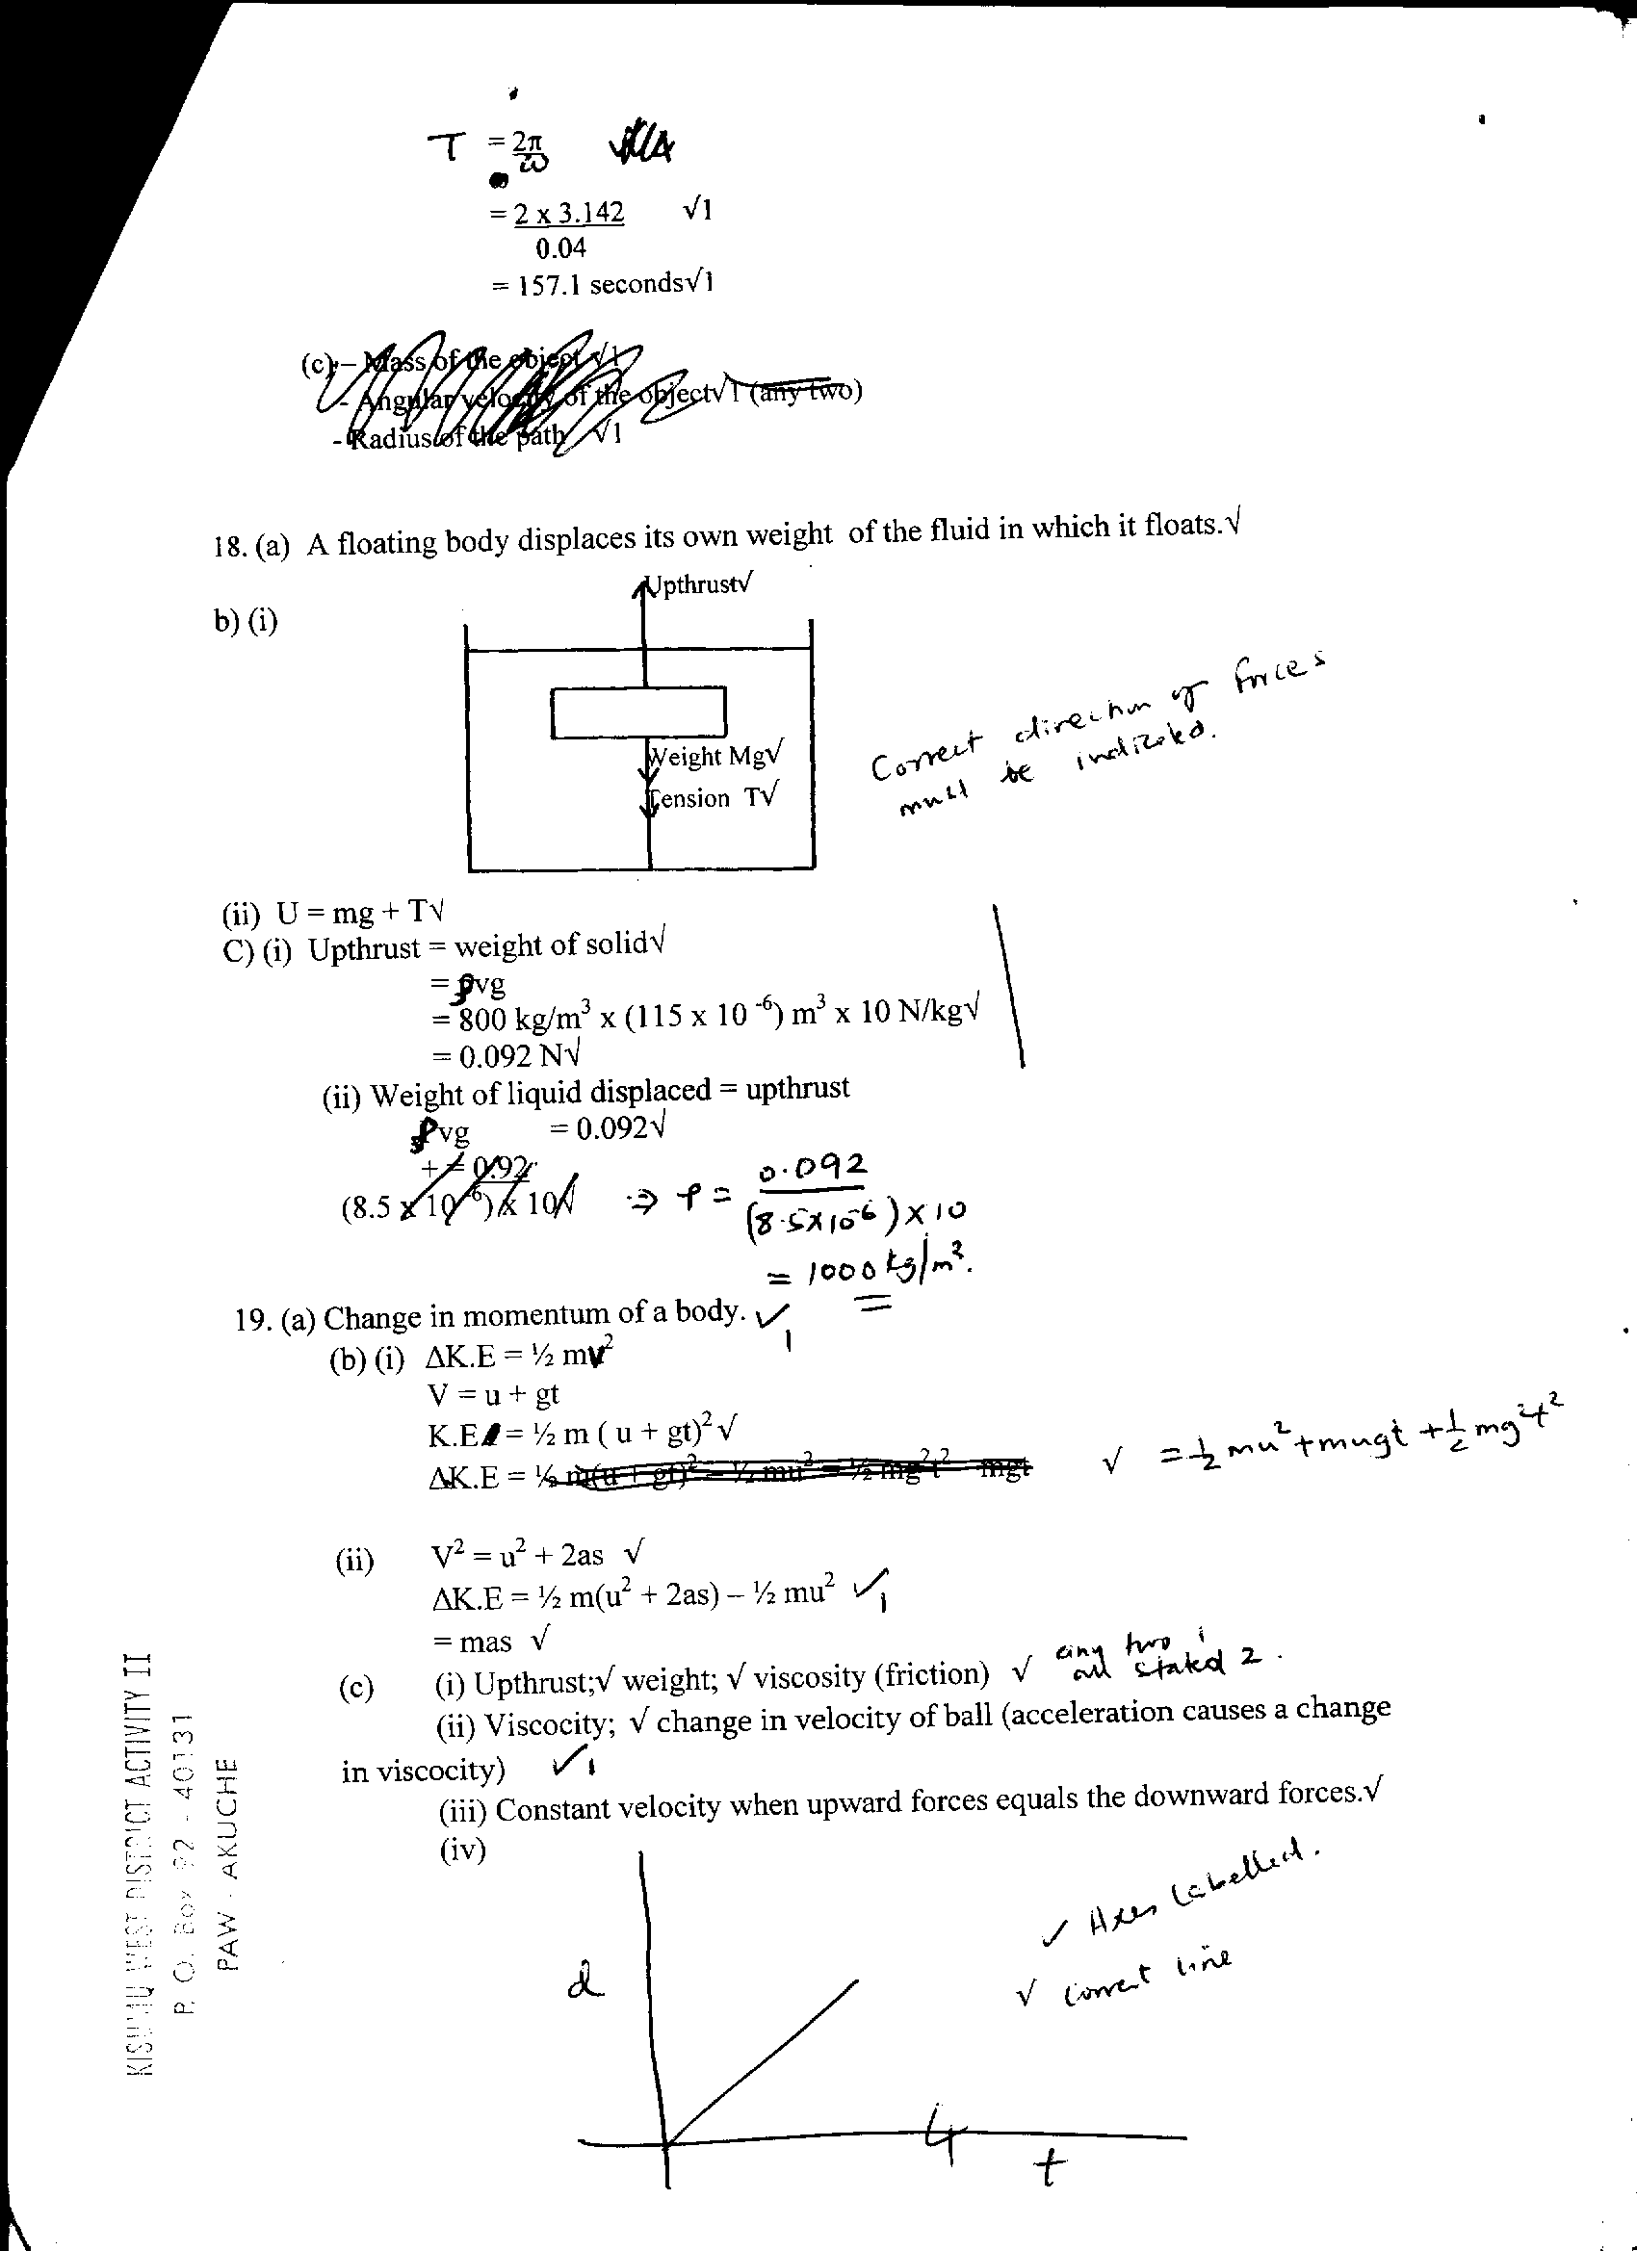

(ii) U = mg + T √1mk

(c) (i) Upthrust = weight of solid √1

= ℓvg

= 800kg/m3 x (115 x 10-6)m3 x 10N/Kg√

= 0.092N √

(ii) Weight of liquid displaced = upthrust

ρvg = 0.92 √

ρ = 0.092

(8.5 x 10-6) x 10

=1082 kg/m3

14. (a)(i) –length of air column √

- temperature of the water √

(ii) –a set of readings of length of air column and corresponding temperature obtained √

- a graph of length of air column (volume) against temperature is plotted.

- a straight line graph is obtained showing that V ά T √

14(b)Heat gained by ice=Heat lost by water

(0.04x340000)+(0.04x4200Q)=0.4X4200(20-Q)

13600+168Q=33600-1680Q

Q=10.82 C

(c) The pressure acting on the bubble reduces as the depth/height below liquid surface reduces. √

(d) Temperature at which a gas will occupy zero volume. √

15). (i) Work done = mgh 🗸 (2mks) = 30 ×10 × 10 = 3000J 🗸

(ii) Work by force 100N = FS (2mks)

=  🗸

= 100 × 38.6370

= 3863.70J 🗸

(iii)Efficiency =  🗸 (3mks)

 🗸

= 77.57% 🗸

(iv) Work done in overcoming friction = 3863.7 – 3000

= 863.7J 🗸(1mk)

(v)

V.R= 1/Sin15

=3.864

Efficiency = 

77.57 =  🗸 (3mks)

M.A = 0.7757 ×3.864

=2.997

16(a) Is a gas that obeys the gas laws completely.;

(b) (i) By carrying out the experiment in a room (where temp. is constant);

(ii) k = ∆P

∆ 1/v

= (4.0 x 105) - (0)

(4.85 x 106) -(0)

= 4 x 10-1

= 4 x 10-1

= 0. 8247 x 10-1

= 8. 247 x 10-2 Nm

(iii) energy/work done

(iv) allow air to adjust to room temperature;

17(a) V1  V2;

T1  = T2

4000 = V2;

310 340

V2 = 4000 X 340;

310

= 4387 litres

17(b) MV-MU=Ft

0.6v-0=720x0.1

V=120m/s

17(c) Upthrust in liquid = 1.04 – 0.72 = 0.32N√1

Upthrust in water = 1.04 – 0.64 = 0.40√1

Density of liquid = 1000Kgm-3 x 0.32 = 0.8 x 103 Kgm-3√1

0.40√1