FORM 2
PHYSICS
MARKING SCHEME

- State the laws of reflection. (2mks)
- Angle of reflection is equal to angle of incidence.
- Incidence ray, the normal and reflected ray at the point of incidence they all lie in the same plane.
- The figure below shows an object O being viewed using two inclined mirrors M1 and
M2. Complete the diagram by sketching rays to show the position of the image as seen
by the eye. (3mks)
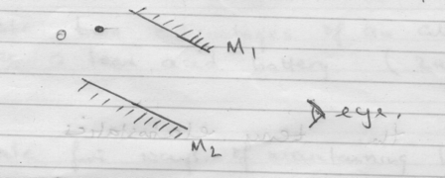
- The figure below shows rays of light being reflected from a mirror. What is the angle
of reflection.
30º
(2mks)

Mirror

i = r = 90º – 30º = 60º

- How many images would be seen from two mirrors when reflecting surfaces makes an
angle of 60º with each other ? (2mks)
number of images = $\frac{360°}{60°}$ = 6 images
- A pinhole camera of length 15cm formed an image 3cm high of a man standing 9m in
front of the camera. What is the height of the man? (3mks)

m = $\frac{V}{U}$= $\frac{hᵢ}{h˳}$ = $\frac{15}{900}= \frac{3}{h˳}$ h_{o} = = $\frac{900 x 3 }{15} =$180cm

- Define the term linear magnification (1 mark)
Numerical Comparison between image height and object height. Or the ratio of image height to object height.
Page 1 of 7
- (a) A concave spherical mirror has a focal length of 10 cm. Calculate the distance where an object must be placed in order to produce a real magnified image three times the size of the object and 30cm from the mirror. (2 marks)

m = $\frac{V}{U}$ 3 = $\frac{30}{U}$ U = $\frac{30}{3}$ = 10cm

(b) An object is placed 20 cm in front of
i) a plane mirror
ii) a concave mirror of focal length 30cm.
State two differences between the images formed in each case. (2 marks)
Plane mirror concave mirror
Laterally inverted erect
Same size as object magnified
Same distance from the mirror as object different distance from the mirror
- (a) Make a list of four devices in your house which are operated by electricity.(4mks)
Electric kettle iron box
Bulbs/ fluorescent mobile phone
Radio Television etc
(b) Two dry cells, two bulbs and connecting wires are provided to you. Show by means of circuit diagrams how you will arrange the two cells to give a large current to flow. (2mks)

- (a) What are the main sources of electricity? (2mks)
High dams/ water falls
Geothermal
Solar energy
Wind mills
Nuclear energy
(b) Define the following terms;
(i) Polarization (1mk)
Accumulation of hydrogen gas on the copper plate increasing the internal resistance of the cell.
(ii) Local action (1mk)
Defect where zinc plate is eaten away by the sulphuric acid during reaction.
(c) What are the remedies of;
(i) Polarization (1mk)
Use of polarizing agent eg potassium dichromate
(ii) Local action (1mk)
Use of pure zinc of amalgamation
- (i) State two advantages of an alkaline battery over a lead acid battery. (2mks)
- alkaline batteries have much longer life span than lead acid
- larger current can be withdrawn from alkaline batteries than lead acid
- they may be left in a discharge condition for a long time without harm
(ii) State three ways of maintaining lead acid accumulator. (3 mks)
-recharge the accumulator after use
-recharge the accumulator relatively even if has not been used because it undergoes self-discharge
-when charging a battery low currents have to be used as specified
-top up the acid level with distilled water to compensate for evaporation
- keep the accumulator in a cool dry place and on a wooden surface.
-never short circuit
-avoid bare flames

- .(a) State the basic law of magnetism. (1mk)
Like poles repel, unlike poles attract
(b) Using Domains theory distinguish between a magnet and a magnetic substance. (3mks)
In a magnet the domains are aligned in the same direction while in a magnetic substance domains are facing in all directions making loops with each other.
- State what is meant by;
(a) a magnetic field (1mk)
-region or space around a magnet where magnetic influence is felt.
(b) a line of magnetic force (1mk)
-it is the path along which a North pole will follow it is free to do so.
- Sketch the arrangement of lines of force in the following case. (2 mks)

N S
S N

- .(a) Show on a ray diagram the centre of curvature, axis, pole and principal focus for a
concave spherical mirror. (2mks)

(b) A concave mirror has a radius of curvature of 20cm. Find the position, magnification
and nature of the image of small pin placed on the axis and at right angles to it and
15cm from the pole by scale drawing (3mks)

- List down three properties of an object whose volume can be measured using the displacement method ( 3 mks)
-denser than the liquid to be used
-does not react with the liquid to be used
-does not absorb the liquid used
- The density of mercury is 13.6 g/cm3. Find the volume of 2720g of mercury in m³ ( 2 mks)
V = $\frac{m}{ρ}$ = $\frac{2720}{13.6}$= 200cm³

V = $\frac{200}{1000000}=$ 0.0002m³

- The density of liquid X is 13600 kg.m³ and that of water is 1000 kg/m³.
- What is relative density ( 1 mk)
Number of time a substance is denser than water
- Determine the relative density of liquid X. ( 2mks)
Relative density = $\frac{13600}{1000}$ = 13.6
- Mixture is made liquid A and water. Liquid A has a volume of X cm³ and water has a volume of 100cm³. Liquid A has a density of 800 kg/m³ and water has a density of 1000 kg/m³. If the mixture has a density of 960 kg/m³, calculate X of liquid A. ( 4 mks)
Density of the mixtures = $\frac{total mass of the mixtures }{total volume of the mixtures}$

Total volume of the mixture = 100 + X
Mass of X = ρxv = 0.8X
Mass of water = 100 x 1 = 100g
Total mass = 0.8X + 100g
0.96 = $\frac{100+0.8X}{100+X}$
0.96( 100 + X) = 100 + 0.8X
96 + 0.96X = 100 + 0.8X
0.96X -0.8X = 100- 96
0.16X = 4
X = 4/0.16 =25cm³

- The mass of an empty density bottle is 25.5g. Its mass when filled with water is 45.2g. When filled with liquid L, its mass 55.2g. Calculate the density of liquid X.
(Density of water is 1000kg/m³) ( 4 mks)
Mass of water = 45.2g – 25.5g =19.7g
Volume of water = 19.7g/ 1g/cm³= 19.7 cm³
Volume of the liquid X = 19.7 cm³
Mass of liquid X = 55.2g – 25. 5g = 29.7g
Density of liquid X = $\frac{m}{V}=\frac{29.7}{19.7} =$ 1.50761g/cm³

- In the diagram below two pins are attached to the end of a magnet as shown.
Explain the behaviour of the pins. (2mks)
S

N

magnet

Pin Pin
Pins get magnetized by induction acquiring same polarity at the lower part thus repelling teach other.

- State one advantage and one disadvantage of using a convex mirror as a driving mirror. (2mks)
Advantages
-provides wide field of view so that overtaking traffic can easily be seen
-forms upright image regardless of the distance of the object
Disadvantage
-forms diminished image giving the impression the vehicles behind are further away than they actually are.
- Sketch rays to show the image formed by the object in the following ray diagram, C is
the centre of curvature of the mirror. (2mks)

O F C

- a) Define pressure and state its S.I Units. (2 marks)
pressure is the force acting normally per unit surface area
SI unit is newton per square meter or Pascal.
b) State Pascal’s principal. (1 mark)
pressure applied at one part of a liquid is transmitted equally to all other part of an enclosed liquid
c) In construction of a mercury barometer care is taken to make sure it has no gas in the space above mercury.
i) How would you test whether there is gas above? (1 mark)
tilt the tube to the level supported by atmospheric pressure, if it does not get filled then it has a gas inside it.
ii)State the problem caused by the presence of gas in the barometer. (1 mark)
the reading obtained will be less than the actual pressure
d) Find the total pressure experienced by a diver 8 meters below the sea surface. Take; Atmospheric pressure = 103 360N/m². Density of sea water 1030kg/m³ (3 marks)
total pressure = P_{A} + ρgh
= 103 360 + 1030 x8 x 10
=103360 + 82400
= 185760Pa

- (a) (i) Why must a liquid and not a gas be used as the ‘fluid’ in a hydraulic machine. (1mk)
Gases are compressible while liquids are incompressible

(ii) State the other important property of a liquid to hydraulic machine depends on (1mark)
-should not be corrosive
-should have wide temperature range
(b)The diagram below shows the principle of the hydraulic car jack
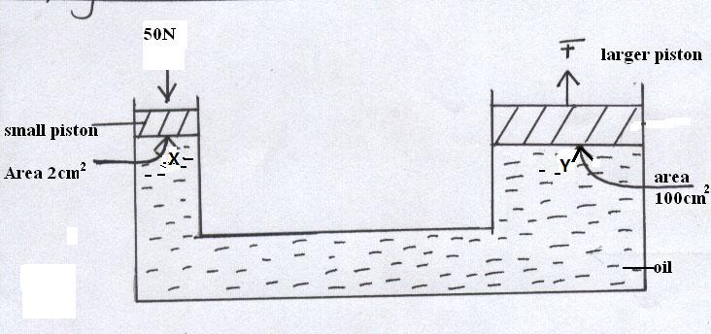
- If a force of 50N is applied to the smaller piston ;calculate the pressure produced in the oil at X (2marks)
P = $\frac{F}{A}$ = $\frac{50N}{0.0002m²}$ = 250000N/M²
- Determine the pressure exerted by oil at Y (1mark)
Pressure at Y = 250000Pa
- If the small piston moves down a distance of 5cm, determine how far upwards the larger piston moves. (2marks)
Volume leaving small piston = volume getting into large piston
ah = AH
2 x 5 = 100 x H
H = $\frac{2 X 5}{100}$ = 0.1 Cm

