END TERM 2 2021
FORM 4 PHYSICS PAPER 2
MARKING SCHEME
SECTION A (25 MARKS)
- A ray is incident on two mirrors inclined at 60⁰ as shown in the diagram below. (3mks)
40⁰
60⁰
Mirror B
Mirror A

Determine the angle of reflection on mirror A, hence trace the path of the ray as it leaves mirror B.
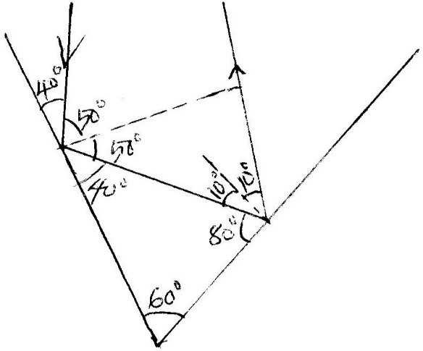
- A) The coils P and S are connected as shown below. P is connected to a battery, rheostat and a switch K. S is connected to a galvanometer G.
K
P
G
S

State the behaviour of the pointer on G in the following cases;
- When K is switched on (closed) (1mk)
When K is switched on the pointer deflects in one direction and comes back to zero.
II) When K is opened. (1mk) The pointer deflects in the opposite direction then goes back to zero.
b) A transformer has 200 turns in the primary coil and 1000 turns in the secondary coil. If the transformer is 100% efficient and the current in the secondary coil is 0.15A, determine the current in the primary coil. (3mks)
$\frac{N_{p}}{N_{s}}$ = $\frac{I_{s}}{I_{p}}$
$\frac{1000}{200}$ = $\frac{0.15}{I_{p}}$
I_{p} = 0.03A
- Figure below shows a simple experiment using a permanent magnet and two metal bars A and B
Put close to the iron filings.
S
N
A
B
A
B
After

During attraction

State with a reason which bar is made from a soft magnetic material. (2mks)
B
Soft iron looses its magnetism faster thereby becoming weaker hence attracting fewer iron fillings.
- The diagram below shows a ray of light xy traveling through a glass block of critical 42⁰ to point A
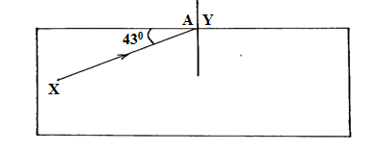
- Calculate the refractive index of the glass block. (3mks)
ɳ = $\frac{1}{\sin{c}}$
= $\frac{1}{\sin{42}}$
ɳ = 1.494
- On the same diagram, draw the path of the ray as it travels past point A. (1mks)
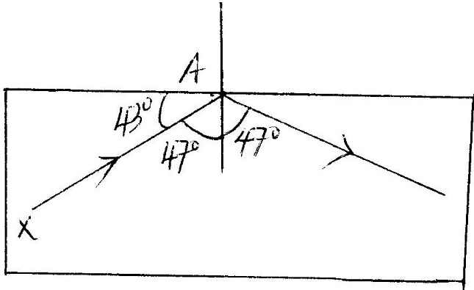
- The photoelectrons liberated from an illuminated metal surface constitute a photoelectric current. What is the effect of decreasing the intensity of illumination on the magnitude of the photoelectric current? (1mk)
Photoelectric current decreases.
- Figure below shows a battery of e.m.f 3.0v connected in series will two capacitors.
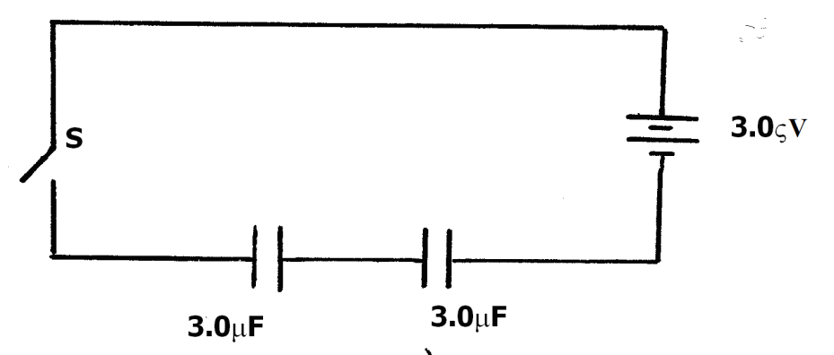
Determine the energy stored in the combined capacitors when the switch is closed. (3mks)
$\frac{1}{C_{T}}$ = $\frac{1}{C_{1}}$ + $\frac{1}{C_{2}}$
C_{T} = $\frac{C_{1} x C_{2}}{C_{1} + C_{2}}$
= $\frac{3 x {10}^{-6} x 3 x{10}^{-6}}{3 x {10}^{-6}+3 x {10}^{-6}}$
C_{T} = 1.5 x 10⁻⁶
E = 1/2CV²
= ½ x 1.5 x 10⁻⁶ x 3²
E = 6.75 x 10⁻⁶ J

- The figure below shows a metre rule in equilibrium with the magnet and weight W .The Soft iron core is fixed to the bench
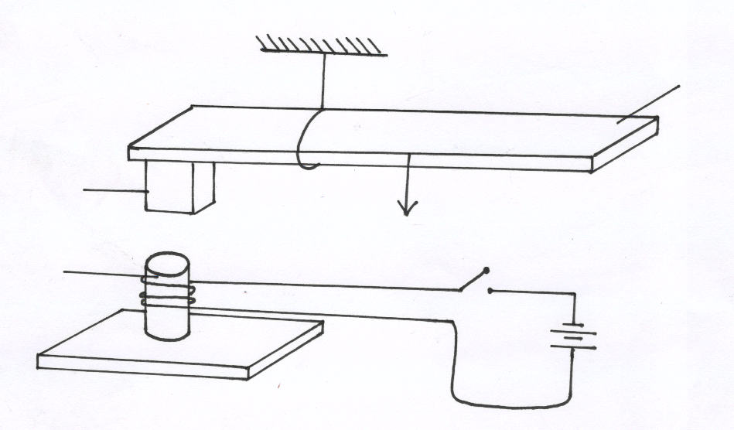
Metre rule
s
Magnet
Soft Iron core
Fixed on bench
N
Bench top
W

State and explain the effect on the metre rule when the switch S is closed (2mks)
The meter rule turns anticlockwise. When the switch is closed the soft iron core is magnetized with the south pole at the top.
- State how polarization is reduced in a dry cell. (1mk)
The presence of manganese iv oxide oxidizes the hydrogen gas to water.
- State two differences between the cathode ray tube (CRT) of a T.V and the cathode ray oscilloscope (CRO). (2mks)
T.V | C.R.O
- Deflection caused by magnetic field.  - Has two-time basis.  - Produces 625 lines per second. | - Deflection caused by electric field.  - Has one-time base.  - Produces 25 lines per second.

- Distinguish between a P-type and a N-type extrinsic semiconductors. (2mks)
P-type is an extrinsic semiconductor obtained by doping intrinsic semiconductor with trivalent atoms.
N-type is an extrinsic semiconductor obtained by doping intrinsic semiconductor by pentavalent atoms.
SECTION B (55 MARKS)
- (a) Students set up a mass attached to a spring such that when it oscillates it taps on water surface in a wide shallow tank as in figure 11 below.
Spring
Mass
800m
B
Water
Direction of
oscillation
Fig. 11

The students measured time for 20 oscillations and found that the mass takes 36 seconds.
Determine:
- The periodic time of the mass (2mks)
T = 36/20 = 1.8 sec

(ii) The frequency of the waves produced on the water surface (2mk)
Frequency = 1/T
f = 1/1.8
f = 0.5556 Hz.
(iii) The speed of the waves if the students counted four ripples between the mass and end B of the tank (3mks)
3λ = 80cm
λ = 80/3 = 26.67
v = fλ
= 0.5556 x 26.67
V = 14.82 cm/s or 0.1482 m/s
(b) State any two factors that would increase the speed of sound in air (2mks)
- Wind blowing in the direction of sound
- High humidity
- Increase in temperature
- decrease in density of air.
- Increase in pressure
(c) An echo sounder of a ship received the reflected waves from a sea bed after 0.20s.
(i) Determine the depth of the sea bed if the velocity of sound in water is 1450m/s (2mks)
D = s x 1/2t
= 1450 x ½ x 0.20s
= 145 m
(ii) When the ship above passes over a sunken reef, the echo sounder receives an echo after 0.16s. Determine the height of the sunken reef (2mks)
Depth from water surface to the top of the reef
= 1450 x ½ x 0.16
= 1450 x 0.08
= 116m
Height of the sunken reef = 145 - 116
- (a) The diagram below shows an X-ray tube drawn by a student. Use it to answer the questions
which follow.
Heating
Voltage
R
S
Evacuated
P
EHT

- State with reason the material used for the part labeled R. (2mks)
Low work function
Mixture of metal oxides. (barium and strontium)
(ii) Why is the tube evacuated (1mk)
The tube is evacuated so that electrons do not lose some of their energy through collision with molecules on their way to target.
(iii) How can the wavelength of the X-rays emitted from this tube be reduced (1mk)
The wavelength of the x – ray emitted is reduced by increasing the heating voltage through the filament.
(b) X-rays are emitted when a tube operates at 3 x 10² V and a current of 0.01 A is passing through it (take e = 1.6 x 10⁻¹⁹C, Me = 9 x 10⁻³¹kg). Calculate ;
(i) The velocity of the electron on hitting the target. (3mks)
½ mv² = ev
V² = $\frac{2ev}{m}$
V = $\sqrt{\frac{2ev}{m}}$
V = $\sqrt{\frac{2 x 1.6 x {10}^{-19} 3 x {10}^{2}}{9 x {10}^{-3}}}$
= $\sqrt{\frac{9.6 x {10}^{-17}}{9 x {10}^{-31}}}$
= 1.0328 x 10⁷
(ii) The minimum wavelength of the X-rays emitted (3mks)
Λ min = hc/ev
= $\frac{6.63 x {10}^{-34} x 1.0328 x {10}^{7}}{1.6 x {10}^{-19} x 3.0 x {10}^{2}}$
= 1.4266 x 10⁻¹⁰ m
C (i) State one properties of X-rays (1mk)
- X- rays are not deflected by both magnetic and electric field
- They penetrate matter.
- Affects photographic emulsions.
- Causes photoelectric emulsions.
- Travel in straight line
- They are electromagnetic radiatons.
(ii) Sate one uses of X-rays (1mk)
    - Used in medicine and surgery.
    - Used to investigate structure of matters
    - Used in study of crystal structure.
- a) Differentiate between a nuclear fussion and nuclear fission. (2mks)
Fission: The splitting of nucleus to release energy
Fusion: The combination of two light nuclei leading to release of energy.
b) The equation below represents a nuclear reaction.
218
84
P_{o}
218
85
A
+
q
p
Y

i) Determine the values of p and q. (2mks)
p…… 1
q…… 0
ii) Identify Y……… Beta particles. (1mk)
c) The figure below represents deflection of various radiations from a radioactive source S placed in electric field between two plates X and Y.
M
S
Y
+
X
-
P

Identify the radiations marked with letters M and P. (2mks)
M……… alpha particles
P………… Beta particles
d) A sample of radioactive substance initially has 8x10²⁵ particles. The half life of the sample is 98 seconds. Determine the number of particles that will have decayed after 294 seconds. (3mks)
N = No (1/2) ^{T/t1/2}
= 8 x 10²⁵ (1/2) ^{294/98}
= 8 x 10²⁵ (1/2) ³
= 1 x 10²⁵
The number of particles that will have decayed
= No – N
= 8 x 10²⁵ – 1 x 10²⁵
= 7 x 10²⁵

14. a) State Ohm’s Law. (1mk)
Ohm’s law states that the current passing through a conductor is directly proportional to the potential difference across it, provided temperature and other physical factors are kept constant.

b) The figure below shows a circuit that can be used to verify Ohm’s law
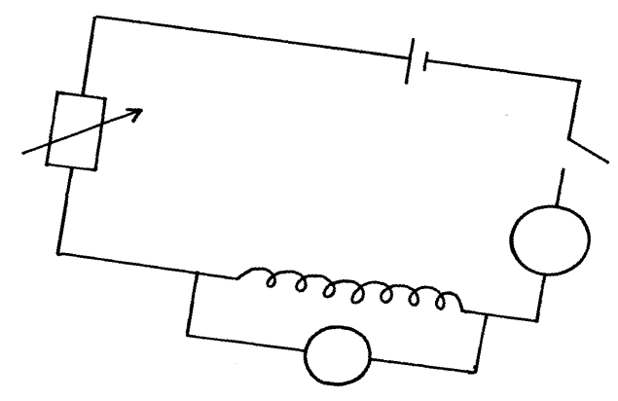
S
Rheostart
Ammeter
A

nichrome wire
V
Explain briefly how the setup can be used to verify ohm’s law (3mks)
- Close the switch and red the corresponding values of A and V
- Adjust the Rheostat and record the other corresponding values of A and B in a table.
- Plot a graph of V against I.
- It is a straight line through the origin and hence V is directly proportional to I
C) The graph below was obtained from experiment to determine the effective resistance of two resistors connected in parallel. If the value of one resistor is 50 ohms. Determine the value of
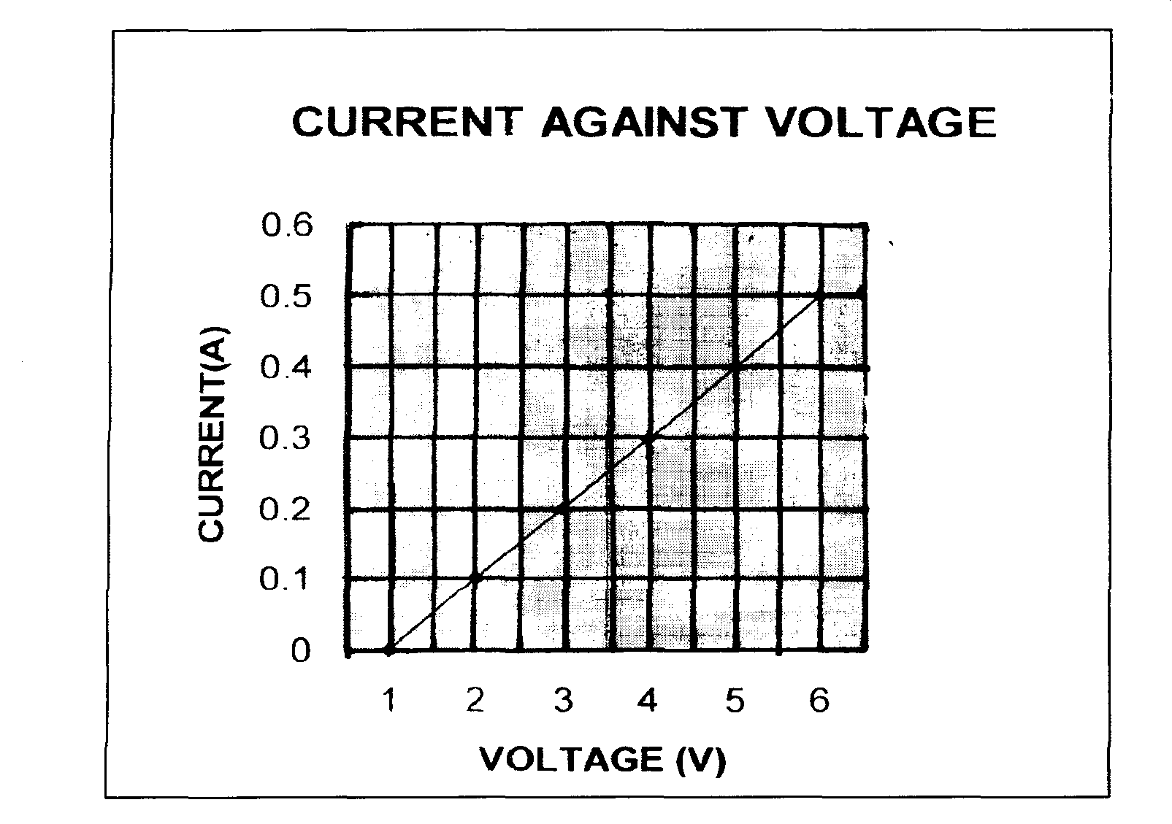
the other resistor.

From the graph, determine
- effective resistance of the two resistors (2mk)
Gradient = $\frac{0.5-0.1}{6-2}$ = $\frac{0.4}{4}$ = 0.1Ω
Gradient = Resistance = 0.1⁻¹ = 10Ω
- the value of the other resistor (3mks)
1/10 = 1/50 + 1/R
1/R = 1/10 – 1/50
1/R = 4/50
R = 50/4
= 12.5 Ω
- (a) An object O stands on the principal axis of a concave mirror as shown in figure 9 below.
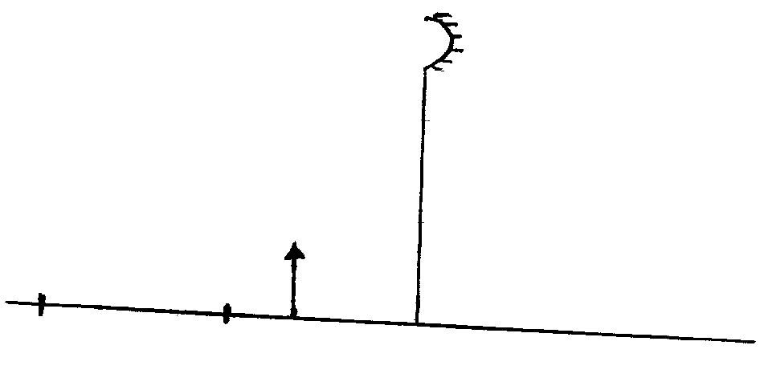
C
F
O
Fig. 9

(i) By drawing suitable rays, show the position of the image (3mks)
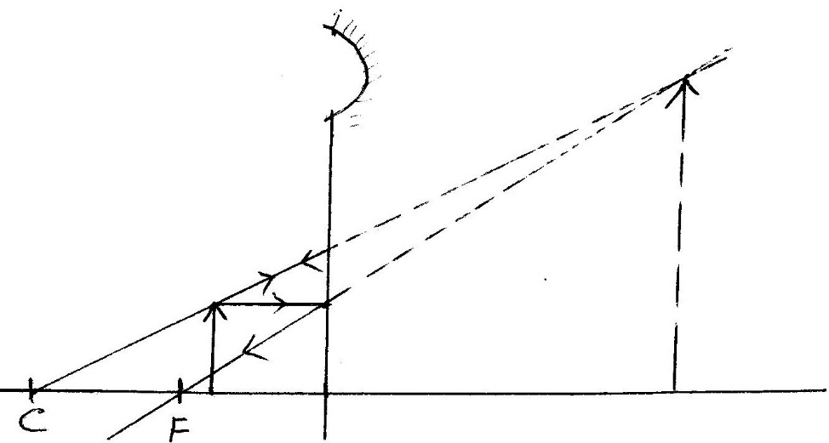
(ii) Determine the magnification of the image formed (2mks)
Magnification = $\frac{Image height }{Object height}$ = 2.8/1.1 = 2.545

(b) In an experiment to determine the focal length of a converging lens, a group of form four
students collected some data and used the results to plot the graph shown in figure below.

Using the graph above, determine:
(i) The object position when the image position is 45 cm (2mks)
V = 45cm m = 3.5
M = v/u
3.5 = 45/u
U = 45/ 3.5
= 12.85cm
(ii) Slope of the graph. (2mks)
Slope = $\frac{3.5-0}{45-10}$
= 3.5/3.5 = 0.1cm
- The focal length of the lens given m = $\frac{v}{f}$ - 1 (2mks)

Focal length = 1 / slope
= 1/0.1
= 10cm

