**PHYSICS PAPER 1 FORM 4**

**MARKING SCHEME**

1. **a)Negative error = 0.06 (-0.06cm)**

**b) Reading = 2.15 + 0.06 = 2.21 cm**

**2. Total mass = m1 + m2**

**M1 = 0.8x x m2= 1 x 100**

**= 0.8xg = 100g**

**Total = (0.8x + 100)g**

1

**Total volume = (x + 100) cm3**

**Density of mixture = 0.8x + 100 = 0.96 1**

**x + 100**

**x = 4 = 25 cm3 1**

**0.16**

**3. Due to constant bombardment of chalk and air particles.**

**4. a) Work done = F x d = Initial K.E.**

**½ x 10 x (400)2 = F x 4**

**1000 100**

**F = 20000 N 1**

**b) K.E. changes to heat and sound.**

**5. - Lower the temperature**

**- Remove impurities**

**6. Energy can neither be created nor destroyed but can be**

**Converted/transformed from one form to another.**

**7. Gas Pressure = Atmospheric Pressure – Pressure due to Hg Volumn**

**Pg = 1.0x105 – 0.4 x 13600x10**

**= 94560N/m2**

**8. **

**26 x (a + 5) = 30(a – 5)**

**26a + 130 = 30a – 150**

**4a = 280**

**a = 70cmHg**

1. **a)-Sum of clockwise moments must be equal to sum of anticlockwise moments about the same point**

**-Sum of upward forces must be equal to sum of downward forces**

**b) sum of clockwise moents *=* sum of anticlockwise moents**

***x(0.3) + 2.0 x 0.1 = (30 x 0.2) + 2 x 0.1***

***0.3x = 6.2 – 2.0***

🗸1

***x = 14N***

1. **To increase surface area of contact thus reducing pressure exerted on the road**
2. **(i) Archimedes Principle states that when a body is partially or**

**completely immersed in a fluid it experiences an upthrust which**

**is equal to weight of the fluid displaced.**

1. **Volume of solid in liquid A = 1cm x 2cm² = 2cm³**

**= 2 x 10-6m³**

**Mass = volume x density**

**= 2 x 10-6 x 8000**

**= 2 x 10-3 x 8**

**= 16 x 10-3kg**

**= 1.6 x 10-2kg**

**W = Mg = 1.6 x 10-1 = 0.16N**

**Volume of the block in liquid B = 1.5cm x 2cm² = 3.0cm³**

**= 3 x 10-6m3**

**M = ρ x V**

**= 12000 x 3 x 10-6**

**= 12 x 3 x 10-3**

**= 36 x 10-3**

**= 0.036kg**

**W = Mg = 0.036 x 10 = 0.36N**

1. **Mass of the block =**

**Upthrust = 0.36 + 0.16**

**= 0.52N = Weight of the block**

**W = Mg**

**0.52 = M x 10**

**M = 0.052kg = 52g**

1. **Density of the block **



1. **(i) collision where only linear Momentum is conserved and bodies moves together after collision (coelesce).**

**(ii) I Momentum before collision = Momentum after collision**

**(1600 x 20) + (800 x 0) = (1600 + 800)V**



**II V = U + at**

**⇒ 13.33 + 15a ⇒ pa = -0.89m/s²**

**V² = U² + 2as ⇒ **

**= 99.83m**

**III Impulse tone for minibus**

**= 5336N**

**Or**

**Or for a car**

**= 5336N**

1. **a)**

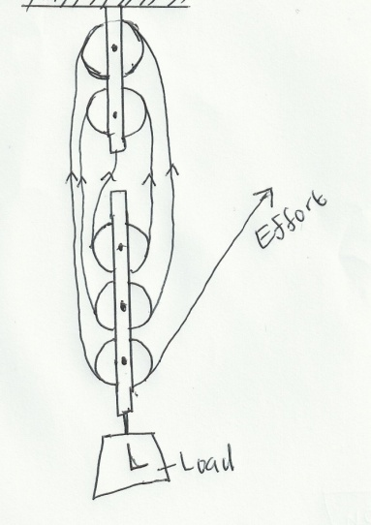

**b) V.R =Number of the ropes supporting the load = 6**

🗸1

**c) **

**M.A = E x V.R**





**Work done against friction = Work input – Work output**

**Mgh**

**Work output = 50 x 10 x 4**

**= 2000J**

**Work input = Effort x distance moved by effort**



**= 2500J**

**Work done against friction = 2500 – 2000**

**= 500J**

**d) Work = total area under the graph**

**= (4000 x 20) + 6000 x 20) + (½ x 6000 x 10) + (½ x 600 x 20)**

**= 80000 + 120000 + 30000 + 60000**

**= 290,000J**

1. **a) The direction is continuously changing.This implies change in velocity**

**hence acceleration.**

**(b) (i)**

**(ii) 2**

**(iii) c=2**

**(iv)**

**(c)(i)**

🗸1

**(ii)**

🗸1

$p=m×slope=20×0.2=4.0N$

**(iii It represents centripetal force**

1. **a) Specific heat capacity is the quantity of heat required to raise the temp.**

**of a unit mass of a substance by one Kelvin.**

1. **i)Heat gained by calorimeter = MCCCΔθ**

**= Heat capacity x Δθ**

**= 40 x (34 – 25)**

**= 40 x 9 = 360J**

**Heat gained by water = MW x CW x Δθ**

**= 0.10 x 4200 x 9**

**= 3780J**

1. **Heat lost by metal block = 3780 + 360 = 4140J**

**(iv) Heat lost by metal block = Heat gained by calorimeter + water**

**Mb x Cb x Δθ = 4140**

**0.15 x Cb x (100 – 34) = 4140**

**(66 x 0.15)Cb = 4140**



1. **I)Q = ML + McΔθ✓1**

$$67200+420x$$





**ii) Heat lost = heat gained**

**67200 + 420x = 67840 – 1696x**

**(420 + 1696)x = 67840 – 67200**

**2116x = 640**

**x = 0.293oC**