NAME………………………………………………… ADM NO. ………………………….. CLASS……

PHYSICS
OPENER EXAMINATION TERM 3, 2022
FORM 3
Time: 2 Hours 30 mins

MULTILATERAL EXAM

INSTRUCTIONS TO THE CANDIDATE:
(a) Write your name and Admission number in the spaces provided above.
(b) This paper consists of two Sections A and B.
(c) There are 11 printed pages, with 21 questions check to confirm that your paper is complete.
(d) Answer all the questions in sections A and B in the spaces provided.
(e) All working must be clearly shown in the spaces provided.
(f) Mathematical tables and electronic calculators may be used.

FOR EXAMINER’S USE ONLY:
Section | Question | Maximum  Score | Candidate’s  Score
A | 1 – 16 | 40
B | 17 | 07
 | 18 | 14
 | 19 | 11
 | 20 | 15
 | 21 | 13
Total Score |  | 100

SECTION A: (40 MARKS)

- A ball bearing is held between the anvil and spindle of a micrometer screw gauge as shown in the Figure 1 below.
Ball bearing
35
30
0
Figure 1

What is the diameter of the ball bearing? (1 mark)
........................................................................................................................................................................................................................................................................................................................................................
- State two properties of a liquid that is suitable for use in a thermometer. (2marks)

..........................................................................................................................................................................................................................................................................................................................................................
- State the basic law of electrostatics. (1 mark)
................................................................................................................................................................ .................................................................................................................................................................

- In an experiment to determine the relative density of a substance using a density bottle the following measurements were taken. (Take density of water to be 1g/cm³)
- Mass of empty density bottle = 43.2 g
- Mass of bottle full of water = 66.4 g
- Mass of bottle filled with liquid X = 68.2g
- volume of liquid X 1mk
……………………………………………………………………………………………………………………………………………………………………………………………………………………………………………………………………………………………………………………………..

II ) Use the data to determine the density of the liquid X. (2marks)
..........................................................................................................................................................................................................................................................................................................................................................
..........................................................................................................................................................................................................................................................................................................................................................
- Why are gases compressible while liquids and solids are almost incompressible? (1mark)
...................................................................................................................................................................................................................................................................................................................................................

- A driver looked into his side mirror and saw a diminished image of a car behind him.
- State the type of mirror the side mirror is made of. (1 mark)
..................................................................................................................................................
- State two reasons why (a) above is preferred as side mirror. (2 marks)
.................................................................................................................................................. ..................................................................................................................................................

- The graph shows variation of extension and stretching force F for a spring which obeys Hooke’s law.

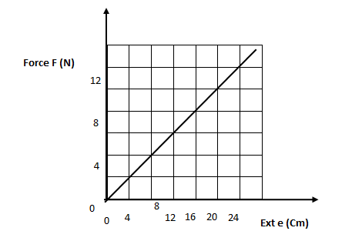
8
- Determine the spring constant in SI units. (2marks)
.......................................................................................................................................................................................................................................................................................................
- The energy stored when the extension is 20cm. (2marks)
...........................................................................................................................................................................................................................................................................................................................................................................................................................................................
- State one factor that would increase the surface tension of pure water in a beaker of water. (1 mark)
............................................................................................................................................................................
- Two rods of copper A and B of the same length but different thickness with candle wax attached to either end are heated as shown in figure 3 below.
Heat
Wax
Wax
A
B

State and explain the observation made. (2 marks)
........................................................................................................................................................................................................................................................................................................................................................
- Figure 4 shows a manometer attached to a gas supply. If the atmospheric pressure is 1.0336 x 10⁵Pa. Calculate the pressure of the gas supply.
(Density of mercury = 13600kg/m³) (3 marks)
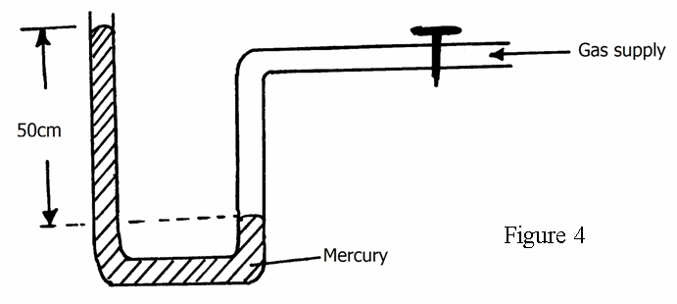
.........................................................................................................................................................................................................................................................................................................................................................
............................................................................................................................................................................
- (a) Define electric current. (1 mark)
................................................................................................................................................................. .................................................................................................................................................................
(b) A current of 3A passes through bulb B for 3 minutes 45 seconds. Determine the quantity of charge through B. (3 marks)

................................................................................................................................................................
................................................................................................................................................................
.................................................................................................................................................................
.................................................................................................................................................................

- The figure 5 below shows two light sheets of paper arranged as shown.
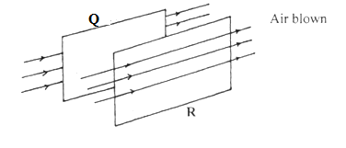

Its observed that the papers move away from each other when strong air is blown at the same time behind paper Q and in front of paper R as shown. Explain (2 marks)
................................................................................................................................................................................................................................................................................................
................................................................................................................................................................................................................................................................................................
- Some plane water waves were produced in a ripple tank. They pass from a region of deep water into a region of shallow water. The figure 6 below shows what the waves look like from above.

Boundary

Direction of wave

Deep water Shallow water

- State what happens at the boundary to:
  - The frequency of the waves. (1mk)

…………………………………………………………………………………………..
  - The speed of the waves (1mk)

………………………………………………………………………………………………
  - The wavelength of the waves (1mk)

……………………………………………………………………………………………

- Define capacitance. (1 mark)

…………………………………………………………………………………………………………………………………………………………………………………………………………………………………………………………………………………………………………
(b) Three uncharged capacitor X, Y and Z, each of the capacitance 12 microfarads, are connected as shown in Figure 7 below

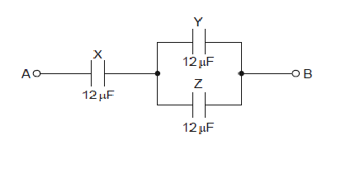
A potential difference of 9.0V is applied between points A and B. Calculate the combined capacitance of the capacitors X,Y and Z. (3 marks)

……………………………………………………………………………………………………………………………………………………………………………………………………………………………………………………………………………………………………………..
…………………………………………………………………………………………………………………………………………………………………………………………………………………………………………………………………………………………………….
- a) figure 8 below Shows the magnetic field pattern of the current carrying conductors shown below. (2 mks)

b) State two factors that determine the strength of an electromagnet. (2 mks)
…………………………………………………………………………………………………………………………………………………………………………………………………………………………………………………………………………………………………………………………….

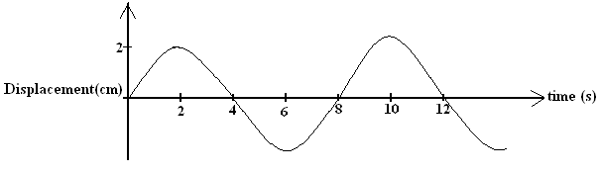
- The figure 9 below shows a wave in progress.
Determine the
a) Amplitude (1 mark)
………………………………………………………………………………………………………………………………………………………………
b) Frequency (2 marks)
………………………………………………………………………………………………………………………………………………………………

SECTION B (60 MARKS)

- A block and tackle is made up of three pulley wheels on top and two pulley wheels at the bottom in figure 10

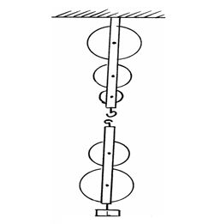

(a) Complete the diagram by drawing the chain which passes over the wheels and indicate where the effort is applied (2 marks)
(b) What is the velocity ratio (V.R) of the machine (1 mark)
................................................................................................................................................
(c) A load of 1120N is lifted by an effort of 250N
Determine
(i) The mechanical advantage (M.A) of the system (2 mark)
..........................................................................................................................................................................................................................................................................

(ii) The efficiency, E, of the system (2 marks)
..........................................................................................................................................................................................................................................................................
- (a) State the principle of conservation of linear momentum. (1mk)
………………………………………………………………………………………………
………………………………………………………………………………………………
- A body of mass 150kg moving at 10m/s collides with a stationary body of mass 100kg. They fuse after collision. Determine the
(i) Total momentum before collision. (2 marks)

..........................................................................................................................................................................................................................................................................

(ii) Their common velocity after collision. (2 marks)

...............................................................................................................................................................................................................................................................................................................................................................................................................
c) (i) State two factors which affect frictional force of a body (2mks)
………………………………………………………………………………………………
………………………………………………………………………………………………
………………………………………………………………………………………………
(ii) Suggest two ways in which friction can be minimized (2mks)
………………………………………………………………………………………………
………………………………………………………………………………………………
(iii) State two advantages of friction (2mks)
………………………………………………………………………………………………
………………………………………………………………………………………………
(d) Give a reason why the inside of a helmet is lined with sponge. (1 mark)

.........................................................................................................................................................................................................................................................................................................................................................

- The figure 11 below shows a balloon filled with air.
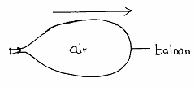

When the mouth is suddenly opened, the balloon moves in the direction shown
above by the arrow. Explain that observation. (2 marks)

..................................................................................................................................................................................................................................................................................................................................

- (a). The section of the tape shown below was produced when a tape running down an incline plane was attached to a ticker-tape timer of frequency 50Hz.

8cm
56cm

i) Indicate above the tape the direction in which the trolley was moving. (1 mark)
ii) What type of current was used to operate the ticker timer? (1 mark)
................................................................................................................................................
iii) Find the acceleration of the trolley in SI units. (3 marks)
................................................................................................................................................................................................................................................................................................................................................................................................................................................................................................................................................................................................
(b). A stone is projected vertically upwards with initial velocity of 40m/s from the ground.
Calculate:
- Time taken to reach maximum height (3 marks)

................................................................................................................................................................................................................................................................................................

- Maximum height reached (3 marks)
................................................................................................................................................................................................................................................................................................
- The graph below shows the variation of p.d (V) across the terminals of a cell and the current drawn from the cell.
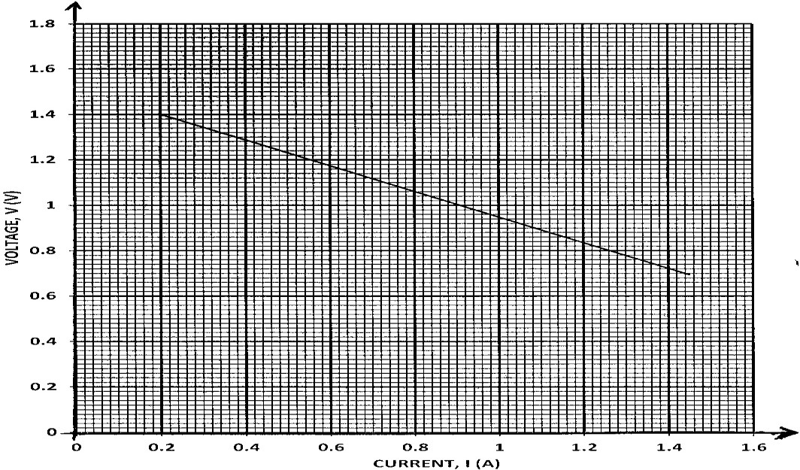

- Use the graph to determine:
  - The electromotive force (e.m.f) E of the cell. (1mk)
……………………………………………………………………………………………………………………………………………………………………………………………..
  - The internal resistance r, of the cell given that E = V + Ir. (3mks)
……………………………………………………………………………………………………………………………………………………………………………………………………………………………………………………………………………………………….
- Draw a circuit diagram that may be used to obtain the values plotted in the graph. (2mks)

- Describe briefly how the circuit you have drawn may be used to carry out the experiment to obtain the values in the graph. (2mks)
………………………………………………………………………………………………………………………………………………………………………………………………………………………………………………………………………………………………………………………………………………………………………………………………………………………………………………………………………………………………………………………………………………………………………………………………………………………………
- Study the circuit diagram below and answer the questions that follow

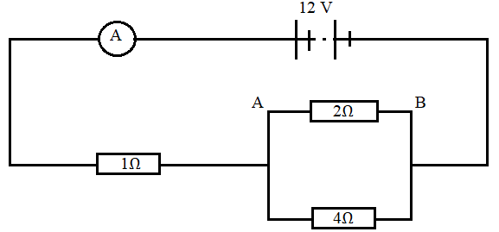
Calculate
- The current flowing through the ammeter. (3 marks)
..................................................................................................................................................................................................................................................................................................................................................................................................................................
ii The PD across AB (2 marks)
.........................................................................................................................................................................................................................................................................................................................................................................................................................................................
Ii The current through the 4Ω (2 marks)
............................................................................................................................................................................................................................................................................................................................................................................................................................................
- (a) State Snell’s law. (1mk)
………………………………………………………………………………………………………………………………………………………………………………………………
- A coin is placed beneath a transparent block of thickness 10cm and refractive index 1.56. Calculate the vertical displacement of the coin. (3mks)

- The speed of green light in a prism is 1.94 × 10⁸m/s.
  - Determine the refractive index of the prism material.
(Speed of light in air = 3.0 × 10⁸m/s). (2mks)

  - Determine the critical angle of the prism material. (2mks)

- State two advantages of using optical fibre in communication. (2mks)
……………………………………………………………………………………………………………………………………………………………………………………………..
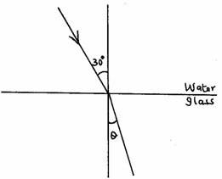
- The refractive indices of water and glass are ³/2 and ⁴/3 respectively. Find the value θ in the figure 13 below. (3mks)

THIS IS THE LAST PRINTED PAGE.

