FORM 3 PHYSICS
OPENER EXAMINATION TERM 3, 2022
MARKING SCHEME.
SECTION A: (40 MARKS)

- A ball bearing is held between the anvil and spindle of a micrometer screw gauge as shown in the Figure 1 below.
Ball bearing
35
30
0
Figure 1

What is the diameter of the ball bearing?
2.50 + 0.33 = 2.88mm (1 mark)
- State two properties of a liquid that is suitable for use in a thermometer. (2marks)
Does not wet the glass
Has a wide range of temperature
It’s a good heat conductor

- State the basic law of electrostatics. (1 mark)
Unlike charges attract while like charges repel.

- In an experiment to determine the density of a substance using a density bottle the following measurements were taken. (Take density of water to be 1g/cm³)
- Mass of empty density bottle = 43.2 g
- Mass of bottle full of water = 66.4 g
- Mass of bottle filled with liquid X = 68.2g
Use the data to determine the density of the liquids.
Volume of liquid X
M= 66.4-43.2 = 23.2g
V = 23.2cm³
Density of liquid X
M = 68.2 – 43.2 = 25.0g
Density = mass/ volume
=25/23.2 = 1.078g/cm3 (3marks)

- Why are gases more compressible while liquids and solids are almost incompressible? (1mark)
Gases have larger intermolecular spaces than liquids and solids.

- A driver looked into his side mirror and saw a diminished image of a car behind him.
- State the type of mirror the side mirror is made of. (1 mark)
Convex mirror

- State two reasons why (a) above is preferred as side mirror. (2 marks)
They produces upright images regardless of object distance.
They have wide range field of view

- The graph shows variation of extension and stretching force F for a spring which obeys Hooke’s law.
Extension e (cm)
0
20
Force F (N)
8
4
12
0
16
12
4
24
8

- Determine the spring constant in SI units. (2mark)
K = F/e = 24-0/12-0 = 24/12 = 2N/cm = 200n/m

ii The energy stored when the extension is 20cm. (2marks) E = 1/2ke²
= ½ x 200 x 0.2²
= 4 J

- State one factor that would increase the surface tension of pure water in a beaker of water.
Lowering the temperature of water. (1 mark)

- Two rods of copper A and B of the same length but different thickness with
candle wax attached to either end are heated as shown below.
Heat
Wax
Wax
A
B

State and explain the observation made. (2 marks)
The wax on rod A falls off first then from B later. A has a longer cross sectional area hence conducts heat faster than B.

- Figure 4 shows a manometer attached to a gas supply. If the atmospheric pressure is 1.0336 x 10⁵Pa. Calculate the pressure of the gas supply.
(Density of mercury = 13600kg/m³) (3 marks)
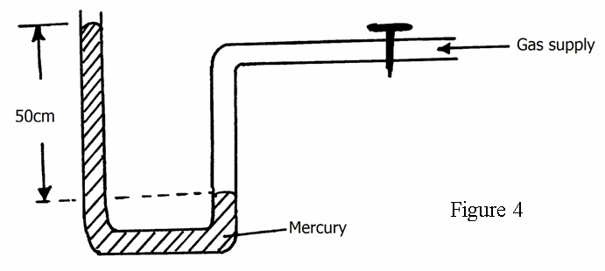

P_{atm} + P_{hg} = P_{gas}
P_{gas} = 0.5 x 13600 x 10 + 1.0336 x 10⁵
= 68000 + 103360 = 171, 360 Pa
- (a) Define electric current. (1 mark)
Its rate of flow of charge or flow of charge per unit time
(b) A current of 3A passes through bulb B for 3 minutes 45 seconds. Determine the quantity of change through B. (2 marks)

Q = It
= 3 x (3 x 60 + 45)
= 675 C

- The figure 5 below shows two light sheets of paper arranged as shown.
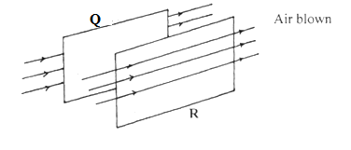
Fig. 5

Its observed that the papers move away from each other when strong air is blown at the same time behind paper Q and in front of paper R as shown. Explain (2 marks)

When air is blown, air moves at high velocity on the outer sides of the paper producing a region of low pressure. Higher atmospheric pressure between them pushes them out.

- Some plane water waves were produced in a ripple tank. They pass from a region of deep water into a region of shallow water. The figure shows what the waves look like from above.
Boundary

Waves move this way

Deep water Shallow water

- State what happens at the boundary to:
  - The frequency of the waves. (1mk)

Frequency not affected
  - The speed of the waves (1mk)

Speed reduces
  - The wavelength of the waves (1mk)

Wavelength reduces

- Define capacitance. (1 mark)
- Ratio of charge to its potential charge per unit potential difference

Three uncharged capacitor X, Y and Z, each of the capacitance 12 microfarads, are connected as shown in Fig 7below

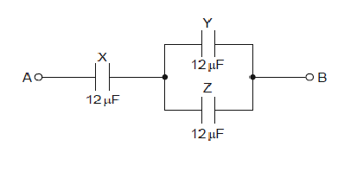
A potential difference of 9.0V is applied between points A and B. Calculate the combined capacitance of the capacitors X,Y and Z. (3 marks)
- parallel =12+12=24
24 and 12 in series
- Product /sum = 24 x12/36
- = 8 microfarads

- Show the magnetic field pattern of the current carrying conductors shown below. (2 mks)

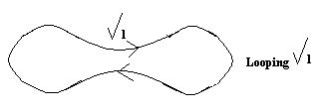

b) State two factors that determine the strength of an electromagnet. (2 mks)
No. of turns
ii) Amount of current Max 2
slope of core

………………………………………………………………………………………………………………………………………………………………………………………………………………………………
- The figure below shows a wave in progress.
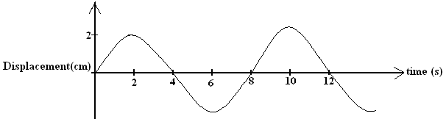

Determine the
a) Amplitude (1 mark)
2/100 = 0.02m

b) Frequency (2 marks)
b) F = 1/T = 1/8HZ

SECTION B (60 MARKS)

- A block and tackle is made up of three pulley wheels on top and two pulley wheels at the bottom in figure 6

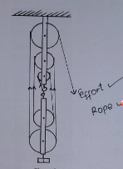

(a) Complete the diagram by drawing the chain which passes over the wheels and indicate where the effort is applied (2 marks)
(b) What is the velocity ratio (V.R) of the machine (1 mark)

VR = 5
(c) A load of 1120N is lifted by an effort of 250N
Determine
(i) The mechanical advantage (M.A) of the system (2 mark)
M. A = 1120/250 = 4.48

(ii) The efficiency, E, of the system (2 marks)
Efficiency = MA/VR = 4.48/5 x 100 = 89.6%

- (a) State the principle of conservation of linear momentum. (1mk)
For a system of colliding bodies the total linear momentum remains constant provided no external forces.
- A rock of mass 150kg moving at 10m/s collides with a stationary rock of mass100kg. They fuse after collision. Determine the
(i) Total momentum before collision. (2 marks)

Momentum = m₁u₁ + m₂u₂
= 150 x 10 +100 x 0
1500Kgm/s

(ii) Their common velocity after collision. (2 marks)

M₁u₁ + m₂u₂ = (m₁ + m₂ ) V
1500 = (150 + 100) V
V = 6m/s

c) (i) State two factors which affect frictional force of a body (2mks)
Normal reaction
Nature of the surface in contact
(ii) Suggest two ways in which friction can be minimized (3mks)
By use of ball bearings
Lubrication by use of oils
Rollers
(iii) State two advantages of friction (3mks)
Enables one to walk
Enables the car to stop when breaks are applied
Lighting fire-matchstick lights because of its friction with the rough surface

d) Give a reason why the inside of a helmet is lined with sponge. (1 mark)

Its meant to increase the time of impact hence reducing the impulsive force produced during the accident.

- The figure below shows a balloon filled with air.
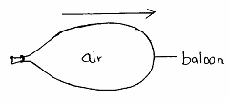

When the mouth is suddenly opened, the balloon moves in the direction shown
above by the arrow. Explain that observation. (2 marks)

the leaving air exert the action action force which produces an equal but opposite reaction.

- (a). The section of the tape shown below was produced when a tape running down an incline plane was attached to a ticker-tape timer of frequency 50Hz.

8cm
56cm

i) Indicate above the tape the direction in which the trolley was moving. (1 mark)
ii) What type of current was used to operate the ticker timer? (1 mark)
alternating current

iii) Find the acceleration of the trolley in SI units. (3 marks)
u = d/t = 8/0.025=400cm/s
or v = f x h 50 x 8 = 400cm/s

v = d / t = 56/0.02 = 2800cm/s
or v = f x h = 56 x 50 = 2800cm/s

a = 2800- 400/( 0.02 x 6) = 200cm/s²

(b). A stone is projected vertically upwards with initial velocity of 40m/s from the ground.
Calculate:
- Time taken to reach maximum height (2 marks)

V = u – gt
0 = 40 – 10t
10t = 40
T = 4s

- Maximum height reached (2 marks)
V² = u² -2gs
0² = 40²- 2 x 10 x s
S = 8 m

- The graph below shows the variation of p.d (V) across the terminals of a cell and the current drawn from the cell.
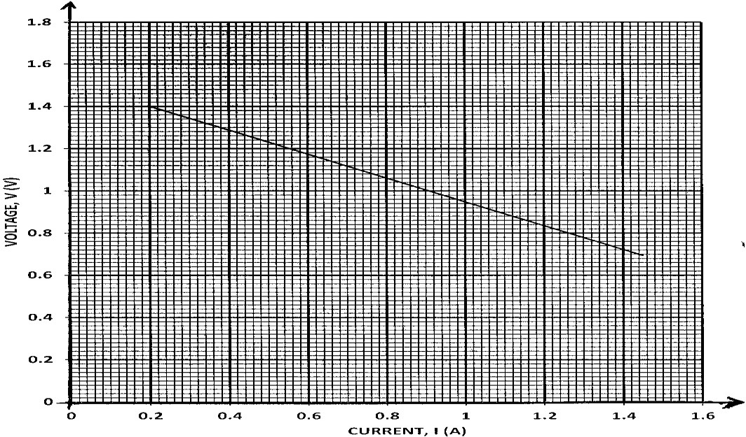

- Use the graph to determine:
  - The electromotive force (e.m.f) E of the cell. (1mk)

E = 1.52 v line graph must be produced to cut the voltage axis
  - The internal resistance r, of the cell given that E = V + Ir. (3mks)

r = change in v/ change in I = (1.4 – 0.8) / (0.2 – 1.26) = 0.57 ohms

- Draw a circuit diagram that may be used to obtain the values plotted in the graph. (2mks)

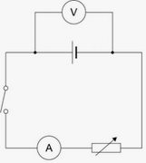

- Describe briefly how the circuit you have drawn may be used to carry out the experiment to obtain the values in the graph. (2mks)

With the the switch closed, adjust the variable resistor so that current is at its minimum. Increase the current using the variable resistor and for each current record the corresponding value of pd across the cell.

- Study the circuit diagram below and answer the questions that follow
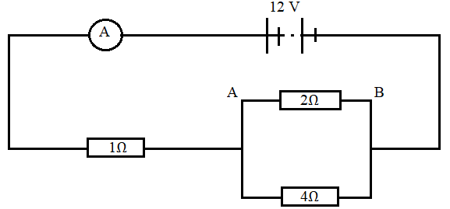
- Calculate
- The current flowing through the ammeter. (3 marks)
Total Resistance 1 + 2x4/(2+4)= 2.333
Current I = 12/2.333 = 5.144A
- The PD across AB (2 marks)
V=IR
=5.144 x 1.33
= 6.841 V
- The current through the 4Ω (2 marks)
I = V/R
= 6.841/4
= 1.710 A

- (a) State Snell’s law. (1mk)

The ratio of the sine of angle of incidence to the sine of angle of refraction is a constant for a pair of media
- A coin is placed beneath a transparent block of thickness 10cm and refractive index 1.56. Calculate the vertical displacement of the coin. (3mks)

n = real depth / apparent depth
  - = 10/ AD
AD = 10/1.56
=6.41cm
- The speed of green light in a prism is 1.94 × 10⁸m/s.
  - Determine the refractive index of the prism material.
(Speed of light in air = 3.0 × 10⁸m/s). (2mks)

n = Velocity of light in air/velocity of light in medium
= 3.0 x 10⁸/1.94 x 10⁸
= 1.546
  - Determine the critical angle of the prism material. (2mks)

Sin c = 1/n

C = sin ⁻¹ ( 1/1.546)
= 40.3⁰
- State two advantages of using optical fibre in communication. (2mks)

-They have carrying capacity
-They are thinner
-They are lighter
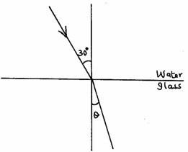
- The refractive indices of water and glass are ³/2 and ⁴/3 respectively. Find the value θ in the figure below.
(3mks)

n₁sin o₁ = n₂ sin o₂
3/2 Sin 30 = 4/3 Sin o
Sin o= 3/2 x ¾ x sin 30
O = Sin ⁻¹ 0.5625
=34.22⁰
THIS IS THE LAST PRINTED PAGE. BEST OF LUCK.

