**NAME: ……………………………………………. ADM NO.…………… CLASS: ……...**

**PHYSICS**

**OPENER EXAMINATION TERM 3, 2022**

**Time: 2 Hours 30 mins**

**MULTILATERAL EXAM**

**INSTRUCTIONS TO CANDIDATES:-**

* *Write your name, Admission number and class in the spaces provided above.*
* *This paper consists of two sections; A and B*
* *Answer all the questions in section A and B in the spaces provided*
* *All working must be clearly shown.*
* *Mathematical tables and electronic calculators may be used*
* *This paper consists of 12 printed pages. Candidates should check to ascertain that all pages are printed as indicated and that no questions are missing.*
* *Candidates should answer the questions in English.*
* *Take g=10N/kg*

**For Examiner’s Use Only:**

|  |  |  |  |
| --- | --- | --- | --- |
| **Section** | **Question** | **Maximum**  **Score** | **Candidate’s**  **Score** |
| **A** | **1 – 14** | **40** |  |
|  | **15** | **11** |  |
|  | **16** | **10** |  |
| **B** | **17** | **10** |  |
|  | **18** | **10** |  |
|  | **19** | **11** |  |
|  | **20** | **8** |  |
| **Total Score** | | **100** |  |

**SECTION A (40 marks)**

1. Figure below shows the readings of a measuring cylinder containing water after an irregular shaped stone has been immersed in it. Initial volume of water in the measuring cylinder was 20cm

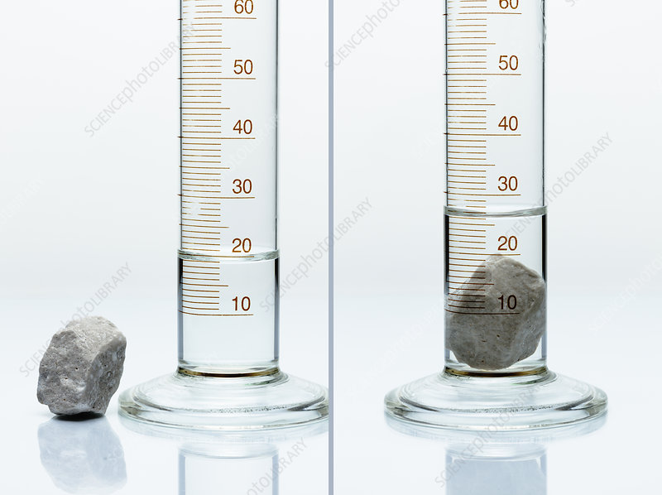

Determine

(i). volume of the stone. (1mk)

………………………………………………………………………………

(ii). Density of the stone given its mass is 50g. (3mks)

…………………………………………………………………………………………………………………………………………………………………………………………………………………………………………..……………………………………………………………………………..…………………………………………………………………………….

1. In a vacuum flask, the walls enclosing the vacuum are silvered inside. state the reason for this. (1mk)

…………………………………………………………………………………………………

1. Explain the following: (2mks)

(i) Wet floors and wet roads are dangerous to walk on.

………………………………………………………………………………….. …………………………………………………………………………………

(ii) Racing cyclist usually wears smooth tight clothes.

…………………………………………………………………………………..

…………………………………………………………………………………

1. State two ways in which a clinical thermometer differs from the normal mercury in glass thermometer. (2mks)

……………………………………………………………………………..

…………………………………………………………………………………

1. Convert each of the following from Kelvin to degrees Celsius. (2mks)
2. 0 K. …………………………………………………………………………………..

…………………………………………………………………………………

1. 326 K.

…………………………………………………………………………………..

…………………………………………………………………………………

1. A mixture consists of 50cm3 of water and 80cm3 of liquid A. If the densities of water and liquid A are 1.0g/cm3 and 0.8g/cm3 respectively. Calculate.

(I) Total mass of mixture. (1mk)

………………………………………………………………………………………………..

……………………………………………………………………………………………….

……………(11).Density of the mixture………………………………………………………………………(2mks)………..

1. .(a) Define the term Brownian motion (1mk)

………………………………………………………………………………..

………………………………………………………………………………..

(b) Differentiate between solids and liquids with relation to intermolecular space and intermolecular force. (3mks)

…………………………………………………………………………………………………..

………………………………………………………………………………………………….

…………………………………………………………………………………………………. ………………………………………………………………………………………………….

1. (a) Define the term temperature and state its SI unit. (2mks)

………………………………………………………………………………………………..

……………………………………………………………………………………………….

(b). Explain why in construction, concrete beams are reinforced with steel. (2mks)

………………………………………………………………………………………………..

……………………………………………………………………………………………….

………………………………………………………………………………………………..

(c). State three effects of anomalous expansion of water. (3mks)

………………………………………………………………………………………………..

……………………………………………………………………………………………….

………………………………………………………………………………………………..

1. (a) State two advantages of mercury over alcohol as thermometric liquid.(2mks)

………………………………………………………………………………………………..

……………………………………………………………………………………………….

………………………………………………………………………………………………..

1. .(a) State the three modes of heat transfer. (3mks)

………………………………………………………………………………………………..

……………………………………………………………………………………………….

………………………………………………………………………………………………..

(b). State any other factor apart from temperature difference affecting thermal conductivity in metals. (2mks)

………………………………………………………………………………………………..

……………………………………………………………………………………………….

………………………………………………………………………………………………

(c). Explain why the ventilators for a room are put near the roof and not near the floor. (2mks)

………………………………………………………………………………………………..

……………………………………………………………………………………………….

………………………………………………………………………………………………..

1. State the laws of reflection. (2mks)

………………………………………………………………………………………………..

……………………………………………………………………………………………….

1. State one applications of electrostatics. (1mk)

………………………………………………………………………………………………..

……………………………………………………………………………………………….

1. State one method of demagnetizing a permanent magnet. (1mk)

………………………………………………………………………………………………..

……………………………………………………………………………………………….

………………………………………………………………………………………………..

1. What is the reading indicated by the micrometer screw gauge below?

(2mks)

0

1

2

3

4

30

25

20

**SECTION B (60MARKS**)

1. (a). State the basic law of magnetism. (1 mark)

………………………………………………………………………………………………..

……………………………………………………………………………………………….

………………………………………………………………………………………………..

(b). The figure below shows how magnets are stored in pairs with keepers at ends.

S

N

A

B

Bar magnets

Keeper

Keeper

Identify pole A…………………. and B……………………. (2mks)

(c). Explain why soft iron keepers are suitable for storing magnets (2mks)

………………………………………………………………………………………………..

……………………………………………………………………………………………….

………………………………………………………………………………………………..

(d) Figure below shows a current carrying conductor. Indicate the direction of current in the conductor hence the magnetic field pattern. (2mks)

conductor

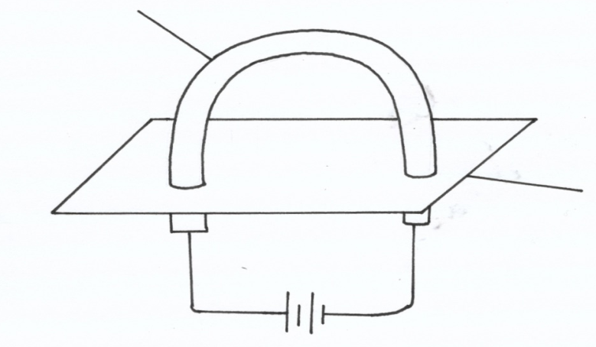

cardboard

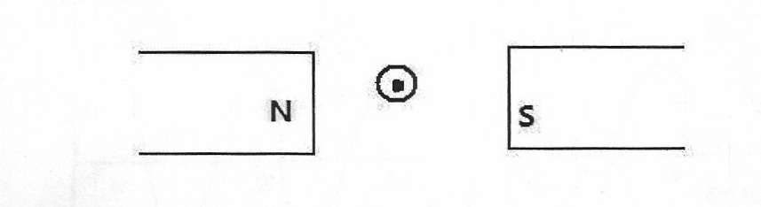 (e). Figure below shows a conductor carrying current placed in the magnetic field of two magnets. Complete the diagram by showing the magnetic field pattern and the direction force F that acts on the conductor. (2mks)

1. State two factors that affect the strength of electromagnet. (2mks)

………………………………………………………………………………………………..

……………………………………………………………………………………………….

1. (a) Differentiate between transverse waves and longitudinal waves…………(2mks)

………………………………………………………………………………………………..

……………………………………………………………………………………………….

……………………………………………………………………………………………….. (b)The figure below shows a wave form in a string.

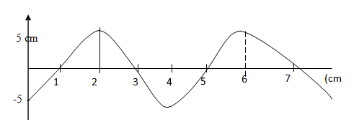

Given that the speed of the wave is 10m/s. With reference to this wave motion, determine;

. (i).Wavelength. (1mk)

………………………………………………………………………………………………..

……………………………………………………………………………………………….

(ii). Frequency. (1mk)

………………………………………………………………………………………………..

……………………………………………………………………………………………….

(iii) Period (3mks)

………………………………………………………………………………………………..

……………………………………………………………………………………………….

(d). A person standing 49.5m from the foot of a cliff claps his hands and hears an echo 0.3 seconds later. Calculate the velocity of the sound in air.

(3mks)

………………………………………………………………………………………………..

……………………………………………………………………………………………….

………………………………………………………………………………………………..

1. (a) In an experiment to estimate the size of an oil molecule, an oil drops of diameter 0.05cm spreads over water to form a circular patch whose diameter is 15cm.

Determine:

(i) Volume of the drop. (2mrks)

………………………………………………………………………………………………..

……………………………………………………………………………………………….

(ii) Area of the patch. (3mks) ……………………………………………………………………………………………….

……………………………………………………………………………………………….

………………………………………………………………………………………………..

(iii) Size of the oil molecule (2mrks)

………………………………………………………………………………………………..

……………………………………………………………………………………………….

(b). State one assumption made in the above calculations. (1mk

………………………………………………………………………………………………..

……………………………………………………………………………………………….

………………………………………………………………………………………………..

(c). Write down each of the following in standard form (2mks)

(i). 0.00000267kg

………………………………………………………………………………………………..

……………………………………………………………………………………………….

………………………………………………………………………………………………..

(ii). 10000000m

………………………………………………………………………………………………..

……………………………………………………………………………………………….

………………………………………………………………………………………………..

1. (a) Define **pressure** and give its S.I nits. (2mks)

………………………………………………………………………………………………..

……………………………………………………………………………………………….

………………………………………………………………………………………………..

(b). The diagram below represents a motor car hydraulic braking system;



Brake fluid

Foot pedal

(i) State **two** properties of the liquid used as a brake fluid (2mks)

………………………………………………………………………………………………..

……………………………………………………………………………………………….

………………………………………………………………………………………………..

(ii) Given that in the diagram **above** the master piston has an area of 15cm2 and the slave piston has an area of 50cm2 a force of 100N is applied on the master piston. Find the force used to stop the car. (3mks)

………………………………………………………………………………………………..

……………………………………………………………………………………………….

………………………………………………………………………………………………..

c. Compare the values of pressure in the two pistons and reason for your answer. (2mks)

………………………………………………………………………………………………..

……………………………………………………………………………………………….

d. Give a reason why gas is not suitable for use in place of the brake fluid. (1mk)

………………………………………………………………………………………………..

……………………………………………………………………………………………….

1. a)State Hookes law. (1mk)

……………………………………………………………………………………………………………………………………………………………………………………………………………………………………………………………………………….

b). A spirsl spring stretches by 0.6cm when a mass of 300g is suspended on it. What is its spring constant. (3mks)

………………………………………………………………………………………………………………………………………………………………………………………………………………………………………………………………………………………………………………………………………………………………………….

c). Two identical springs each of spring constant 3N/cm are used to support a load of 30N as shown.

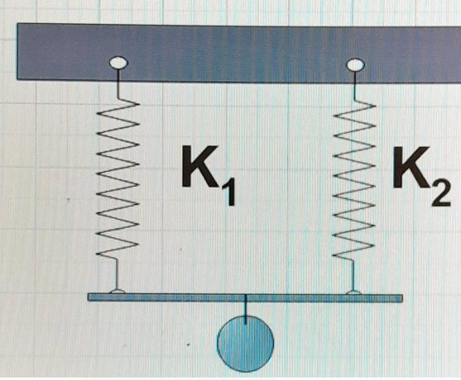

Determine the extension on each spring. (3mks)

……………………………………………………………………………………………………………………………………………………………………………………………….

d). A graph of stretching force F(N) against extension e (mm) for a spiral spring is as shown below.

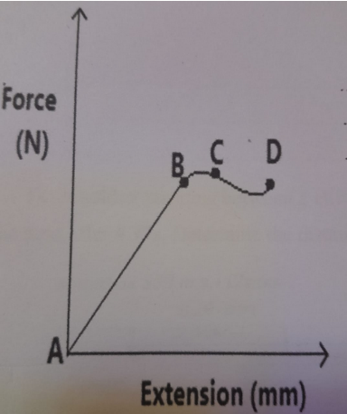

a). Explain the shape of the graph between;

(i). Point Aand B. (2mks)

……………………………………………………………………………………………………………………………………………………………………………………………………………………………………………………………………………..

(ii). Point C and D. (2mks)

……………………………………………………………………………………………………………………………………………………………………………………………………………………………………………………………………………..

20.a). Define the following term as applied to concave and convex mirrors.

Principal focus. (2mks)

………………………………………………………………………………………………………………………………………………………………………………………………………………………………………………………………………………………………………………………………………………………………………….

b). A concave mirror of focal length 10cm forms a virtual image 5cm high and 30cm from the mirror. Calculate;

(i). object distance. (3mks)

…………………………………………………………………………………………………………………………………………………………………………………………………………………………………………………………………………………..

(ii). Magnification of the image. (3mks)