**TERM 2 2022 OPENER EXAM FORM 2**

**PHYSICS FORM THREE**

**MARKING SCHEME**

**Time 1hr 45mins**

1. A spherical ball bearing of mass 0.0024 kg is held between the anvil and spindle of a micrometer screw gauge. Use this information and the position of the scale in the figure below to answer the questions **(a)** and **(b)** below:

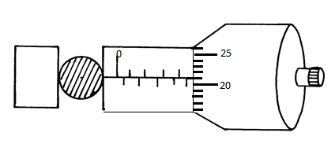

1. What is the diameter of the ball bearing? (1 mk)

**4.71mm**

1. Find the density of the ball bearing correct to 3 significant figures (3 mks)
2. Explain why it is dangerous for a bus to carry standing passengers. ( 2 mks)

**The position of CoG will be raised making the bus unstable**

1. Differentiate between cohesive and adhesive forces. (2mks)

**Cohesive force is the force of attraction between molecules of the same kind**

**Adhesive force is the force of attraction between molecules of the differnt kind**

Explain the cause of random motion of smoke particles as observed in Brownian motion experiment using a smoke cell. (2mks)

**Air molecules are in constant random motion they bombard the smoke particles**

**randomly**

1. The Figure 2 shows two identical thermometers. Thermometer **A** has a blackened bulb while thermometer **B** has a silvery bulb. A candle is placed equidistant between the two thermometers

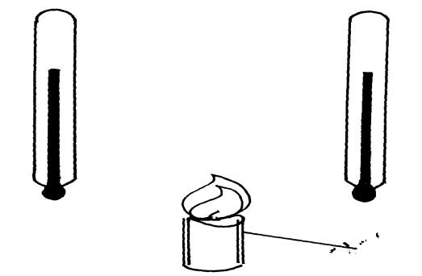

Candle

B

A

State with a reason the observations made after sometime (2 mks)

**Thermometer a will record a high value. Dull surfaces are good absorbers of heat energy**

1. Give a reason why water is not suitable as a barometric liquid. (1 mk)

**It gives a long measurable column of about 10m**

1. A uniform metre rule is balanced as shown below.

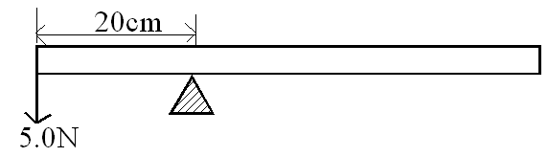

Find the weight of the metre rule (3mrks)

**W= 3.333N**

1. State the difference between a soft magnetic material and a hard magnetic material.(1 mk)

**Soft magnetic materials are materials which are easily magnetized and they don’t retain they magnetism for so long.**

**Hard magnetic materials are materials which are not easily magnetized and they retain they magnetism for so long.**

1. The Figure shows a scale of part of a vernier calliper.

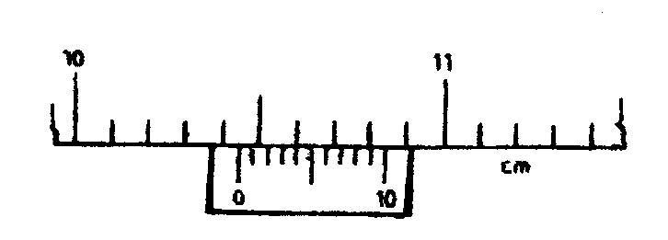

What is theactual reading indicated by the scale if the vernier caliper has a zero of +0.02cm. (2mks)

**10.44 – 0.02 = 10.42cm**

1. A uniform plank of wood is pivoted at its centre. A block of wood of mass 2 kg is balanced by a mass of 1.5 kg placed 30 cm from the pivot as shown in the diagram below. Neglect the mass of the plank

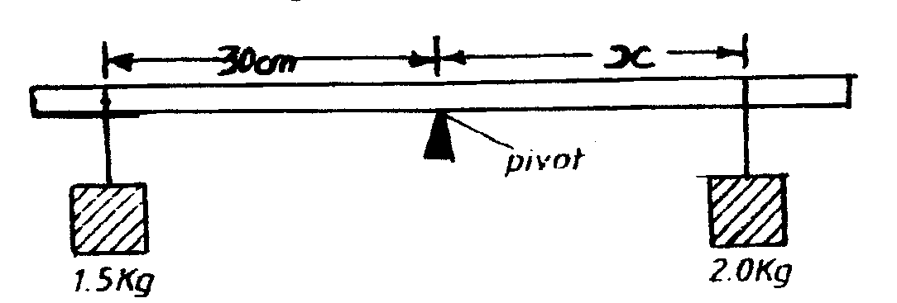

Calculate the distance X. (3mks)

**X = 22.5g**

1. A highly negative charged rod is gradually brought close to the cap of a positively charged electroscope. It is observed that the leaf collapses initially and the leaf diverges. Explain this observation (2mks)
2. State the right hand grip rule.(2maks)

**The right hand grip rule states that if a coil carrying a current is grasped in the right hand such that the fingers point in the direction of current in the coil, then the thumb points in the direction of North Pole.**

1. The figure below shows an object O and its image I formed by a concave mirror.

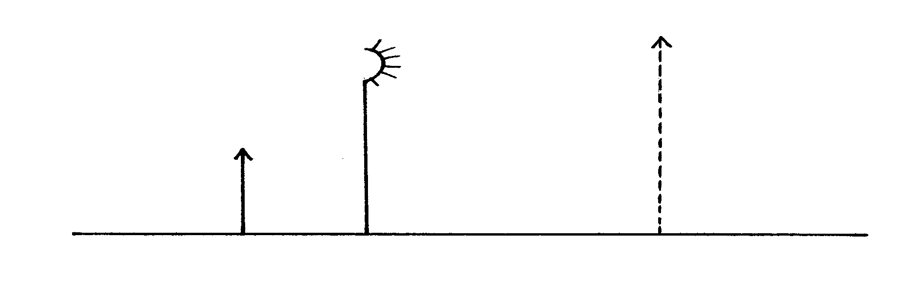

Using suitable rays, to locate the focal length of the mirror. (3mks)

1. The figure **below** shows a uniform rectangular lamina.

Locate and indicate the centre of gravity of lamina. (3mks)

1. Use the information below to answer questions below

In an experiment to determine the density of a liquid, the following readings were made.

Mass of empty density bottle = 20g

Mass of bottle filled with water = 70g

Mass of bottle filled with a liquid = 695g

1. Find the density of the liquid, given that density of water is 1000kgmˉ³. (4mks)

**13.5g/cm3**

1. Find the mass of the liquid. (2mks)

**675g**

1. In an attempt to make a magnet, a student used the double stroke method as shown below.

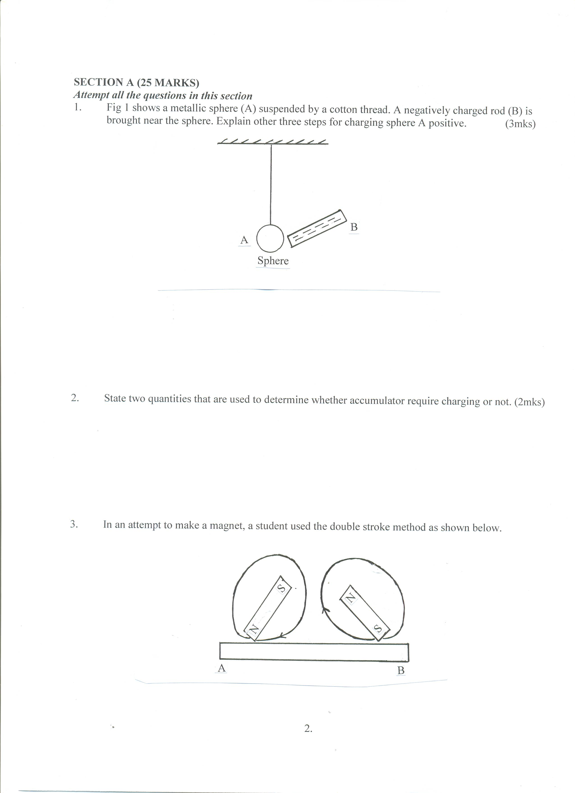

State the polarities at the ends A and B (2mks)

**A South pole B North pole**

1. An object is placed 30cm in front of a concave mirror of focal length 20cm. Determine
   1. Position of the image (3mks)

**60cm**

* 1. Magnification (2mks)

**2**

* 1. Name two applications of concave mirrors (2mks)

**Shaving mirrors**

**By dentist in examining teeth**

**In telescopes for astronomical observations**

**Solar concentrators**

1. A metre rule is balanced by masses 18g and 12g suspended from its ends. Find the position of its pivot. (3mks)

**18 * x = 12(100-x)**

**X =40cm mark**

1. Explain the function of constriction present in a clinical thermometer. (1mrk)

**Prevent backflow of mercury before the nurse record the temperature**

1. Define the term moment of force. (2mrks)

**Moment of a force is the product of the force (F) and the perpendicular distance from the line of of the force and the point of support**

1. State the two laws of reflection (4mks)

**The incident ray, the reflected ray and the normal at the point of incidence all lie on the same plane.**

**The angle of incidence, i, equals the angle of reflection, r.**

1. Give that the diameter of an oil drop is 0.15cm and the diameter of a circular patch formed by the same drop on water is 35.35cm.Calculate the thickness of the oil molecule. (4mks)
2. State two differences between mass and weight.(2mks)

**Differences between mass and weight**

|  |  |
| --- | --- |
| **mass** | **Weight** |
| **1. Its a quantity of matter on a body.** | **1.It is a pull of gravity on a body .** |
| **2. It’s measured in kg.** | **2. It is measured in (N)** |
| **3.Same everywhere .** | **3. Varies from one place to another.** |
| **4. Measured using a beam balance.** | **4.Measured using a spring balance** |
| **5.Has magnitude only (scalar quantity)** | **5.Has both magnitude and direction.(vector quantity)** |
|  |  |

1. Name two factors that affect stability of a body(2mrks)

**The area of the base**

**The position of the centre of gravity**

1. The figure 2, below, U-tube contains two immiscible liquids P and Q. If the density of Q is 900kg/m³ and that of P is 1200kg / m³, Calculate the height of liquid Q. (3 marks)



1. State two defects of a simple cell (2mks)

**Polarisation**

**Local action**