Name: …………………………………………… Adm. No………...... Date……………………...

232
PHYSICS
FORM 1
OPENER EXAMINATION TERM 3, 2022
TIME: 2½ HOURS

MULTILATERAL EXAM THIRD TERM 2022
PHYSICS FORM 1

INSTRUCTIONS TO CANDIDATES:
- Write your name, admission number, date of examination in the space provided above.
- Answer all the questions in the spaces provided.
- All working must be clearly shown in the spaces provided.
- Mathematical tables and electronic calculators may be used.
- This paper consists of 9 printed pages. Candidates should check the question paper to ascertain that all the pages are printed as indicated and no questions are missing

For Examiner’s Use Only

Candidate scores

SECTION A : 40MKS
- The following are branches of physics. Elaborate what each one of them entails.
  - Thermodynamics (1mk)

  - Atomic physics (1mk)

- State how
- physics is related to RELIGION (1mk)

- Physics is related to HOMESCIENCE (1mk)

- Define a LABORATORY (1mk)

- State the first aid measures you would undertake if any of the following calamities befall you:
(a)Cuts (1mk)

(b)Eye damage due to chemicals (1mk)

- (a) Define length stating its SI units (2mk)

(b) A 240 cm long rod when standing perpendicular to the ground cast its shadow 160 cm long on the ground. If a tree casts its shadow 990cm long on the ground at the same time, determine the height of the tree (3mks)

- The diameter of the bore of capillary tube is 2.0mm. Calculate the cross section area of the bore in cm². (take $π=3.142$) (3mks)

- (a) Define density of substance. (1mk)

(b) A cylindrical glass of mass 770 grams has a radius of 7cm and height 20cm. Calculate its density in g/cm3 (3mks)

- The mass of a density bottle is 20g when empty and 45g when full of water. When full of mercury, its mass is 360g. Determine the density of mercury (take density of water to be 1gm/cm³)
Calculate
    - Mass of water (1mk)

    - Volume of water (1mks)

    - Volume of mercury (1mk)

    - Density of mercury (2mks)

- (a) Define a force stating its SI units (2mk)

- A form 1 student has a mass of 60kg. Determine his weight (g = 10N/kg) (2mks)

(c) The figures below shows a free spring and stretched spring. Indicate with arrows the tension forces in fig (ii) (1mk)
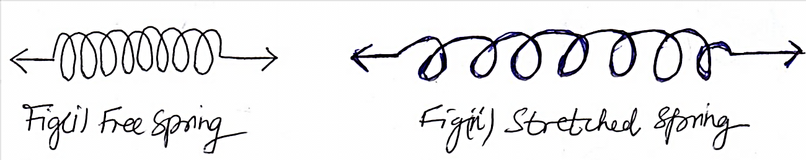

- (a) Name two situations where friction is applied (2mks)

(b) A body weighs 30N in air and 26 N when immersed in water. Determine the upthrust force experienced by the body while inside water (3mks)

- (a) State how the following factors affect surface tension in a liquid (2mks)
    - Presence of impurities

    - Rise in temperature

(b) Explain;
Why the meniscus of water curves upwards as shown below (2mks)
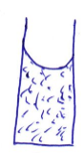

- Trucks which carry heavy loads have many wheels. Explain (2mks)

SECTION B: 60 MKS
- State three (3) differences between MASS and WEIGHT (3mks)
MASS | WEIGHT

- A diver is 8m below the surface of water in a dam. If the density of water is 1000kg/m3 determine the pressure due to the water on the diver (take g = 10N/kg) (3mks)

- (a) State the principle of transmission of pressure in liquids (1mk)

(b)The figure below shows a simple hydraulic press used to compress a bale. The cross section areas of A and B are 0.002m² and 0.30m² respectively
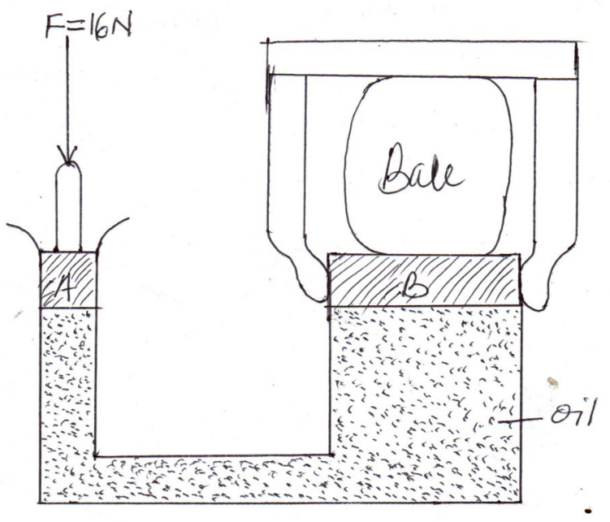
Determine
    - Pressure exerted on the oil by the force 16N applied at A (2mks)

    - Force produced on B compressing the bale. (hint: pressure on B = pressure on A) (3mks)

- (a) Define ATMOSPHERIC PRESSURE. (1mk)

(b) The following diagram shows one limb of a manometer connected to a gas supply. And due to the pressure of the gas Pg the water level in the other limb has risen a height as shown.
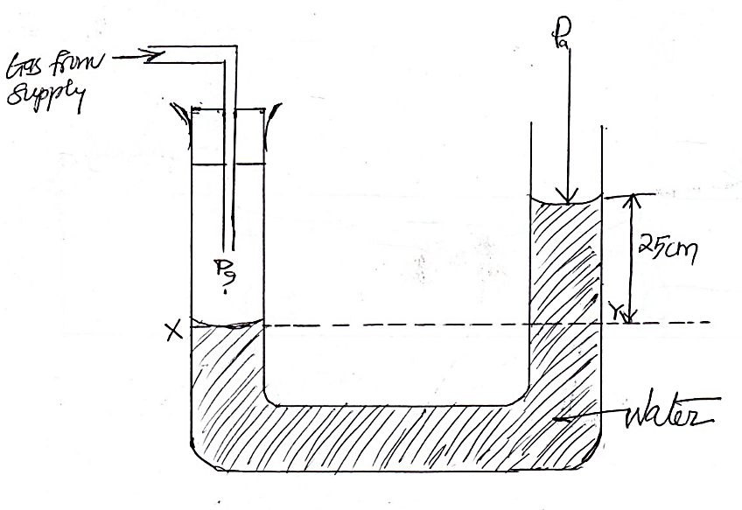
P_{g} = gas pressure
P_{a} = atmospheric pressure
Determine pressure of the gas, Pg given that atmospheric pressure = 103000N/M², density of water = 1000Kg/m³ and g = 10N/kg (3mks)

- A lift pump is used to raise water from wells. Why is the pump unable to raise water the theoretical height of 10m (2mks)

- (a) state the kinetic theory of matter state (1mk)

(b) How does temperature affect Brownian motion (1mk)

(c) Give two reasons why it is possible to compress gases but not solids or liquids (2mks)

- (a) What is diffusion (1mk)

(b) State two (2) factors on which diffusion of a gas depends on: (2mks)

- (a) What is anomalous expansion of water (1mk)

(b) Draw a graph of volume of water against its temperature as it is heated and its temperature is raised from 0°c to 15°c (3mks)
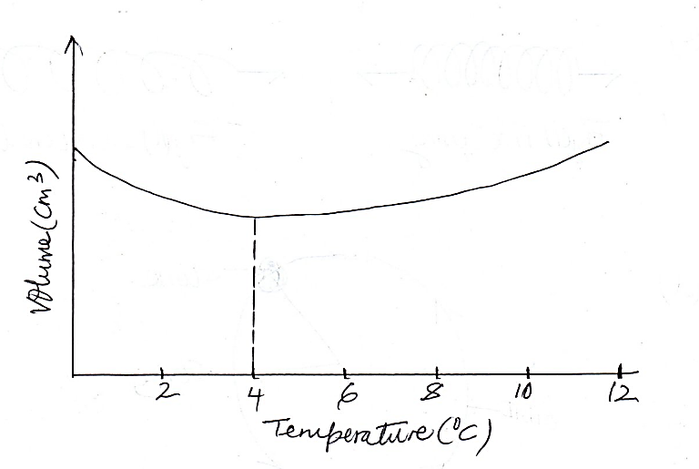

(c) State two effects of anomalous expansion of water (1mk)

- (a) Draw a well labelled diagram of a liquid in glass thermometer (3mks)
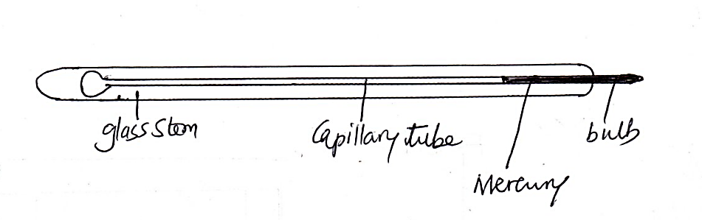

(b) state the functions of the main features of the thermometer you’ve drawn above (3mks)

- State three (3) differences between alcohol and mercury as thermometric liquids (3mks)
Alcohol | mercury
- (a) Differentiate between heat and temperature (2mks)

- (a) State the three factors affecting thermal conductivity of a material (3mks)

- (a) Define convection (1mk)

(b) State two types of convections (2mks)

(c) In an experiment to demonstrate convection currents in gases, in which a candle was lighted underneath chimney B and a burning straw attached to chimney A as shown below. Show on the diagram what happens to the smoke that is produced by the burning straw (2mks)
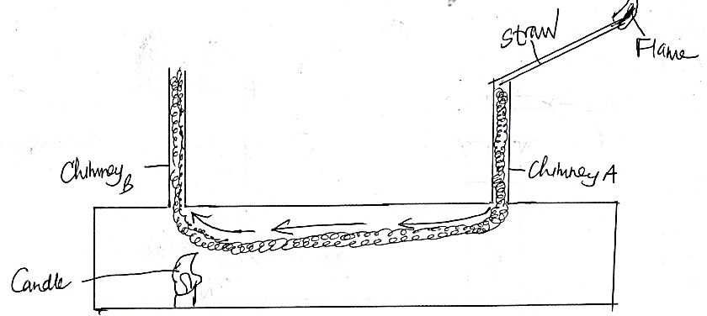
(c) Give an explanation of what you have indicated in the diagram in 27 (b) (3mks)

- (a) Define thermal radiation (1mk)

(b) In an experiment to compare absorption of heat by different surfaces, the following setup was used and temperatures by thermometers T_{A} and T_{B} were recorded after 2 minutes. Water in tins A and B was cold at the same temperature at the beginning of the experiment and the source of heat, H placed equal distant from tins A and B.
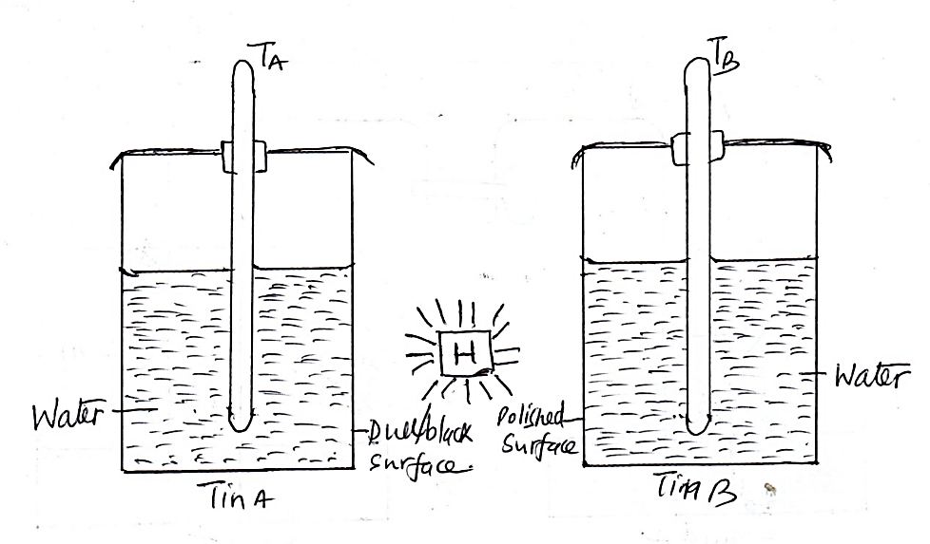
- Which of the two thermometers recorded the higher reading (1mk)

- Give a reason for your answer in (i) above (2mks)

- What conclusion can you draw from the graph you have drawn (1mks)

- State which feature in the thermos flask (vacuum flask) reduces heat loss through
  - conduction and convention (1mks)

  - . radiation (1mk)

  - Evaporation (1mk)

