Name………………………………………………………... Adm No ……………………………...
Candidate’s Signature ………………………………………………. Date: ………………………………...
121/1
MATHEMATICS
Paper 1
Time: 2¹/₂ Hours

Kenya Certificate of Secondary Education (K.C.S.E)

INSTRUCTIONS TO THE CANDIDATES
- Write your name and index number in the spaces provided above
- This paper contains two sections; Section 1 and Section 11.
- Answer all the questions in section 1 and only five questions from Section 11
- All workings and answers must be written on the question paper in the spaces provided below each question.
- Marks may be given for correct working even if the answer is wrong.
- Calculations and KNEC Mathematical tables may be used EXCEPT where stated otherwise.
- Show all the steps in your calculations, giving your answers at each stage in the spaces below each question.

FOR EXAMINERS’S USE ONLY
Section 1
Question | 1 | 2 | 3 | 4 | 5 | 6 | 7 | 8 | 9 | 10 | 11 | 12 | 13 | 14 | 15 | 16 | Total
Marks

Section 1I GRAND TOTAL
Question | 17 | 18 | 19 | 20 | 21 | 22 | 13 | 24 | Total
Marks

This paper consists of 16 printed pages. Candidates should check carefully to ascertain that all the pages are printed as indicated and no questions are missing.

SECTION I (50 MARKS)
Answer all questions in this section in the spaces provided.
- Without using a calculator ,evaluate

Giving your answer as mixed fraction (3mks)

- Two boys and a girl shared some money. The younger boy got of it; the elder boy got of the remainder and the girl got the rest. Find the percentage share of the younger boy to the girl’s share. (4mks)

- Three numbers, 1400,1960 and n have a G.C.Dand L.C.M of 70 and 2² x 5² x 7² x 11 respectively.Find the least possible value of n (3mks)

- A bus starts off from Kitale at 9. a.m and travels towards Kakamega at a speed of 60km/hr. At 9.50 a.m, a matatu leaves Kakamega and travels towards Kitale at a speed of 60Km/h. How far from Kitale will the two vehicles meet? ( 3mks)

- Find the equation of a straight line which is equidistant from the points A(2,3) and B (6,1) (3mks)

- Simplify the expression completely (3mks)

12x ² – 16x
20 - 11x – 3x²

- Given that sin θ = and θ is an acute angle, find without using tables tan² θ + Cos² θ. Give your answer as a mixed fraction. (3mks)

- Solve for y in the equation below. (4mks)

8(2²)^{y} = 6 (2^{y}) – 1

- Using a ruler, a pair of compasses only and (proportional) a set square, construct on the upper side division of line BC, a line BD such that DBC = 37.5º. Use the line BD to divide BC into 4 equal portions. (3mks)

- Sketch the net of the solid below. (2mks)
C
F
E
4cm
4cm
12cm
5cm
D
5cm

6cm
A
B

- In a regular polygon, each interior angle is xº and each exterior angle is
- Find angle Xº (1mk)

- Find the number of sides of the polygon (2mks)

- The figure below represents a plot of land ABCD such that AB= 85m, BC 75m CD= 60m DA = 50m and angle ACB = 90º. (not drawn to scale)

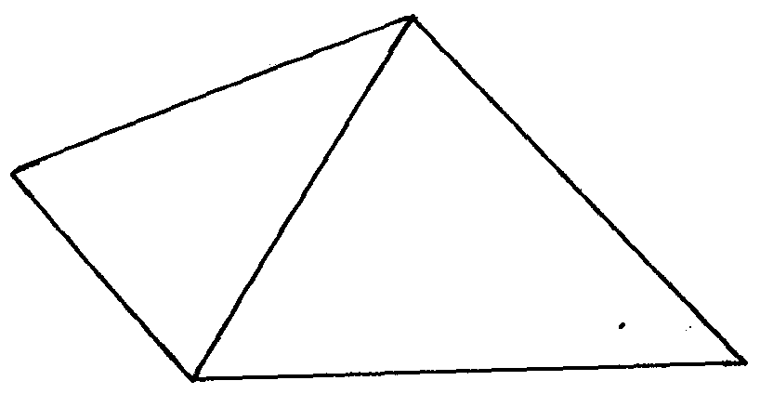

D
A
B
C
60m
50m
85m
75m

Determine the area of the plot, in hectares correct to two decimal places. (4mks)

- An open rectangular box measures externally 32cm long, 27cm wide and 15cm deep. The box is made up of metal 1cm thick. If it has a mass of 1.5kg, what is the density of the box to 4 significant figures? (3mks)

- Find the integral values of x which satisfy the following inequalities;
2x + 3 > 5x – 3 > -8 (3mks)

- A Kenyan bank buys and sells foreign currency as shown below.

 | Buying Ksh | Selling Ksh
1 US dollar ($) | 63.00 | 63.20
1 UK pound (£) | 125.00 | 125.95

A tourist arrived in Kenya with £ 9600 which he converted into Kshs at a commission of 5%. He later used ¾ of the money before changing the balance of dollars at no commission calculate ; to the nearest dollar, the amount he received. (3mks)

- The histogram shown below represents the distribution of marks obtained in attest. The bar marked A has a height of 3.2 units while B has aheight 1.2 units. If the frequency of the class represented by B is 6, find the frequency of the bar represented by A. (3mks )

Frequency density

3

2
A

B
A
1

74.5
84.5
69.5

SECTION II (50 MARKS)
Answer any five questions in this sections in the spaces provided.
- The figure below (not drawn to scale) shows a quadrilateral ABCD inscribed in a circle. AB = 5cm, BC = 8cm, CD = 7cm andAD = 8cm. AC is one of thediagonals of length 10cm.

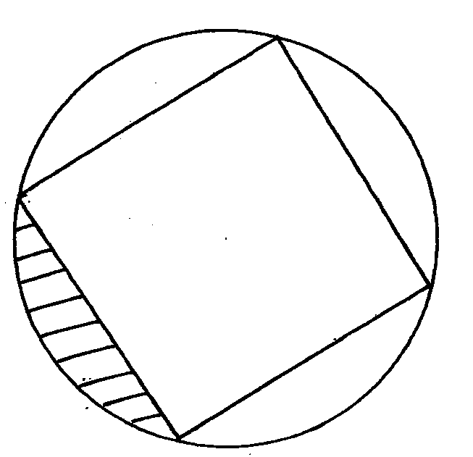

8cm
D
C

7cm
B
A
8cm
5cm

- Find the size of angle ABC. (3mks)

- Find the radius of the circle. (2mks)

- Hence, calculate the area of the shaded region. (5mks)

- In the figure below OB = b , OC = 3OB and OA = a
∼
∼

- Given that OD = 1/3 OA and AN = ½ AC, CD and AB meet at M. Determine in terms of a and b
∼
C
N
∼
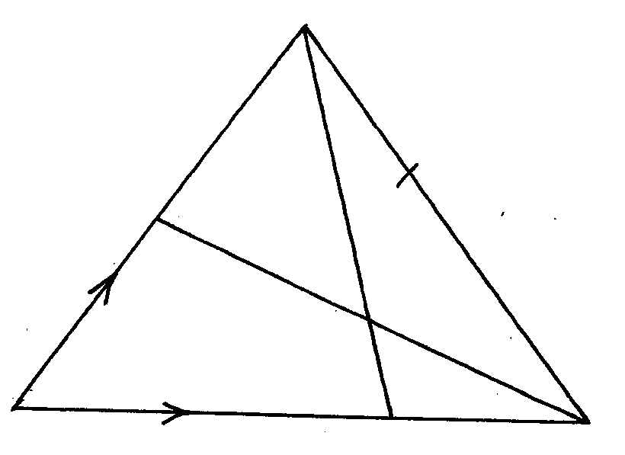

B

O
M
D
A

- AB (1mk)

- CD (1mk)

- Given that CM = k CD and AM = hAB determine the values of the scalars k and h (5mks)

- Show that O,M and N are collinear. (3mks)

- Three variables p, q and r are such that p varies directly as q and inversely as the square of r.
  - When p = 18, q = 24 and r = 4.
Find p when q = 30 and r = 10. (4mks)

  - Express q in terms of p and r. (1mk)

  - If p is increased by 20% and r is decreased by 10% find:
    - A simplified expression for the change in q in terms of p and r. (3mks)

    - The percentage change in q. (3mks)

- A circular lawn is surrounded by a path of uniform width of 7m. The area of the path is 21% that of the lawn.
- Calculate the radius of the lawn. (4 marks)

- Given further that the path surrounding the lawn is fenced on both sides by barbed wire on posts at intervals of 10 metres and 11 metres on the inner and outer sides respectively. Calculate the total number of posts required for the fence. (4 marks)

- Calculate the total cost of the posts if one post costs sh 105. (2 marks)

- The diagram below represents two vertical watch – towers AB and CD on a level ground. P and Qare two points on a straight road BD. The height of the tower AB is 20m and road BD is 200m

20m
A
B
P
Q
D
C

- A car moves from B towards D. At point P, the angle of depression of the car from pointsA is 11.3ºCalculate the distance BP to 4 significant figures. (2mks)

- If the car takes 5 second to move from P to Q at an average speed of 36km/hr, calculate the angle of depression of Q from A to 2 decimal places. (3mks)

- Given that QC = 50.9 cm, calculate
(i) The height of CD in meters to 2 decimal places; (2mks )

(ii) The angle of elevation of A from C to the nearest degree. ( 3mks)

- The parents of acertain mixed secondary school decided to buy a school van worth Ksh. 900,000. Each student was to contribute the same amount of money. 50 students were transferred from the school; as a result each f the remaining students had to pay Ksh. 600 more.
- Find the original number of the students in the school. (5mks)

- Find the percentage change in contributions per student. (3mks)

- If the ratio of boys to girl in the school was 11: 7 find the amount money contributed by boys alone.

(2mks)

- Five members of ‘SILK’, a self-supporting enterprise Jane, Jepchoge, Esther, Mama Charo and Chepkoech were given a certain amount of money to share amongst themselves. Jane got 3/8 of the total amount while Jepchoge got 2/5 of the remainder. The remaining amount was shared equally among Esther, Mama Charo and Chepkoech each of which received Kshs. 6,000;
  - How much was shared among the five business women? (3mks)

  - How much did Jepchoge get? (2mks)

  - Jane, Jepchoge and Chepkoech invested their money and earned a profit of Kshs. 12,000. A third of the profit was left to maintain the business and the rest was shared according to their investments. Find how much each got. (5mks)

- Onyango and Juma live 200km apart. One day, Onyango left his house at 7.00am and travelled towards Juma’s house at an average speed of 30km/hr. Juma left his house at 7.30am on the same day and travelled towards Onyango’s at an average speed of 40km/hr.
- Determine:-
    - The time they met. (2mks)

    - The distance from Onyango’s house where the two met. (2mks)

    - How far was Onyango from Juma’s house when they met? (2mks)

- The two took 15 minutes at the meeting point and then travelled to Juma’s house at an average speed of 20km/hr. Find the time he arrived at Juma’s house.(2mks)

