MIDTERM 2 EXAMINATIONS 2022
MATHEMATICS
FORM 3 TIME: 1 ½ HOURS
SECTION I: 20 MKS (Answer all questions in this section)
- Given that$P=\left[\begin{matrix}1 & 2 \\ 0 & 4\end{matrix}\right]$, $Q=\left[\begin{matrix}2 & 0 \\ 1 & 3\end{matrix}\right]$ and$R=\left[\begin{matrix}3 & 0 \\ 2 & 2\end{matrix}\right]$, find $3P+2Q-R$ (3mks)

- Find the value of x and y in the matrices below: (3mks) $\left[\begin{matrix}x & y\end{matrix}\right]\left[\begin{matrix}2 & 4 \\ 1 & 3\end{matrix}\right]=\left[\begin{matrix}7 & 17\end{matrix}\right]$

- (a) Find the inverse of the matrix $\left[\begin{matrix}2 & 4 \\ 1 & 3\end{matrix}\right]$ (1mk)

(b) Hence, solve the following pair of simultaneous equations using matrix method
$$2x+4y=12$$
$x+3y=8$ (3mks)

- In the figure below, ABCD is a cyclic quadrilateral and BD is a diagonal. EADF is a straight line, ﮮCDF =68º, ﮮBDC = 45º, and ﮮBAE = 98 º.
Calculate the size of:
  - ﮮABD (2mks)

  - ﮮ CBD (2mks)

- In the figure below, BT is a tangent to the circle at B. AXCT and BXD are straight lines. AX = 6 cm, CT = 8 cm, BX = 4.8 cm and XD = 5 cm.
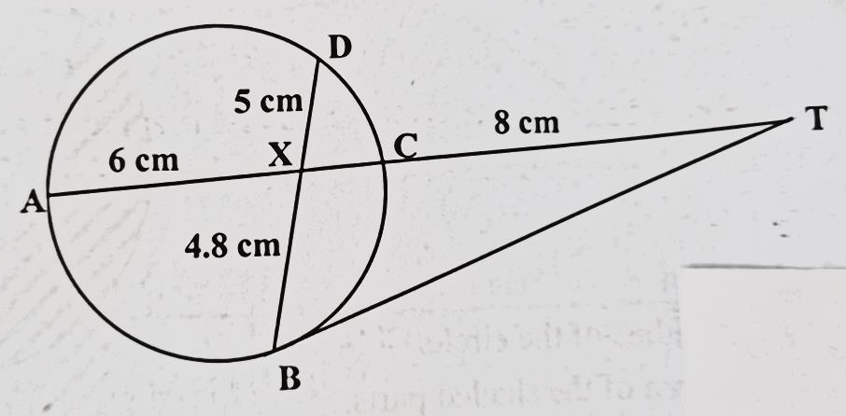
Find the length of:
  - XC (2mks)

  - BT (2mks)

- Calculate the accumulated amount on a loan of sh.9 000 for 2 years at 12.5% p.a. compounded semi-annually. (2mks)

SECTION II: 30 MKS (Answer all questions in this section)
- In the figure below, P, Q, R, and S are points on the circle centre O. PRT and USTV are straight lines. Line UV is a tangent to the circle at S, angle RST = 50⁰ and angle RTV =150⁰.
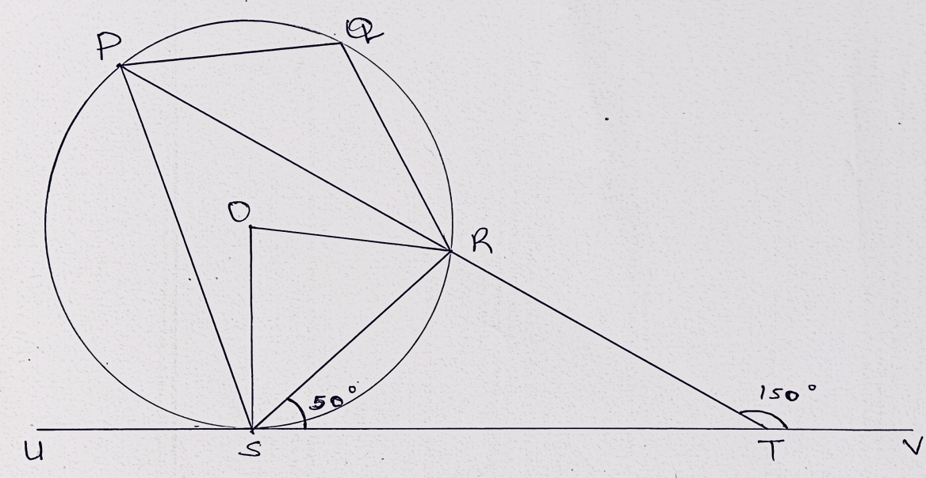
- Calculate the size of :
- Angle ORS (2mks)

- Angle USP (1mk)

- Angle PQR (2mks)

- Given that RT = 7 cm and ST = 9 cm, calculate to 3 significant figures:
  - The length of line PR (2mks)

  - The radius of the circle (3mks)

- Income tax for all the income earned was charged at the rates shown.
Total Income p.a. (K.£) | Rate in sh. per K£
1 – 1980  1981 – 3960  3961 – 6440  6441 – 7920  7921 – 9900  Excess of 9900 | 2  3  5  7  9  10
  - Peter earned a salary of Kshs.10 500 per month. In addition he was given a house allowance of Kshs. 6500 per month. He got tax relief of Kshs. 300 per month. Find ;
- His taxable income p.a. (2mks)

- Income tax he pays per month, correct to 1 decimal place. (5mks)

  - A part from income tax the following deductions are made per month. NHIF of Kshs.320, widow and pension scheme of 2% of his gross salary. Calculate his net monthly pay, correct to 1 decimal place. (3mks)

- A youth group decided to raise Ksh 480,000 to buy a piece of land costing Ksh. 80,000 per hectare. Before the actual payment was made, four of the members pulled out and each of those remaining had to pay an additional Kshs. 20,000.
  - If the original number of the group members was x, write down;
- An expression of how much each was to contribute originally. (1mk)

- An expression of how the remaining members were to contribute after the four pulled out. (2mks)

  - Determine the number of members who actually contributed towards the purchase of the land. (4mks)

(c) Calculate the ratio of the supposed original contribution to the new contribution. (2mks)

(d) If the land was sub-divided equally, find the size of land each member got. (1mks)

