NAME…………………………………………………………………………….
ADM.NO……………………….………………….CLASS………………….
MID – TERM 3 EXAM
MATHEMATICS PAPER 1
FORM THREE 2022

INSTRUCTION TO CANDIDATES
- Write your name and admission number in the spaces provided above.
- This paper consists of two sections A and B.
- Answer all the questions in section A and any FIVE questions in section B.
- All working must be clearly shown.
- Silent non-programmable electronic calculators and mathematical tables may be used.
- This paper consists of 13 printed pages.
- Students should check the question paper to ascertain that all pages are printed as indicated and that no question is missing.
- Candidates should answer the question in English.

Section A: Answer all questions in this section
- Simplify$\frac{\frac{2}{3} of 5\frac{2}{5}-2\frac{2}{10}}{\frac{3}{5}÷4\frac{1}{2}+1\frac{3}{5}}$ (3mks)

- Given that$X:Y=2:3$, find the ratio$(5X-4Y):(X+Y)$. (3mks)

- Ken has three buckets of capacities 18 litters ,24 litters and 30 liters .He tries filling them with containers of different capacities in order to find out which one can fill each of the buckets exactly .Find the greatest capacities of the container that he should use to accomplish his goal (3mks)

- If it takes 20 men, 10 days to lay 300 meters of pipes. Find how many days it will take 15 men to lay 270 meters of pipes.(3mks)

5) Calculate the area of an equilateral triangle of side 25cm. (3mks)

- The sum of the exterior angles of a pentagon is 3x+3y while the sum of its interior angles is 12y-6x. Find the values of x and y.(3mks)

- If the position vector of A and B are A=3ḭ-5į+2ḵ and B=2ḭ+į-3ḵ, respectively, Find AB. (3mks).

- Five is subtracted from a certain number, the result doubled and then divided by 3. If the answer is 10, Find the number.(2mks)

- The table below shows the heights to the nearest centimeter of 100 seedlings in a nursery.
Height(cm) | Frequency
10-14 | 12
15-19 | 20
20-24 | 48
25-29 | 14
30-34 | 16

- State the modal class.(1Mk)

- Calculate the median height(2mks)

- Arrange all the prime numbers between 10 and 20 in ascending order to form a number. Hence state the total value of the fourth digit from the left of the number that is formed. (2mks)

- Solve for x in the following equation. (4mks)
$$\log_{4}{9-\log_{4}\left(3x+2\right)=1+\log_{4}{(3x-2)}}$$

- Write down the integral values of x that satisfy the following inequalities.(3 Mks)
$$3<13-2x$$
$$12+5x≥7$$

- Find the negative values of t if, $x^{2}+tx-(t-3)$ is a perfect square. (3 Mks)

- If the line through P(-3,9) and Q(6,-3) cuts the y-axis at T, determine the coordinates of T. (3 mks)

- A hospital A, B, and C are such that B is 18KM North of A and C is 25KM from A. C is on bearing of 160ﹾ from B. Calculate the bearing of A from C.(3mks)

- Without using a calculator, evaluate: (3mks)
- $\frac{-9+\left(-7\right)×\left(-8\right)-(-5)}{-2+(-6)÷3×6}$

- $I$f$\frac{mn^{2}}{m^{3/4}} ÷\frac{m^{t}}{n^{k}}=m^{\frac{-3}{4}}n^{4},$ Find $2t+k$. (3mks)

SECTION B
Answer any FIVE questions you are comfortable with.
(17)On a grid provided ,draw a square MNPQ whose vertices are ;M(-5,-2), N (-4,-2) , P (-4 ,-3) (1MK)
(a)On the same axis as in (a) above , draw M!N!P!Q! the image of MNPQ under enlargement scale factor -3 , center (-2,-1) (3mks)

(b)M”N” P” Q” , The image of M!N!P!Q! Under a reflection on the line y=0 (3mks)

(c)M”! N”! P”! Q”! the image of M” N”P” Q” positive two quarter turn about the origin (3mks)

(18)Mahinda sold 180 bags of maize in September 2018. The cost of each bag was sh. 2800. Calculate the amount of money that he received from the sale of maize that month. (1mk)

- In October that year, the price of a bag of maize decreased by 24% and the number of bags that he sold increased by 30%. Determine the percentage decrease in the amount of money he recovered from the sale of maize.(3mks)

- In November that year, the price of a bag of maize changed in the ratio 7:8. Find the price of each bag in November. (2mks).

- The amount that he received from the sale of maize in September was Sh.1260 more than what he received in November. If the number of bags that were sold in November were $t\%$ more than those that were sold in September. find $t.$(4mks)

(19)In the figure below, $OA=ạ$and $=ḇ$ . Points M and N are on sides OA and OB respectively. Such that OM:MA=3:5 and ON:NE=2:1

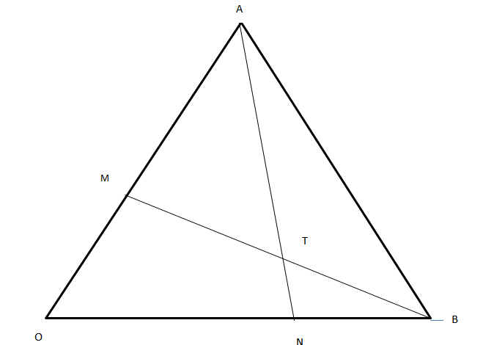
- Express the following vectors in terms of ạ and ḇ
- AB (1mk)

- AN(1mk

- BM (1mk)

- Lines AN and BM intersect at T such that AT=hAN and BT=k BM. By expressing OT in two different ways, Find the values of h and k. (5Mks)

- OT is produced to a point Q on AB. if 2AQ=5QB, use the ratio theorem to find OQ in terms of ạ and ḇ (2Mk)

(20)Wax is melted and then transferred into two containers A and B. Glass cubes and metallic cubes of different size are then sunk into the wax in the two containers. The wax in each container is then left to cool with cubes in it. The masses of the material from containers A are in the ratios glass:wax=2:15 and wax:metal=3:1
- Find the ratio glass:metal:wax in the material from contain A (Where the ratio is that of masses, not volumes).(2mks)

- Each of the two groups of material that were emptied from the containers had a mass of 440g. If the ratio of the total mass of the metal cubes from container A to that of the metal cubes from container B is 5:6. Find:
- The mass of glass cubes from container(2mks)

- The total mass of wax and glass cubes from container(2mks)

- If the ratio of the mass of wax to that of glass cubes from container B is 3:1 how much less is the mass of wax from container B than the mass of wax from container A? (3mks)

(21) A salesman is paid a commission of 2.5% on sales worth sh. 150 000. He is also paid a monthly salary of sh.15 000. In January 2018, he sold 28 men’s suits and 42 ladies’ suits. If each of the men’s suits costs Sh. 4500 and each of the ladies’ suit costs Sh.3500:
- Calculate the salesman’s January 2012 earnings. (3mks)

- In February 2018, the salesman’s monthly salary was increased by 5%. His total earnings that month were Sh. 17 575. Calculate
- The total amount of money received from the sales of men’s suits if ladies’ suits sold were 18 more that of men’s suits. (5mks)

- The amount he could have earned in February had he allowed a discount of 5% on suit. (2mks)

22) The measurements, in the metres , of a fruit farm using a base line $AB=260m$ were recorded as shown below.
 | B
 | 210 | 80 to P
to N 70 | 170
 | 140 | 30 to Q
to M 40 | 60 | 60 to R
 | A
- Use a suitable scale to draw from the map of the farm.(4mks)

- Find the area of the farm in hectares. (6mks)

23)Terry and Gelishoni live in two towns 240kmapart. One day at 9: 45 a.m. Terry left his town and drove towards Gelishontown at an average speed of 60km/h .Gelishoni left his town at 10:50 a.m. On the same day and drove towards Terry town at an average speed of 80km /h
a) Find the distance from Terry to the place where the two met (5mks)

b) The time two met (2mks)

- The two continued on their respective journeys until each reached in their destination.Determine who reached his destination earlier and by how long (3mks)

24) Using a rule and a pair of compass only construct triangle PQR in which QR =5cm,PR=7cm and angles PRQ=135 (3MKS)

(b) Measure angle PQR (1mk)

(c) At P drop a perpendicular to meet QR produced at T (1MK)
(d) Measure PT (1mk)

(e) Construct a circle touching the points PQR (2mks)

(f) Find the area of the circle (2mks)

