PANGANI POST MOCK EXAMINATION
2022
MARKING SCHEME

Kenya Certificate of Secondary Education (K.C.S.E)

121/2 MATHEMATICS ALT. A
MARKING SCHEME

SECTION I
No. | Marking scheme | Marks | Comments
 |  | M1  M1  M1  A1 | All ✓ logs  Attempt to +, -  Attempt to  CAO
  Number | Logarithm | Working
  23.56  0.28²  4329  7.528  = 0.007528 | 1.3721  .8944  0.2665  3.6364  .6301  8767 | .4472  .4472  _________  .8944  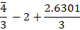  .8767
 |  | 04
 | d² = P² 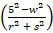  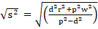  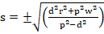 | M1  M1  A1 | Taking squares on both sides  collecting terms in s²  ✓answer with ±
 |  | 03
 | 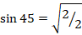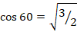  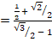  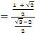  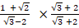  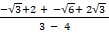 | B1  B1  M1  A1 | all ✓ ratios  ✓simplified forms of Num. & Den.  × by ✓conjugate  Acc.
 |  | 04
 | 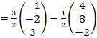  =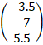  (2dp) | M1  A1  B1
 |  | 03
 | 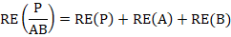 | M1  M1  A1
 |  | 03
 | . 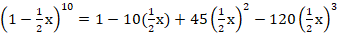 | B1  M1  A1
 |  | 03
 | 276  240  300  A  B  2  :  3  :  ratio | B1  B1  B1 | for 276  ✓simplified ratio
 |  | 03
 | P | B1  B1  B1 | ✓table  ✓values of (x – y)
  y  x | 0 | 1 | 2 | 3 | 4 | 5 | 6
  0 | 0 | -1 | -2 | -3 | -4 | -5 | -6
  1 | 1 | 0 | -1 | -2 | -3 | -4 | -5
  2 | 2 | 1 | 0 | -1 | -2 | -3 | -4
  3 | 3 | 2 | 1 | 0 | -1 | -2 | -3
  4 | 4 | 3 | 2 | 1 | 0 | -1 | -2
  5 | 5 | 4 | 3 | 2 | 1 | 0 | -1
  6 | 6 | 5 | 4 | 3 | 2 | 1 | 0
 |  | 03
 | 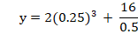 | M1  A1  M1  A1 | ✓ values of k and m
 | B  C  A  7.2  6.8  120⁰ | 04
 |  | M1  A1  M1  A1 | given to at least 4 s.f
 |  | 04
 | SLABS:  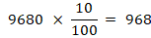 | B1  B1  M1  M1  A1 | CAO  CAO  Acc. Ksh 17, 306.67
 |  | 04
 | =0 | M1  M1  A1 | determinant = 0  both values✓
 |  | 03
 | 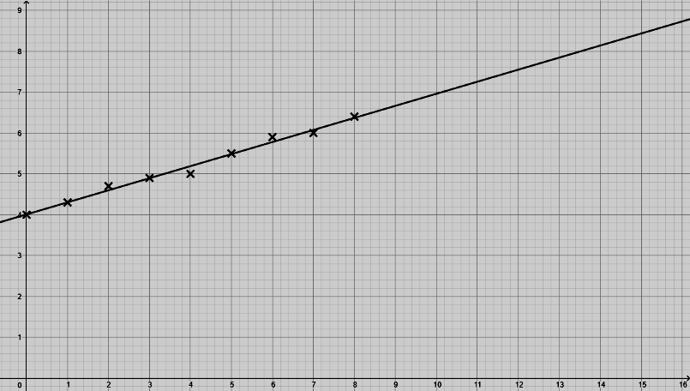  Length, l(cm) of the metal rod  Temperature, T(°C) | P1  L1 | all points ✓ plotted  appropriate line ✓drawn
 |  | 02
 | 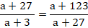  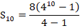 | M1  A1  M1  A1 | ✓values of a and r
 |  | 04
 | 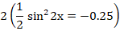 | B3 | award  B3 for all ✓  B2 for any 4 ✓  B1 for any 3 ✓  B0 for 2 or less ✓
 |  | 03
 | - Centre 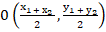  = 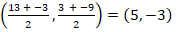  - Equation of circle  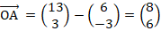  Equation | B1  M1  A1 | for ✓coordinates of centre
 |  | 03

SECTION II
No. | Marking scheme | Marks | Comments
 | - 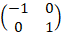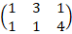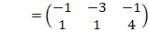  - 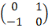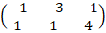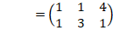  - 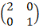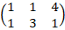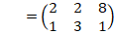  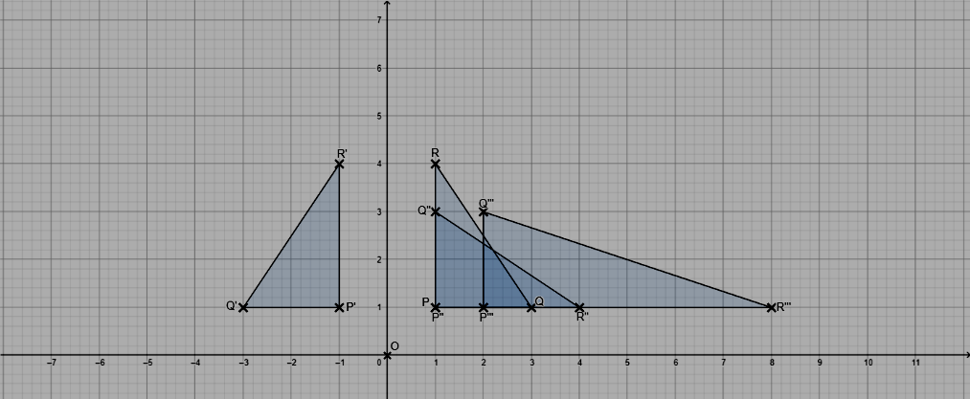 | B1  B1  B1  B1  B1  M1  A1  B1  M1  A1 | ✓coordinates of  ✓coordinates of  ✓coordinates of
 |  | 10
 | 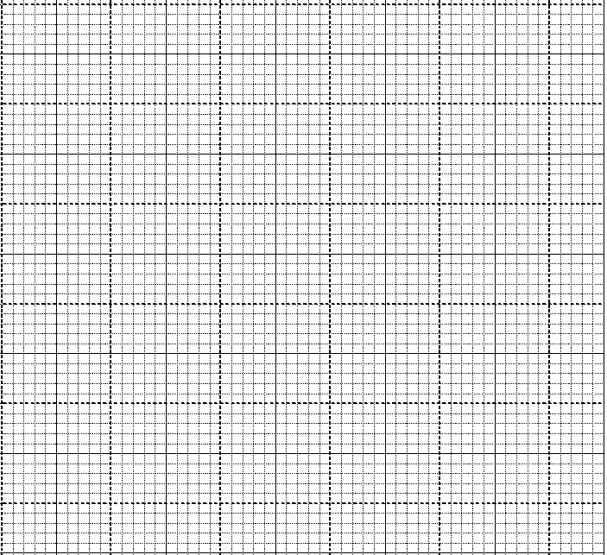  0  10  20  30  40  50  10  20  30  40  50  60  70  60  y  x  x  x  x  x  x  x  Cumulative frequency (Matches)  Upper Class Boundaries (Goals)  (ii) | S1  P1  C1  B1  B1 | appropriate scale used  all points ✓plotted  smooth curve  60 – 16 = 44 + 1 = 45
 | (b)  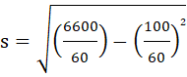  481638  (c) 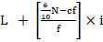  = | B1  M1  A1  M1  A1 | for column  acc. 10.35 to 4 s.f
  class | f | x | d=x-25 | d² | fd | fd² | cf
  0-10 | 2 | 5 | -20 | 400 | -40 | 800 | 2
  10-20 | 14 | 15 | -10 | 100 | -140 | 1400 | 16
  20-30 | 24 | 25 | 0 | 0 | 0 | 0 | 40
  30-40 | 12 | 35 | 10 | 100 | 120 | 1200 | 52
  40-50 | 8 | 45 | 20 | 400 | 160 | 3200 | 60
   | 𝚺ƒ=60 |  |  |  | 𝚺ƒd=100 | 𝚺ƒd²=6,600
 |  | 10
 |  | B1  B1  B1  B1  B1  B1  B1  B1  B1  B1 | for  for ✓∆ABC drawn  ✓locating centre O  ✓arc, locus of M  ✓perp. Bisector of BC, locus of Q  ✓dotted circle, centre C radius 3 cm, locus of R  ✓line parallel to BC, 3 cm away, locus P  ✓region shaded
 |  | 10
 | H  21  10  cm  20.4  18.47  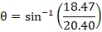  21  18.47  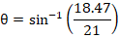  18.47  5  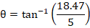 | B1  M1  A1  B1  M1  A1  M1  A1  M1  A1 | for ✓slant height  for ✓height
 |  | 10
 | 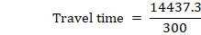  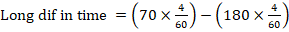 | B1  B1  M1  A1  B1  M1  A1  B1  M1  A1
 |  | 10
 | - Trapezium rule  - Mid-ordinate rule  - Exact area  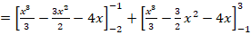  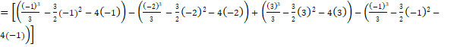  =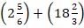  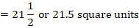  - 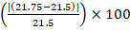 | B1  M1  A1  M1  A1  M1  M1  A1  M1  A1 | Sketch  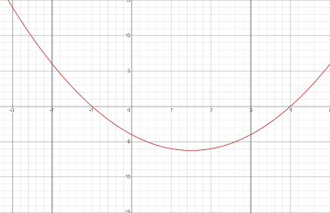
  X | -2 | -1.5 | -1.0 | -0.5 | 0 | 0.5 | 1.0 | 1.5 | 2.0 | 2.5 | 3.0
  Y | 6 | 2.75 | 0 | -2.25 | -4 | -5.25 | -6 | -6.25 | - 6 | - 5.25 | - 4.0
 |  | 10
 | 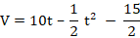  - 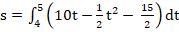  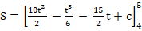  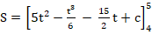  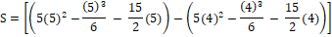  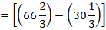  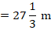  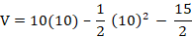 | B1  M1  A1  M1  M1  M1  A1  B1  M1  A1 | ✓velocity (award B0 for wrong units)  ✓substitution  ✓velocity (award A0 for wrong units)  ✓limits  ✓integral  attempt to subst. & subtr.  for t = 10s  ✓subst.  ✓velocity (award A0 for wrong units)
 |  | 10
24  x + y =600  x = 500  x= 2y  x  100  200  300  400  0  100  200  300  400  500  y  R  |||||||||||||||||||||||||||||||||||||||||||||||||||||| | - (i)  (ii)graph  x  x  x  - objective function: 1000x + 800y  possible values:  (480, 240); (495, 245); (499,249) etc  1000(480) + 800(240) = Ksh 672,000  1000(495) + 800(245) = Ksh 691,000  1000(499) + 800(249) = Ksh 698,200  Hence, max. cost = Ksh 698,200 | B1  B1  B1  B1  B1  B1  B1  B1  B1  B1 | B1 for each ✓inequality  B1 for each straight line ✓ drawn and shaded  ✓objective function stated  at least 3 points tested, one must give max. value  (alt. use of objective line)  ✓max. value
 |  | 10
||||||||||||||||||||||||||||||||||||||||||||||||||||||

