MUSIC MARKING SCHEME

511/2
MUSIC (Aurals)

  - Repetitive Drum Pattern
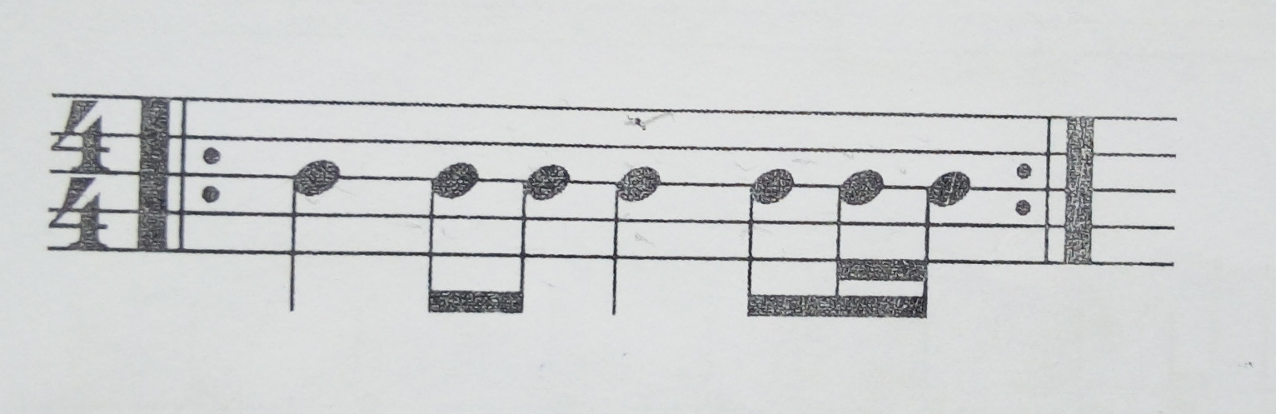

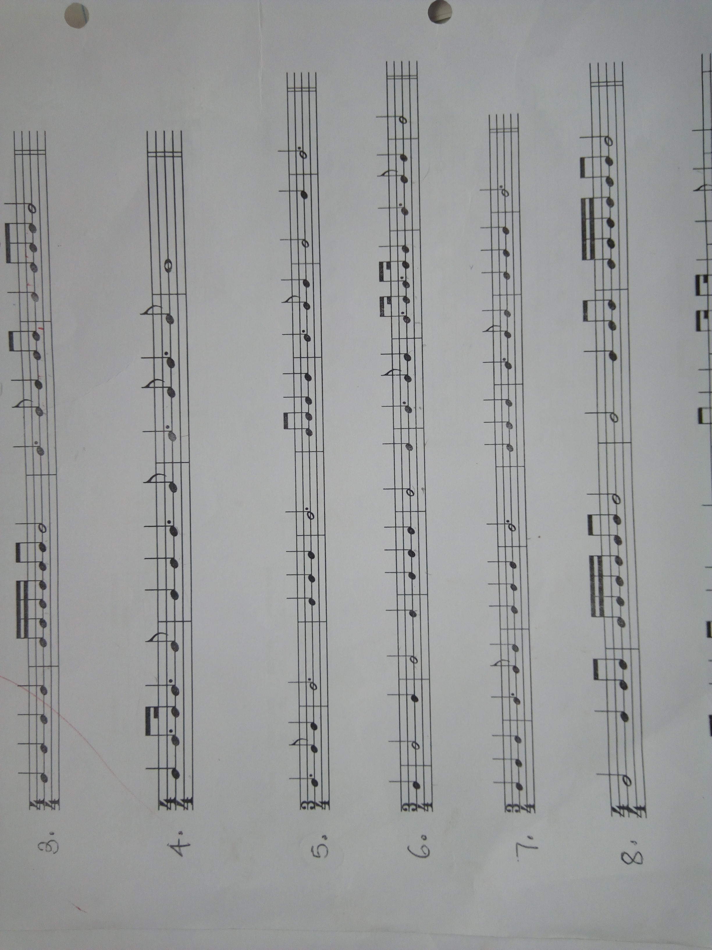
B. Rhythm of a melody in simple time

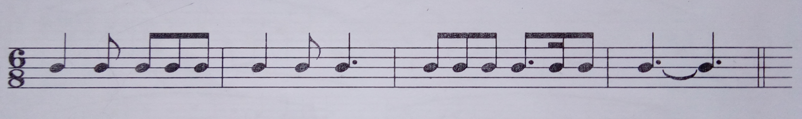
C. Rhythm of a melody in compound time

- a.Melody in a major key.
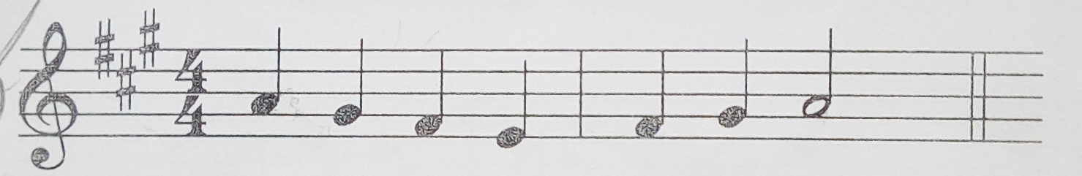

b. Melody in a minor key.

- Intervals
- Major 3rd
- Major 2nd

- Cadences
- Interrupted
- Imperfect
- Plagal
- Perfect

- Modulation
  - B Minor
  - B Flat Major

