NAME___________________________________________ADM NO______CLASS_____

511/3
MUSIC
TIME: 2½ hours
ARISE AND SHINE JOINT EXAMINATION
BOMET EAST SUBCOUNTY-BOMET COUNTY
THE YEAR 2023
Instructions
- Follow the instructions in each section.
- This paper consists of 11 printed pages.
- Check the question paper to ensure that all the pages are printed as indicated and that no questions are missing.
- Answer all the questions in the spaces provided.
- For question 4, answer any two questions from a, b, c and d.

For examiner’s use only
Section | Question | Maximum score | Candidate’s score
A | 1 | 15
 | 2 | 15
B | 3 | 14
 | 4 | 14
 | 5 | 10
 | 6 | 10
 | 7 | 6
C | 8 | 16
Total Score |  | 100

SECTION A: BASIC SKILLS
Answer all questions in this section
- a) Use the given opening to compose a melody of sixteen bars for voice, with a modulation to the relative minor and return to the tonic. Introduce a syncopation. (9 marks)

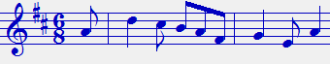

______________________________________________________________________________________________________________________________________________________________________________________________________________________________________________________________________________________________________________________________________________________________________________________________________

______________________________________________________________________________________________________________________________________________________________________________________________________________________________________________________________________________________________________________________________________________________________________________________________________

______________________________________________________________________________________________________________________________________________________________________________________________________________________________________________________________________________________________________________________________________________________________________________________________________

______________________________________________________________________________________________________________________________________________________________________________________________________________________________________________________________________________________________________________________________________________________________________________________________________

______________________________________________________________________________________________________________________________________________________________________________________________________________________________________________________________________________________________________________________________________________________________________________________________________
b) Use the text below to compose a melody and set the text to it. (6 marks)
Twatangaza twahimiza, amani ni muhimu,
Dumisheni amani, ili nchi iwe salama.

2. Harmonize the following melody for SATB. Choose appropriate chords from I, ii, IV, V and vi. Use a passing six four chord. (15 marks)

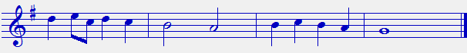

SECTION B: HISTORY OF MUSIC AND ANALYSIS (54 marks)
3. a) Apart from warming, state two other ways of tuning membranophones. (2 marks)
__________________________________________________________________________________________________________________________________________________________________________________________________________________________________________
(b) Solo and chorus as a style of singing has its advantages. Outline any four of these advantages. (4 marks)
_________________________________________________________________________________________________________________________________________________________________________________________________________________________________________________________________________________________________________________________________________________________________________________________________________________________________________
(c) State two differences between bung’o and nzumari. (2marks)
____________________________________________________________________________________________________________________________________________________________
(d) Give any four points justifying the importance of a music student participating in the Kenya Music Festival competitions. (4 marks)
____________________________________________________________________________________________________________________________________________________________________________________________________________________________________________________________________________________________________________________________________________________________________________________________________________________________________________________________________________________________________________________________
e) What is the difference between orutu and arutu? (2mks)
____________________________________________________________________________________________________________________________________________________________
WESTERN MUSIC
Answer any TWO questions from a, b, c and d.
4 a) Claudio Monteverdi
i) Give three styles used by Monteverdi to bring emotional intensity to his music. (3mks)
________________________________________________________________________________________________________________________________________________________________________________________________________________________________________________________________________________________________________________________
ii) State two ways in which Monteverdi’s association with St. Marks cathedral was significant.
_________________________________________________________________________________________________________________________________________________________________________________________________________________________________________
(2mks)
iii) What was Monterverdis contribution to the development of the madrigal?
____________________________________________________________________________________________________________________________________________________________
(2mks)
b) ALESSANDRO SCARLATTI
i) Give any four contributions of Alessandro Scarlatti to the Music of the Baroque period. (4mks)
__________________________________________________________________________________________________________________________________________________________________________________________________________________________________________________________________________________________________________________________________________________________________________________________________________________________________________________________________________________________________________________________________________________________________
ii) Alessandro had a number of Contemporaries who directly and indirectly influenced his music. State any six of them. (3mks)____________________________________________________________________________________________________________________________________________________________________________________________________________________________________________________________________________________________________________________________________________________________________________________________________________________________________________________________________________________
c) CHRISTOPH WILLIBALD GLUCK
i) Explain three ways in which Gluck’s travels contributed to his musical growth. (3mks)
________________________________________________________________________________________________________________________________________________________________________________________________________________________________________________________________________________________________________________________
ii) State two reform operas by Gluck. (2mks)
___________________________________________________________________________________________________________________________________________________________
iii) How did the following people impact on Gluck’s music
David Garrick (1mk)
____________________________________________________________________________________________________________________________________________________________ Ranieri Calzabigi (1mk)
____________________________________________________________________________________________________________________________________________________________
d) CLAUDE DEBUSSY
i) State Debussy’s country of origin (1mk)
__________________________________________________________________________
ii) Explain the reason behind Debussy’s admission to Frances leading musical college to study music. (1mk)
____________________________________________________________________________________________________________________________________________________________
iii) Outline two music areas studied by Debussy in the above mentioned college. (2mks)
_______________________________________________________________________________________________________________________________________________________________________________________________________________________________________________________________
iv) Give three charecteristics of Debussy’s music. (3mks)
____________________________________________________________________________________________________________________________________________________________________________________________________________________________________________________________________________________________________________________________________________________
5. Prescribed Traditional African Music
Chuka drummers. PPMC recording
- Describe this performance in terms of media. (3marks)
_________________________________________________________________________________________________________________________________________________________________________________________________________________________________________

- State the instrument that initiates transition in the performance. (1 mark)
________________________________________________________________________________________________________________________________________________________________________________________________________________________________________
c) Explain three ways in which variation has been achieved in the performance. (3mks)
________________________________________________________________________________________________________________________________________________________________________________________________________________________________________________________________________________________________________________________
d) Describe the sequence of events in the introduction section. (1mk)
____________________________________________________________________________________________________________________________________________________________
e) Give two reasons that justify this performance as being African Music. (2mks)
_________________________________________________________________________________________________________________________________________________________________________________________________________________________________________
6. Prescribed Western music:
Sonata da Chiesa Opus 3 Fourth movement by Corelli Archangelo
a) i) Sate a musical term which best describes the progression between the last beat of bar one and first beat of bar two. (1mk)
______________________________________________________________________________
ii) Identify any other passages with similar progression as (i) above. (1mk
______________________________________________________________________________
b) i) Give the texture of the music between bar 11 – 14. (1mk)
______________________________________________________________________
ii) Explain your answer in 1b above 1mk
____________________________________________________________________________________________________________________________________________
c) i) In which musical period was this performance written ? 1mk
_____________________________________________________________________________
ii) Give a reason for your answer in (ci) above 1mk
________________________________________________________________________
d) Identify two sections with an ascending interval of an octave 2mks
____________________________________________________________________________________________________________________________________________________________
e) Using bar numbers, describe the form of this music. 2mks
____________________________________________________________________________________________________________________________________________________________

7. ANALYSIS OF UNPREPARED WORK (6 marks)
Answer the following questions with reference to the music piece below.
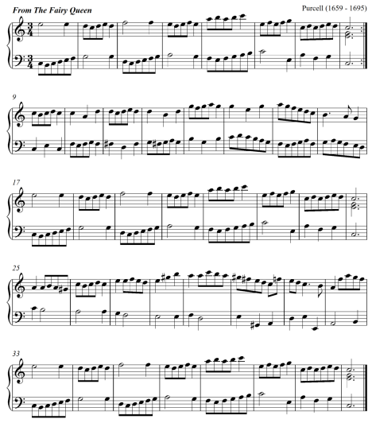

(a) For what medium is this music written? (1 mark)
_________________________________________________________________________
(b) Describe the form of this music citing bar numbers. (2 marks)
____________________________________________________________________________________________________________________________________________________________
(C) Give the key scheme of the music. (1 ½ marks)
____________________________________________________________________________________________________________________________________________________________
(d) State the bar numbers in which the following developmental devices have been used. (1 mark)
(i) Sequence ____________________________________________________________
(ii) Scalic motion ________________________________________________________
(e) Describe the range of the music. ( ½ mark)
_________________________________________________________________________

SECTION C: GENERAL MUSIC KNOWLEDGE (16 MARKS)
a) (i) Differentiate between a whole consort and a broken consort. (2marks)
____________________________________________________________________________________________________________________________________________________________________________________________________________________________________________________________________________________________________________
(ii) Outline three ways through which hip-hop music has influenced the performance of traditional dances in Kenya. (3 marks)
____________________________________________________________________________________________________________________________________________________________________________________________________________________________________________________________________________________________________________(iii) State four factors that influence the quality of sound produced on a traditional African fiddle. (4 marks)
_____________________________________________________________________________________________________________________________________________________________________________________________________________________________________________________________________________________________________________________________________________________________________________________________________________________________________________________________________________________________________________________________________________
(b) The following melody was written for trumpet in B flat. Rewrite it in concert pitch. (4 mks)
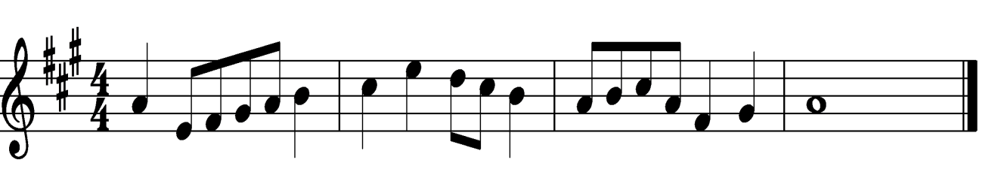
(d) Name any three composers of the Kenya national anthem. (3 marks)
_________________________________________________________________________________________________________________________________________________________________________________________________________________________________________

THIS IS THE LAST PAGE

