Name………………………………………………………………..IndexNo…………………………
Candidates Signature……………. Date………………………………
511/3
MUSIC
Paper 3
July 2021
2 ½ hours.

MOKASA JOINT EXAMINATION
Kenya Certificate of Secondary Education
MUSIC
Paper 3
2 ½ hours.

Instructions to Candidates

- Write your name and index number in the spaces provided above
- Sign and write the date of examination in the spaces provided.
- Answer all questions in this paper
- In question 4 choose any two of the questions numbered (a), (b), (c) and (d)
- DO NOT remove any pages.
- This paper consists of 11 printed pages
- Candidates should check the question paper to ensure that all the pages are printed as indicated and no questions are missing.

For Examiners Use Only
Section | Question | Maximum Score | Candidate’s Score
A | 1a | 09
 | 1b | 06
 | 2 | 15
B | 3 | 14
 | 4 | 14
 | 5 | 10
 | 6 | 10
 | 7 | 06
C | 8 | 16
Grand Total |  | 100
SECTION A: BASIC SKILLS
- a) Continue the given opening to make a melody of 16 bars for voice. Modulate to the Dominant before returning to the tonic. Incorporate dynamic variations. Add phrase marks. (9 marks)
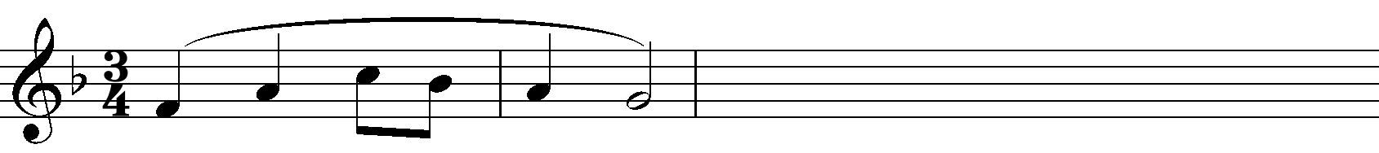

(b) Using staff notation, compose a tune to suit the following lyrics. Add phrase marks. (6 marks)
‘Singing, dancing and making merry;
Lads and lasses in joyous pleasure,

- Copy and harmonize the given melody for Soprano, Alto, Tenor and Bass (SATB). Choose appropriate chords from the following; I, ii, IV, V and vi. Use a passing six four. Indicate the chords that you use. (15 marks)

SECTION B: HISTORY AND ANALYSIS (48 marks)
3. AFRICAN MUSIC

a) Identify each of the following Kenyan instruments: (4marks)

Arupepe - ..……………………………………………………………………………
Embegete - ………..……………………………………………………………………
Tuonik - …………………………………………………………………………….
Mwazigizi - ……………………………………………………………………………..
b) Name three Kenyan dances that acquire their names from the instruments that accompany them. (3 marks)
……………………………………………………………………………………………………..
……………………………………………………………………………………………………..
……………………………………………………………………………………………………..
c) State any three roles of Music in an initiation ceremony. (3 marks)
………………………………………………………………………………………………………………………………………………………………………………………………………………………………………………………………………………………………………………………
d) Differentiate between a lyre and a fiddle. (4 marks)
………………………………………………………………………………………………………………………………………………………………………………………………………………………………………………………………………………………………………………………
………………………………………………………………………………………………………………………………………………………………………………………………………………………………………………………………………………………………………………………

4. WESTERN MUSIC

Answer any two of the questions (a), (b), (c) and (d).

(a) William Byrd
i) During which period of Music History did William Byrd live? (1 mark)
………………………………………………………………………………………………………
ii) Why is William Byrd referred to as the King of English Music? (2 marks)
………………………………………………………………………………………………………………………………………………………………………………………………………………
iii) Outline any two events that Byrd held jointly with Tallis. (2 marks)
………………………………………………………………………………………………………………………………………………………………………………………………………………
iv) Outline two appointments held by Byrd during his musical career. (2 marks)

………………………………………………………………………………………………………
………………………………………………………………………………………………………
b) Haydn Franz Joseph
- State two duties he performed while in Esterhazy. (2 marks)
………………………………………………………………………………………………………………………………………………………………………………………………………………………………………………………………………………………………………
- Name any two of his symphonies. (2 marks)
………………………………………………………………………………………………………………………………………………………………………………………………………………………………………………………………………………………………………
iii) What stood out about the Emperor String Quartet by Haydn. (1 mark)
……………………………………………………………………………………………………………………………………………………………………………………………………

iv) Outline any two influences on Haydn’s musical career. (2 marks)
……………………………………………………………………………………………………………………………………………………………………………………………………

c) Franz Liszt
- What was Franz Liszt’s Nationality? (1 mark)
……………………………………………………………………………
- Give one example of Liszt’s symphonic poem. (1 mark)
…………………………………………………………………………….
- Outline any two early influences on his musical career. (2 marks)
……………………………………………………………………………………………………………………………………………………………………………………………………
- Name any three works by Liszt. (3 marks).
…………………………………………………………………………………………………
…………………………………………………………………………………………………
…………………………………………………………………………………………………

d) Bela Bartok
i) State the three areas in Music which Bela Bartok specialized in. (3 marks)
……………………………………………………………………………………………………………………………………………………………………………………………………
…………………………………………………………………………………………………
ii) Outline any two influences on Bela Bartok’s composition. (2 marks)
…………………………………………………………………………………………………
…………………………………………………………………………………………………
iii) Identify the following works by Bela Bartok. (2 marks)
- The wooden Prince - ..……………………………………………………..
- Bluebeard’s Castle - ………………………………………………………

5. Prescribed Traditional African Music Chivoti by Diwani Nzaro from Youtube.
- Name the media in the recording (2 marks)
……………………………………………………………………………………………………………………………………………………………………………………………………
…………………………………………………………………………………………………
- State any two roles of the melodic instrument in the recording. (2 marks)
……………………………………………………………………………………………………………………………………………………………………………………………………
- Outline any three characteristics of African Music evident in this work. (3 marks)
…………………………………………………………………………………………………
………………………………………………………………………………………………… d) Describe the beginning of the performance in the recording. (3 marks)
…………………………………………………………………………………………………
…………………………………………………………………………………………………
…………………………………………………………………………………………………
6. Prescribed Western: Too Much I Once Lamented: by Thomas Tallis
a) (i) What type of work is “Too Much I Once Lamented”? (1 mark)
…………………………………………………………………………………………………
(ii) Give a reason for your answer in (i) above. (1 mark)
…………………………………………………………………………………………………
b) State the media of this work. (2 marks)
…………………………………………………………………………………………………
c) Using bar numbers, identify four stylistic features used between bars 1 to 34. (4 marks)
……………………………………………………………………………………………………………………………………………………………………………………………………………………………………………………………………………………….………………
………………………………………………………………………………….………………
d) Identify the dynamics used in this work. (2 marks)
………………………………………………………………………………………………………………………………………………………………………………………………………………

7. Unprepared Analysis
Study the music extract below and answer the questions that follow.

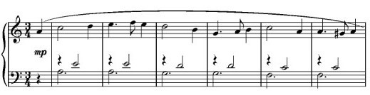

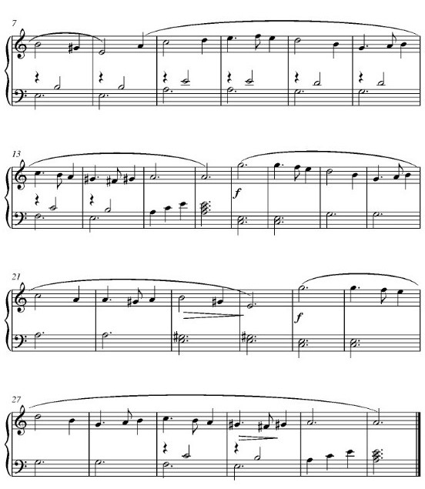

a) By use of bar numbers, identify the form of this work. (2 marks)
………………………………………………………………………………………………………
………………………………………………………………………………………………………
b) For what instrument is this music scored? (1 mark)
………………………………………………………………………………………………………
c) Name the tonic key of this music. (1mark)
………………………………………………………………………………………………………
d) Name the key to which the music modulates at bar 17. (1 mark)
………………………………………………………………………………………………………
- Write any two commonly used rhythmic motifs in the melody. (1 mark)

SECTION C: GENERAL MUSIC KNOWLEDGE (16 marks)
8. a) Translate the following melody from staff to sol-fa notation. (4 marks)

b) Define the following musical terms (4 marks)
- Ostinato
………………………………………………………………………………………………………………………………………………………………………………………………
- Symphony
………………………………………………………………………………………………………………………………………………………………………………………………
- A tempo
………………………………………………………………………………………………………………………………………………………………………………………………
iv) Passion
………………………………………………………………………………………………………………………………………………………………………………………………

- (i) State any two roles of a producer in the Music industry. (2 marks)
………………………………………………………………………………………………………………………………………………………………………………………………………………
(ii) State four steps to consider before sight reading a piece of Music. (2 marks)
………………………………………………………………………………………………………………………………………………………………………………………………………………
………………………………………………………………………………………………………………………………………………………………………………………………………………

d) Transpose the following music a Major 3rd up. (4 marks)

