**511/3**

**MUSIC**

**Paper 3**

**July 2021**

**2 ½ hours.**

**MOKASA JOINT EXAMINATION**

Kenya Certificate of Secondary Education

MUSIC

Paper 3

2 ½ hours.

**MARKING SCHEME**

**SECTION A: BASIC SKILLS**

1. a) Continue the given opening to make a melody of 16 bars for voice. Modulate to the Dominant before returning to the tonic. Incorporate dynamic variations. Add phrase marks. (9 marks)

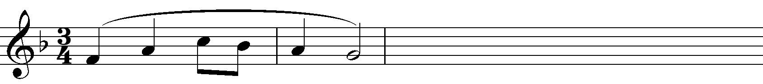

***16 Bars- 1 mark***

***Correct Modulation- 2 marks***

***Lyricism- 2marks***

***Dynamic Var - 1mark***

***Phrasing- 2 marks***

***Cadences- 1 mark (Final and any other)***

(b) Using staff notation, compose a tune to suit the following lyrics. Add phrase marks. (6 marks)

***‘Singing, dancing and making merry;***

***Lads and lasses in joyous pleasure,***

***Syllabic division- 1 mark Accentuation- 1 mark***

***Lyricism- 2 marks Cadences – 1 mark (Final and any other)***

***Phrasing- 1 mark***

***Penalise if not indicated***

***Key signature- ½ mark***

***Time signature- ½ mark***

1. Copy and harmonize the given melody for Soprano, Alto, Tenor and Bass (SATB). Choose appropriate chords from the following; **I, ii, IV, V** and **vi.** Usea passing **six four**. Indicate the chords that you use. (15 marks)



***Each correct chord ½ mark – 5 marks Cadences - 2mark***

***Chord progression- 2 marks Brace, bar lines- 1 mark***

***Voice leading- 1 ½ marks***

***Voice range -1 ½ marks***

***Passing six-four- 2 marks***

**SECTION B: HISTORY AND ANALYSIS (48 marks)**

**3. AFRICAN MUSIC**

a) Identify each of the following Kenyan instruments: (4marks)

Arupepe - **A horn from Iteso community**

Embegete - **A single headed drum from Kuria community**

Tuonik - **A cowbell from Sabaot community**

Mwazigizi - **A single stringed fiddle from the Taita community**.

b) Name **three** Kenyan dances that acquire their names from the instruments that accompany them. (3 marks)

**Isukuti dance**

**Mabumbumbu dance**

**Peke dance**

**Shiriri dance**

**Chepkon’go**

c) State any **three** roles of Music in an initiation ceremony. (3 marks)

* **Encourage the initiates to be brave**
* **Mock cowards**
* **Educate the initiates on their new roles in the society after the ceremony**
* **Educate the community on the culture passed down from generation to generation**
* **Entertain the gathering**

***Any other correct answer***

d) Differentiate between a lyre and a fiddle. (4 marks)

* **A fiddle has 1 or 2 strings while a lyre has 6-8 strings**
* **Most fiddles are played by bowing while most lyres are played by plucking**
* **A fiddle is smaller in size then the lyre**
* **A fiddle is played while being held under the arm while lyres are placed between the legs on the ground while playing**

***Any other correct answer***

**4. WESTERN MUSIC**

*Answer any* ***two*** *of the questions (a), (b), (c) and (d).*

**(a) William Byrd**

i) During which period of Music History did William Byrd live? (1 mark)

* ***Renaissance Period***

ii) Why is William Byrd refered to as the King of English Music? (2 marks)

* ***He established English music genres that other composers emulated/ followed.***
* ***Developed the English madrigal***
* ***Wrote virginal and organ music that that elevated the English keyboard style.***
* ***Composed a great deal of Church music to English lyrics***

iii) Outline any **two** events that Byrd held jointly with Tallis. (2 marks)

* ***Was co-organist with Talis at the Royal chapel***
* ***Jointly granted the monopoly to import, print, publish and sell music and music paper.*** *(accept any of the events)*

iv) Outline any **two** appointments held by Byrd during his musical career. (2 marks)

* **Organist and master at the Lincoln Cathedral**
* **Gentleman of the Royal Chapel**

**b) Haydn Franz Joseph**

1. State **two** dutieshe performed while in Esterhazy. (2 marks)

* **He was assistant music director.**
* **He was Kapellmeister.**
* **Composed symphonies, operas, operattas, masses, chamber music and dance music.**
* **He rehearsed and conducted performances of his own and other’s works.**
* **Coached singers**
* **Settled disputes among musicians in his charge.**

1. Name any **two** of his symphonies. (2 marks)

* **Surprise**
* **Military**
* **Clock**
* **Drum roll**
* **London**

iii) What stood out about the Emperor String Quartet by Haydn. (1 mark)

**It provided the melody for the national anthems of both Germany and Austria**

iv) Outline **two** influences in Haydn’s musical career. (2 marks)

* **Wolfgang Amadeus Mozart considerably influenced Haydn in symphonic technique.**
* **Other composers e.g. C.P.E Bach who influence him in writing symphonies and sonatas in 3 movements.**
* **Influenced by the concertos of Antonio Vivaldi.**
* **When he visited London, he was inspired by the works of G.F. Handel.**

**c) Franz Liszt**

1. What was Franz Liszt’s Nationality? (1 mark)

* **Hungarian**

1. Give **one** exampleof Liszt’s symphonic poem. (1 mark)

* ***A Faust Symphony***

1. Outline any **two** influences on his early music training. (2 marks)

* **His father Adams Liszt who taught him piano at the age of five.**
* **His teacher Carl Czerny at Vienna.**
* **His friend Frederick Chopin**

1. Name any **three** works by Liszt. (3 marks).

* **Oratorios: *Die Legende von der heiligen Elisabeth* and *Christus***
* **Symphony: *A Symphony to Dante’s Divina Commedia***
* **12 symphonic poems, *A Faust Symphony***
* **Piano** [**concerto**](https://www.britannica.com/art/concerto-music)**, *in E-flat, A major and E-flat***
* **Piano Sonata: *piano sonata in B Minor***
* **Rhapsody:** [***Hungarian Rhapsody No. 2 in C-Sharp Minor***](https://www.britannica.com/topic/Hungarian-Rhapsody-No-2)
* **Mass: *Hungarian Coronation Mass***

**d) Bela Bartok**

i) State the **three** areas in Music which Bela Bartok specialized in. (3 marks

* **Composition**
* **Performance (piano)**
* **Ethnomusicology**

ii) Outline any **two** influences on Bela Bartok’s composition. (2 marks)

* **His mother taught him piano formally by the age of 5 years**
* **His teachers like Istyan Thomas (piano and composition)**
* **His contemporaries like Zoltan Kodaly who researched folk music with him, Richard Strauss**
* **Music of his predecessors like Claude Debussy, Johannes Brahms**
* **His tours to different countries in Europe where he collected folk music and interacted with other composers**
* **Folk music from Europe and Asia**
* **Nature and environment he was in at different points of hi career**

1. Identify the following works by Bela Bartok (2 marks)

* The Wooden Prince- **Ballet**
* Bluebeards castle- **Opera**

5. **Prescribed Traditional African Music**  *Chivoti by Diwani Nzaro from Youtube.*

1. Name the media in the recording (2 marks)

* **A Chivoti-flute.**
* **Two shaken idiophones- one low pitch and a high pitch.**
* **A struck idiophone-upatsu.**

1. State any **two** roles of the melodic instrument in the recording. (2 marks)

* **Provides the main melodic tunes hence dictate the musical form.**
* **Pitches the performance**
* **Enriches the music texture.**

1. Outline any **three** characteristics of African Music evident in this works. (3 marks)

* **The main melodic instrument is accompanied by other percussive instruments hence enhances the performance in the presentation.**
* **The music is polyrhythmic; emphasis is laid to the vitality and variations of the many underlying rhythms.**
* **The music depicts an implied call-response style either in the melodic instrument itself or between the melodic instrument and the percussive section.**

d) Describe the beginning of the performance in the recording . (3 marks)

**The music begins with the struck idiophone-upatsu followed by the low pitch shaken idiophone with is immediately followed by the melodic instrument-chivoti and finally the second high pitched shaken idiophone follow suit in a syncopated rhythm.**

**6. Prescribed Western: Too Much I Once Lamented:** *by Thomas Tallis*

a) (i) What type of work is Too Much I Once Lamented? (1 mark)

* **Ballet**

(ii) Give a reason for your answer in (i) above. (1 mark)

* **It has a fa-la-la-la refrain**

b) State the media of this work. (2 marks)

* **Choral work scored for soprano 1, soprano 2, alto, tenor, and bass.**

1. Using bar numbers, identify four stylistic features used between bars 1 to 34. (4 marks)

* **Word painting: bar 15-22 on the word ‘*tormented*’, bar 49-58 on the word ‘*wringing*’.**
* **Upward scalic movement: bar 24- 33 on the bass line.**
* **Sequence: bar24-25 is sequenced at 26-27 on the bass.**
* **Imitation: bar 28-29 on the bass imitated at bar 30-31 on the alto.**
* **Melismatic: bar 4-7 on the tenor.**
* **Repetition: bar 73 repeated at bar 74 on the bass.**

e) Identify the dynamics used in this work. (2 marks)

* **mf- bar 1-12**
* **f – bar 13-20, 30-35, 59-62, 70-77**
* **dim- bar 21-23**
* **mp- bar 23-25,63-65**
* **cresc.- bar 26-29, 51-58,66-69**
* **p-bar 36-50**

**7. Unprepared Analysis**

Study the music extract below and answer the questions that follow.

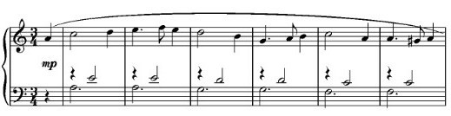

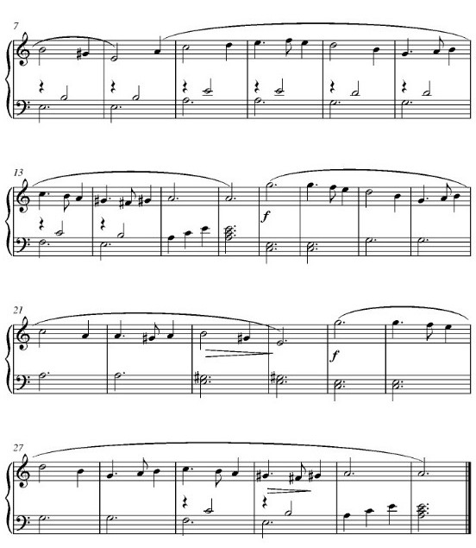

a) By use of bar numbers, identify the form of this work. (2 marks)

* ***The music is in binary form (AB)***
* ***Bar 1 to 16 forms the first section A, while bar 17 to 32 forms the second section B***

b) For what instrument is this music scored for? (1 mark)

* ***Scored for keyboard (Piano)***

c) Name the tonic key of this music. (1mark)

* ***The tonic key of this music is A minor***

d) Name the key to which the music modulates to at bar 17. (1 mark)

* ***The music modulates to the relative major key C major***

e) Write any **two** commonly used rhythmic motifs in the melody. (1 mark)



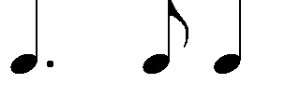

**SECTION C: GENERAL MUSIC KNOWLEDGE (16 marks)**

**8.** a*)* Translate the following melody from staff to sol-fa notation. (4 marks)



**Doh is F major**

**Beat= Crotchet**

**4{|m:-.f:m.r:d.t,|d.,r:m.f:r:-|d.t,:l,.t,:d:t,|d:-:-:-||}**

**4**

b) Define the following musical terms (4 marks)

1. Ostinato

***A short musical phrase or melody that is repeated over and over, usually at the same pitch***

1. Symphony

***A major work for an orchestra usually composed in four movements, at least one of which is in sonata form.***

1. A tempo

***Go back to the original speed.***

iv) Passion

***A type of oratorio telling the story of Jesus Christ’s crucifixion.***

1. (i) State any **two** roles of a producer in the Music industry. (2 marks)

* **Records the raw music**
* **Edits the music**

(ii) State **four** steps to consider before sight singing/ Reading a piece of Music. (2 marks)

* **Key signature**
* **Time signature**
* **Range**
* **Rhythm**
* **Any leaps that require attention**
* **performance directions**
* **Dynamics**

d) Transpose the following music a Major 3rd up. (4 marks)



