511/1
MUSIC PRACTICAL
Paper 1
THE YEAR 2023
SIGHT READING EXERCISES

ARISE AND SHINE JOINT EXAMINATION YEAR 2023
BOMET EAST SUBCOUNTY
PAPER 1
SIGHT READING EXERCISES

____________________________________________

SIGHT READING

- voice
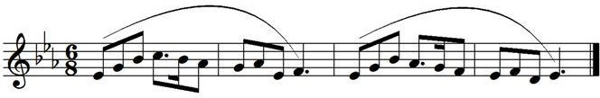
- voice
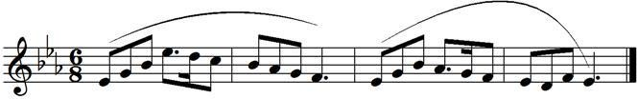

3. Recorder
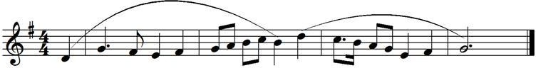

4. Recorder
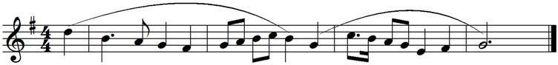

5. GUITAR
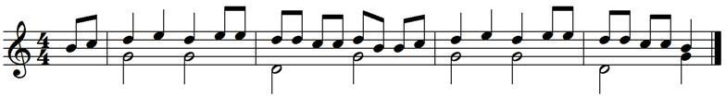

6. FLUTE

7. VIOLIN
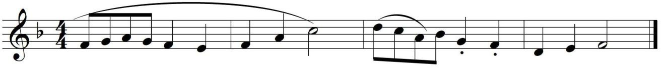

8. VIOLA
9. CLARINET

10.SAXOPHONE

11. TRUMPET/CORNET

12. HORN

13. CELLO/DOUBLE BASS

14. TROMBONE/EUPHONIUM/TUBA

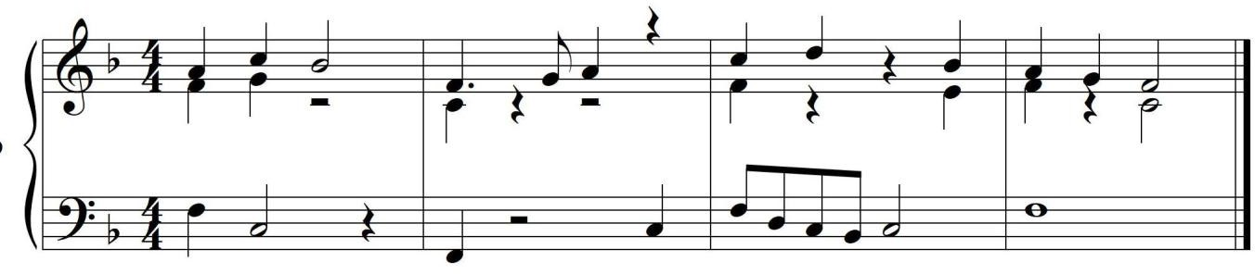
15. PIANO

