**Name:……………………………………………………………………………Index No:………………………**

**Candidate’s Signature:……………...**

**Date:………………………………….**

**511/3**

**MUSIC**

**Paper 3**

**December 2021**

**2½ Hours**

**SAMIA SUB COUNTY JOINT EXAMINATION**

**Kenya Certificate of Secondary Education**

**MUSIC**

**Paper 3**

2½ Hours

**Instructions to candidates**

1. **Write your name and index number in the spaces proved above**
2. **Sign and write the date of the examination in the spaces**
3. **Answer all the questions in this paper**
4. **In question 1 choose either (a) or (b)**
5. **In question 4 choose any two of the questions numbered (a), (b), (c) and (d)**
6. **All answers must be written in the spaces provided**
7. **This paper consists of 9 printed pages**
8. **Candidates should check the question paper to ensure that all the pages are printed as indicated and that no questions area missing**
9. **Candidates should answer the questions in English**

**For official use only**

|  |  |  |  |
| --- | --- | --- | --- |
| **Section** | **Question** | **Maximum**  **Score** | **Candidate’s**  **Score** |
| **A** | 1a | 9 |  |
| 1b | 6 |  |
| 2 | 15 |  |
| **B** | 3 | 14 |  |
| 4 | 14 |  |
| 5 | 10 |  |
| 6 | 10 |  |
| 7 | 6 |  |
| **C** | 8 | 16 |  |
| **Grand total**  **Grand Total** | | **100**  **100** |  |

**SECTION A. BASIC SKILLS ( 30 MKS)**

1. Melody
2. Starting with the given opening, compose a melody of sixteen bars for voice, modulating to the **relativemajor** and returning to the tonic. Introduce dynamics. (9 marks)



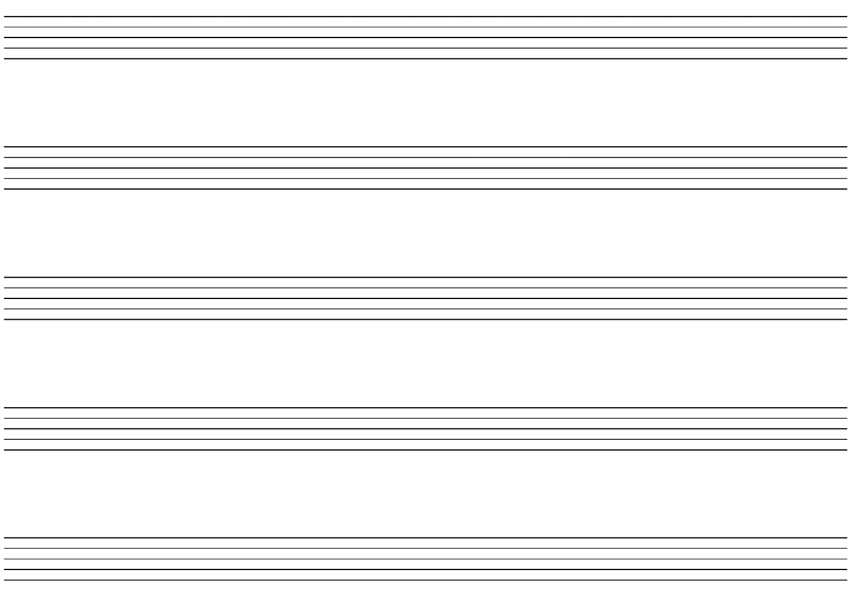

1. Using staff notation, compose a tune to the following words. Add phrase marks. (6 marks)

*Singing, playing and dancing together*

*Keeps the children united and happy*





1. Harmonize the following melody for soprano, alto tenor and bass (SATB). Choose appropriate chords from, I, ii, IV, V and vi. Incorporate a passing **sixfour** in the **firstbar**. (15 marks)





**SECTION B. HISTORY AND ANALYSIS.**

1. AFRICAN MUSIC (14 MKS)
2. Name three communities that traditionally perform the following dances (3marks)
3. Ohangla

………………………………………………………………………………………….

1. Gitiiro

………………………………………………………………………………………….

1. Entabanan

…………………………………………………………………………………………

1. Give any **four** advantages of using call and response style of singing ( 4marks)

……………………………………………………………………………………………………………………………………………………………………………………………………………………………………………………………………………………………………………………………………………………………………………………………………………………………………………………………………………………………………………………………………………………………………………………………………………….

1. What are self sounding instruments?(2marks)

…………………………………………………………………………………………………………………………………………………………………………………………………….

1. The style of performing African folksongs has changed over the years, give any **two** factors that have contributed to this change.(2 marks)

………………………………………………………………………………………………………………………………………………………………………………………………………………………………………………………………………………………………………

1. State **three** roles of music in harvesting (3marks)

………………………………………………………………………………………………………………………………………………………………………………………………………………………………………………………………………………………………………………………………

1. **WESTERN MUSIC**
2. ***WILLIAM BYRD***
3. State **two** factors that influence Byrd as acomposer( 2marks)

…………………………………………………………………………………………………………………………………………………………………………………………………………………………………………………………………………………………………………………………………………………………………………

1. State any **three** of his contributions to instrumental music (3marks)

………………………………………………………………………………………………………………………………………………………………………………………………………………………………………………………………………………………………………………………………………………………………………

1. Name any **two** of his contemporaries (2 marks)

………………………………………………………………………………………………………………………………………………………………………………………………………………………………………………

1. ***JOSEPH HAYDN***
2. Why is Hayden refers to as father of symphony. Give three reasons (3 marks)

………………………………………………………………………………………………………………………………………………………………………………………………………………………………………………………………………………………………………………………………………………………

1. Name the title of haydens most popular oratorios (2 marks)

………………………………………………………………………………………………………………………………………………………………………………………………………………………………………………………………………………………………………………………………………………………………………

1. Name **two** limitations of patronage to hydns music career (2marks)

………………………………………………………………………………………………………………………………………………………………………………………………………………………………………………………………………………………………………………………………………………………

1. ***FRANZ LISZT***
2. State the nationality of List (1mark)

…………………………………………………………………………………………………………….

1. Describe les preludes (2 marks)

………………………………………………………………………………………………………………………………………………………………………………………………………………………………………………

1. Name any two examples of lists piano works (2 marks)

………………………………………………………………………………………………………………………………………………………………………………………………………………………………………………

1. Name any two contemporaries of liszt (2marks)

…………………………………………………………………………………………………………………………………………………………………………......................................................................................................

1. ***BELLA BARTOK***
2. In which period of western music history did he compose (1mark)

……………………………………………………………………………………………………………….

1. State any three factors that influenced Bartoks music compositions (3 marks)

………………………………………………………………………………………………………………………………………………………………………………………………………………………………………………………………………………………………………………………………………………………………………

1. What is night music? (2 marks)

………………………………………………………………………………………………………………………………………………………………………………………………………………………………………………

1. Which instrument is Bartok associated with? (1 mark)

………………………………………………………………………………………………………………………

1. **PRESCRIBED AFRICAN MUSIC. (10 mks)**

***(Chivoti by Diwani Nzaro from you tube)***

1. What type of african performance is this recording? (1mark)

………………………………………………………………………………………………………………..

1. Explain three roles of the main medium (3marks)

………………………………………………………………………………………………………………………………………………………………………………………………………………………………………………………………………………………………………………………………………………………………………

1. Identify the two styles of perfoemnce evident in the recording (2 marks)

………………………………………………………………………………………………………………………………………………………………………………………………………………………………………………………………………………………………………………………………………………………………………………………………………………………………………………………………………………………………

1. Explain how climax has been achieved in the performance (2 marks)

………………………………………………………………………………………………………………………………………………………………………………………………………………………………………………

1. Describe the ending of the performance (2marks)

………………………………………………………………………………………………………………………………………………………………………………………………………………………………………………

1. **PRESCRIBED WESTERN WORK (10 mks)**

***(TOO MUCH I ONCE LAMENTED)***

1. Give **two** features which identify ‘too much I once lamented’ as a ballet . (2marks)

………………………………………………………………………………………………………………………………………………………………………………………………………………………………………………

1. Identify the following melodic devices used in the following sections in the music (2marks)
2. Bar 53-56 in the tenor voice

………………………………………………………………………………………………………………………

1. Bar 75in the bass and alto voices

………………………………………………………………………………………………………………………

1. State three contrasting features between the first and second refrains of the works (3marks)

………………………………………………………………………………………………………………………………………………………………………………………………………………………………………………………………………………………………………………………………………………………………………………………………………………………………………………………………………………………………

1. By use of bar numbers , describe the form of this music ( 2marks)

………………………………………………………………………………………………………………………………………………………………………………………………………………………………………………………………………………………………………………………………………………………………………………………………………………………………………………………………………………………………

1. Describe the metre used in this music ( 1mark)

………………………………………………………………………………………………………………………

1. **UNPREPARED ANALYSIS** (6 marks)

**Study the piece below and answer the questions that follow.**

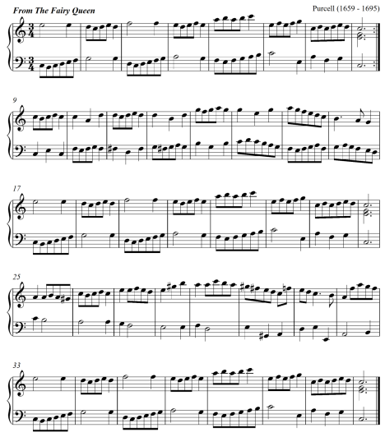

1. For what medium is this music written? (1 mark)

……………………………………………………………………………………………………

1. Describe the form of this music citing bar numbers. (2 marks)

…………………………………………………………………………………………………………………………………………………………………………………………………………

1. Give the key scheme of the music. (1 ½ marks)

…………………………………………………………………………………………………………………………………………………………………………………………………………

1. State the bar numbers in which the following developmental devices have been used. (1 mark)
2. Sequence ………………………………………………………………………………
3. Scalic motion …………………………………………………………………………
4. Describe the range of the music.  ( ½ mark)

………………………………………………………………………………………………….

**SECTION C: GENERAL MUSIC KNOWLEDGE (16 MARKS)**

1. a) (i) Differentiate between a whole consort and a broken consort. (2marks)

____________________________________________________________________________________________________________________________________________________________________________________________________________________________________________________________________________________________________________________________

1. Outline **three** ways through which hip-hop music has influenced the performance of traditional dances in Kenya. (3 marks)

____________________________________________________________________________________________________________________________________________________________________________________________________________________________________________________________________________________________________________

1. State **four** factors that influence the quality of sound produced on a traditional African fiddle. (4 marks)

________________________________________________________________________________________________________________________________________________________________________________________________________________________________________________________________________________________________________________________________________________________________________________________________________________________________________________________________________________________________________________________________________________________________________________________________________________________________________________________

1. The following melody was written for trumpet in B flat. Rewrite it in concert pitch. (4 mks)

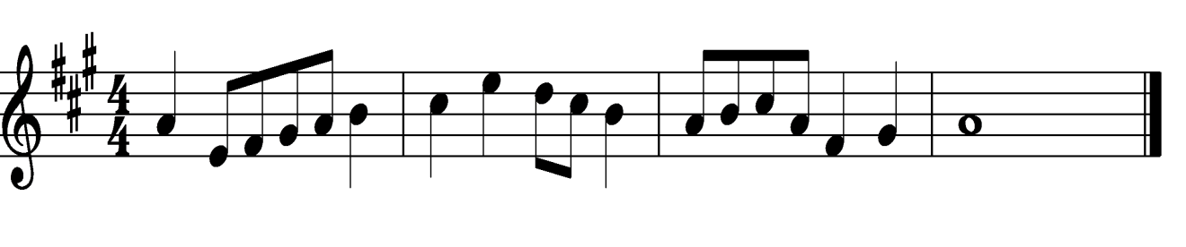



1. Name any **three** composers of the Kenya national anthem. (3 marks)

______________________________________________________________________________________________________________________________________________________________________________________________________________________________________________________

**THIS IS THE LAST PRINTED PAGE**