FORM THREE GEOGRAPHY PAPER 2 (312/2)
MARKING SCHEME MID TERM 3 2022
SECTION A
1. (a) Give three ways in which minerals occur (3marks)
- As veins and lodes
- As beds and seams.
- As alluvial deposits.
- As weathered products.
- As evaporates.

(b) State three factors which influence the exploitation of minerals. (3marks)
- The mode of occurrence of the mineral
- Market value of the mineral
- Size of the mineral deposit.
- The quality of the ore in an area.
- Availability of large amounts of capital for exploration and exploitation.
- Advanced level of technology as specialized equipment/machinery is required.
- Availability of highly skilled and specialized labour in a country.
- Well-developed transport system mainly road rail pipeline and water.

2. (a) What is a photograph? (2marks)
A photograph is an image of an object which is recorded by a camera on alight sensitive film, paper or a memory card.

(b) State three characteristics of oblique aerial photographs. (3marks)
- Covers large areas
- Objects on the foreground appear larger and decrease in size towards the background
- The horizon may be covered.

3. (a) Name three climatic elements that influence agriculture . (3marks)
- Temperature
- Rainfall
- Humidity
- Sunshine
- Winds

(b) State three characteristics of extensive mechanized grain cultivation. (3marks)
- Very large farms ranging between 240 and 1600 hectares.
- Farm operations from Land preparation to harvesting are mechanized.
- Monoculture is practiced.
- High yields due to very large farms.
- Wheat is the main crop grown.
- Heavy capital is invested in farm operations, purchasing and maintenance of machinery.

4. State four reasons why British Columbia region in Canada is a major producer of softwoods. (4marks)
- High rainfall on the windward slopes of the Rocky Mountains favours growth of large trees.
- Rugged landscape due to Rockies hinders settlement and agriculture favouring natural coniferous forests.
- Cool to cold climate on the uplands favours the growth of coniferous trees.
- Availability of extensive uninhabited land favour the establishment of softwood forests.
- Permanent rivers such as river Fraser provides cheap water transport for logs.
- Coastal location of some softwood forests favour exploitation and exportation through Vancouver Port.
5. (a) Give two forms of commercial livestock farming. (2marks)
- Ranching
- Dairy farming
(b) Name two indigenous breeds of cattle kept by nomadic pastoralists in Kenya. (2marks)
- Zebu
- Boran
- Ankole cattle

SECTION B
6. The table below shows the value in Ksh Million of exports from Kenya and imports from the main geographical regions of the world in 2016. Use it to answer question (a) and (b).
GEOGRAPHICAL REGION | EXPORTS | IMPORTS
AFRICA | 235,000 | 140,000
EUROPE | 142,000 | 264,000
MIDDLE EAST | 50,000 | 195,000
FAR EAST | 90,000 | 762,000
AMERICAS | 53,000 | 65,000

(a) (i) What is the difference in value between exports and imports from Africa? (2marks)
Ksh 235,000 million – Ksh 140,000 = Ksh 95,000 million
OR = Ksh 95,000,000,000
OR = Ksh 95 Billion
(ii) Calculate the total value of imports in the year 2016. (2marks)
140,000 + 264,000 + 195,000 + 762,000 + 65,000 = Ksh 1,426,000,000,000
OR = Ksh 1,426,000 Million
OR = Ksh 1,426 Billion
OR = Ksh 1.43 Trillion

(iii) What is the percentage of the region with the least export value in 2016? (2marks)
Middle East 50,000 X 100% = 8.93%
560,000

(b) (i) A part from comparative bar graphs, give two other statistical methods that can be used to present the data in the table. (2marks)
- Comparative line graph.
- Proportional divided circles
(ii) Using a vertical scale of 1cm to represent Ksh 50 Billion, draw a comparative bar graph to present the data. (10marks)
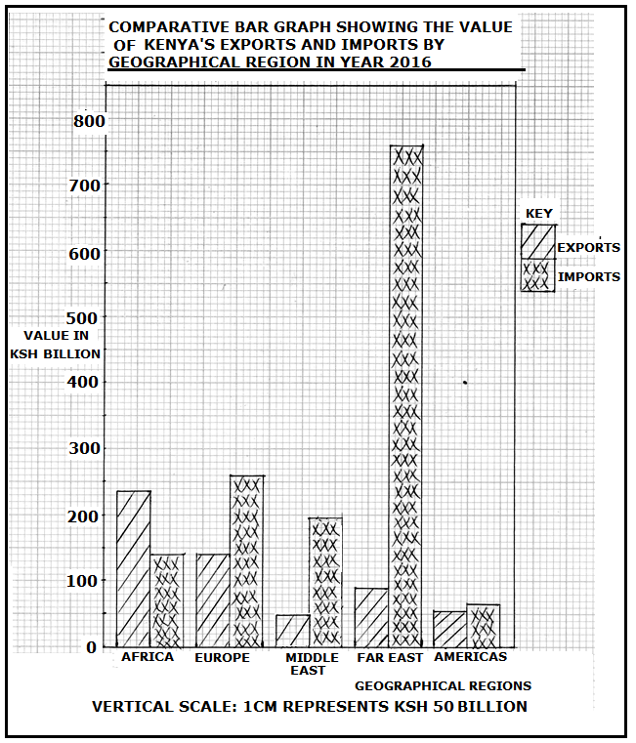
(iii) State three conclusions that can be made from the graph that you have drawn. (3marks)
- Value of exports to Africa was higher than imports.
- Value of exports and imports from Americas were almost equal.
- Exports to the Middle East region had the least value.
- Imports from the Far East had the highest value.
- Imports from Americas had the lowest value.
(c) State four characteristics of bar graphs. (4marks)
- Bar graphs are two dimensional
- All bars originate from zero.
- Bars representing the same item/commodity are shaded uniformly.
- The width of the bars must be uniform.
- Space in between bars in some bar graphs must be uniform.
- Dependent variables are plotted along the vertical axis.
- Independent variables are plotted along the horizontal axis.
- Bar graphs must have a comprehensive title.
7. Study the map of East Africa below and use it to answer question (a).
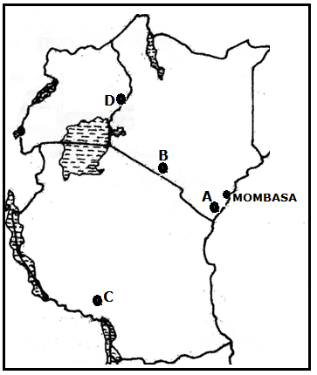

(a) Identify the minerals in the parts marked A, B, C and D. (4marks)
A - Titanium
B - Soda ash
C - Gold
D - Limestone
(b) (i) Apart from solution method, give three other methods of underground mining.. (3marks)
- Vertical Shaft
- Adit /drift
- Drilling
(ii) Describe how minerals are extracted using solution method. (6marks)
- This method is used to extract sulphur, salt, and potash.
- A vertical hole is drilled using a machines to reach the zone with the mineral.
- Three pipes are inserted through the holes to reach the deposit.
- Superheated water is passed into the deposit through the first pipe.
- After the mineral melts/dissolves, hot compressed air is pumped into the underground to create pressure.
- The dissolved or molten mineral then rises to the surface through the third larger pipe.
- At the surface, water is evaporated leaving the mineral

(c) State four negative effects of mining on the environment. (4marks)
- Occurrence of derelict land
- Destruction of vegetation / clearing of vegetation
- Loss of biodiversity in the area
- Dust from limestone blasts pollutes the air
- Large open pits destroy the beauty of land
- Heaps of rock waste promotes soil erosion
(d) Explain four contributions of petroleum production to the economies of Middle East countries. (6marks)
- Middle East countries earn foreign exchange from exports of crude oil and refined petroleum products e.g. Saudi Arabia
- The petroleum industry provides employment opportunities to many people who earn income thus improving their standards of living.
- Revenues obtained from the sale of petroleum has enabled Middle East countries to develop efficient roads, railways health and education institutions.
- Development of petro-chemical industries in the countries which also employ many people.
- Oil wealth has enabled some countries to construct nuclear power stations for electricity supply.
- Petroleum production has led to the growth of modern sites within the Arabian and Iranian deserts such as Dubai, Riyadh, Abu Dhabi and Doha

8. (a) (i) What is forestry?. (2marks)
- Forestry is the practice of managing and using forests, trees and their associated resources for human benefits.
OR
- Forestry is the science of developing and managing forests including cultivating them.
(ii) State three reasons why afforestation is being encouraged in Kenya (4marks)
- To protect water catchment areas.
- To protect soil from erosion by wind/water.
- To ensure sustainable supply of forest products.
- To put more land under forest cover.
- To regulate climate.
- To purify the air.
- To check the extinction of indigenous trees.
(b) Explain four factors that favour the growth of Mau forest. (8marks)
- The Mau area receives high rainfall between 1000mm and 1500mm annually which encourages the growth of trees.
- Moderate to high temperatures in the area between 14⁰C and 20⁰C which favours the growth of a variety of tree species.
- Some areas are rugged/steep which discourages settlement and cultivation allowing the growth of forests.
- The area has deep, well drained volcanic soils that allows tree roots to penetrate deep into the ground.
- The area is a gazetted forest thus human activities such as settlement and cultivation are prohibited.
- Enactment of laws recently has allowed the re-establishment of the forest
(c) Explain three problems that face forestry in Canada. (6marks)
- Over-exploitation in some areas at times results in shortage of some key tree species that take long to mature.
- Cold climate especially in Northern Canada causes trees to take long to mature thus delays in harvesting.
- Rugged land in mountainous regions hinders smooth exploitation.
- Inaccessibility in the northern parts during winter due to heavy snowfall which hinders exploitation
- Accidental fires mainly started by lightning during summer which destroys large tracts of forest land.
- Pests such as aphids and caterpillars at times destroys some tree species such as cypress.
(d) You intend to carry out a field study on a forest in your sub county.
(i) State three reasons why it is important to conduct a pre visit of the area. (3marks)
- Helps to draw up objectives for the study.
- Helps on to identify appropriate routes to follow during the study
- One introduces himself to the resource persons/guides
- Helps to draw a route map.
- Helps to design a working schedule.
- It helps to access suitability of the area of study.
- Helps to identify the problems likely to be encountered and how to solve them in advance.
- Helps to identify suitable methods of data collection
- Helps in general planning for the study.
(ii) State three observations that that you would make to indicate that the forest is well managed. (3marks)
- Occurrence of trees in blocks.
- Selective and rotational felling of trees.
- Presence of tree nurseries in the area.
- Presence of a forest guard posts.
- Observation of fence around the forest.
- Presence of impounded tracks with logs at the forest station.

9. Study the sketch map of Ghana below and use it to answer the following questions
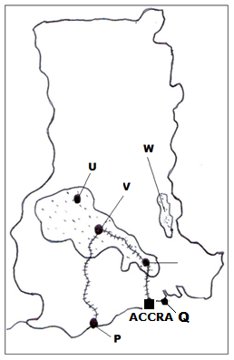
- Name (i) The cocoa growing areas marked U, V and W (3marks)
- U- Sunyani
- V- Kumasi
- W- Akwapim
ii) The port cities marked P and Q (2marks)
- P-Takoradi
- Q- Tema
b) State five physical conditions favoring cocoa growing in Ghana (5marks)
- Cocoa growing areas receive high rainfall annually (1300-1800mm)
- High temperatures (24⁰C- 30⁰C) in growing areas throughout the year.
- The rainfall in growing areas is well distributed throughout the year
- Occurrence of high relative humidity (70% to 80%) in growing areas
- Cocoa growing areas lie below 750m above sea level and have gently sloping land
- There is plenty of sunshine due to equatorial location of Ghana which favours maturing and ripening of cocoa pods
- Presence of deep well drained loam / volcanic soils that are rich in iron and potassium
c) Describe the stages involved in cocoa processing in Ghana. (7marks)
- Yellow ripe cocoa pods are cut using long sharp knives and piled at a central point
- The pods are split open with a sharp knife and cocoa beans scooped out by hand.
- The cocoa beans are put in heaps on mats and are covered with banana leaves to allow fermentation for up to six days
- Fermented beans are cleaned and washed
- After washing the beans are spread on racks / tables covered with mats to allow them to dry in the sun till they turn brown.
- Damaged or poor quality beans are sorted out / removed
- Dry beans are packed in bags and taken to buying centres
- Grade 1 are the unbroken clean and dry beans and fetch the best price

d) Explain four economic problems facing cocoa farmers in Ghana (8marks)
- Fluctuation of cocoa prices in the world market which at times lowers income to farmers thus lowering their morale
- Shortage of labour at times during harvesting leading to delays
- Smuggling of cocoa mainly from Ivory Coast into Ghana which threatens the quality of cocoa from Ghana
- Impassable feeder roads in some areas which delay the delivery of cocoa to buying areas
- Competition for land for other economic activities such as construction and for food crops which lowers the quantity of cocoa produced.

10. (a) State three physical condition that favour coffee growing in the central highlands of Kenya. (3marks)
- Warm to hot conditions or moderate to high temperatures (10⁰C to 26⁰C)
- High rainfall between 1000mm to 2100mm annually.
- Well distributed rainfall throughout the year.
- Deep, well drained volcanic soils that are slightly acidic.
- Medium to high altitude areas between 910m and 2100m above sea level.
- A Sunny dry period to allow ripening of the berries.

(b) Describe the stages involved in coffee production from picking to marketing. (8marks)
- Harvesting involves hand picking of Red Berries leaving green ones.
- Harvested Red Berries are immediately taken to processing factories.
- At the Coffee factory, Berries are poured on a mat and sorted by hand to remove unripe and spoiled berries.
- The Berries are weighed and poured into a tunnel which leads them to a machine that removes the outer covering pulp.
- The beans obtained are fermented in tanks for some time.
- The Beans are washed and sun dried on racks for about a week.
- Some dried beans are packed in bags and marketed as unroasted coffee.
- Other dried beans are peeled using a machine to remove husks.
- Peeled beans are sorted and graded according to size and quality.
- The beans are roasted at about 100⁰C and allowed to cool.
- Finally, the beans are ground into powder and packed ready for sale.
(c) Give four differences between coffee production in Kenya and in Brazil. (8marks)
- In Brazil, most of coffee is produced in large estates called Fazendas while in Kenya most of the coffee is produced by small scale farmers.
- In Kenya, Coffee is grown in the highlands while in Brazil, coffee is grown in the plateau.
- In Kenya, drought is the main weather problem while in Brazil, frost is the main weather problem.
- In Kenya, coffee yield per hectare is high due to soil preservation while in Brazil yield per hectare is low due to soil exhaustion.
- In Kenya small scale farmers mainly market their coffee through cooperatives while in Brazil, marketing of coffee is done by companies.
- In Kenya labour in small scale farms is mainly offered by family members while in Brazil, work in the fazendas is done by tenants/hired labourers.
(d) Your Geography class carried out a field study on a coffee farm
(i) State four methods the class would use to collect data. (4marks)
- Administering questionnaires
- Interviewing/Asking questions
- Observations
- Taking measurements
- Taking photographs
- Content analysis
(ii) During the study, the class collected data on quantities of coffee produced from the farm in the last five years. State two statistical methods that the class may have used to present the data. (2marks)
- Drawing pie charts
- Drawing graphs
- Drawing statistical table

