STEPHJOY GIRLS HIGH SCHOOL
FORM TWO MATHEMATICS HOLIDAY ASSIGNMENT

NAME..............................................................ADM..................CLASS...........

1. A triangle has sides 10cm, 7cm and 9cm. Find its area. (3marks)
2. Find the acute angle x, given that cos x = sin 2x. (3marks)
3. A rally car travelled for 2 hours 40 minutes at an average speed of 120km/h. The car consumes an average of 1 litre of fuel for every 4 kilometers. A litre of fuel costs Ksh.59. Calculate the amount of money spent on fuel. (3marks)

4. Two similar solids have surface areas 48cm² and 108cm²respectively. Find the volume of the
smaller solid if the bigger one has a volume of 162cm³. (3marks)
5. A triangle flower garden has an area of 28m². Two of its edges are 14 metres and 8 metres. Find the angle between the two edges. (3marks

6. Solve the following inequalities and state the integral values (3marks)
2x – 2 ≤ 3x + 1 <x + 11

7. The figure below is a cone with the vertex at A and diameter BC. The cone is cut off along DE.
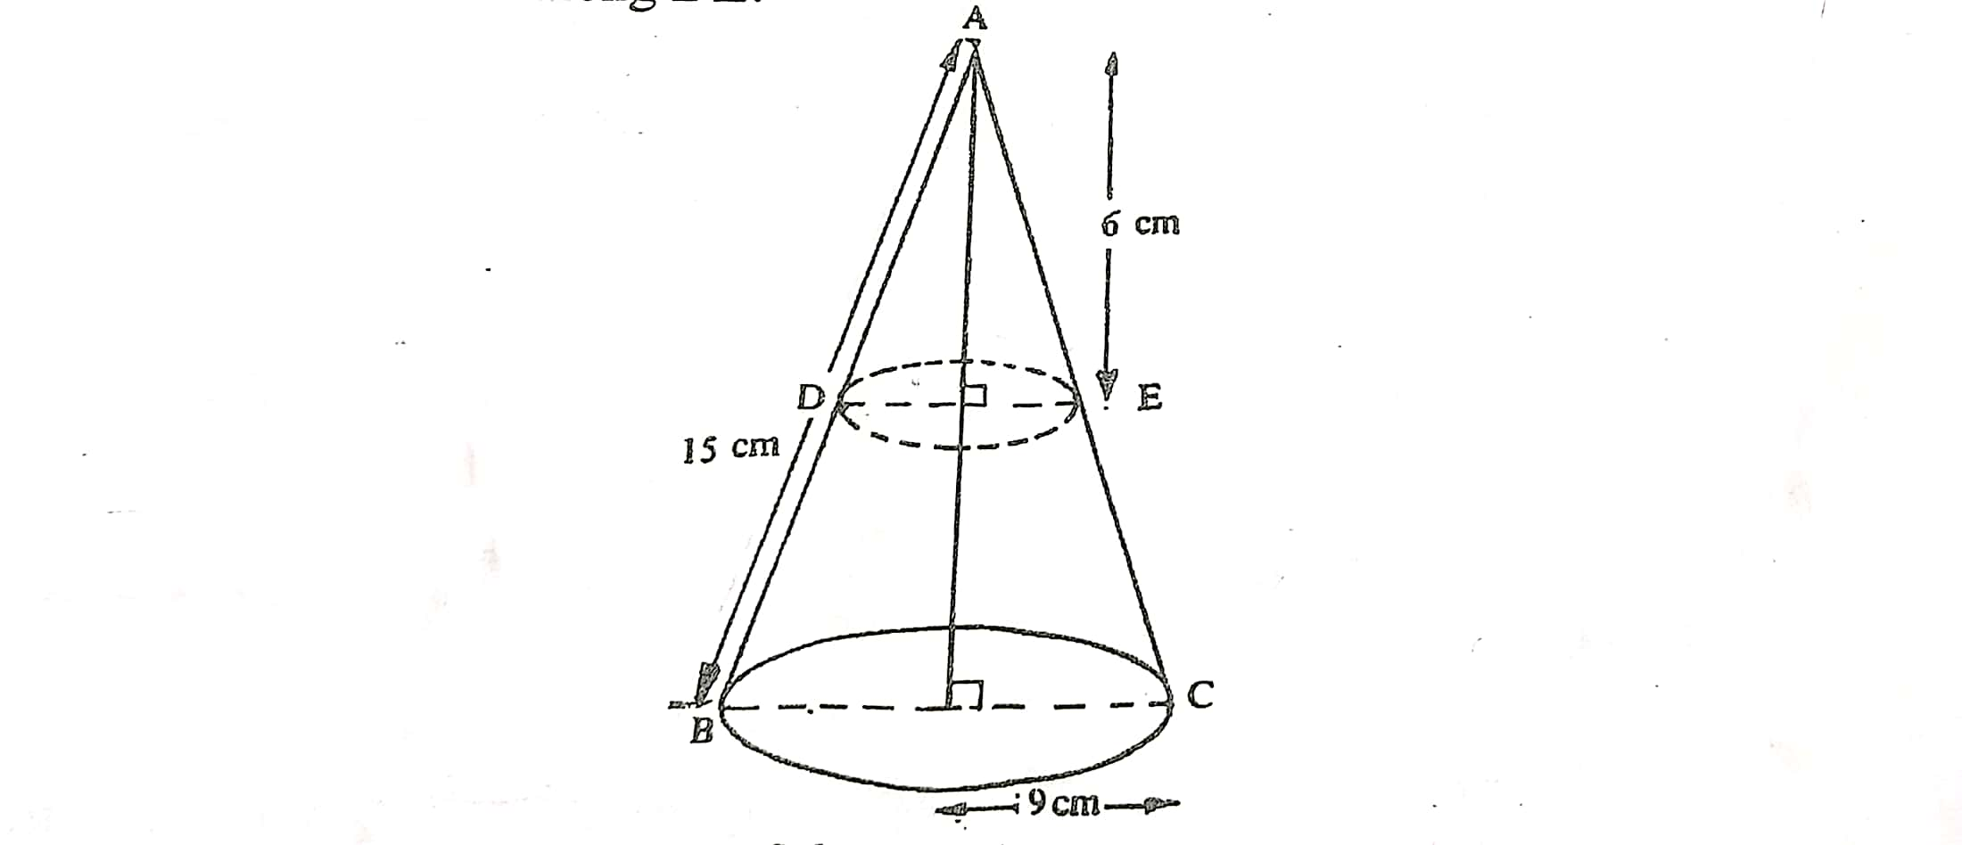
(a) Find the base radius of the smaller cone. (2 mark)
(b) Find the volume of the frustrum. (3marks)

8. A line passes through the points A (2, 6) and B (4, -8). Find the equation of the perpendicular bisector of line AB. (3 marks) (3marks)

9. The table below shows the distribution of marks scored by 60 pupils in a test.

Marks | 11-20 | 21-30 | 31-40 | 41-50 | 51-60 | 61-70 | 71-80 | 81-90
Frequency | 2 | 5 | 6 | 10 | 14 | 11 | 9 | 3

a) State the modal class of the marks (1mark)
b) Calculate the mean (3 marks)

10. Evaluate without using tables or a calculator the value of $\frac{1.33×0.51}{0.19×0.0017}$ (3marks)
11. Find all the integral values of $x$ which satisfy the inequalities. (3marks)
$20-x>5+2x≥x+5$

12When a certain number is divided by 48, 72 or 100 the remainder is 3 in each case. Find the number. (3marks)

13 Factorize fully the expression; hence simplify. (3mks)
15.Solve for m in the equation; 2^{3m+1} − 2^{3(m−1)} = 120. (3maks)
14. Given that p = 2i − 3j + k, q = 3i − 4j − 3k and r = 3p + 2q, find the magnitude of r to 2 significant figures. (3maks)

15. State the system of linear inequalities defining the unshaded region R given below (3maks)
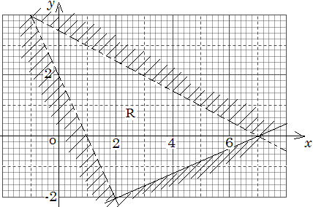
16 Given that Cos (90-β) = $\frac{\sqrt{3}}{2}$, determine without using trigonometric tables the value of Cos β (2mks)

17 The interior angles of a regular polygon are one and a half time the size of exterior angles. Find the number of sides of the polygon. (3 marks) {3 marks1. Evaluate: $\frac{\frac{1}{2} of 18 -3+2\frac{1}{2}×\frac{3}{-5}}{\frac{1}{2}+ 3\frac{3}{4} ÷ \frac{3}{4}}$ (3 marks)
18. The straight line joining the points P (a, 7) and Q (13, a) is parallel to the line whose equation is
3y + 2x = 9. Find the value of a. (3 marks )

19. The figure below shows a histogram. (3mks)
Frequency
Density
2.0
1.6
1.2
0.8
0.4
0

0

7.5 9.5 11.5 15.5 21.5
Length in x cm

Fill in the table below the missing frequencies.
Length in x cm | Frequency
7.5≤ x ≤ 9.5 | 12
9.5≤ x ≤ 11.5
11.5≤ x ≤ 15.5
15.5≤ x ≤ 21.5

20. Solve for x in the equation. (3 marks)
$\frac{{81}^{2x} x {27}^{x}}{9^{x}}$ = 729

21. The GCD of 6480, 7200 and a third number is 144. The L.C.M of the three numbers
is 2⁵ x 3⁵ x 5² x 7³. Find the smallest third number. (3 marks )

23. Use tables of reciprocals only to find the value of
$\frac{5}{0.0829}$ - $\frac{14}{0.581}$ (3 marks)

24. Mutua bought 8 pairs of trousers and six shirts at Sh. 4160. Had he bought twice as many shirts and half as many trousers, he would have saved Sh. 160. Find the cost of each item. (3 marks)

25. Two containers have base area of 750cm² and 120cm² respectively. Calculate the volume of the larger container in litres given that the volume of the smaller container is 400cm³. (3 marks)

26.The diagram below shows the speed-time graph for a bus travelling between two stations. The bus begins from rest and accelerates uniformly for 30 seconds. It then travels at a constant speed for 60 seconds and finally decelerates uniformly for 40 seconds.
Speed
(m/s)
Time in seconds

Given that the distance between the two stations in 2090m. Calculate
(a) The maximum speed, in km/h the bus attained (3 Marks)

(b) The acceleration (2 Marks)

(c) The distance travelled during the last 20 seconds (2 Marks)

(d) The time the bus takes to travel the first half of the journey (3 Marks)

27. The date below shows marks scored by 48 students in a geography exam.

Marks % | 30-39 | 40-49 | 50-59 | 60-69 | 70-79 | 80-89
Students | 6 | 10 | x | 9 | 12 | 2

- Determine the value of x (2mks)
- State the modal class (1mk)
- Calculate the (3mks)
- Mean mark
- Median mark (4mks)

28 a) The figure shows a velocity- time graph of a car

Velocity m/s
60

5 25 30 time (sec)
- Find the total distance covered by the car in metres (3mks)

- Calculate the deceleration of the car (3mks)

b) A lorry left kisumu at 8.00am and travelled towards the Nakuru at an average speed of 72km/h. At 8.30am a matatu left kisumu and followed the lorry at an average speed of 96km/h.
Determine the time of the day when the matatu caught up with the lorry (4mks)

29. A bus left Malaba town at 6.00am and travelled at an average speed of 80km/h towards Nairobi which is 510km away. At 6.30am a salon car left Nairobi the same day following the same route and travelled at average speed of 100km/h towards Malaba. After 1 hour, the car had a puncture which took 15minutes to repair before proceeding with the journey;
Determine
- The distance covered by the bus in 30minutes (1mks)
- The time of the day when car met the bus. (6mks)

30 The diagonals of a rectangle P, Q, R, S intersect at (5, 3). Given that the equation of line PQ is 4y - 9x =13 and that of line PS is y -4x =5
- The co-ordinators of P (3mks)
- The co-ordinates of R (2mks)
- The equation of line RQ (2mks)
- The equation of a perpendicular line drawn to meet PR at (5,3) (3mks)

31. A Kenyan bank buys and sells currencies at the exchange rates below
Currency | Buying (ksh) | Selling (ksh)
1 euro  1 us dollar | 147.87  74.22 | 148.00  74.50

An American tourist arrived in Kenya with 24,000 Euros. He converted all the euros to Kenya shillings at the bank. He spent a total sh. 200,000 while in Kenya and converted the rest into US dollars at the bank. Find the amount in dollars that he received. (3mks)

32. A major sector of a circle subtends an angle of 150 at the centre. The radius of the circle is 7cm and the centre is at O as shown

If the sector is folded into a conical shape, calculate the radius of the cone correct to 1 d.p (3mks)
33 Amoit bought 2 pens and 5 exercise books at a cost of sh. 275. Allan bought 4 such pens and exercise books from the same shop at a cost of sh. 415 by letting sh. X and y to be the costs of a pen and a book respectively, find the cost of each item (4mks )

34 Okech left some money in his will to be shared amongst his wife, son and daughter in the ratio 4:3:2 respectively. If the daughter received sh. 120,000 less than the mother’s share, find the total amount of money Okech left in his will. (2mks)

35. Use tables of reciprocals to find the reciprocal of 0.3758. Hence find the value $\frac{\sqrt[3]{0.125}}{0.3758}$ correct to 4.S.f (4mks)

36 Okedi sold goods whose marked price is sh. 340,000 at a discount of 2%. He was paid sh. 16660 as commission for the total sales. Calculate the percentage rate of commission (3mks)

37. The interior angle of a regular polygon is three and a half times the exterior angle. Determine the sides of the polygon (3mks)
38. Simplify $\frac{\left(1\frac{3}{7}-\frac{5}{8}\right)+\frac{2}{3} of 1\frac{1}{5}}{\frac{3}{4}+1\frac{5}{7} ÷\frac{4}{7} of 2\frac{1}{3}}$ (4mks)

39 A straight line ax + by = 16 passes through A (2, 5) and B (3, 7). Find the values of a and b (3mks)

40. Simplify $\frac{2-x-x^{2}}{{3x }^{2}-2x-1}$ (3mks)

41. Solve for X where $0≤x≤ = {90}^{0}$
$\sin{2x -\cos\left(x-30\right)=0}$ (2mks)

42. Solve for X in
$2x-4 ≤3x+2 <10-x$
Hence represent your solution on a number line (3mks)

