**MOMALICHE CYCLE 10-2023**

**MATHEMATICS PAPER 2 MARKING SCHEME**.

|  |  |
| --- | --- |
| 1 | * Xy=24   X=24/y……………….…..(i)  (10y + x) – (10x + y)= 18  9y – 9x = 18  Y – x = 2 ……………………(ii)**M1**  Substituting  Y-24/y= 2  Y2 -2y – 24 =0  Y2- 6y + 4y -24 =0**M1(solving quadratic equation**)  Y(y-6) + 4(y-6) =0  (y+4)(y-6)=0  Ignoring negative value  y=6 while x=4  **The number is 46 A1** |
|  | **Total 3mks** |
| 2 | |  |  | | --- | --- | |  | **M1**  **M1**  **M1**  **A1** | |
|  | **Total 4mks** |
| 3 | * Actual volume = 1/3x 3.142 x 212 x 14.0 = 6466.236 * Minimum volume =1/3 x 3.142 x 20.52x 13.95 = 6139.9786 * Maximum volume = 1/3x 3.142 x 21.52 x 14.05 = 6802.024 **M1** * Absolute error = $\frac{max-min}{2}$ = $\frac{6802.024-6139.9786}{2}$ =331.0227 **M1**   % error = $\frac{Absolute error }{actual volume}x100=\frac{331.0227}{6466.236}$ x100= 5.1192% **M1** |
|  | **Total3mks** |
| 4 | Cos 300=Sin 600=**M1(for correct sine and cos)**  (1+ $\frac{\sqrt{3}}{2}$)( 1+ $\frac{\sqrt{3}}{2}$) 1+ $\frac{\sqrt{3}}{2}$ + $\frac{\sqrt{3}}{2}$ + $\frac{3}{4}$ (1- $\frac{\sqrt{3}}{2}$)( 1+ $\frac{\sqrt{3}}{2}$) 1- $\frac{3}{4}$**M1(for correct rationilization) $\frac{ 7}{ 4}$**  + $\frac{ 2\sqrt{3}}{2}$ $$\frac{1}{4}$$ $\frac{ 7}{ 4}$ + 4Г3 A1 |
|  | **Total 3 Mks** |

|  |  |
| --- | --- |
| 5 | Log228**M1(for correct 28)**  Dropping the logs $\frac{x+7}{x-7}=$ 8 **B1(for dropping logs)**  x + 7 = 8x – 56  63=7x  X=9 **A1** |
|  | **Total 3 mks** |
| 6 | A = 450,000(1 +)18**M(for correct substitution)**  A= 1,284,453 **A1** |
|  | **Total 2 mks** |
| 7 | AX.CX = DX.XB  6XC = 5 X 4.8**M1**  XC = $\frac{5 X 4.8}{6}$ = 4 cm**M1**  BT2= 8 X 18  BT = = 12**A1** |
|  | **Total 3mks** |
| 8 | X2 + 8x – 48 = 0**M1**  Product = -48 and sum = 8  Factors (12, -4)  X2 + 12x – 4x – 48 =0 X(x + 12) -4(x +12) =0 **M1(for solving quadratic equation)**  Either x + 12=0 or x – 4=0  X= -12 or x = 4 **A1** |
|  | **Total 3mks** |
| 9 | * C=k + hL2   25,000= k + 400h  45,000= k + 900h  -20,000= -500h   * h= 40**M1**   25,000= k + 400(40)   * k= 9,000**M1**   C = 9,000 + 40(82)   * C= Ksh. 11,560 **A1** |
|  | **Total 3mks** |
| 10 | 2nd = a + d  4th = a + 3d  7th = a + 6d $\frac{a+3d}{a+d}$ = $\frac{a+6d}{a+3d}$ $M1$ (a + 3d)( a + 3d)=( a + 6d)( a + d)  a2 + 6ad + 9d2=a2 + 7ad + 6d2  3d2= ad hence a= 3d = 3(2) = 6 **B1**   * r= $\frac{12}{8}=1.5$**A1** |
|  | **Total 3mks** |
| 11 | Use ratio theorem where m= 3 and n=-2  OM= $\frac{np+mq}{m+n}$ = $\frac{-2( \begin{matrix}1 \\ 2) \\ 3\end{matrix}+3\begin{matrix}4 \\ ( 5 ) \\ -3\end{matrix}}{3+ -2}$**M1**  = $\frac{( \begin{matrix}-2 \\ -4 ) \\ -6\end{matrix}+\begin{matrix}12 \\ ( 15 ) \\ -9\end{matrix}}{1}$ = $\begin{matrix}10 \\ ( 11 ) \\ -15\end{matrix}$**M1**  Coordinate of M is (10, 11, -15)**A1** |
|  | **Total 3mks** |
| 12 |  |
|  | **Total 4mks** |
| 13 | 1. A can fill $\frac{ 1}{3}$ of the tank in 1 hr.   C can empty $\frac{ 1}{5}$ of the tank in 1 hr.  Fraction filled by both tanks in 1 hr= $\frac{ 1}{3}$- $\frac{ 1}{5}$ = $\frac{ 2}{15}$ Fraction filled in 4 hrs = $\frac{ 2}{15}$ x4 = $\frac{ 8}{15}$ Empty fraction = 1 - =**A1** |
| 1. Fraction filled in one hour by all pipes = $\frac{ 1}{3}$ + $\frac{ 1 }{2}$**- $\frac{ 1}{ 5}$** = $\frac{19}{30}$**M1**   Tme to fill the empty fraction = $\frac{ 7}{15}$ ÷ $\frac{ 19}{30}$ = $\frac{ 7}{15}$ x $\frac{ 30}{19}$ = $\frac{ 14}{19}$ hours**A1**  or=0.7368 hours |
|  | **Total 4mks** |

|  |  |  |
| --- | --- | --- |
| 14 | Arrange numbers in ascending order  1, 2, ***4***, 4, 5, **6**, 6, 7, ***7***, 8, 9.  Lower quartile Q1 = 4**M1**  Upper quartile Q3 = 7  interquartile range = 7 – 4 = 3**A1** | |
|  | **Total 2mks** | |
| 15 | (3x – 10)0= Sin-10.4337 = 25.70**M1**  (3x – 10)0 = 25.70, 154.30, 385.70, 514.30,  3x= 35.70, 164.30, 395.70, 524.30  X= , , , **M1**  X= 11.90, 54.770, 131.90, 174.770**A1 (Award 1 mark if all the angles are there).** | |
|  | **Total 3mks** | |
| 16 | 1. (3x)4 – 4(3x)3(y) + 6(3x)2(y)2 – 4(3x)(y)3 + (y)4**M1**   81x4 – 108x3y + 54x2y2 – 12xy3 + y4**A1** | |
| 1. 3x=6   X=2 and y=0.2  81(24) – 108(23)(0.2) + 54(22)(0.22)**M1(for correct substitution)**  1286 – 172.8 + 8.64  = 1131.84**A1** | |
| 17  (a) | | | Net Tax per annum  Taxable income p.a = ( K£12,000 + 15% of K£12,000 - $\frac{ 1.200 x 12}{20}$)  = K£ 13,080 p.a.**M1**  1st band 2100 x 10% = 210  2nd band 2100 x 15% = 315**B1**  3rd band 2100 x 20% = 420**B1**  4th band 2100 x 25% = 525**B1**  Remaining 4680 x 30% = 1,404**B1**  Gross tax = K£ 2874 P.a.**M1**  Net tax = Gross tax – relief  Net tax = K£ (2874 – 1320 – 80)  = K£ 1474 p.a.**A1** | |
| (b) | | | Deductions per month  Tax per month = $\frac{ 1474 x 20}{12}$ = 2,456. 67  Premium per month = $\frac{ 800 x 20}{12}$ = Shs. 1,333.33  Total deductions per month = 2,456. 67 + 1,333.33 + 600 + 500 = Shs 4890 p.m.**M1**  Taxable income per month = $\frac{ 13080 x 20}{12}$ = 21,800**M1**  Net pay = Ksh 21, 800 – 4890 = Shs 16, 910**A1** | |
|  | | | **Total 10 mks** | |

|  |  |
| --- | --- |
| 18. | C:\Users\FRED\OneDrive\Desktop\Screenshot_20230328-093708.jpg |
|  | **Total = 10 mks** |
| 19. | (a)(i) PR = **M1**  **= 14.14** **A1**  (ii) VO2 = 132 - 7.072 = 169 – 49.98 =  VO = = 10.91 cm**A1**  (b) (i) Tan  =  = Tan -1= 57.060**A1**  (ii) Angle between MR and base PQRS = Tan -1**M1**  = 57.060**A1**  (iii)Tan ᾱ = **M1**  = 65.360**A1** |

1. a) Complete the table below for y=sin 2x and y=sin ( 2x + 30) giving values to 2d.p.(2mks)

|  |  |  |  |  |  |  |  |  |  |  |  |  |  |
| --- | --- | --- | --- | --- | --- | --- | --- | --- | --- | --- | --- | --- | --- |
| x | 0 | 15 | 30 | 45 | 60 | 75 | 90 | 105 | 120 | 135 | 150 | 165 | 180 |
| Sin 2x | 0 | 0.5 | 0.87 | 1 | 0.87 | 0.5 | 0 | -0.5 | -0.87 | -1 | -0.87 | -0.5 | 0 |
| Sin (2x+30) | 0.5 | 0.87 | 1 | 0.87 | 0.5 | 0 | -0.5 | -0.87 | -1 | -0.87 | -0.5 | 0 | 0.5 |

b) Draw the graphs of y=sin 2x and y = sin (2x + 30) on the axis. (4mks)

*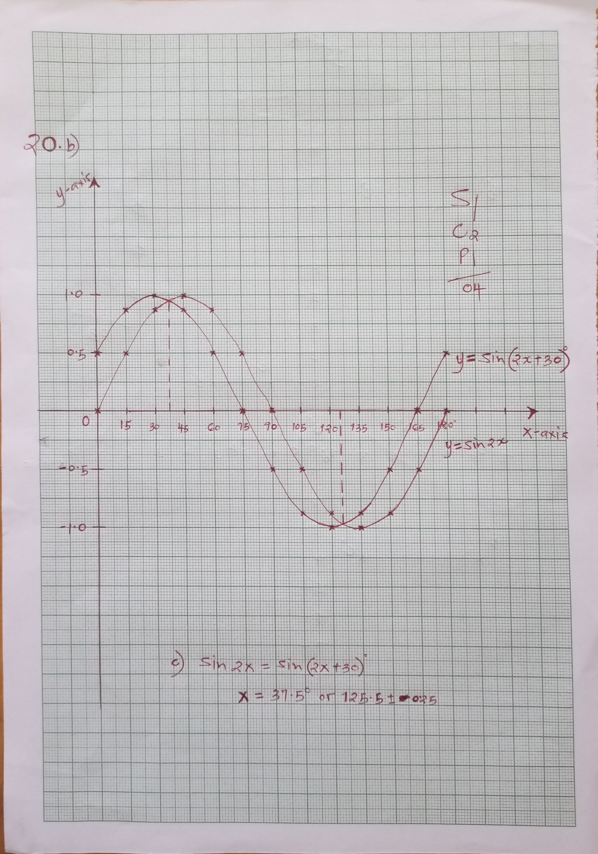*

c) Use the graph to solve  (1mk)

**x = 37.5 o OR 125.5o**

d) Determine the transformation which maps  (1mk)

**Translation -30o**

**0**

e) State the period and amplitude of  (2mks)

**Period 180o amplitude 1unit**

1. a)

*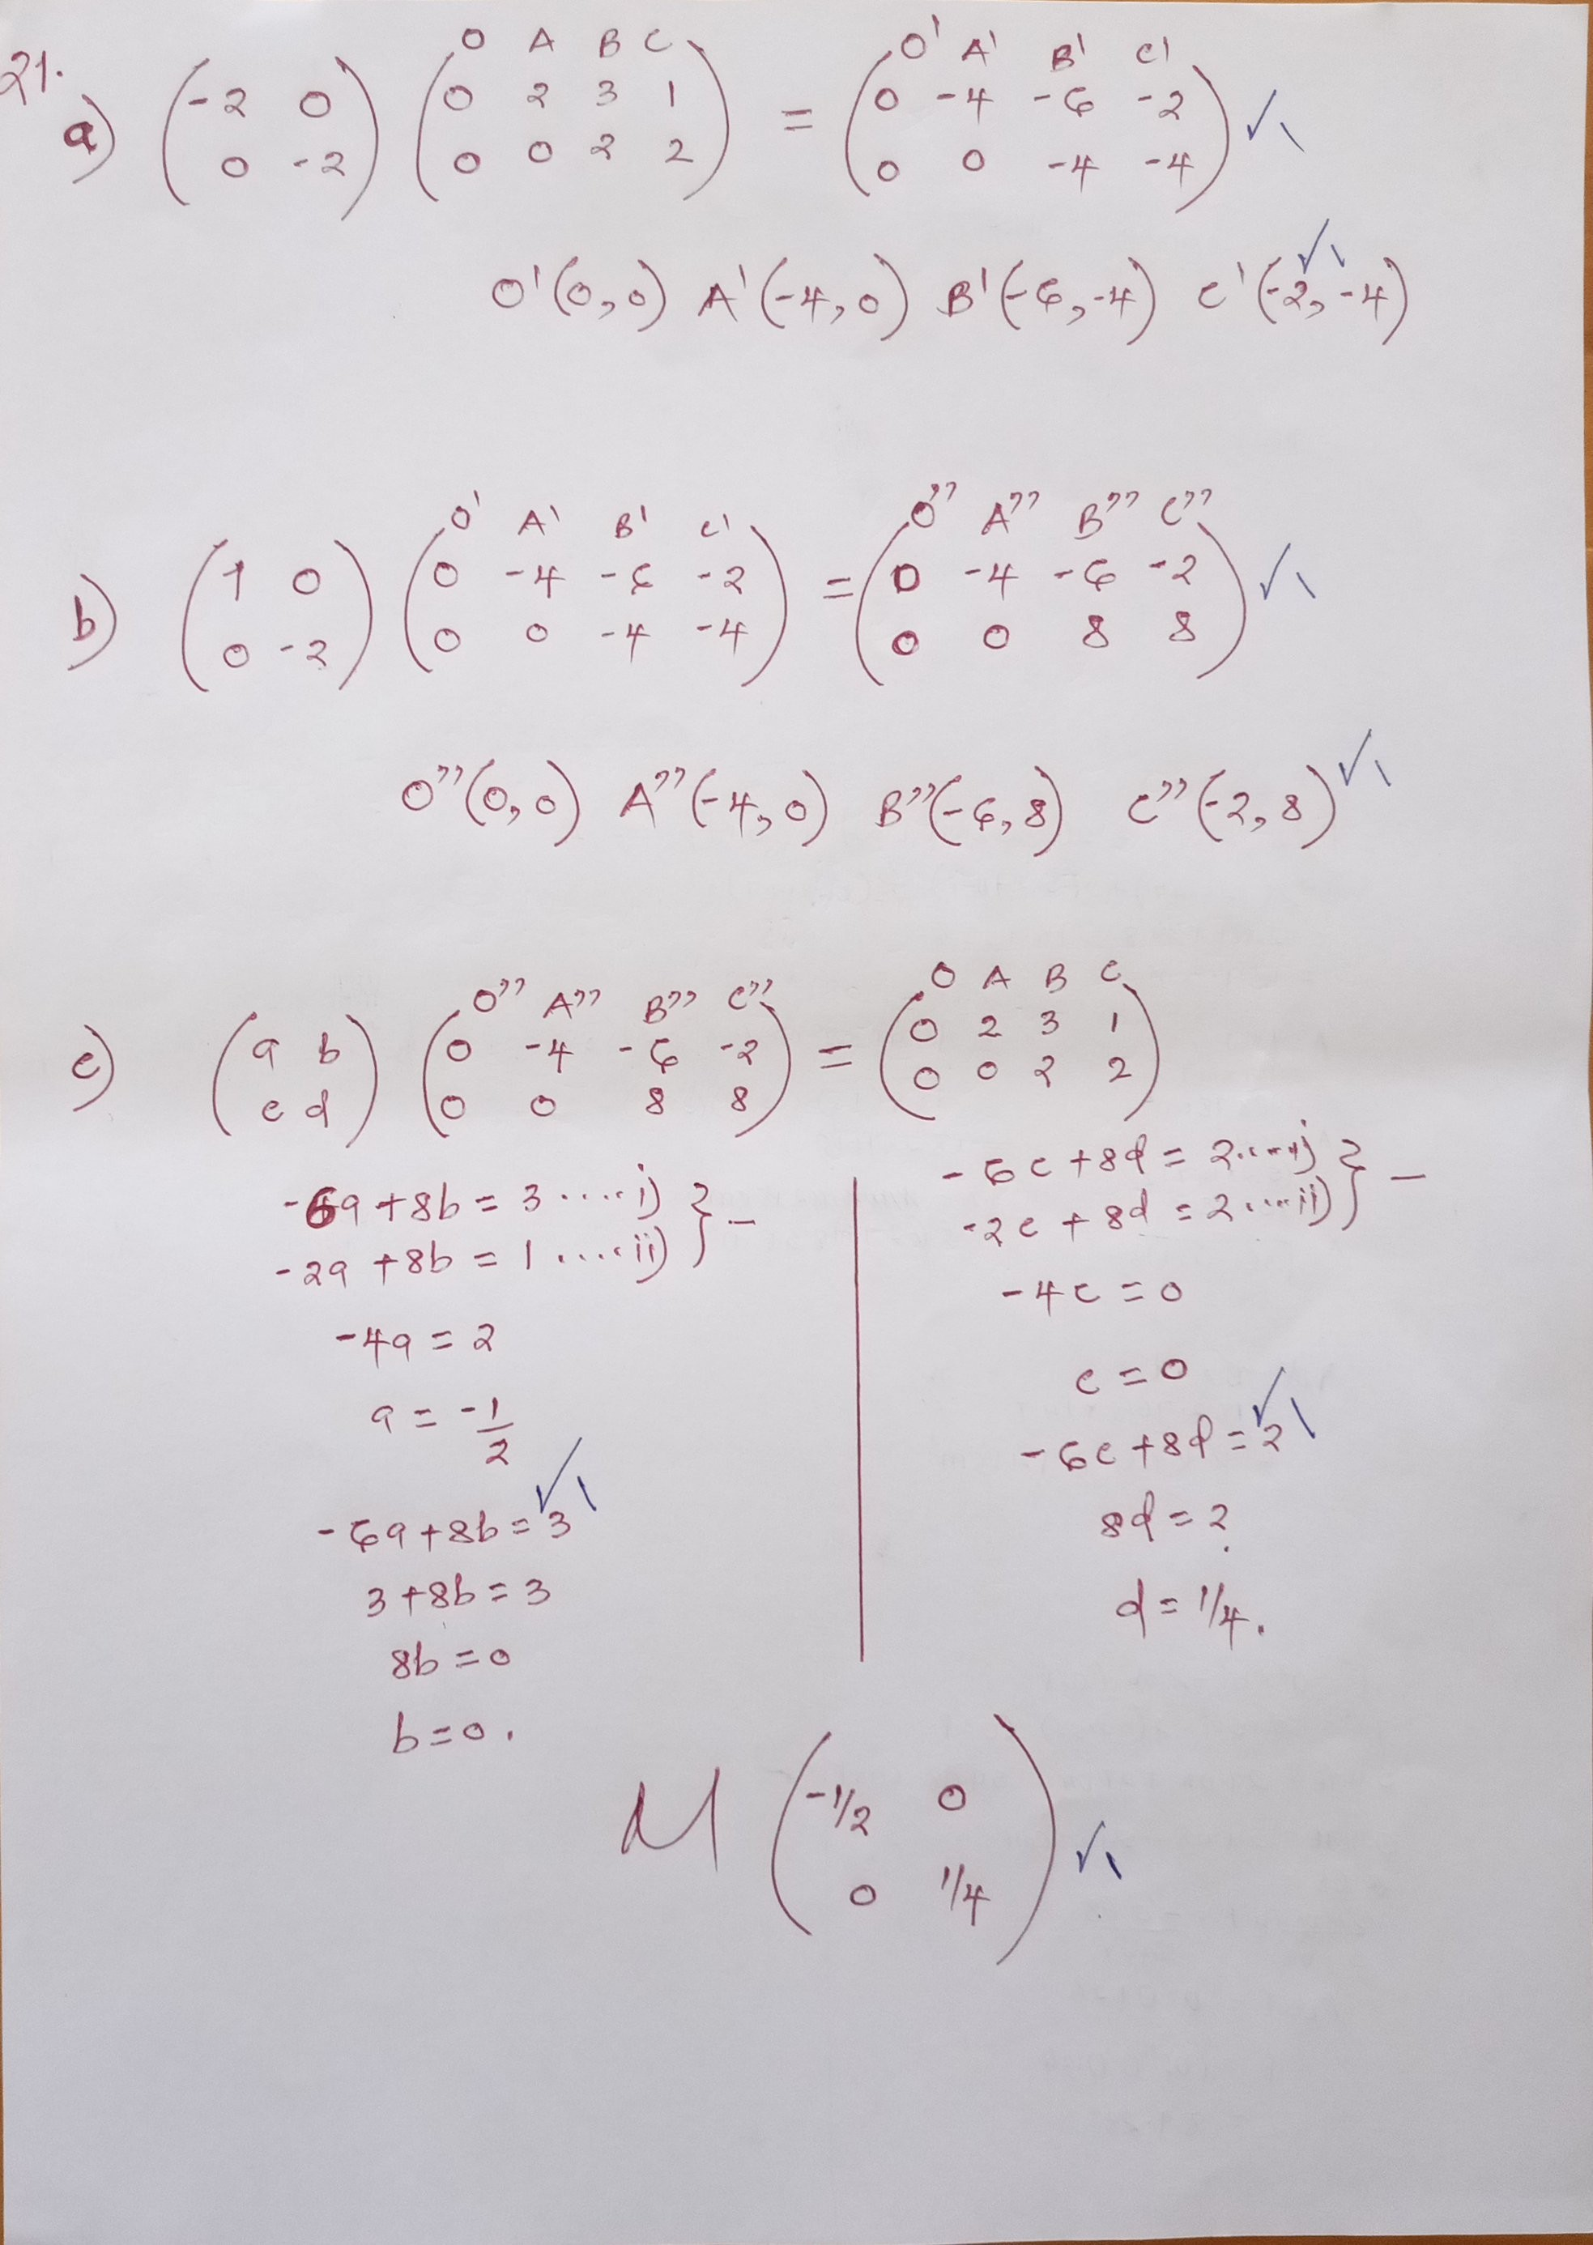*

*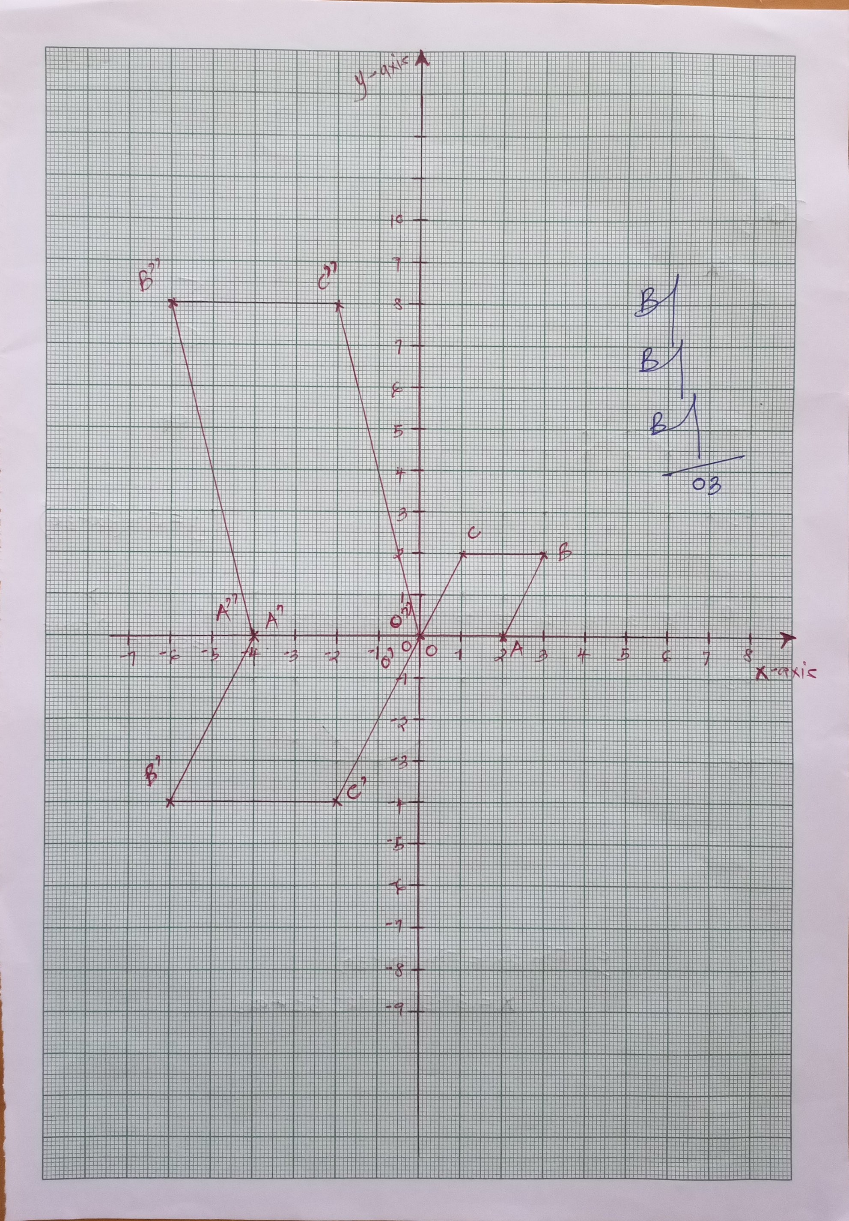*

22.

.Let A = 62

|  |  |  |  |  |  |  |
| --- | --- | --- | --- | --- | --- | --- |
| **Marks** | **f** | **x** | **D=x-A** | **fd** | **d²** | **fd²**  B1 d value  B1 fd²ratio  B1 - |
| 45-49 | 3 | 47 | -15 | -45 | 225 | 675 |
| 50-54 | 9 | 52 | -10 | -90 | 100 | 900 |
| 55-59 | 13 | 57 | -5 | -65 | 25 | 325 |
| 60-64 | 15 | 62 | 0 | 0 | 0 | 0 |
| 65-69 | 5 | 67 | 25 | 25 | 25 | 125 |
| 70-74 | 4 | 72 | 40 | 40 | 100 | 400 |
| 75-79 | 1 | 77 | 15 | 15 | 225 | 225 |
|  | F = 50 |  |  | Efd - 120 |  | =2650 |

1. Mean x = A + Efd

Ef

62 + -120 / 50 M1

= 62 – 2.4 = 59.6 A1

b) v = Efd² - Efd ² M1

Ef Ef

= 2560 - 120 ² = 53 – 5.76 M1A1

50 50

c) s.d= Efd² - Efd

Ef Ef M1

47.24

= 6.873 A1

23.

*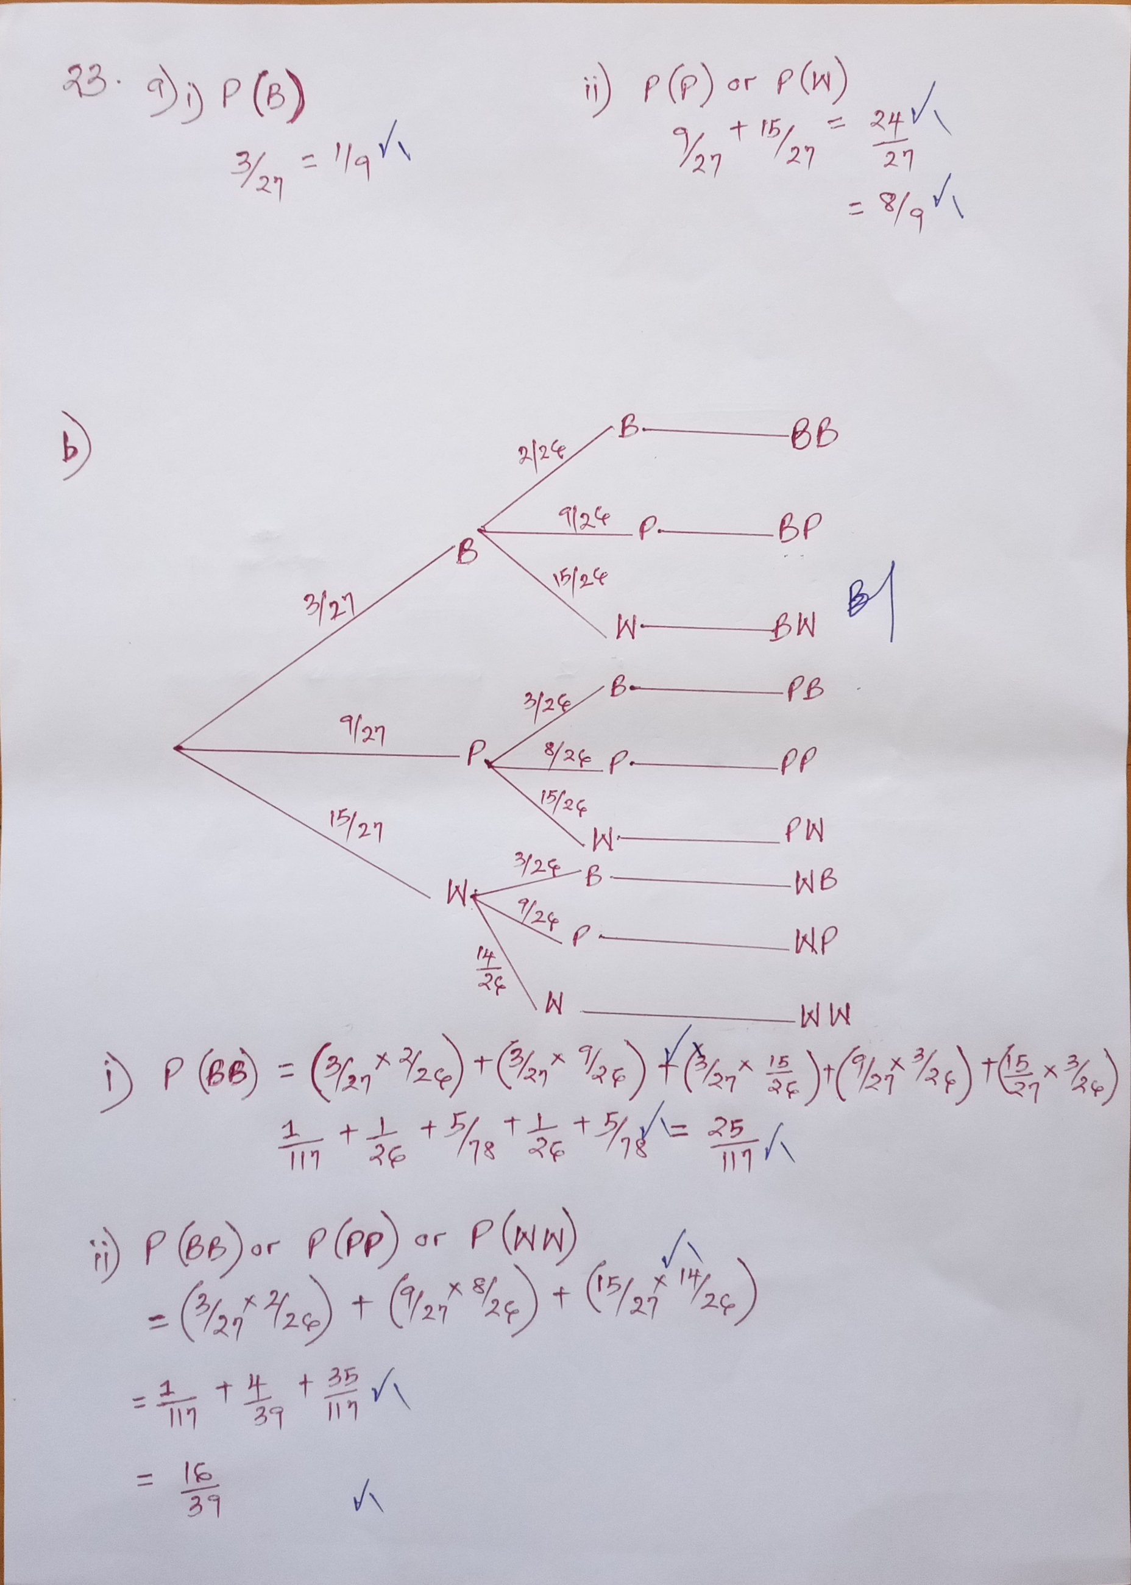*

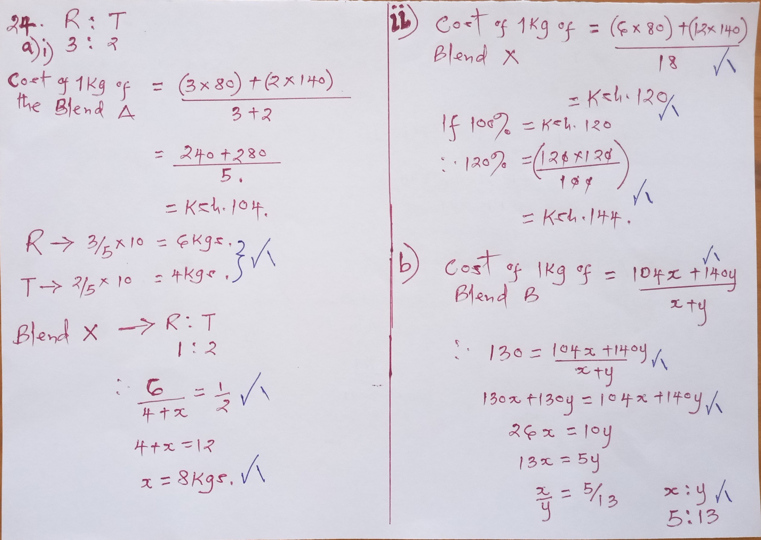24.