NAME …………………………………………………… ………………………….
SCHOOL ……………………………………………… DATE …….………………
ADM No ………………………………………………. CLASS ………………….
CANDIDATE’S SIGNATURE …………………….………………………..
121/2
MATHEMATICS
PAPER 2
JUNE/JULY 2021
TIME: 2¹/₂ HOURS
MOKASA ONE EXAM
Kenya Certificate of Secondary Education (K.C.S.E)

INSTRUCTIONS TO THE CANDIDATES

- Write your name and school and index number in the spaces provided above
- This paper contains two sections; Section 1 and Section 11.
- Answer all the questions in section 1 and only five questions from Section 11
- Show all the steps in your calculations, giving your answers at each stage in the spaces below each question.
- Marks may be given for correct working even if the answer is wrong.
- Non-Programmable silent calculators and KNEC Mathematical tables may be used EXCEPT where stated otherwise.

FOR EXAMINERS’S USE ONLY
Section 1
Question | 1 | 2 | 3 | 4 | 5 | 6 | 7 | 8 | 9 | 10 | 11 | 12 | 13 | 14 | 15 | 16 | Total
Marks
Section 1I GRAND TOTAL
Question | 17 | 18 | 19 | 20 | 21 | 22 | 13 | 24 | Total
Marks

This paper consists of 16 printed pages. Candidates should check carefully to ascertain that all the pages are printed as indicated and no questions are missing.

SECTION I (50 marks): Answer all questions in this section
1. Use logarithm tables to evaluate $\sqrt[3]{\frac{0.4239 ×149.6}{\log{6}}}$ ( 4 marks)

2. Solve the equation 6^{2x+1} = 2^{3x+1} ( 3 marks)

3. Kevin truncated 0.00627 to 3 decimals and 487.74 to 3 significant figures. Calculate his percentage error in calculating product of numbers in truncated values to 1 decimal places.
( 3marks)

4. A new laptop depreciates at 8% per annum in the first year and 12% per year in the second year. If its value at the end of the second year was sh121,440. Calculate the original value of the laptop. (3marks)

5. Rationalize the denominator and simplify ( 3 marks)
$$\frac{\sqrt{3}}{\sqrt{5}}\frac{+ 2\sqrt{5}}{- \sqrt{3}}$$

6. In the figure below angle A=68⁰, B= 39⁰, BC= 8.4cm and CN is the bisector of angle ACB. Calculate the length CN to 1decimal place. ( 3 marks)
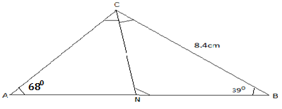

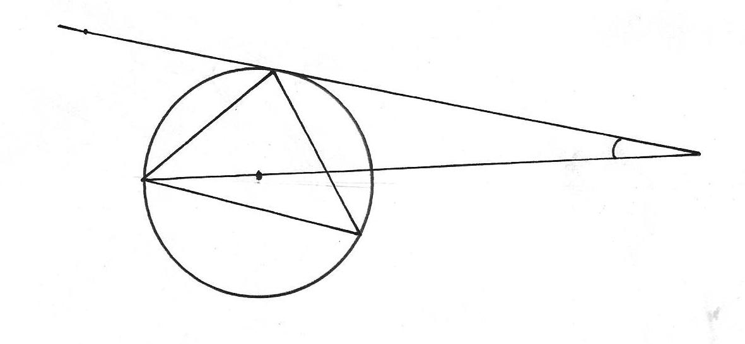
7. In the figure below R, T and S are points on a circle centre O. PQ is a tangent to the circle at T, POR is a straight line and ∠ QPR =20º. Find the size of ∠ RST (3marks)
Q
T
O
S
P
20º
R

8. Use binomial expansion to find the value of (1.02)⁵ correct to 3 decimal place. ( 4 marks)

9. Make x the subject of the equation (3 marks)

10. The equation of the circle is given by x² + y² + 8x -2y -1 = 0 . Determine the radius and the centre of the circle. (3marks)

11. Given that the minor arc of a circle subtends an angle of 140⁰ at the centre of a circle of radii 3.5cm. Calculate the area of the major segment correct to 4 significant figures ( 3 marks)

12. Given that the matrix is a singular matrix, find the values of x. (3marks)

13. The mass of a mixture A of peas and millet is 72 kg. The ratio of peas to millet is 3:5 respectively;
(a)Find the mass of millet in the mixture. (1mark)

(b)A second mixture of B of peas and millet of mass 98 kg is mixed with A. The final ratio of peas to millet is 8:9 respectively. Find the ratio of peas to millet in B (2marks)

14. Draw a line AB= 8cm long. Divide the line proportionally into5 equal parts. Locate a point Y on the line AB such that AY: YB = 3:2. ( 3 marks)

15. A solid prism is made of a pentagonal cross section of sides 10cm. If the prism is 30cm long calculate area of the cross section hence the volume of the prism (3 marks)

16. Given that X = 2i + j -2k, y = -3i + 4j – k and z= 5i + 3j + 2k and that p= 3x – y + 2z, find the magnitude of vector p to 3 significant figures. (3marks)

SECTION II (50 Marks) Answer any five questions in this section
17. The masses in kilograms of patients who attended a clinic on a certain day were recorded as:
38 52 46 48 60 59 62 73 49 54 49 41 57 58 69 72 60 58 42 41
79 62 58 67 54 60 65 61 48 47 69 59 70 52 63 58 59 49 51 44
67 49 51 58 54 59 39 59 54 52

a) starting with class 35-39, make a frequency distribution table for the data indicating the class and frequency. ( 3 marks)

b ) state the modal class ( 1 mark)

c) Calculate the mean mass ( 3 marks)

d) Calculate the median mass ( 3 marks)

18. The income tax rates of a certain year were as shown below:

Monthly taxable income in Ksh | Tax rate in %
0-9680 | 10
9681-18800 | 15
8801-27920 | 20
27921- 37040 | 25
37041 and above | 30

In that year, Sayao monthly earnings were as follows; basic salary Ksh. 30 000, house allowance Ksh.15 000, and medical allowance of Ksh 3,500. He is entitled to a monthly tax relief of Ksh. 1056.
- Calculate Sayao’s taxable income ( 2 marks)

- Calculate his P.A.Y.E ( 5 marks)

- A part from P.A.Y.E, other deductions is education insurance policy Ksh. 1500 and Ksh 2500 as cooperative shares. Find his net income at end of the month. ( 3 marks)

19. A Quantity P varies partly as the square of m and partly as n. When p= 3.8, m = 2 and n = -3, When p = - 0.2, m = 3 and n= 2.

a) Find
i) The equation that connects p, m and n (4marks)

ii) The value of p when m = 10 and n = 4 (1mark)

b) Express m in terms of p and n (2marks)

c) If P and n are each increased by 10%, find the percentage increase in m correct to 2 decimal place. (3marks)

20.a) Complete the table below by filling in the blank spaces ( 2 marks
x | 0⁰ | 30⁰ | 60⁰ | 90⁰ | 120⁰ | 150⁰ | 180⁰ | 210⁰ | 240⁰ | 270⁰ | 300⁰ | 330⁰ | 360⁰
y=Cos x | 1.00 | 0.87 |  | 0.00 |  | 1.00 |  | -0.87 |  |  |  | 0.87
y=3sinx | 0.00 |  |  | 3.00 |  |  |  |  |  |  |  | -1.50 | 0.00
b) using the scale 1cm to represent 30⁰ on the x-axis and 2 cm to represent 1 unit on the vertical axis, draw on the graphs of cosx and 3sinx ( 5 marks)

c) use your graph to solve the equation cosx =3sinx ( 2 marks)

d) What is the difference in the values of y=cosx and y=3sinx at x=120⁰ ( 1 mark)

21. The 5th term of an AP is 16 and the 12th term is 37.
Find;
- The first term and the common difference ( 3 marks)

- The sum of the first 21 terms (2 marks)

b) The second, fourth and the seventh term of an AP are the first 3 consecutive terms of a GP. If the common difference of the AP is 2.
Find:
- The common ratio of the GP ( 3 marks)

- The sum of the first 8 terms of the GP (2 marks)

22. In driving to work, John has to pass through three sets of traffic lights. The probability that he will have to stop at any of the lights is ¾
- Draw a tree diagram to represent the above information. (2 marks)

- Using the diagram, determine the probability that on any one journey, he will have to stop at:
- All the three sets. (2 marks)

- Only one of the sets (2 marks)

- Only two of the sets (2 marks)

- None of the sets. (2 marks)

23. The figure below shows a lampshade in the form of a conical frustum

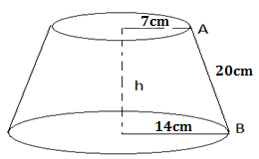
The top and bottom radii are 7cm and 14cm respectively. The slant height AB is 20cm. Calculate:
- The slant height of the original cone correct to two decimal places ( 2 marks)

- The height h, of the lampshade ( 2 marks)

- The curved surface area of the lampshade ( 3 marks)

- The volume of the lampshade correct to 4 significant figures ( 3 marks)

24. Gary bought 5 tins of plums and 3 tins of peaches from a supermarket for Ksh.75, while Mike bought 3 tins of plums and 5 tins of peaches for Ksh.77
a) Set up the simultaneous equations which represent the given information
(2 marks)

b) Write down the matrix equation ( 2 marks)

c) Using the matrix method, find the cost of
i) 4 tins of plums ( 5 marks)

ii) 2 tins of peaches ( 2 marks)

