TERM 2 2022
MID-TERM EXAM
FORM 4
TIME: 1 ½ HOURS

NAME ---------------------------------------------------ADM. NO. --------------------- CLASS-------------------
1. The equation of a circle is given by X² + Y² – 10Y + 16 = 0.
Find the radius of a circle and its Centre. (4mks)

2. The point (5,2) undergoes transformation 3 2 followed by translation -6. Determine the Co-ordinates of the image. (3mks)

3. Using a ruler and a pair of compasses only construct a parallelogram. a. PQRS in which PQ=6 QR=4 and angle SPQ=75º (3mks)

b. Determine the perpendicular distance between PQ and SR. (1mk)

4. a. Find the values between O^{O} and 360º which satisfy the equation 2 Ө = -0.5. (4mks)

b. Determine the amplitude, period and phase angle of the following equation. (3mks)
Y = 6 Sin (x/2 – 90)⁰

5. The first term of AP is 2 and the sum of 10 terms of the AP is 650. Find the value of d. (2mks)

SECTION B (CHOOSE 3 QUESTIONS)
6. The figure below represents a towel model. The base PQR is an equilateral triangle of side 9cm. The length VP=VQ=VR=20.5cm. Point M is the mid-point of PQ and VM =20cm. Point N is on the base and vertically below V.
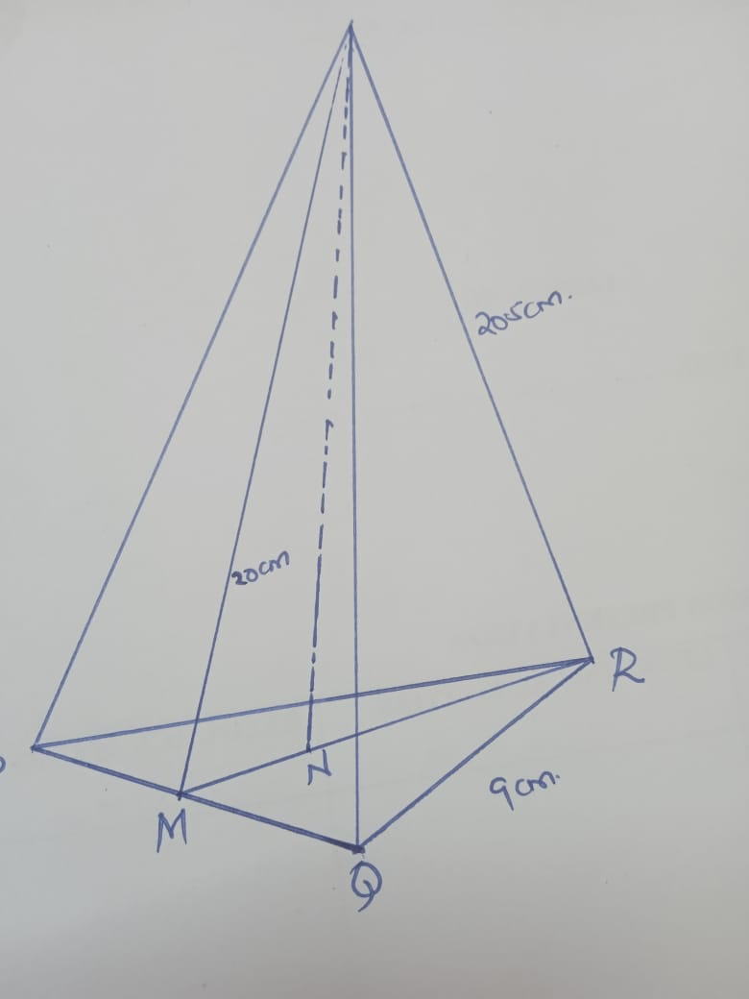
Calculate
a.i) Length of RM (2mks)

ii. Height of the model (2mks)

iii. Volume of the model (3mks)

b. The model is made up of a material whose density = 2700kg/m³. Find the mass of the model. (3mks)

7. The table below shows distribution of marks scored in a test by standard eight pupils in a Mathematics test.
Marks | 30-34 | 35-39 | 40-44 | 45-49 | 50-54 | 55-59 | 60-64 | 65-69 | 70-74 | 75-79
No. of pupils | 1 | 5 | 10 | 10 | 19 | 20 | 8 | 8 | 4 | 3

Using assumed mean of mark of 57 calculate.
- The actual Mean of the grouped data. (3mks)

- The standard deviation. (7mks)

8. OABC is a parallegram with O(0,0), A(2,0), B(3,2) C(1,2). O¹A¹B¹C¹ is the image of OABC under transformation -2 0
- -2
- i. Find the co-ordinates of O¹A¹B¹C¹ (2mks)

ii. On the grid provided draw OABC and O¹A¹B¹C¹ (2mks)

- i. Find O¹¹A¹¹B¹¹C¹¹ the image of O¹A¹B¹C¹ under the transformation matrix (¹₀ ₋₂⁰). (2mks)

ii. Draw O¹¹A¹¹B¹¹C¹¹

- Find a single matrix that maps O¹¹A¹¹B¹¹C¹¹ onto OABC. (3mks)

9. Using trapezium rule find the area bounded by the curve (4mks)
a. Y=-X²+6X+1 X=0 and X=6

- Calculate the exact area under the curve. (4mks)

- Find the percentage error introduced by the trapezium rule. (2mks)

10. Complete the table below, giving the rules correct to 1 decimal place.
X^{O} | 0 | 40 | 80 | 120 | 160 | 200 | 240
2SIN(X+20)² | 0.7 | - | 2.0 | - | 00 | - | -2.0
[3 COS X | 1.7 | 1.3 |  | 0.9 |  | -1.6

b. Using the same scale drawing on X and Y axis draw the graphs of 2sin(x+20) and [3 cos x for 0≤x≤240.

c. Using the graphs above determine the values for X which 2sin(x+20)² =[cosX.

- Determine the difference in amplitude between the two graphs.

