FORM 4 ENTRANCE EXAMS 2023

- $\log{(2x-11)- \log{2= \log{3- \log{x }}}}$  $$\frac{2x-11}{2 }= \frac{ 3 }{x}$$  $$x( 2x-11=6$$  $$2x^{2} – 11x – 6 = 0$$  $$2x^{2} – 12x + x – 6 = 0$$  $$2x( x-6) + 1(x – 6) = 0$$  $$2x + 1 = 0 x- 6= 0$$  $$2x = -1 x =6$$  $X= - ½$ |  | $M_{1}$ for $\frac{2x-11}{2 }= \frac{ 3 }{3 }$  $M_{1}$ for $attempting to solve quadritic$  $$equation$$  $A_{1}$ for $both values of x$
- Actual area  = ½̸ $×{6̸4̸}^{32} ×3.5 =11.2$  Limits $\begin{matrix}6.45 \\ 6.35 \end{matrix} \begin{matrix}3.55 \\ 3.45\end{matrix}$  Max area ½ $×6.45 ×3.55 =11.45$  Min area ½ $×6.35 ×3.45= 10.93$  A.E. A - $\frac{\max{- min }}{2 } \frac{11.45-10.95 }{2 }=0.25$  $$\% Error = \frac{0.25}{1.2 } ×100$$  = $=2.2\%$ |  | $M_{1}$ for $limits$  $M_{1}$ for ½ $×6.35 ×3.45$  $A_{1}$ for $\% error$
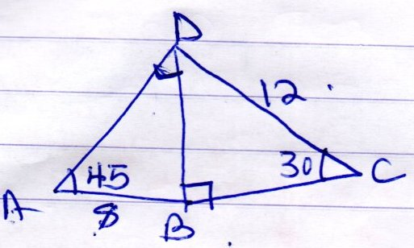  $\frac{BD }{\sin{30 }}= \frac{ 12 }{\sin{90 }}$  BD = $\frac{12 ×\sin{30 }}{\sin{90 }}=6$  $$\frac{8 }{\operatorname{Sin}{ADB }}= \frac{6 }{\sin{45 }}$$  $$\operatorname{Sin}{ADB= \frac{8×sin{45 }}{6 }}$$  = 0.942  ADB = $\sin^{-1} 0.942$  = 70.39 |  | $M_{1}$ for $expression to find BD$  $M_{1}$ for $\operatorname{Sin}{ADB= \frac{8×sin{45 }}{6 }}$  $A_{1}$ for $\% correct Angle$
- $\frac{\sqrt{48}}{\sqrt{5}+ \sqrt{3}} ×\frac{\sqrt{5}-\sqrt{3} }{\sqrt{5}-\sqrt{3 }}$  $$\frac{\sqrt{240}-\sqrt{144 }}{5-2 }=\frac{4\sqrt{15}-12}{3}$$  = $\frac{4}{3} \sqrt{15 }- 4$ |  | $M_{1}$ for $multipying by conjugate$  $M_{1}$ for $5-2$  $A_{1}$ for $\% C.A$
- (a) (1+ x) ⁷  $$1^{7}{x }^{0}+ x^{1} –{ x }^{2}+ {x }^{3}$$  $$1 4 6 4$$  $$= 1 + 4x + 6x^{2} + 4x^{2}$$  $$(b) ({0.94)}^{7} = ( {1 + -0.06)}^{7} x = -0.06$$  $$1 + 4 (-0.06) + 6( -0.06^{2}) + 4 (-0.06^{3})$$  $$1 + 0.24 + 0.0036 =1.244$$ |  | $B_{1}$ for $corrrect expansion$  $M_{1}$ for $x= -0.06$  $A_{1}$ for $correct value$
- $P =$ $\frac{{Kt}^{3}}{\sqrt{5}}$  16 = $\frac{K 2^{3}}{\sqrt{9 }}$  $\frac{ 16 ×3 }{8 }= \frac{8}{8 }K$ $\frac{ 16 × -3 }{8 }=K$  $$K=6 K= -6$$  $P =$ $\frac{{6t}^{3}}{\sqrt{5}}$  P = $\frac{ 6 ×{3 }^{3}}{\sqrt{36} }=$ $\frac{ 6 × 27 }{6}= 27$  P = $\frac{-6 ×{3 }^{3}}{\sqrt{36} }=$ $\frac{- 6 × 27 }{6}= - 27$ |  | $M_{1}$ for 16 = $\frac{K 2^{3}}{\sqrt{9 }}$  $M_{1}$ for $P = \frac{ 6 ×{3 }^{3}}{\sqrt{3} }$  $A_{1}$ correct value of P.
- $\left(\begin{matrix}3 & x \\ x+1 & 2 \end{matrix}\right)$ $\left(\begin{matrix}1 & 2 \\ 3 & 0 \end{matrix}\right)= \left(\begin{matrix} 3+3x & 6 \\ x+1+6 & 2(x+n)\end{matrix}\right)$  $$= \left(\begin{matrix}3+3x & 6 \\ x+7 & 2x+2 \end{matrix}\right)$$  $$\left( 3+3x\right)( 2x+2 )=6 ( x+7)$$  $$6x+6+6x^{2}+ 6x=6x+42$$  $$6{x }^{2}+ 12x – 6x + 6 – 42 = 0$$  $$6x^{2} – 6x – 36 = 0$$  $$x^{2} – x – 6 = 0$$  $${x }^{2}– 3x + 2x – 6 = 0$$  $$x( x- 3) + 2( x-3 ) = 0$$  $$x+ 2 = 0 x – 3 = 0$$  $$x = -2 x = 3$$ |  | $M_{1}$ for $\left( 3+3x\right)( 2x+2 )=6 ( x+7)$  $M_{1}$ for $Attempting to solve quadratic$  $$equation$$  $A_{1}$ for $x = -2$  $A_{1}$ for $x = 3$
- $3x^{2}+8x-6=0$  $$x^{2} + \frac{ 8}{8}x – \frac{6}{3 }=0$$  $$x^{2} + \frac{8}{3}x+K=2+K$$  $$K=( {\frac{8}{3} ÷2)}^{2}= \frac{ {8̸ }^{4}}{3 } × \frac{1}{2̸}= {\left(\frac{4}{3}\right) }^{2}= \frac{16}{9 }$$  $$x^{2}+ \frac{8}{3 }x + \frac{16}{9 }= 2+ \frac{ 16 }{9 }$$  $${\left( x+ \frac{4}{3 }\right)}^{2 }=3 \frac{7}{9 }$$  $x+ \frac{4 }{3 }= \sqrt{3\frac{7}{9 }}$ $x= -1.944-1.333$  $x=1.944-1.333$ $x= -3.277$  $$x=0.611$$ |  | $M_{1}$ for $x^{2}+ \frac{8}{3 }x + \frac{16}{9 }= 2+ \frac{ 16 }{9 }$  $M_{1}$ for $x+ \frac{4 }{3 }= \sqrt{3\frac{7}{9 }}$  $A_{1}$ for $both values of x$
- (a) ${TS }^{2 }=8(8+x$  $$144 = 64 + 8x$$  $$80 = 8$$  $$10 = x$$  $$Vu = 10cm$$  $$(b)vx = 4cm \left(\frac{2}{5̸ } ×{1̸0̸}^{2} \right)$$  $$Xu= 10cm – 4 = 6$$  $$4×6=3 ×x x= \frac{ 4 x {6̸}^{2} }{3̸ } =8cm$$  $Sx = 8cm$ |  | $M_{1}$ for $144=64+8x$  $A_{1}$ for $C.A$  $M_{1}$ for $vx or xu$  $A_{1}$ for $8cm$
- $\frac{r }{p }= \frac{ m }{\sqrt{n-1 }}$  $$\frac{r^{2} }{{p }^{2}}= \frac{ {m }^{2}}{n-1 }$$  $$r^{2} \left(n-1 \right)= m^{2}p^{2}$$  $r^{2}$n $-r^{2}$= $m^{2}p^{2}$  $$\frac{r^{2}n}{r^{2}}= \frac{ m^{2}p^{2}+r^{2} }{{r }^{2}}$$  $n=$ $\frac{m^{2}p^{2}+r^{2} }{r^{2}}$ |  | $M_{1}$ for $squaring$  $A_{1}$ for $C.A$
- $x^{2}+4x+K+y^{2}-2y+K=4$  $K= {\left(\frac{4 }{2 }\right)}^{2}=4$ $K= {\left(\frac{-2 }{2 }\right)}^{2}=1$  $$x^{2}+4x+4 +y^{2}-2y+1=4+4+1$$  $$\begin{matrix}{\left(x+2\right)}^{2} + & {\left(y-1\right)}^{2}= & a \\ {\left(x-a\right)}^{2} + & {\left(y-b \right)}^{2}= & r^{2} \\ a= -2 & b= +1 & r=3\end{matrix}$$ |  | $M_{1}$ for competing the square  $A_{1}$ for$centre$  $A_{1}$ for$radius$
- $\begin{matrix} 5th = & a+4d=82 \\ 12th= & a+11d=103 \end{matrix}$  $\begin{matrix}-7= & -21 \\ d= & 3\end{matrix}$  $a+4d=82$  $a+12=82$  $a=82-12$  $= 70$  (ii)= $\frac{n}{2 }( 2a+(n-$1)d  = $2\frac{1}{2}\left(2×70+20 ×3\right)$  = 2 ½ ($\left(140+60\right)$  = 2100 |  | $M_{1}$ for $-7d= -21 (or equivalent)$  $A_{1}$ for $term 1$  $M_{1}$ for $substitution$  $A_{1}$ for $C.A$
- $\left(\begin{matrix}2 & 3 \\ 5 & 2\end{matrix}\right)$ $\left( \begin{matrix} x \\ y \end{matrix}\right)= \left(\begin{matrix}39 \\ 81\end{matrix}\right)$  D = $2 ×2-3 ×5$  $$=4-15= -11$$  $$rec of D= -\frac{1}{11}$$  $$\left(\begin{matrix}x \\ y \end{matrix}\right) = \frac{-1}{11} \left( \begin{matrix}2 & -3 \\ -5 & 2\end{matrix}\right) \left(\begin{matrix}39 \\ 81\end{matrix}\right)$$  $\left(\begin{matrix}\frac{-2}{11} & \frac{3}{11} \\ \frac{5}{11} & \frac{-2}{11}\end{matrix} \right) \left(\begin{matrix}39 \\ 81\end{matrix}\right)$  $$x= \frac{-2}{11}×39+ \frac{3}{11}×81=15$$  $$y= \frac{5}{11}×39+ \frac{-2}{11}×81=3$$ |  | $M_{1}$ for $determinant$  $M_{1}$ for $\frac{-1}{11} \left( \begin{matrix}2 & -3 \\ -5 & 2\end{matrix}\right) \left(\begin{matrix}39 \\ 81\end{matrix}\right)$  $A_{1}$ for $correct values of x and y$
- $3x-1 > -4 2x+1≤7$  $$3x >-4+1 2x≤6$$  $$3x > -3 x ≤3$$  $$x> -1$$  $$- 1 <x ≤3$$ |  | $M_{1}$ for $3x > -3$  $A_{1}$ for $x ≤3 and x >-1$  $B_{1}$ for $number line with correct$  $$arrow$$
- Area $=P=10+7+9$  = 26  S= 13  A = $\sqrt{ 13 \left(13-10\right)\left( 13-7\right)\left(13-9\right)}$  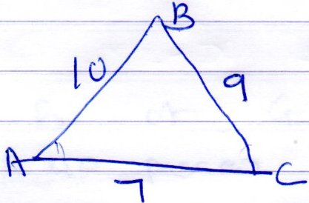  $=30.5$  ½ $×10 ×7 ×sinBAC=30.5$  = $\sin{BAC= \frac{30.5 }{35 }}$  = $0.8714$  $$BAC=60.6$$ |  | $M_{1}$ for $for substitution of a,$  $$b c and S in the formula$$  $A_{1}$ Correct Area  $M_{1}$ for $\sin{θ= \frac{30.5 }{35 }}$  $A_{1}$ for $correct angle$
- .$A= P{\left( 1+ \frac{r}{100} \right)}^{n }$  = $1250000 {\left(1+ \frac{6}{100}\right)}^{7}$  $=1250000 × {1.06}^{7 }$  $$=1879537.82$$ |  | $M_{1}$ for $substitution$  $M_{1}$ for ${\left(1+ \frac{6}{100}\right)}^{7}$  $A_{1}$ for $Amount$
- B and passes and not prefect  $\frac{6}{11} ×\frac{ 5 }{8 }× \frac{7 }{8 }= \frac{ 105 }{352 }$  (ii) G and prefect and pass  $\frac{5}{11} ×\frac{ 2 }{11}× \frac{4}{7 }= \frac{ 40}{847 }$  (iii) B or G  B NP passes or G NP passes  = $\frac{6}{11} ×\frac{ 5 }{8 }× \frac{7 }{8 }$ + $\frac{5}{11} ×\frac{ 9 }{11}× \frac{4}{7 }$  = $\frac{105 }{ 352 } + \frac{ 180 }{847 }$  = $0.5108$ |  | $M_{1}$ for $\frac{7}{8 }$  $M_{1}$ for $\frac{6}{11} ×\frac{ 5 }{8 }× \frac{7 }{8 }$  $A_{1}$ for $C.A$  $M_{1}$ for $\frac{5}{11} ×\frac{ 2 }{11}× \frac{4}{7 }$  $A_{1}$ for $C.A$  $M_{1}$ for $\frac{6}{11} ×\frac{ 5 }{8 }× \frac{7 }{8 }$ + $\frac{5}{11} ×\frac{ 9 }{11}× \frac{4}{7 }$  $A_{1}$ for $\frac{105 }{ 352 }$  $A_{1}$ for $\frac{180 }{847 }$  $A_{1}$ for $0.5108$
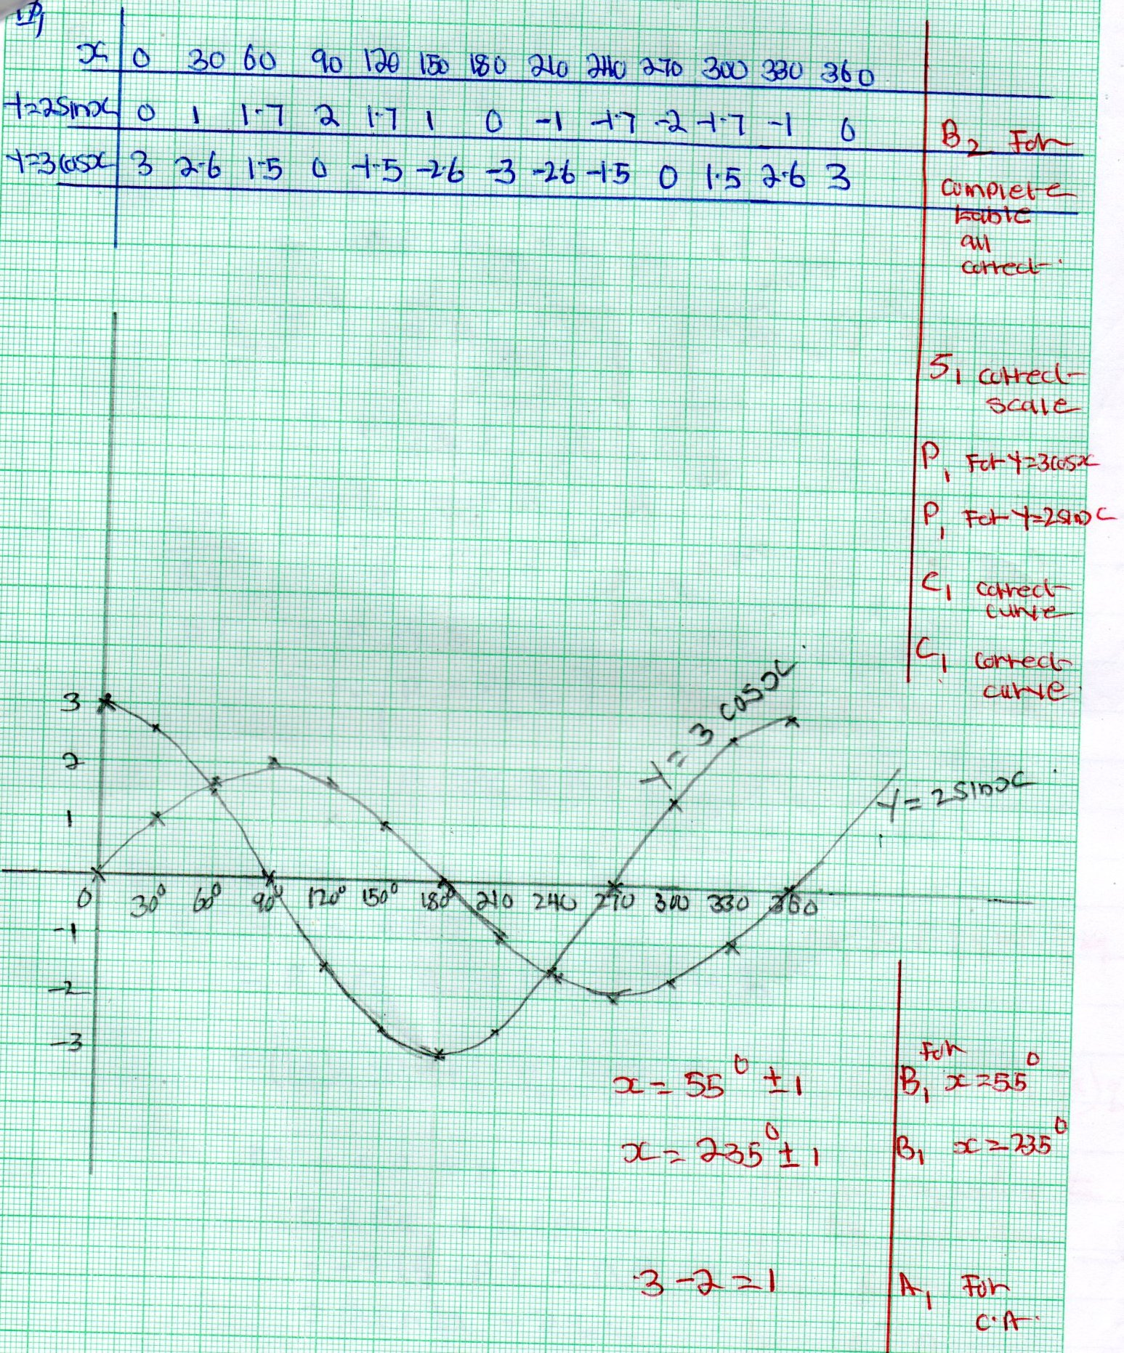
- (a) (i) $PQ=PO+OQ$  = $- P+q$  (ii) $RS=RQ+Q S$  =$-PQ+ \frac{1}{3 }OQ$  $= P-q+ \frac{1}{3 }q$  P $- \frac{2 }{3 } q$  (b) $\frac{ST }{RS }= \frac{ K}{T }$  $ST=KRS$  $K=\left(P- \frac{2 }{3 }q \right)$  $$=KP \frac{-2 }{3 }qK$$  (ii)Expressing RT in two ways  RT = RS + ST  = $P- \frac{2}{3}q+KP- \frac{2}{3 }Kq$  $=\left(1+K\right)P{+(\frac{-2}{3}- \frac{2}{3 }K)}^{q}$  $$RT=RP+PT$$  = $2PQ + nOP$  = -$2(q- p) + nP$  = $(2+ n)p – 2q$  $(1 +K) P + ( {\frac{-2}{3 }- \frac{2}{3 }K)}^{q}=\left( 2+n \right)p-2q$  $\frac{-2}{3}- \frac{2}{3}K= -2$ $1 + K = 2+ n$  $K=2$ $1+ 2 = 2+ n$  $1 = n$ |  | $B_{1}$ for $PQ$  $M_{1}$ for $P-q+ \frac{1}{3}q$  $A_{1}$ for $P- \frac{2}{3}q$  $M_{1}$ for $K(P-\frac{2}{3}q)$  $A_{1}$ for $correct vector$  $M_{1}$ for $P- \frac{2}{3}q+KP- \frac{2}{3 }Kq$  $M_{1}$ for $\left(1+K\right)P{+(\frac{-2}{3}- \frac{2}{3 }K)}^{q}$  $M_{1}$ for $equating the two expression$  $A_{1}$ for $K$  $A_{1}$ for $n$
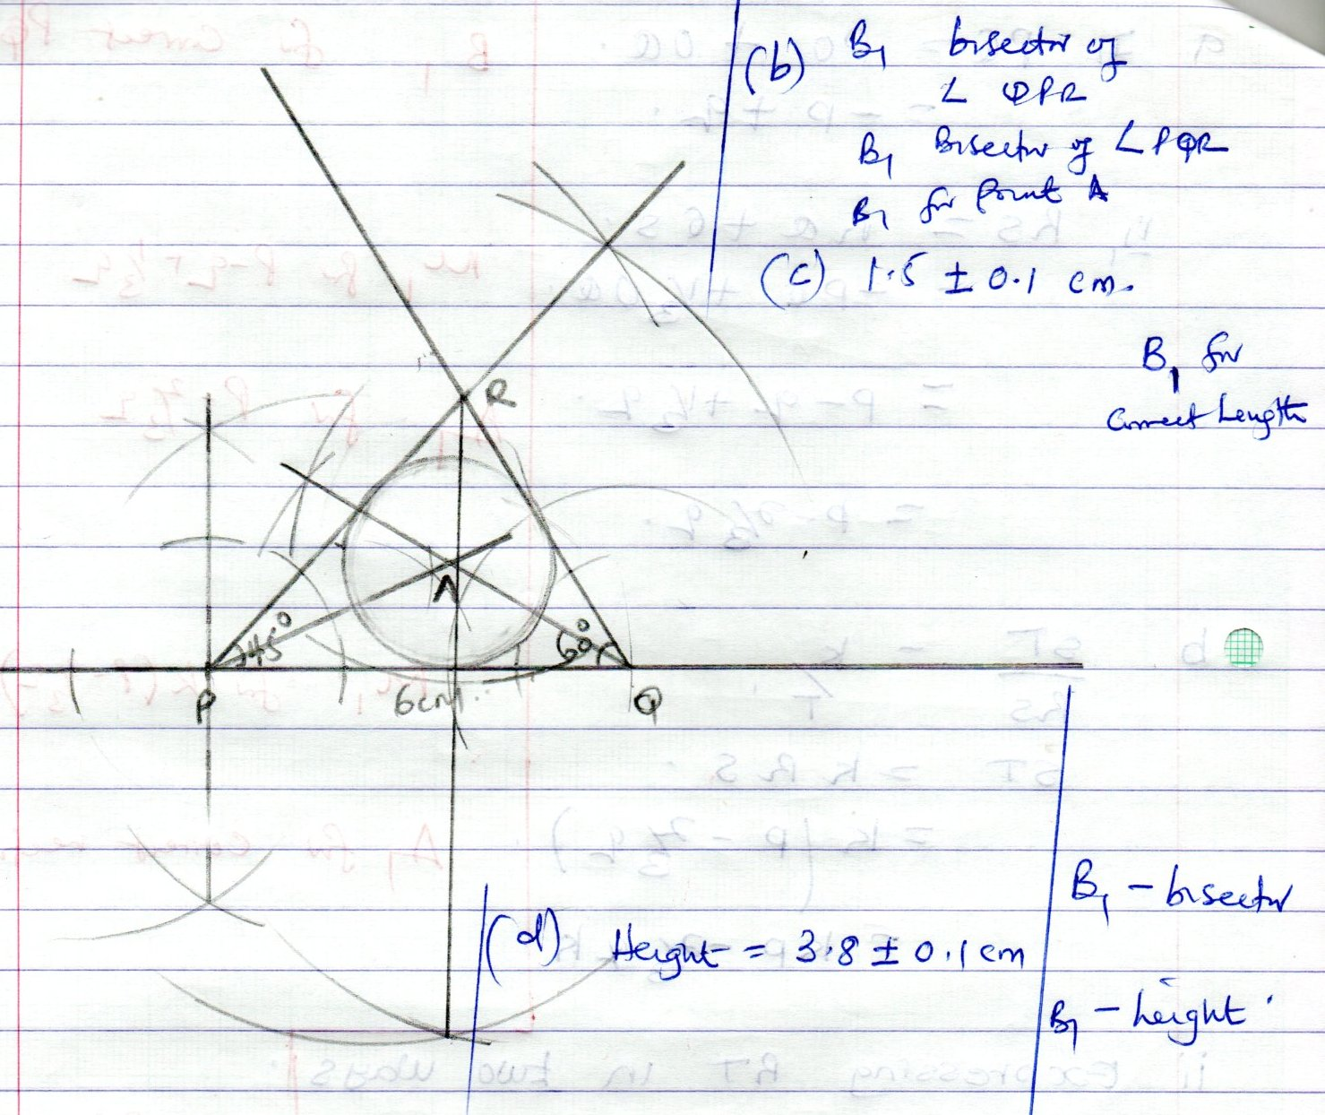
- G$L^{2}= {9 }^{2 }+ {30}^{2}$  $$GL=31.3$$  (b) $FJ^{2}=FH^{2 }+ {HJ }^{2}$  $$FH^{2}=40+ {9 }^{2}$$  $$FH =HI$$  $$FJ^{2}={41}^{2}+ {30 }^{2}$$  $$FJ^{2}=50.8$$  (c)EM and EFGH  EM projection = EG  $$<GEM$$  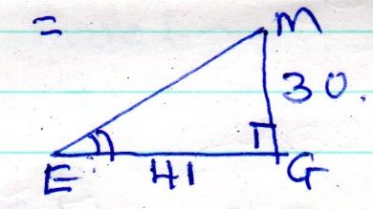  Tan $θ= \frac{30}{41 }=0.7317$  Q = 36.2  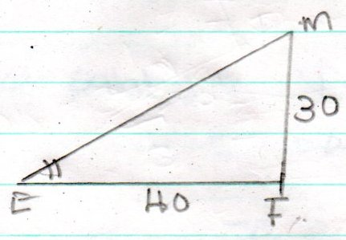  Tan $θ= \frac{30}{41 }=0.75$  Q = 36.87 |  | $M_{1}$ for ${9 }^{2 }+ {30}^{2}$  $A_{1}$ for $correct lenght$  $M_{1}$ for $FH^{2}=40+ {9 }^{2}$  $M_{1}$ for $FJ^{2}={41}^{2}+ {30 }^{2}$  $A_{1}$ for $50.8$  $M_{1}$ for $Tan θ= \frac{30}{41 }$  $M_{1}$ for $projution$  $A_{1}$ for $Q$  $M_{1}$ for $Tan θ$  $A_{1}$ for $angle$
- Taxable income  = 35600 + 3200  = 38800  - 1st 9400 $×\frac{10}{100}=940$  Next 8600$×$ $\frac{15 }{100}×8600=1290$  Next 8600$×$ $\frac{20 }{100}×8600=1720$  Next 9000 $×$ $\frac{25}{100}×9000=2250$  Next 3200 $×\frac{30}{100} ×3200=960$  $\begin{matrix}Total tax = & 71 60 \\ less relief & 1172 \end{matrix}$  Shs $5988$  (b) Basic salary = taxable income – allowances  = 38800 – 8000  Sacco = $\frac{6}{100}×30800= 1848$  Net salary = T.1 – (PAYE + Sacco  $= 38800 – (5988 + 1848)$  $$= 38800 – 7836$$  $= Ksh 30964$ |  | $M_{1}$ for $addition$  $A_{1}$ for $38800$  $M_{1}$ for $first slab$  $M_{1}$ for $2^{nd } and 3^{rd}slabs$  $M_{1}$ for $last 2 slabs$  $A_{1}$ for $gross tax$  $A_{1}$ for $Net tax$  $M_{1}$ for $1848$  $M_{1}$ for $substration$  $A_{1}$ for $C.A$
Mass | $$X$$ | $$F$$ | $$Fx$$ | $d x$ -$\overline{x}$ | $$d^{2}$$ | $$Fd^{2}$$ | $$x^{2}$$ | $${Fx}^{2}$$
0 – 9 | 4.5 | 3 | 13.5 |  |  |  | 20.25 | 60.73
10 – 19 | 14.5 | 7 | 101.5 |  |  |  | 210.25 | 1471.75
20 – 29 | 24.5 | 8 | 196 |  |  |  | 600.25 | 4802
30 – 39 | 34.5 | 9 | 310.5 |  |  |  | 1190.25 | 10712.25
40 – 49 | 44.5 | 12 | 534 |  |  |  | 1980.25 | 23763
50 – 59 | 54.5 | 18 | 981 |  |  |  | 2970.25 | 53464.5
60 – 69 | 64.5 | 25 | 1612.5 |  |  |  | 4160.25 | 104006.25
70 – 79 | 74.5 | 10 | 745 |  |  |  | 5550.25 | 55502.5
80 – 89 | 84.5 | 6 | 507 |  |  |  | 7140.25 | 42841.5
90 – 99 | 94.5 | 2 | 189 |  |  |  | 8930.25 | 17860.5
 |  | 100 | 5190

- Modal class  = 60 – 69  - (i) Mean =$\frac{ ƸFx}{ƸF} = \frac{ 5190 }{100}=51.9$  (ii) standard deviation  $\sqrt{\frac{ ƸFx^{2}}{ƸF}- {\left(\frac{ ƸFx}{ƸF}\right)}^{2}}$  = $\frac{314485}{100}- {\left(51.9\right)}^{2}$  = 3144.86 – 2696.61  =$\sqrt{448.24 }$  =21.17$± 0.1$ | $B_{1}$ for $Modal class$  $M_{1}$ for $ƸFx$  $M_{1}$ for $ƸF$  $A_{1}$ for $Mean$  $M_{1}$ for $\frac{314485}{100}- {\left(51.9\right)}^{2}$  $M_{1}$ for $Square root$  $A_{1}$ for $C.A$
- (d)$\left(\begin{matrix} a & b \\ c & d \end{matrix}\right)\left(\begin{matrix}0^{11} & A^{11} & B^{11} \\ 0 & -4 & -6 \\ 0 & 0 & 8\end{matrix} \begin{matrix}C^{11} \\ -2 \\ 8\end{matrix}\right)=\left( \begin{matrix}0 & A & B \\ 0 & 2 & 3 \\ 0 & 0 & 2\end{matrix} \begin{matrix}C \\ 1 \\ 2\end{matrix}\right)$  $\begin{matrix}-4a=2 \\ a=-\frac{1}{2}\end{matrix}$ $\begin{matrix} - 6a+8b=3 \\ 8b=3+6a \\ \begin{matrix}8b=3-3 \\ b=0 \end{matrix} \end{matrix} \begin{matrix}-4c=0 \\ \begin{matrix}c=0 \\ -2c+8d=2 \\ \begin{matrix}8d=2 \\ d=\frac{1}{4}\end{matrix}\end{matrix} \end{matrix}$  $matrix= \left(\begin{matrix}-\frac{1}{2} & 0 \\ 0 & \frac{1}{4}\end{matrix}\right)$ | $M_{1}$ for $finding cordinates$  $A_{1}$ for $cordinates$  $B_{1}$ for $OABC drawn$  $B_{1}$ for $O^{1}A^{1}B^{1}{C }^{1}drawn$  $M_{1}$ for $Attempting to find cordinates$  $$of O^{11}A^{11}B^{11}{C }^{11}$$  $A_{1}$ coordinates of $O^{11}A^{11}B^{11}{C }^{11}$  $B_{1}$ for $O^{11}A^{11}B^{11}{C }^{11}drawn$  $M_{1}$ for $Attempting to find matrix$  $A_{1}$ for $a= -\frac{1}{2}$  $A_{1}$ for $matrix$
