FORM 4 ENTRANCE EXAMS 2023

- $2 \frac{1}{3 }– 1 \frac{1}{5 o} of 4$  $\frac{6}{5} ×4= \frac{24 }{5 }$  $$\frac{7}{3}=-\frac{24}{5}= \frac{35}{15}- 72= -\frac{37}{15}$$  ¼ - $\left(-\frac{\begin{aligned}1 \\ 1\end{aligned}}{3}\right)2$  ¼ - $\frac{1}{9}= \frac{9-4 }{36 }= \frac{5 }{36}$  $$-\frac{37}{15 }×\frac{36}{5}=17\frac{19}{25}$$ | $M_{1}$ for $-\frac{37}{15}$  $M_{1}$ for $\frac{5}{36}$  $A_{1}$ for $19\frac{19}{25}$
- No. std Log  0.006628 ${6.628×10}^{-3}$ $\overline{3} .8214$  $3$  $\overline{7} .4642$  +  193.9 ${1.939×10}^{2}$. $2.2876$  $\overline{5} .7518$  2.2822 ${2.2822×10}^{0}$. $0.3584$  $\frac{ 5 ̅ .3934}{5}$  0.1198 ${1.198×10}^{-1}$. $\overline{1}.0.786$ | $M_{1}$ for $–correct logs$  $M_{1}$ for $\overline{5} .7518$  $M_{1}$ for $\overline{1}.0.786$  $A_{1}$ for $C.A$
- ${49 }^{3/2}=( \sqrt{49} )^{3}= 7^{3}=343$  $$256 = ( \sqrt[4]{256} )^{3}=64$$  $$2401= ( \sqrt[4]{2401} )^{3}=243$$  $$343×\frac{64}{343}=64$$ | $M_{1}$ for $343$  $M_{1}$ for 64, 343  $A_{1}$ for $C.A$
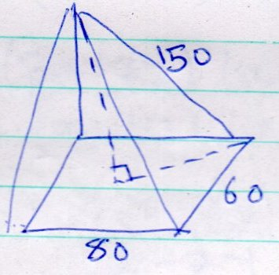  Length of diagonal  $$\sqrt{{80}^{2}+ {60}^{2 }}=100$$  ½ diagonal = 50  Height = ${150}^{2}- {50}^{2}$  $$= 22500 – 2500$$  $$= 20000$$  =$\sqrt{20000}=141.4$  $$\frac{1}{3}×80 ×60 ×141.4$$  226. 2 | $M_{1}$ for $height$  $M_{1}$ for expression of volume  $A_{1}$ for $C.A$
- $2x^{2} – xy – 6y^{2}$  $$2x^{2} – 4xy + 3xy – 6y^{2}$$  $$2x (x-2y) + 3y( x-2y)$$  $$(2x+3y) (x – 2y)$$  $$x^{2}- 4xy + 4y^{2}$$  $$x^{2}– 2xy – 2xy + 4y^{2}$$  $$x(x-2y) – 2y( x-2y)$$  $$(x-2y) (x-2y)$$  $$\frac{\left(2x+3y\right)(x-2y)}{x-2y) (x-2y)}$$  $$\frac{2x+3y}{x-2y }$$ | $M_{1}$ for $(2x+3y) (x – 2y)$  $M_{1}$ for $(x-2y) (x-2y)$  $A_{1}$ for $C.A$
- $x+y=13$  $$(10y + x ) - ( 10x + y) = 9$$  $$10y + x – 10x – y = 9$$  $$9y – 9x = 9$$  $$y – x = 1$$  $-\begin{matrix}x+ y = 13 \\ -x+y=1\end{matrix}$  $$2x = 12$$  $$y=6$$  $$x + y = 13$$  $$6 +y = 13$$  $Y = 7$ | $M_{1}$ for$9y – 9x = 9$  $M_{1}$for $2x = 12$  $A_{1}$ for $both values of x and y.$
- $int+ext=180$  $$3x + x + 20 = 180$$  $$4x + 20 = 180$$  $$4x +160$$  $$X = 40$$  $$Ext = 40 + 20 = 60$$  $$Ext = 360/n= 360/n=60$$  $$n= \frac{360}{60}=6$$  Number of triangles $= n – 2$  $$= 6- 2$$  $= 4$ | $M_{1}$ for$expression$  $M_{1}$for $\frac{360}{60}$  $A_{1}$ for$C.A$
- $<BAC=180-110$  $$= {70}^{0}$$  $$\frac{14}{\sin{70}}= \frac{AC}{\sin{70}}$$  AC = $\frac{14 ×\sin{70 }}{\sin{70 }}$  AC = 14  Area = ½ $×14 14×\sin{40 }$  $=62.99$  $=63.0$ | $M_{1}$ for$expression$ of AC  $M_{1}$for $for expression of area$  $A_{1}$ for$C.A$
- $O+T =1$  $$\left(\begin{matrix}3 \\ 6\end{matrix}\right)+ \left(\begin{matrix}2 \\ -4\end{matrix}\right)= \left(\begin{matrix}5 \\ 2\end{matrix}\right)$$  Distance - $\sqrt{5^{2}+ 2^{2}}$  = $5.385$ | $M_{1}$ for$addition of vectors$  $M_{1}$for $for expression of distance$  $A_{1}$ for$C.A$
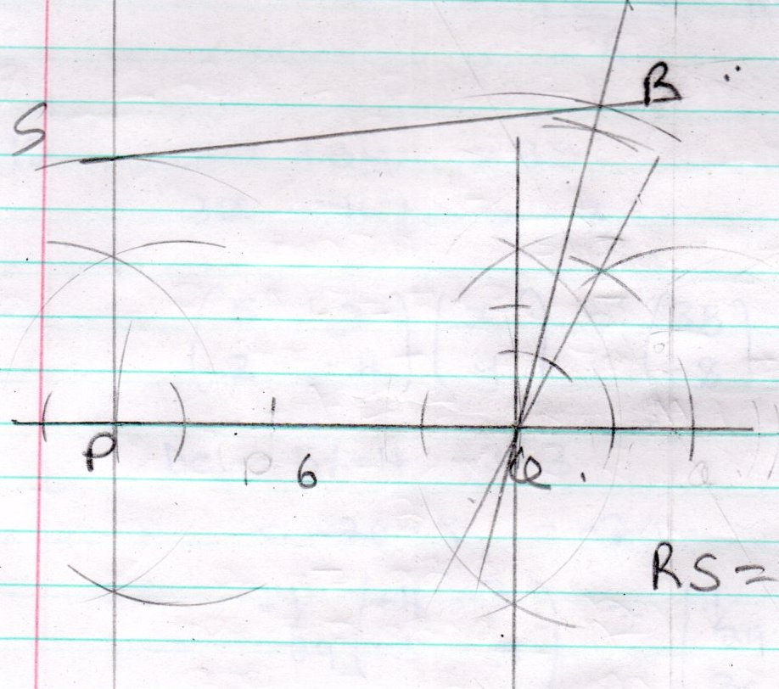  Rs = 7.cm  1: 4000  7.4: 7.4 $×4000$  = 29600 | $B_{1}$ for$PQR and SPQ$  $B_{1}$for $for complete figure$  $B_{1}$for $for RS$  $B_{1}$ for$C.A$
- $\frac{\sin{{30}^{0}-\sin{{60}^{0}}}}{\tan{{60}^{0}}}$  Sin ${30}^{0}=\frac{1}{2} \tan{{60}^{0 }} = \sqrt{3}$  $$\sin{{60}^{0}}= \frac{\sqrt{3}}{2 }$$  ½ - $\frac{\frac{\sqrt{3}}{2}}{\sqrt{3}}= \frac{\frac{1}{2}- \sqrt{3×\sqrt{3} }}{\sqrt{3} × \sqrt{3}}$  = $\frac{\sqrt{3}-3 }{2} ÷3= \frac{\sqrt{3}-3 }{2 } × \frac{1}{3}$  = $\frac{\sqrt{3 }-3 }{6 }$ | $M_{1}$ for$trigonometric ratio$  $M_{1}$for $for rationalising$  $A_{1}$ for$C.A$
- $5x+3y=38$  $$3x – 4y = -8$$  $$\left(\begin{matrix}5 & 3 \\ 3 & -4 \end{matrix}\right) \left(\begin{matrix}x \\ y \end{matrix}\right) = \left(\begin{matrix}35 \\ -8 \end{matrix}\right)$$  Del = 5x – 4 -3 $×3$  = -20 – 9 = -29.  $$-\frac{1}{29} \begin{matrix}-4 & -3 \\ -3 & 5\end{matrix} = \left(\begin{matrix}\frac{4}{29} & \frac{3}{29} \\ \frac{3}{29} & \frac{-5}{29}\end{matrix}\right)$$  $$\left(\begin{matrix}x \\ y\end{matrix}\right) = \left(\begin{matrix}\frac{4}{29} & \frac{3}{29} \\ \frac{3}{29} & \frac{-5}{29}\end{matrix}\right) \left(\begin{matrix}35 \\ -8 \end{matrix}\right)$$  $x=4 y=5$ | $B_{1}$ for$determinant$  $M_{1}$for $inverse$  $A_{1}$ for$C.A$
- Reciprocal of  $$2.47 ×{10}^{2}$$  $$=0.4049 × {10}^{2}=40.49$$  $\sqrt[3]{3.025 }$ $=1.446$  $$=40.49 ×1.446=58.55$$ | $M_{1}$ for$reciprocal$  $M_{1}$for $\sqrt[3]{}$  $A_{1}$ for$C.A$
- 1 US dollar = $Ksh 101. 9378$  $$20, 000 = 20,000 ×101.9378$$  $$=Ksh 2038756$$  $$1 S.A = 7.6326$$  $$\frac{2038756}{7.6326} =2038756$$  $$= 267111.6$$  $$= 267112 S.A$$ | $M_{1}$ for$expression$  $M_{1}$for $expression$  $A_{1}$ for$C.A$
- $5-3x ≤x-7 <11-2x$  5x – 3x $≤x- 7 x-7 <11-2x$  5+ 7 $≤x+3x x+2x <11+7$  $$12 ≤4x 3x <18$$  $$3≤x x <6$$  $$3≤x <6$$  $3, 4 , 5$ | $M_{1}$ for$separating inequality$  $M_{1}$for $3≤x and x <6$  $A_{1}$ for$C.A$
- 5184 $= 2×2×2×2×2×2×3×3×3×3$  $$\sqrt{5184}=2×2×2×3×3$$  = 72  2744 $= 2×2×2×7×7×7$  $$\sqrt[3]{2744}=2×7=14$$  = $\frac{72}{14} = 5\frac{1}{7}$ | $M_{1}$ for$factors of 5184$  $M_{1}$for $factros of 2744$  $M_{1}$for and $\sqrt[3]{}$  $A_{1}$ for$C.A$
- (a) $A\left( 3, 6\right) B\left(7, 12\right) \left(x , y\right)$  Gradient of AB = $\frac{12-6 }{7-3 }= \frac{ 6 }{4 }= \frac{3}{2 }$  $$\frac{y-6}{x-3 }= \frac{3}{2 }$$  $$2(y – 6) = 3( x- 3)$$  $$2y – 12 = 3x – 9$$  $$2y = 3x – 9 + 12$$  $$2y = 3x + 3$$  b. mid point of AB  $\frac{3+7}{2 } , \frac{6+12}{2 }$  $$( 5,9) (x, y)$$  Perpendicular bisector gradient = $- \frac{2}{3 }$  $$\frac{y-9 }{x-5 }= -\frac{2}{3 }$$  $$3( y-9) = -2(x- 5)$$  $$3y – 2y = -2x + 10$$  $$3y = -2x + 10 + 27$$  $$3y = -2x + 37$$  AB $⊥BC gradient of Bc= - \frac{2}{3}, B\left( 7, 12\right)$  $\left(x, y \right) x \frac{y-12 }{x-7 }= -\frac{2}{3 }$ 3y= – 2x + 14 + 36  $$3y= -2x+50$$  $$3 \left(y-12\right)= -2\left(x-7\right)$$  $$3y – 36 = -2x + 14$$ | $M_{1}$ for$gradient$  $M_{1}$for $expression$  $A_{1}$ for$equation$  $M_{1}$ for$mid point$  $M_{1}$for $gradient$  $M_{1}$ for$expression$  $A_{1}$ for$equation$  $M_{1}$ for$expression= -\frac{2}{3}$  $M_{1}$for $x-multiplication$  $A_{1}$ for$C.A$
- $\begin{matrix}A : & B : & C \\ 120000 : & 180000 : & 240000 \\ 12 : & 18 : & 24\end{matrix}$  $$\begin{matrix}2 & : 3 & : 4\end{matrix}$$  - $\frac{20}{100} ×225000=45000$  - $\frac{35}{100} ×225000=78750$  (b) Remainder$=225000-45000-78750$  = 101 250  $$2: 3 : 4 = 9$$  = 101250  - $\frac{2}{9} ×101 250=22, 500$  - $\frac{3}{9} ×101 250=33, 750$  - $\frac{4}{9} ×101 250=45,000$  (c)$2:3:4=9$  45000  (d)$\frac{4}{9} ×45000=20,000$  Chirchir new share = $240,000+20,000$  = 260,000 | $M_{1}$ for$multiplication$  $A_{1}$ for$C.A$  $A_{1}$ for$C.A$  $M_{1}$ for$101250$  $A_{1}$ for$C.A$  $A_{1}$ for$C.A$  $A_{1}$ for$C.A$  $M_{1}$ for$expression$  $M_{1}$ for$addition$  $A_{1}$ for$C.A$
- 400km  Nairobi Mombasa  8.00am 8.30am  80Km/h 120Km/h  Time = $\frac{D }{S}= \frac{400̸}{120̸ }=3 \frac{1 }{3 } hrs$  $= 3: 20min$  $$+\begin{matrix}8 : & 30 \\ 3 : & 20 \end{matrix}$$  $$\begin{matrix}11 : & 50 am \end{matrix}$$  (ii) Distance by coast bus for ½ hr.  = 80 $×\frac{1}{2}=40Km$  R.D = 400 - 40 = 360 Km  R.S = 80 + 120 = 200Km/h  R.T = $\frac{260 }{200}=1 \frac{4}{5 } hr=1 hr:48min⁡$  Time met = $\begin{matrix}8 : & 30 \\ 1 : & 48 \end{matrix}$  $$\begin{matrix} 10: & 18am \end{matrix}$$  = 10: 18am  - R.T = $1 \frac{4}{5 }hr$  Coast by distance in 1$\frac{4}{5 }$  = 80 $×1 \frac{4}{5 }$  = 144 km  Distance = 40 + 144  = 184  - In 3hr20min coast bus covers  = 80 $×3\frac{1}{3 }$  = 80 $× \frac{10}{3 }=266\frac{2}{3 }km$  Distance from Mombasa $= 400 –{266}^{\frac{2}{3}}$  $=133\frac{1}{3}Km$ | $M_{1}$ for$3\frac{1}{3} hr$  $M_{1}$for $addition$  $A_{1}$ for$C.A$  $M_{1}$ for$40km$  $M_{1}$for $RD and R.S$  $M_{1}$for $expression of R.T$  $A_{1}$ for$C.A$  $M_{1}$for $expression of distance$  $A_{1}$ for$C.A$  $M_{1}$for $400 –{266}^{\frac{2}{3}}$  $A_{1}$ for$C.A$
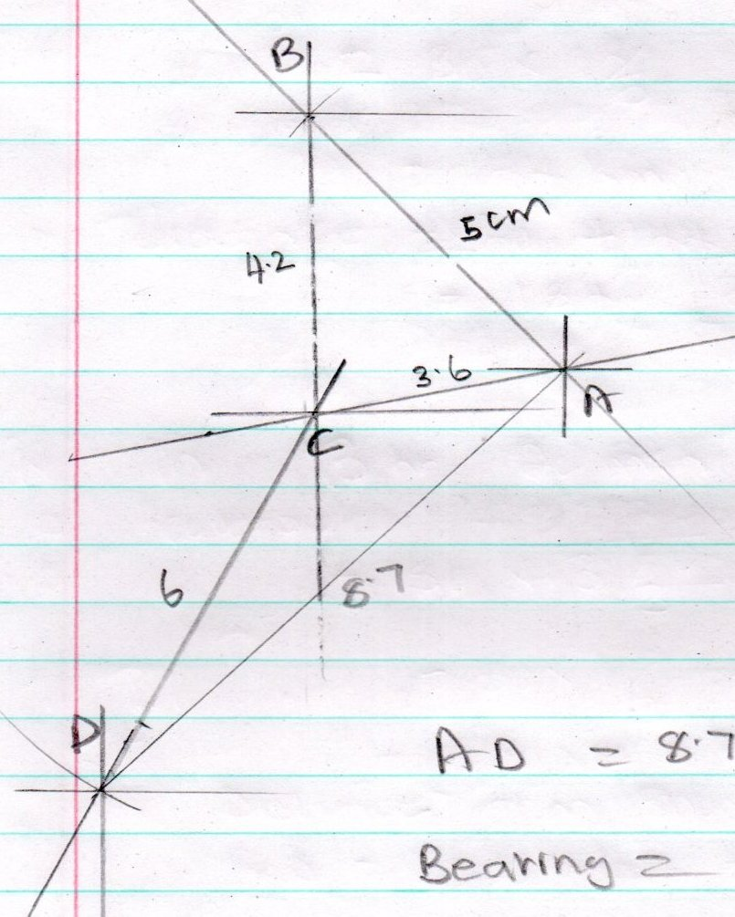  AD = 8.7 cm = $43.5 km ±1$  Bearing = ${047}^{0}$ | $B_{1}$ for$point B$  $B_{1}$for $point C$  $B_{1}$for $Point D$  $B_{1}$for $8.7 ±0.1$  $A_{1}$ for$43.5±1$  $A_{1}$ for${047}^{0}±1$
- $y=x-6x+7$

$$x$$ | 0 | 1 | 2 | 3 | 4 | 5 | 6
$$x^{2}$$ | 0 | 1 | 4 | 9 | 16 | 25 | 36
$$-6x$$ | 0 | -6 | -12 | -18 | -24 | -30 | -36
$$7$$ | 7 | 7 | 7 | 7 | 7 | 7 | 7
$$y= x^{2} – 6x + 7$$ | 7 | 2 | -1 | -2 | -1 | 2 | 7

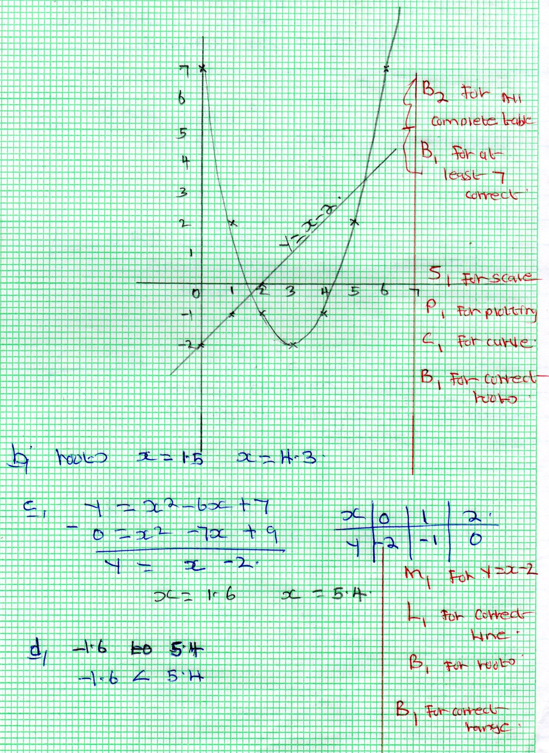
- (i) $<ROP= {128}^{0}$  Angles on a straight line  (ii) $<PSR= {116}^{0}$  Angle on cyclic quadrilateral  (iii) $<ORP= {26}^{0}$  Base angle of isosceles triangle  (iv)$<TRP= {64}^{0}$  Angle between a chard a tangent( Nagle in alternate segment)  - $<RTP={53}^{0}$  Angles on a triangle. | $B_{1}$for $Angle$  $B_{1}$for $Reason$  $B_{1}$for $Angle$  $B_{1}$for $Reason$  $B_{1}$for $Angle$  $B_{1}$for $Reason$  $B_{1}$for $Angle$  $B_{1}$for $Reason$  $B_{1}$for $Angle$  $B_{1}$for $Reason$
- AB height = $\sqrt[3]{ {7.2}^{2}-{3.4}^{2} }$  $= 6.347$  Area ABC  = ½ $3.4 ×6.347$  = 10.78  = 10.8  (ii) $Area of BCD = 10.8$  A= ½ $×3.4 ×7.5 ×\sin{BCD }$  $\begin{matrix}10.8 \\ 10.8 \\ 1.7 ×7.5 \end{matrix}= 1.7 ×7.5 ×\sin{BCD=\sin{BCD }}$  0.8471 sin BCD  $\sin^{-1}0.8471=BCD$  = 57.8 = BCD  (iii) B$D^{2}=3.4+7.5-2×3.4 ×7.5\cos{57.8}$  $BD = 6.37$  (iv)$<BDC = \frac{34}{\sin{BCD }} \frac{3.4 }{\sin{BDC }} = \frac{6.37 }{\sin{57.8 }}$  $Sin BDC – \frac{3.4 ×\sin{57.8}}{6.37}$  $$Sin BDC = 0.4517$$  $$BDC = \sin^{-1}0.4517$$  $$BDC = 26.9$$ | $M_{1}$for $expression of height$  $M_{1}$for $expression of Area$  $A_{1}$ for$C.A$  $M_{1}$for $expression of Area$  $M_{1}$for $0.8471$  $A_{1}$ for$C.A$  $M_{1}$for $expression$  $A_{1}$ for$C.A$  $M_{1}$for $expression$  $A_{1}$ for$C.A$
Marks x F Tx-A FT CF  48 – 52 50 3 -14 -42 3  53 – 57 55 4 -9 -36 7  58 – 62 60 10 -4 -40 17  63 – 67 65 12 1 12 29  68 – 72 70 8 6 48 37  73 – 77 75 $$\frac{3}{40}$$ 11 $$\frac{33}{-25}$$ 40  - Modal class 63 – 67  - Mean = A$+\frac{ƸFt}{ƸF}$  64 + $\frac{-25 }{40 }$  = $63 \frac{3}{8 }$ | $B_{1}$for $modal class$  $M_{1}$for $mid point$  $M_{1}$for $\frac{-25 }{40 }$  $A_{1}$ for$C.A$
