Name _________________________________________ Index No______________________
School ____________________________ Candidate’s Signature ___________________
Date __________________________
121/2
MATHEMATICS
PAPER 2

MARCH/APRIL, 2023
TIME: 2 ½ Hours

ARISE AND SHINE TRIAL EXAMINATIONS
Kenya Certificate of Secondary Education (KCSE)

121/2
2 ½ hours

Instructions to Candidates
- Write your name and index number in the space provided above.
- This paper consists of TWO sections: section I and section II.
- Answer all the questions in section I and only five questions from section II.
- All workings and answers must be written on the question paper in the spaced provided below each question.
- Non-programmable silent electronic scientific calculators and KNEC Mathematical tables may be used EXCEPT where stated otherwise
- The paper consists of 15 printed pages.
- Candidates should check carefully to ascertain that all the pages are printed and no questions are missing.

For Examiner’s Use Only
Section I
Question | 1 | 2 | 3 | 4 | 5 | 6 | 7 | 8 | 9 | 10 | 11 | 12 | 13 | 14 | 15 | 16 | Total
Candidate’s Score
Section II Grand Total

Question | 17 | 18 | 19 | 20 | 21 | 22 | 23 | 24 | Total
Candidate’s Score

SECTION I: 50 MARKS
- Given that the expression 4X² + 28x + (K + 37) is a perfect square. Find the value of K. (3 marks)

- Calculate the percentage error in the volume of a cylinder whose radius 8.75cm and its height 32.5cm. (3 marks)

- Make X the subject of the formula (3 marks)
b = $\frac{C\sqrt{X^{2}-1}}{X}$

- In the figure, O is the centre of the circle. Line AB is parallel to line DC and angle ΔDC = 55⁰
Determine the size of ΔACB. (3 marks)
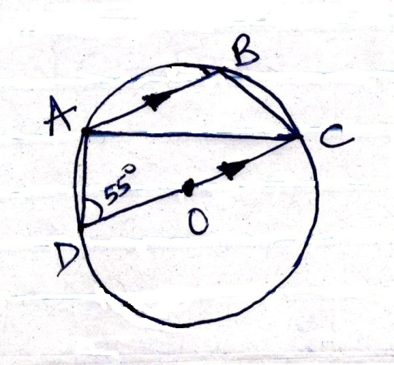

- Solve for X given that;
½ Log₂ 9 + Log₂ [5x – 4] = 7 (3 marks)

- An inlet tap can fill an empty tank in 6 hours. It takes 10hrs ro fill the tank when the inlet tap and outlet tap are both opened at the same time. Calculate the time the outlet takes to empty the full tank when the inlet tap is closed. (2 marks)

- Solve the equation (4 marks)
x + 3y = 13
x² + 3y² = 43

- Simplify $\frac{4}{\sqrt{6} + \sqrt{2}}$ (2 marks)

- The cash price of a TV set is Ksh.20,000. A customer bought it on hire purchase terms by paying a deposit of Sh.10,000 followed by 18 equal monthly installments of Sh.900 each. Annual interest, compounded semi-annually was charged on the balance for the period of 18 months. Determine correct to 1d.p the rate of interest per annum. (4 marks)

- The equation of a circle is given by X² + 4X + y² – 2y – 4 = 0. Determine the centre and radius of the circle. (3 marks)

- In the figure AOBP is a straight line. PZ is a tangent to the circle. If PZ = 12cm and BP = 6cm, find the radius of the circle. (3 marks)
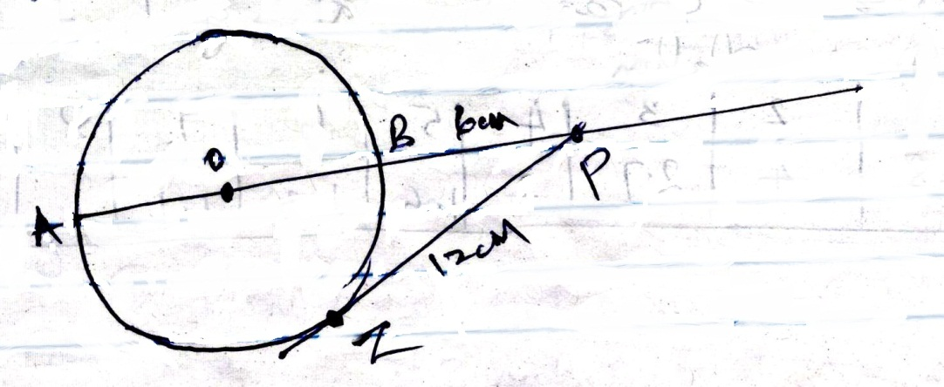

- (a) Expand $\left(1- \frac{3}{10}X\right)$ ⁵ Leave the co-efficient as fraction in their lowest form. (2 marks)

(b) Use the first three terms of the expansion in (a) above to estimate the value
$\left(0.97\right)$ ⁵ (4 marks)

- Using the assumed mean of 50, determine the variance of the following set of numbers;
52, 45, 42, 59, 56, 46. (3 marks)

- The table below shows the value of t and the corresponding values of h for a given relation.
t | 1 | 2 | 3 | 4 | 5 | 6 | 7 | 8
h | 8 | 4 | 2.7 | 2 | 1.6 | 1.3 | 1.1 | 1

- On the grid, draw the graph to represent the information on the table given.(2 marks)

- Use the graph to determine the rate of change of h at t = 4. (2 marks)

- Given that P = 2i – 3j + k, Q = 3i – 4i – 3k and R = 3P + 2Q, find │R │correct to 2 decimal places. (3 marks)

- Maize flour and millet flour were mixed. If the maize flour costs sh.60 per kilogram and millet flour sh.90 per kilogram, find the ratio of maize flour to millet flour that gives a mixture costing sh.85 per kilogram. (3 marks)

SECTION II: 50 MARKS
Attempt Only Five Questions In This Section

- A cup has 8 white plates and 4 brown ones all identical in shape and size. Mrs. Kamau selected 3 plates at random without replacement.
- Draw a tree diagram representing this information. (2 marks)

- Find the probability that she chooses:
- Two white plates and one brown in that order. (2 marks)

- At least one white plate. (3 marks)

- Three plates of the same colour. (3 marks)

- (a) A quantity P varies partly as the square of M and partly a constant. When P = 3.8, M = 2 and when P = -0.2, M = 3.
Find:
- The equation that connects P and M (4 marks)

- The value of P when M = 10. (1 mark)

(b) Q varies as the cube of x and inversely as the square root of R. If X is increased by 20% and R is decreased by 36%;
- Find the law connecting Q, X and R. (2 marks)

- Find the percentage change in Q (3 marks)

- Three consecutive terms of geometric progression are 9^{2x+1}, 81^{x} and 729 respectively.
Calculate.
- The value of x (3 marks)

- Find the common ratio (2 marks)

- Calculate the sum of the first 10 terms of the series. (2 marks)

- Given that the fifth and sixth terms of this G.P forms the first two consecutive of arithmetic sequence; calculate the sum of the first 20 terms of the sequence. (3 marks)

- The table below shows income tax rates in a certain year.
Monthly taxable income  in Kshs | Tax rates
0 – 12298  12299 – 23885  23886 – 35472  35473 – 47059  47060 and above | 10%  15%  20%  25%  30%
In the year, the monthly earnings of Mr.Korir
Basic salary Ksh.60,000
Medical allowance Ksh.16,500
Ksh.4,837.50 was erroneously exempted from his taxations.
- Calculate Mr. Korir taxable income (2 marks)

- Calculate Mr. Korir net tax for that month if his personal tax relief was Sh.1408 per month. (6 marks)

- Calculate Mr. Korir net pay for that month. (2 marks)

- The vertices of the triangle ABC are A(3, 3); B(1, 1) and c $\left[5, 3\right]$ are mapped onto triangle A₁B₁C₁ by a matrix $\left(\begin{matrix}0 & 1 \\ 1 & -2\end{matrix}\right)$
- (i) Find the co-ordinates of A₁ B₁ and C₁ (2 marks)

(ii) On the grid provided below, draw triangle ABC and A₁B₁C₁ (2 marks)

- (i) Triangle A₂B₂C₂ is the image of the triangle A₁B₁C₁ under a transformation matrix. $\left(\begin{matrix}-2 & 0 \\ 0 & -1\end{matrix}\right)$
Determine the co-ordinates of A2, B2 and C₂ (2 marks)

(ii) Find the area of triangle A₂B₂C₂ (2 marks)

- Determine a single matrix that maps ABC onto A₂B₂C₂ (2 marks)

- The table below shows the distances in kilometers covered by employees of a certain factory.

Distance (Km)  Number of workers | 1 – 5  3 | 6 – 10  6 | 11 – 15  8 | 16 – 20  7 | 21 – 25  4 | 26 – 30  2

If the actual mean of the data above is 14.5km;
- (i) Fill in the table given below.
Class | Frequency | Midpoint (x) | d = x-14.5 | d² | fd²
1 - 5 | 3
6 – 10 | 6
11 – 15 | 8
16 – 20 | 7
21 – 25 | 4
26 - 30 | 2
 | ∑f = |  |  |  | ∑fd² =
(ii) Use the values obtained from the table above to calculate standard deviations. (2 marks)

- (i) Find upper and lower quartiles. (2 marks)

(ii) Hence calculate quartile deviation. (2 marks)

- In this question use a ruler and a pair of compasses.
- (i) Construct triangle ABC such that AB = 9cm, AC = 7cm and ΔCAB = 60⁰ (2 marks)

(ii) Construct the locus of point P within the triangle such that P is equidistant from A and B. (2 marks)
(iii) Construct the locus of point Q within the triangle such that CQ ≤ 3.5cm. (2 marks)
- On the diagram in part (a)
- Shade the region R, containing all the points enclosed by the Locus of P and Q, such that AP≥BP (2 marks)

- Find the area of triangle ABC (3 marks)

- The table below shows some values of the curves y₁ = 2 cos x and y₂ = 3 sin x
- Complete the table to 1 decimal place (2 marks)

X⁰ | 0⁰ | 30 | 60 | 90 | 120 | 150 | 180 | 210 | 240 | 270 | 300 | 330 | 360
Y₁ = 2 cos x | 2 |  | 1 | 0 |  | -1.7 |  | -1.7 | -1 |  | 1 | 1.7 | 2
Y₂ = 3 sin x | 0 | 1.5 |  | 3 | 2.6 |  | 0 |  | -2.6 |  |  | -1.5 | 0

- On the grid provided, draw the graph of y₁ = 2 cos x and y₂ = 3 sin x for 0⁰ ≤ x ≤ 360⁰
On the same axes (5 marks)
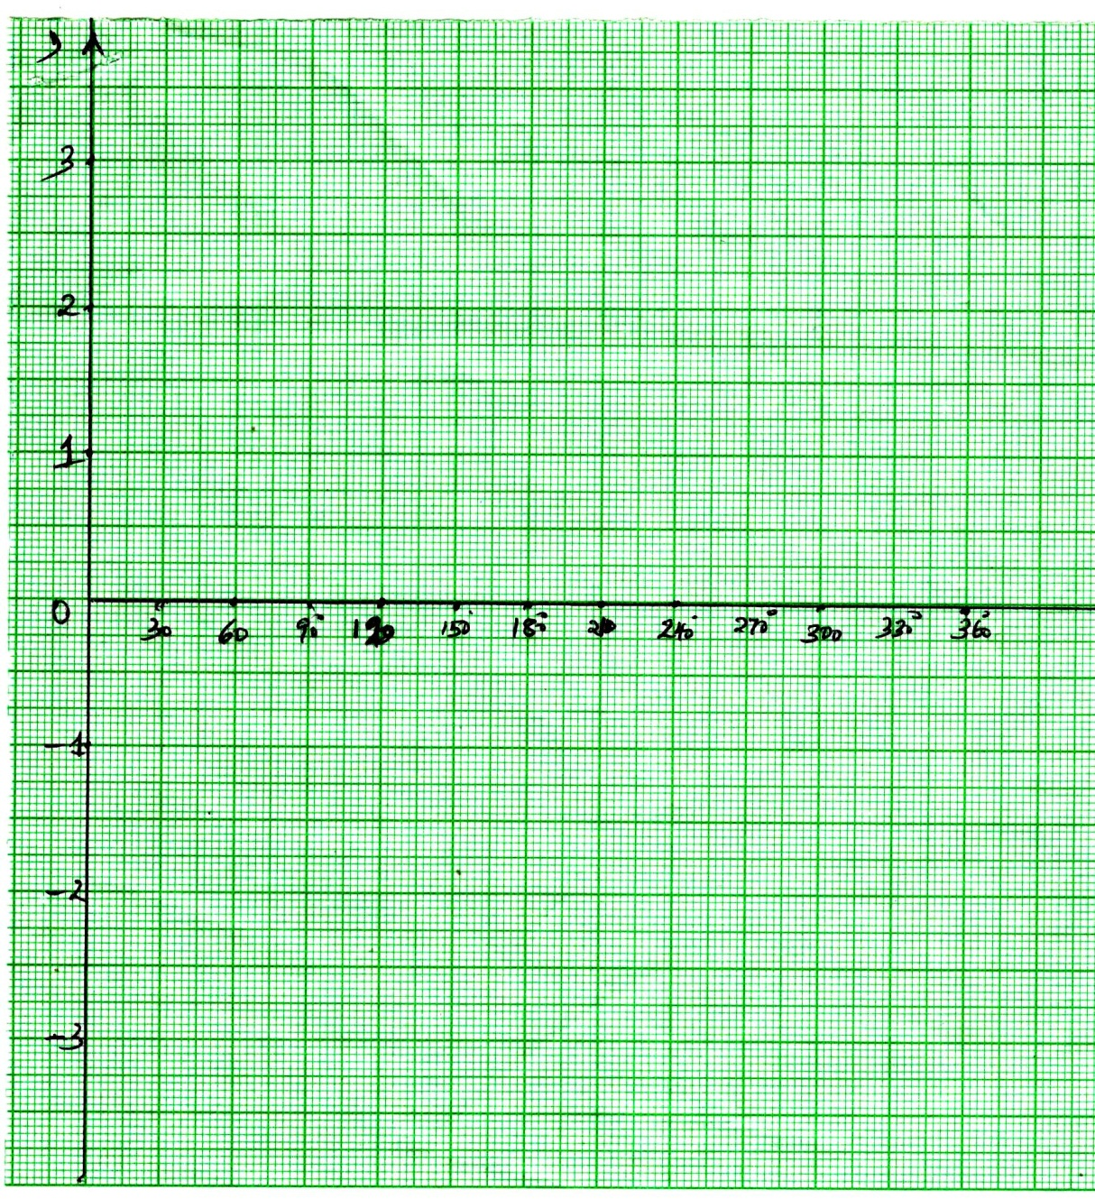

- Use the graph to find the values of x when 2 cos x = 3 sin x (2 marks)

- Find the difference of the amplitude of y = 2 cos x and y = 3 sin x. (1 mark)

