NAME :………………………………..INDEX NO. ……………………………CLASS:………….
ADM NO: ………………… DATE: …………………… SIGN:……………………..
121/1
MATHEMATICS
Paper 1
2 ½ hours ARISE AND SHINE
MATHEMATICS
FORM 4 TRIAL 1 EXAMINATION- 2023
Kenya Certificate of Secondary Education (KCSE)
INSTRUCTIONS TO CANDIDATES
- Write your name and admission number in the space provided at the top of this page
- This paper consists of two sections; section I and section II.
- Answer ALL questions in section I and only FIVE questions in section II
- Show all the steps in your calculations; giving your answers at each stage in the spaces provided below each question.
- Marks may be given for correct working even if the answer is wrong.
- Non-programmable silent electronic calculators and KNEC mathematical tables may be used.
- This paper consists of 15 printed pages

FOR EXAMINER’S USE ONLY
1 | 2 | 3 | 4 | 5 | 6 | 7 | 8 | 9 | 10 | 11 | 12 | 13 | 14 | 15 | 16 | 17 | TOTAL
SECTION I
Grand total
17 | 18 | 19 | 20 | 21 | 22 | 23 | 24 | TOTAL
SECTION II

Paper I Alt A
SECTION I (50 MARKS)
1. Solve for x.
$\frac{x -1}{1}$ = $\frac{1}{2x-3}$
(3 marks)

2. A man left ¹/₅ of his estate to his wife and ²/₃ of the remainder to be divided equally to each of his two sons. The rest was to be shared in the same ratio among his six cousins. If each cousin got
sh 60,000, how much money did the son got. (4 marks)

3. Solve for x in the equation:
5^{3y+3} + 5^{3y-1} = 125.2 (4 marks)

4. The average lap time for 3 athletes in a long distance race is 36 seconds, 40 seconds and 48 seconds respectively. If they all start the race at the same time, find the number of times the slowest runner will have been overlapped by the fastest runner at the time they all cross the starting point together again.
(3 marks)

5. Simplify the expression
3x² – 4xy + y²
18x² – 2y²
(3 marks)

6. In a triangle PQR below, QR = 12cm, $∠PQR=$80º and $∠PRQ$ = 30º
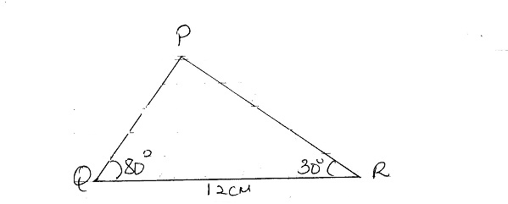
Calculate, correct to 4 significant figures, the area of triangle PQR. (3 marks)

- Mr. Wanyonyi travelled by train from Butere to Nairobi. The train left Butere on a Sunday 2350 hours and travelled for 7 hours 15 minutes to reach Nakuru. After 45 minutes stop in Nakuru, the train took 5 hours 40 minutes to reach Nairobi. Find the time, in the 12-hour system and the day Mr. Wanyonyi arrived in Nairobi. (3 marks)

- Find the reciprocal of 0.005041 hence evaluate $\frac{3}{0.005041}$ (2 marks)

- Line BC below is a side of triangle ABC and also a side of a Parallelogram BCDE

B C

Using a ruler and a pair of compasses only, construct:
- The triangle ABC given that $∠ABC$ = 120º and AB = 6cm (1cm)
- (ii) the parallelogram BCDE whose area is equal to that of the triangle ABC and point E is on line AB
(3 marks)

- Given that 4p – 3q = $\left({10 \atop 5}\right)$ and p + 2q = $\left({-14 \atop 15}\right)$; find the value of p and q (4 marks)

- A Kenyan bank buys and sells foreign currencies using the rates shown below.
Buying Selling
(Ksh) (Ksh)
1 Euro 86.25 86.97
100 Japanese Yen 66.51 67.26

A Japanese travelling from France arrives in Kenya with 5000 Euros, which he converts to Kenya Shillings at the bank while in Kenya he spent a total of Ksh. 289,850 and then converted the remaining Kenya shillings to Japanese Yen at the bank.
Calculate the amount of Japanese that he received. (3 marks)

- From a viewing tower 40 metres above the ground, the angle of depression of an object on the ground is 36º and the angle of elevation of an aircraft vertically above the object is 48º. Calculate the height of the aircraft above the objet on the ground. (3 marks)

- The interior angle of a regular polygon with 3x sides exceeds the interior angle of another regular polygon having x sides by 40º. Determine the value of x (3 marks)

- The mass of two similar cans is 960g and 15000g. If the total surface area of the smaller can is 144cm², determine the surface area of the larger can. (3 marks)

- The table below show the mean marks in a mathematics test of two classes
Class | Number of students | Mean mark
A | 45 | 62
B | 43 | 65

Calculate, correct to 2 decimal places, the mean mark of the classes. (2 marks)

- The figure below ABCDE is a cross-section of a solid. The solid has a uniform cross-section. Given that AP is an edge of the solid, complete the sketch showing the hidden edges with a broken line.
(3 marks)
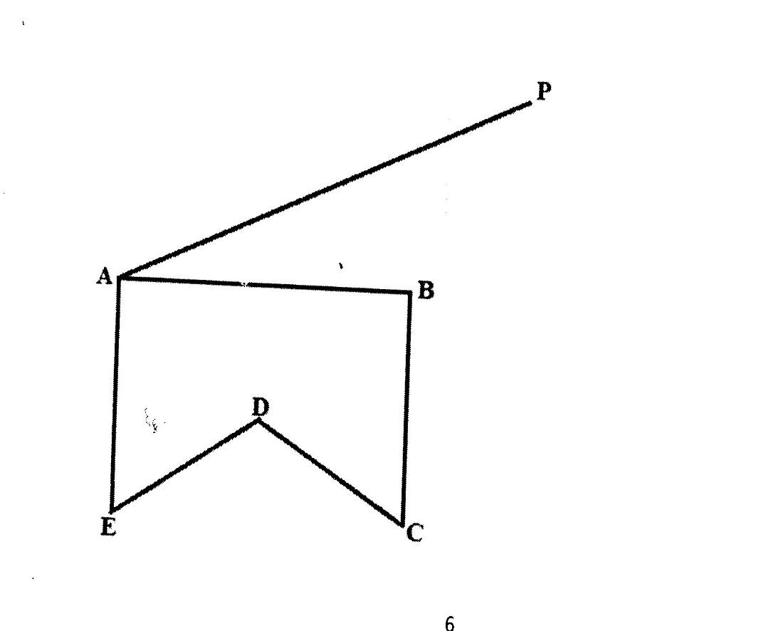

SECTION II (50 MARKS)
Answer only five questions in this section in the spaces provided.

- Two lines L₁:2y – 3x = 6 = 0 and L₂ = 3y + x – 20 = 0 intersect at a point A.
- Find the coordinates of A (3 marks)

- A third line L₄ is perpendicular to L₂ at point A. Find the equation of L₃ in the form y = mx + c, where m and c are constants. (3 marks)

- Another line L4 is parallel to L₁ and passes through (-2, 3). Find the x and y intercepts of L₄
(4 marks)

- One day Mr. Makori bought some oranges worth Ksh 45, on another day of the same week his wife Mrs.Makori spent the same amount of Money but bought the oranges at a discount of 75 cents per orange
a) If Mr.Makori bought an orange at Kshs x, write down and simplify an expression for the total number of oranges bought by the two in the week. (3 marks)

b) If Mrs.Makori bought 2 oranges more than her husband, find how much each spent on an orange.
(5 marks)

- Find the number of oranges bought by the two. (2 marks)

- Give points P, Q, R, V and T lie on the same plane, Point Q is 53km on the bearing of 055º of P, Point R lies 162º of Q at a distance if 58km. Given that point T is west of P and 114km from R and V is directly South of P and S40ºE from T.
a) Using a scale of 1:1,000,000, show the above information in a scale drawing. (3 marks)

b) From the scale drawing determine
i) The distance in km of point V from R (2 marks)

ii) The bearing of V from Q. (2 marks)

iii) Calculate the area enclosed by the points PQRVT in squares kilometers. (3 marks)

- The figure below represents a conical vessel which stands vertically. The vessels contain water to a dept of 30cm. the radius of the water surface in the vessel is 21cm (Take $π$= ²²/₇)
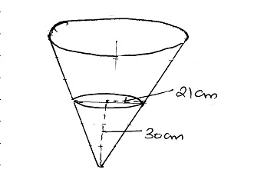
(a). Calculate the volume of the water in the vessel in cm³. (2 marks)

(b) When a metal sphere is completely submerged in the water, the level of the water in the vessel rises by 6cm. calculate:
(i) the radius of the new water surface in the vessel. (2 marks)
(ii) the volume of the metal sphere in cm³ (3 marks)
(iii). the radius of the sphere (3 marks)

- The mases to the nearest kilogram of some student were recorded in table below
Mass (kg) | 41-50 | 51-55 | 56-65 | 66-70 | 71-85
Frequency | 8 | 12 | 16 | 10 | 6
Height of rectangle |  |  |  |  | 0.2
a). Complete the table above to 1 decimal (2 marks)
b) on the grid provided below, draw a histogram to represent the above information (3 marks)
c) Use the histogram to
i) State the class in which the median mark lies. (1 mark)

ii) Estimate the median mark (2 marks)

iii) The percentage number of students with masses of at least 74kg. (2 marks)

- a) Given that A=$\left(\begin{matrix}3+3x, & 6 \\ x+7, & 2x+2\end{matrix}\right)$ is a singular matrix, find the values of x (3 marks)

(b) John bought 3 exercise books and 5 pens for a total of Ksh 200. If John had bought 2 exercise books and 4 pens, he would have spent Ksh 60 less. Taking e to represent the price of an exercise.
i) Form two expressions to represent the above information. (2 marks)

ii) Use matrix method to find the price of an exercise book and that of a pen. (3 marks)

iii) A teacher of a class of 45 students bought 3 exercise books and 2 pens for each student. Calculate the total amount of money the teacher paid for the books and the pens. (2 marks)

23. In the figure below, AC = 12cm, AD = 15cm and B is a point on AC $∠$BAD = $∠$ADB= 30º
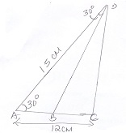
Calculate, correct to one decimal place: -
- the length of CD (3 marks)

- the length of AB; (3 marks)

- the area of triangle BCD (2 marks)

- the size of $∠$BDC (2 marks)

24. On the grid below, an object T and its image T’ are drawn.
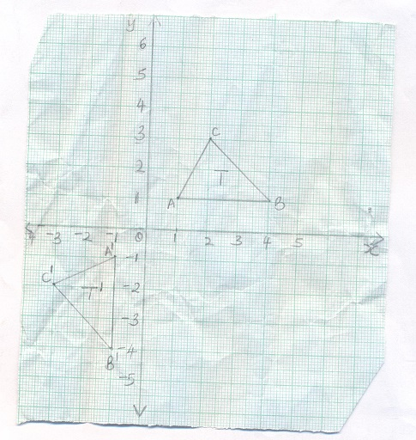
- Find the equation of the mirror line that maps T onto T’ (1 mark)

- (i) T’ is mapped onto T” by positive quarter turn about (0,0). Draw T” (2 marks)

ii) Describe a single transformation that maps T onto T”. (2 marks)

- T” is mapped onto T” by an enlargement, centre (2,0), scale factor -2. Draw T’’’ (2 marks)

- Given that the area of T’’’ is 12cm², calculate the area of T. (3 marks)

