MATHEMATICS
OPENER EXAMINATION TERM 3, 2022
PAPER II MARKING SCHEME
No | WORKINGS | Comments
1 | $$\frac{50x+70y}{x+y}=58$$  $$50+70y=58x+58y$$  $$8x=12y$$  $$x:y=3:2$$ | M1  M1  A1
2 | $$\frac{10+6d}{10+2d}=\frac{10+2d}{10}$$  $${\left(10+2d\right)}^{2}=10(10+6d)$$  $$100+40d+4d^{2}=100+60d$$  $${4d}^{2}=20d$$  $$4d=20$$  $$d=5$$ | M1  M1  A1
3 | $${\left(\frac{-30}{2}\right)}^{2}=9k$$  $$\frac{900}{4}=9k$$  $$36k=900$$  $$k=25$$ | M1  A1
4 | $$V^{2}=\frac{ax^{2}y}{W-y}$$  $$V^{2}W-V^{2}y=ax^{2}y$$  $$V^{2}W=V^{2}y+ax^{2}y$$  $$y=\frac{V^{2}W}{V^{2}+{ax}^{2}}$$ | M1  M1  A1
5 | $$P=\frac{KR^{2}\sqrt{Q}}{\sqrt[4]{M}}$$  $$K=\frac{300×\sqrt[4]{16}}{2^{2}×\sqrt{9}}=\frac{300×2}{4×3}=50$$  $$P=\frac{50R^{2}\sqrt{Q}}{\sqrt[4]{M}}$$  $$2500=\frac{50×5^{2}×\sqrt{Q}}{\sqrt[4]{81}}$$  $$Q={\left(\frac{2500×\sqrt[4]{81}}{50×25}\right)}^{2}=36$$ | M1  M1  M1 A1
6 |  | B1 – rectangle  B1 – L₁  B1 --L₂  B1 --L₃
7 | $$AC=\sqrt{6^{2}+6^{2}}=\sqrt{72}$$  $$Ax=\frac{1}{2}AC=3\sqrt{2}$$  $${Vx}^{2}={12}^{2}-{\left(3\sqrt{2}\right)}^{2}=144-18=126$$  $$Vx=\sqrt{126}=11.22 cm$$ | M1  M1  A1
8 | - ${\left(2-\frac{1}{3}x\right)}^{5}=32-\frac{80}{3}x+\frac{80}{9}x^{2}-\frac{40}{27}x^{3}$  - $1.93=2-\frac{1}{3}x$  $$x=0.21$$  $${1.93}^{5}=32-\frac{80}{3}\left(0.21\right)+\frac{80}{9}{\left(0.21\right)}^{2}-\frac{40}{27}{\left(0.21\right)}^{3}$$  $$=32-5.6+0.392-0.01372$$  $$=26.78 (4 s.f)$$ | B1  M1  A1
9 | - $\frac{120}{100}×500 000=Sh. 600 000$  - ${600 000 (1+0.1)}^{3}$  $$=600 000{\left(1.1\right)}^{3}=Sh. 798 600$$ | M1 A1  M1 A1
10 | $$\cos{4x=-0.5}$$  Cosine is negative in 2nd and 3rd quadrants  $$4x=120°, 240°, 480°, 600°$$  $$x=30°,60°,120°, 150°$$ | M1  A1
11 | Time difference = $5 hr 44 mins=344 mins$  Latitude difference = $\frac{344}{15}=22.93°$  Rome $\left(42°N, 44.7°W\right)$  Distance = $\frac{22.93}{360}×2×\frac{22}{7}×6370×\cos{42}$  $=1895.3 km$ | M1  M1  A1
12 | - P(B) = $\frac{8}{15}$  - P(G) or P(R) = $\frac{2}{15}+\frac{5}{15}=\frac{7}{15}$ | B1  M1 A1
13 | - $\left(\begin{matrix}5 \\ 1 \\ 2\end{matrix}\right)=\left(\begin{matrix}-1 \\ -2 \\ -3\end{matrix}\right)+\left(\begin{matrix}x \\ y \\ z\end{matrix}\right)$  $x=5+1=6$  $$y=1+2=3$$  $$z=2+3=5$$  Coordinates of Q are $\left(6, 3, 5\right)$  - $\left|PQ\right|=\sqrt{5^{2}+1^{2}+2^{2}}=\sqrt{30}=5.477 units$ | M1  A1  B1
14 | $$det=-4-1=-5$$  ASF $=\left|det\right|=5$  Area of triangle PQR = $\frac{1}{5}×40=8 sq. units$ | M1  M1 A1
15 | $$x$$ $$0$$ $$0.5$$ $$1$$ $$1.5$$ $$2$$ $$2.5$$ $$3$$ $$3.5$$ $$4$$ $$4.5$$ $$5$$ $$5.5$$ $$6$$  $$y$$ 3 3.25 4 5.25 7 9.25 12 15.25 19 23.25 28 33.25 39  - $A=1\left(3.25+5.25+9.25+15.25+23.25+33.25\right)$  $=89.5 sq units$ | B1 – all values  M1  A1
16 | $$\log\left(5x+75\right)-\log{9=\log\left(2x-9\right)+\log{10}}$$  $$\frac{5x+75}{9}=10(2x-9)$$  $$5x+75=90\left(2x-9\right)$$  $$180x-5x=810+75$$  $$x=\frac{885}{75}=11\frac{4}{5}$$ | M1  M1  M1  A1
17 | - $∠EBC=∠BFE=38°$  Angles subtended by the same chord  - $∠EGF=90°$  Angle subtended by the diameter EF  - $∠FBH=26°$  Base angles of an isoceless triangle  - $∠HEB=∠BFH=26°$  Angles subtended by the same chord BH  - $∠HAF=2×26=52°$  Opposite angles of cyclic quadrilateral BEFH | B1  B1  B1  B1  B1  B1  B1  B1  B1  B1
18 | - Buying price per Kg = $\frac{\left(25×5\right)+\left(30×2\right)+\left(45×1\right)}{8}=\frac{230}{8}=Sh. 28.75$  $$\frac{120}{100}×28.75=Sh. 34.50$$  Profit per Kg = $Sh. 34.50-28.75=Sh. 5.75$  - (i) $\frac{112}{100}×25=sh. 28$  $$\frac{112}{100}×30=sh. 33.60$$  $$\frac{112}{100}×45=sh. 50.40$$  Cost price = $\frac{\left(28×5\right)+\left(233.60\right)+\left(50.4×1\right)}{8}=Sh. 32.20$  $$\frac{120}{100}×32.20=Sh. 38.64$$  (ii) $40.25-32.2=Sh. 8.05$  $$\frac{8.05}{32.20}×100=Sh. 25\%$$ | M1  M1  A1  M1  M1  M1 A1  M1  M1 A1
19 | - Taxable income $=\left(\frac{38 300+12 000+3600}{20}\right)×12=$K£ 32 340  - Gross tax  1st band $=8800×2=17600$  2nd band = $8000×3=Sh.24000$  3rd band = $8000×5=Sh. 40 000$  4th band =754$0×7=Sh. 52 780$  Total tax due = $\frac{17 600+24 000+40 000+52 780}{12}=Sh.11, 198.30 p.m$  Net tax = $11 198.30-\left(1172+138\right)=Sh. 9 888.30$  - (i) Total deduction = $\left(\frac{2}{100}×38 300\right)+4600+14200+9 888.30$  $$=Sh.29 454.30$$  (ii) $Net pay=Sh. 53900 – 29454 .30$  $= sh 24445.70$ | M1 A1  M1  M1  M1  M1 A1  M1  M1  A1
20 | - On the diagram  - Transformation I  $$\left(\begin{matrix}2 & 0 \\ 1 & 0\end{matrix}\right)\left(\begin{matrix}2 & 4 & 3 \\ 1 & 1 & 4\end{matrix}\right)=\left(\begin{matrix}4 & 8 & 6 \\ 2 & 4 & 3\end{matrix}\right)$$  $$A^{'}\left(4,2\right) B^{'}\left(8,4\right) C'(6,3)$$  Transformation II  $$\left(\begin{matrix}1 & 0 \\ 0.5 & 2\end{matrix}\right)\left(\begin{matrix}4 & 8 & 6 \\ 2 & 4 & 3\end{matrix}\right)=\left(\begin{matrix}4 & 8 & 6 \\ 6 & 8 & 9\end{matrix}\right)$$  $$A^{''}\left(4,6\right) {B'}^{'}\left(8,8\right) C''(6,9)$$  Transformation III  $$\left(\begin{matrix}1 & -2 \\ 0 & 1\end{matrix}\right)\left(\begin{matrix}4 & 8 & 6 \\ 6 & 8 & 9\end{matrix}\right)=\left(\begin{matrix}-8 & -8 & -12 \\ 6 & 8 & 9\end{matrix}\right)$$  $$A^{'''}\left(-8, 6\right){B''}^{'}\left(-8, 8\right)C'''(-12, 9)$$  - $\left(\begin{matrix}1 & -2 \\ 0 & 1\end{matrix}\right)\left(\begin{matrix}1 & 0 \\ 0.5 & 2\end{matrix}\right)\left(\begin{matrix}2 & 0 \\ 1 & 0\end{matrix}\right)=\left(\begin{matrix}-4 & 0 \\ 3 & 0\end{matrix}\right)$  - Area of object = $0.5×2×3=3 sq. units$ | B1  B1  B1  B1  B1  B1  B1  M1 A1  B1
21 | Marks Mid point $$d=x-A$$ $$f$$ $$fd$$ $$cf$$  $$10-19$$ 14.5 $$-40.5$$ 2 $$-81$$ 2  $$20-29$$ 24.5 $$-30.5$$ 4 $$-122$$ 6  $$30-39$$ 34.5 $$-20.5$$ 5 $$-102.5$$ 11  $$40-49$$ 44.5 $$-10.5$$ 7 $$-73.5$$ 18  $$50-59$$ 54.5 $$-0.5$$ 10 $$-5$$ 28  $$60-69$$ 64.5 $$9.5$$ 6 $$57$$ 34  $$70-79$$ 74.5 $$19.5$$ 3 $$58.5$$ 37  $$80-89$$ 84.5 $$29.5$$ 2 $$59$$ 39  $$90-99$$ 94.5 $$39.5$$ 1 $$39.5$$ 40  $$f=40$$ $$fd=-170$$  $\overline{x}=55+\left(\frac{-170}{40}\right)$  $=55-4.25=50.75$  - $29.5+\left(\frac{10-6}{5}\right)×10$  $$=29.5+8$$  $$=37.5$$ | B1 for table  M1  A1  M1  A1
 | 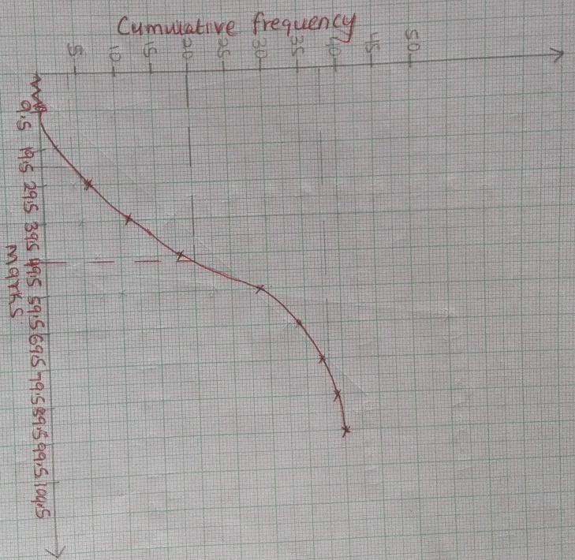
 | - (i) $\frac{5}{10}×40=20th position ⟹50.5$  (ii) $24.5-82.5$ marks | B1  B1
22 | $${x }^{0}$$ $${0 }^{0}$$ ${60}^{0}$ ${120}^{0}$ ${180}^{0}$ $${240}^{0}$$ $${300 }^{0}$$ $${360}^{0}$$ $${420}^{0}$$ $${480}^{0}$$ $${540}^{0}$$  $$\cos{x}$$ 1.00 0.5 $$-0.5$$ -1.00 $-0.5$ 0.50 1 0.5 -0.5 $-1$  $2cos(x+30$) 1.73 0 $-1.73$ $$-1.73$$ 0.00 1.73 1.73 0 $$-1.73$$ $$-1.73$$ | B1 – for $\cos{x}$  B1 – for $2\cos{(x+30)}$
 | - (i) Period =$360°$  (ii) Phase angle = $30°$ | B1  B1
 | - On a graph
 | - $216°-396°$ | B1
23 | - $a=\frac{dV}{dt}=8t-2$  At $t=2, a=8\left(2\right)-2=14 m/s^{2}$  - Acceleration is minimum when $\frac{dV}{dt}=0$  $8t-2=0$  $$t=\frac{1}{4}seconds$$  - $V=4{\left(\frac{1}{4}\right)}^{2}-2\left(\frac{1}{4}\right)+9$  $$=\frac{4}{16}-\frac{1}{2}+9$$  $=8.75 m/s$  - $S=\int{V dt}=\frac{4}{3}t^{3}-t^{2}+9t+c$  $$S=\int_{1}^{2}{\left(4t^{2}-2t+9\right)dt}$$  $$=\left(\frac{32}{3}-8+18\right)-\left(\frac{4}{3}-1+9\right)$$  $$=\frac{62}{3}-\frac{28}{3}$$  $$=11\frac{1}{3}m$$ | M1  M1 A1  M1  A1  M1  A1  M1  M1  A1
24 | $$x$$ $$-4$$ $$-3$$ $$-2$$ $$-1$$ $$0$$ $$1$$ $$2$$ $$3$$  $$2x^{2}$$ 32 18 8 2 0 2 8 18  $$3x$$ $$-12$$ $$-9$$ $$-6$$ $$-3$$ 0 3 6 9  $$-11$$ $$-11$$ $$-11$$ $$-11$$ $$-11$$ $$-11$$ $$-11$$ $$-11$$ $$-11$$  $$y$$ 9 $$-2$$ $$-9$$ $$-12$$ $$-11$$ $$-6$$ 3 16 | B1 B1
 | - On a graph
 | $$x$$ $$-3$$ $$0$$ $$3$$  $$y$$ $$-5$$ 1 7 | B1
 | - (i)  $$y=2x^{2}+3x-11$$  $$0=2x^{2}+3x-11-$$  $$y=0$$  Values of x are $x=-3.2$ or $x=1.7$  (ii)  $$y=2x^{2}+3x-11$$  $$0=2x^{2}+x-12-$$  $$y=2x+1$$  Values of x are $x=-2.7 or x=2.2$  (iii)  $$y=2x^{2}+3x-11$$  $$0=2x^{2}+3x-3-$$  $$y=-8$$  Values of x are $x=-2.2 or x=0.8$ | B1  B1  B1

